SonarQube
Code Quality Analysis with SonarQube and SonarScanner
Name | Roll Number | Experiment
K. Sai vardhan | 2420030095 | SonarQube setup and code analysis
Part A — Installing SonarQube
- Open the browser, search for SonarQube installation, and go to the download page:
https://www.sonarsource.com/products/sonarqube/downloads/
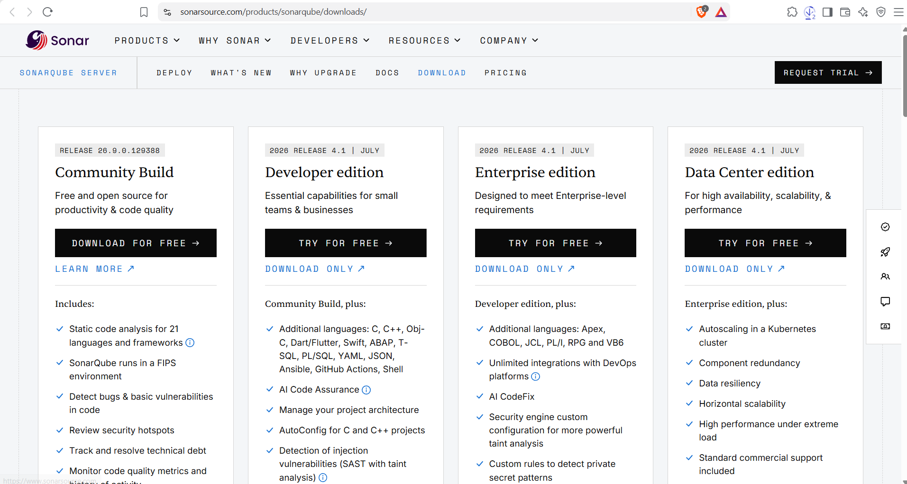
Figure 1. SonarQube editions on the download page
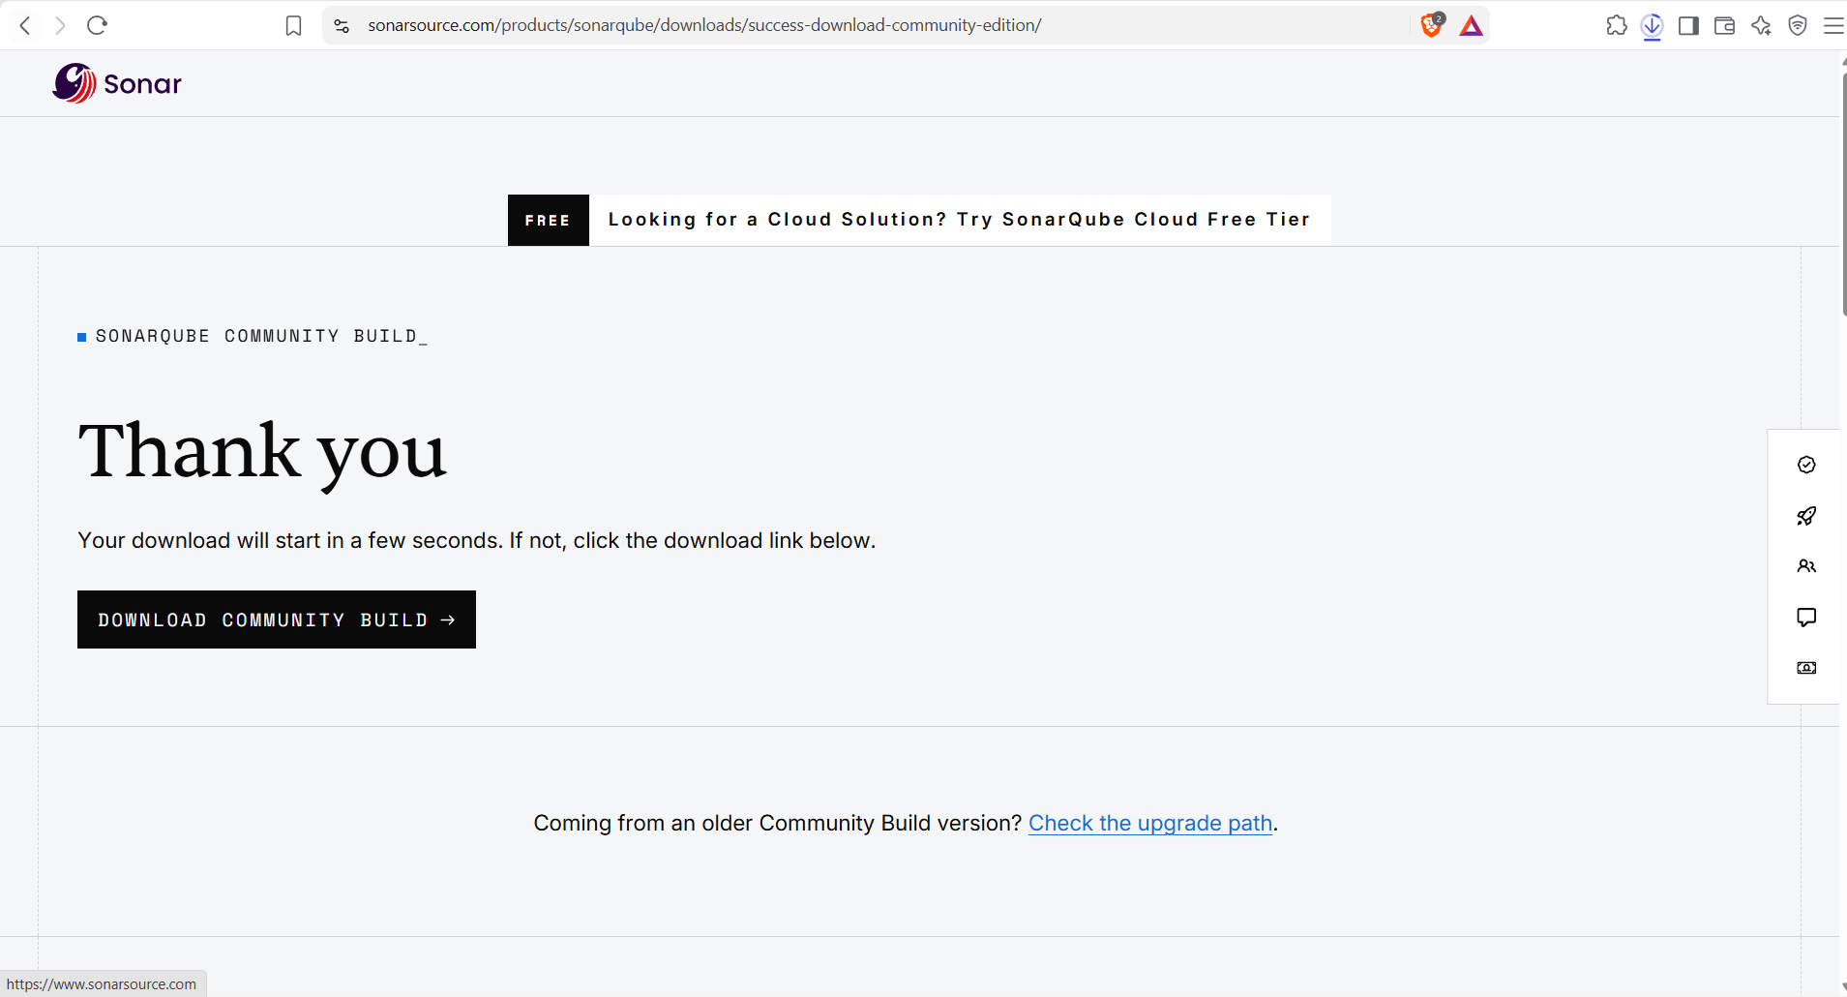
Figure 2. Download confirmation page
- Once the download is complete, extract the zip folder into the C drive.
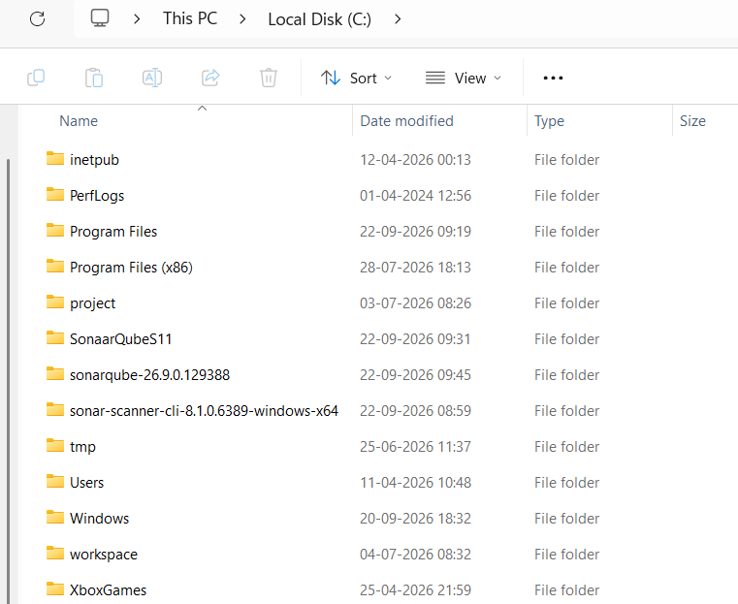
Figure 3. SonarQube folder extracted in the C drive
- Open C Drive → SonarQube folder → bin → windows (choose the folder for your operating system), and copy its path.
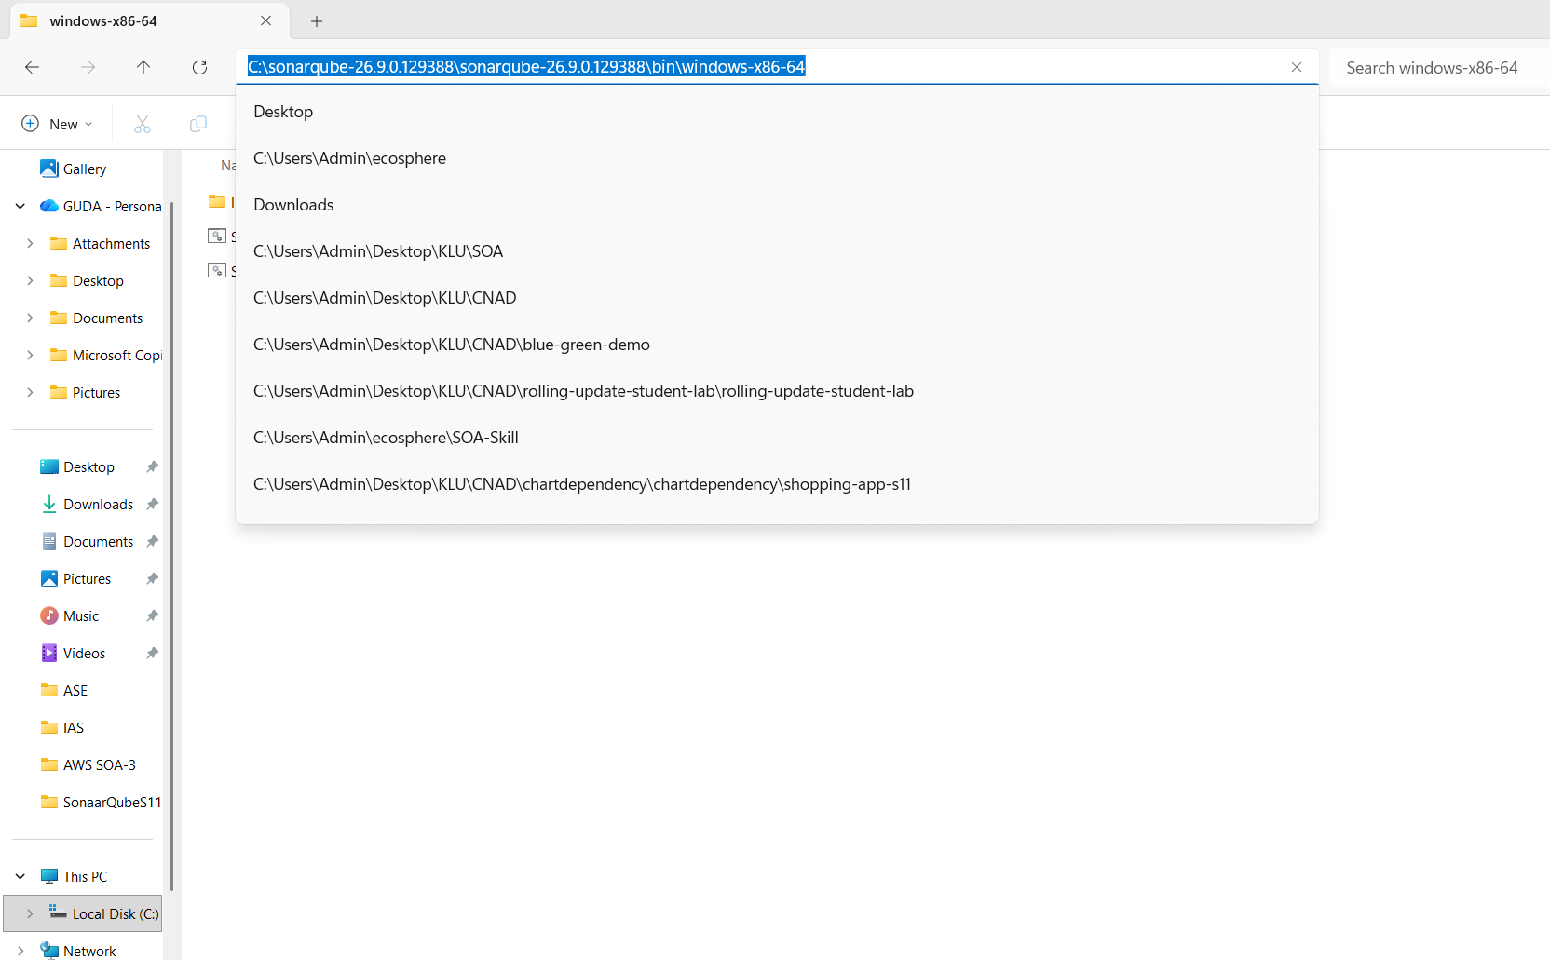
Figure 4. Copying the path of the bin folder
- Open Edit the system environment variables. Select Path, click Edit → New, paste the copied path, and click OK three times.
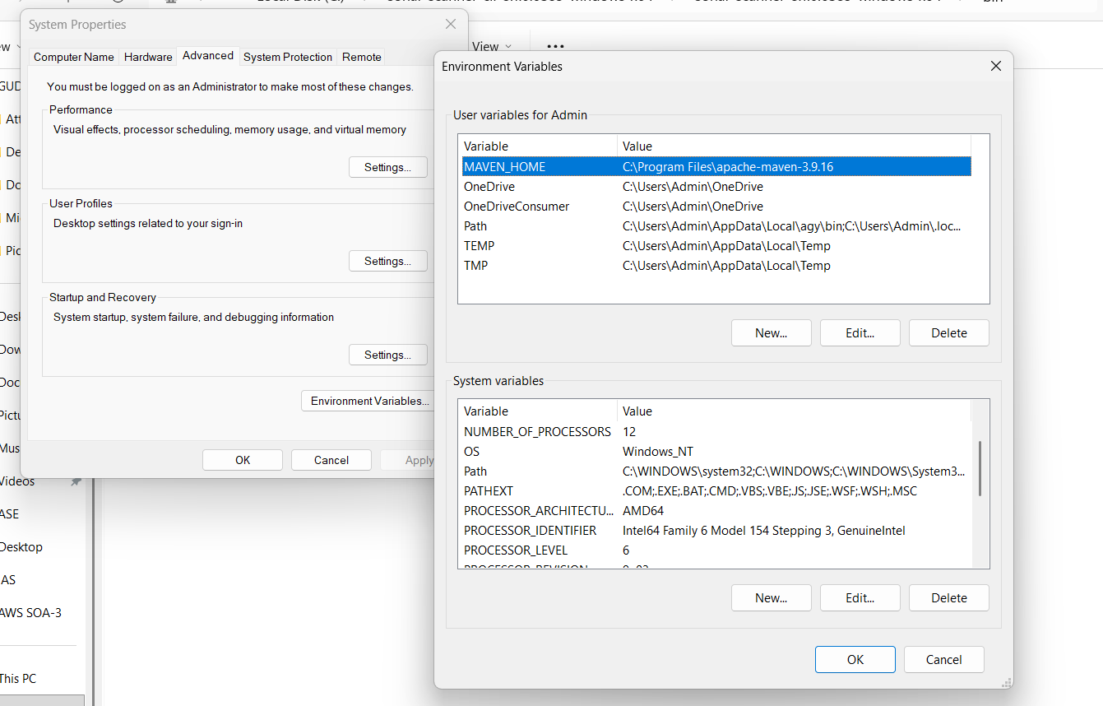
Figure 5. System Properties and Environment Variables windows
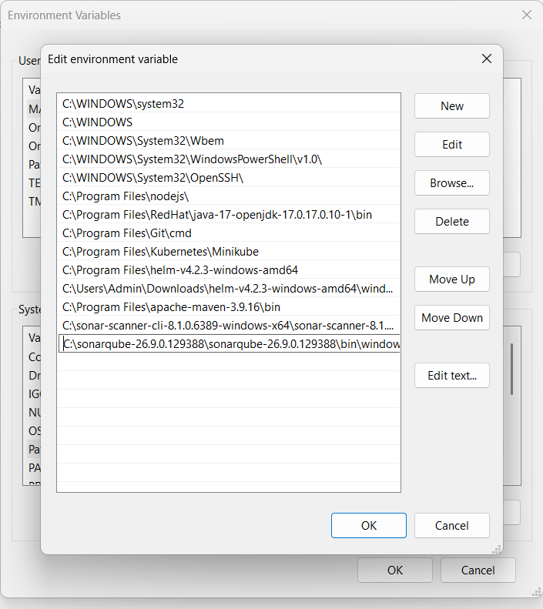
Figure 6. SonarQube path added to the Path variable
Part B — Installing SonarScanner
- Search for sonar scanner installation on Windows and open the documentation page:
https://docs.sonarsource.com/sonarqube-server/9.9/analyzing-source-code/scanners/sonarscanner
- Choose your operating system on the SonarScanner page, and the zip folder will start downloading.
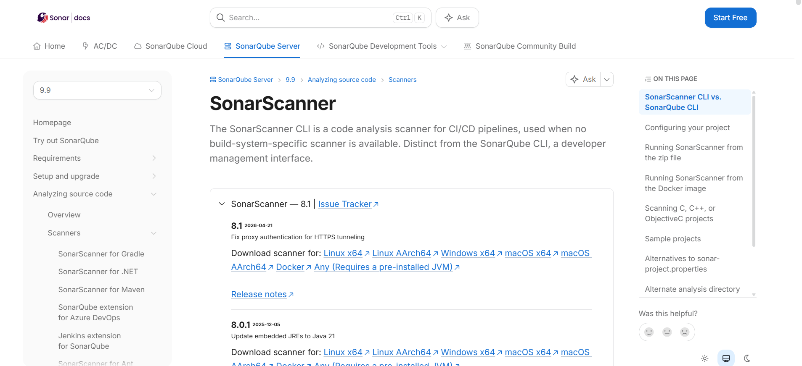
Figure 7. SonarScanner documentation page
- Extract the downloaded zip folder into the C drive.
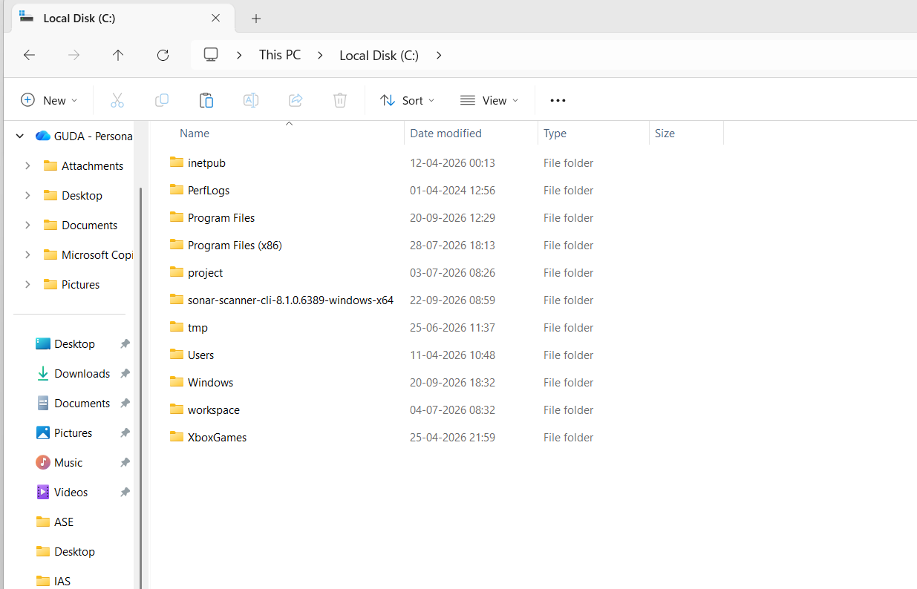
Figure 8. SonarScanner folder extracted in the C drive
- Open C Drive → SonarScanner folder → bin and copy its path.
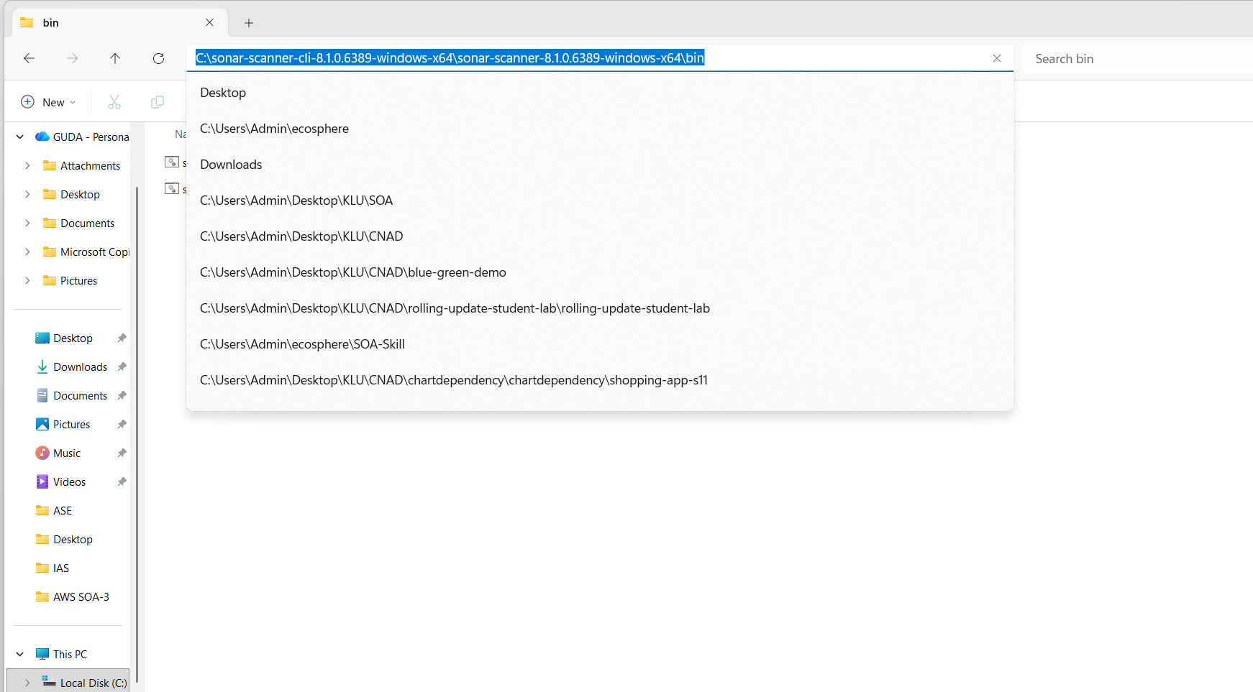
Figure 9. Copying the path of the SonarScanner bin folder
- Add this path to the system environment variables in the same way as before: Path → Edit → New → paste the path → OK three times.
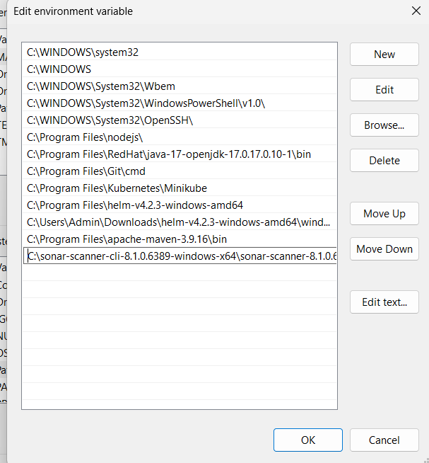
Figure 10. SonarScanner path added to the Path variable
Part C — Starting the Server and Creating a Project
- Open Command Prompt, type the following command, and press Enter:
StartSonar
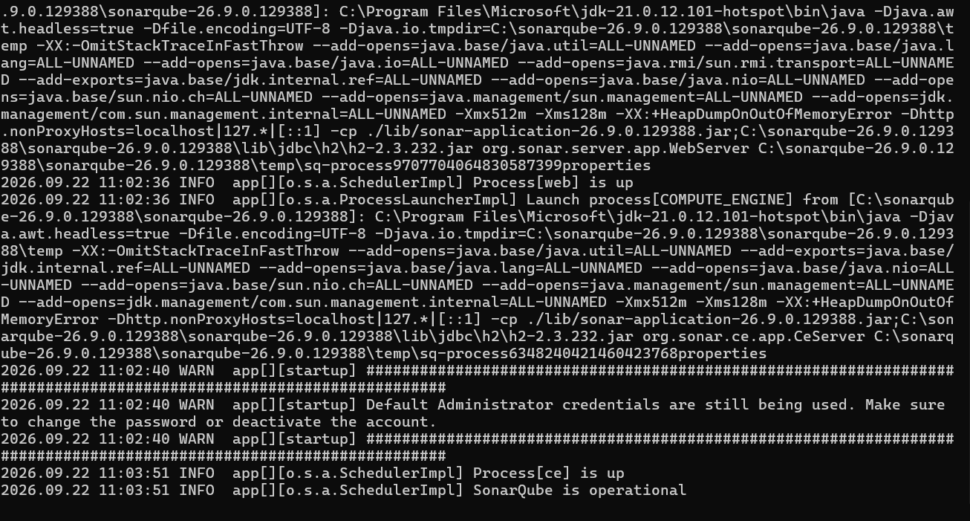
Figure 11. SonarQube server starting in Command Prompt
- Wait until the log shows that the process is up and SonarQube is operational.
Note: do not close this Command Prompt window. Minimise it instead, because closing it shuts the server down.
- Open the browser, go to localhost:9000, and press Enter. Log in with the username admin and the password admin.
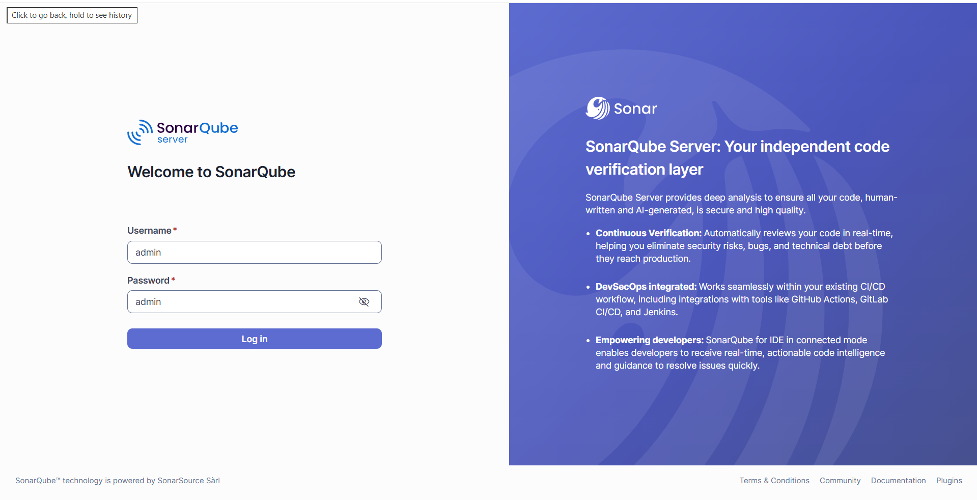
Figure 12. SonarQube login page
- Click Create a local project, enter the project name, and click Next.
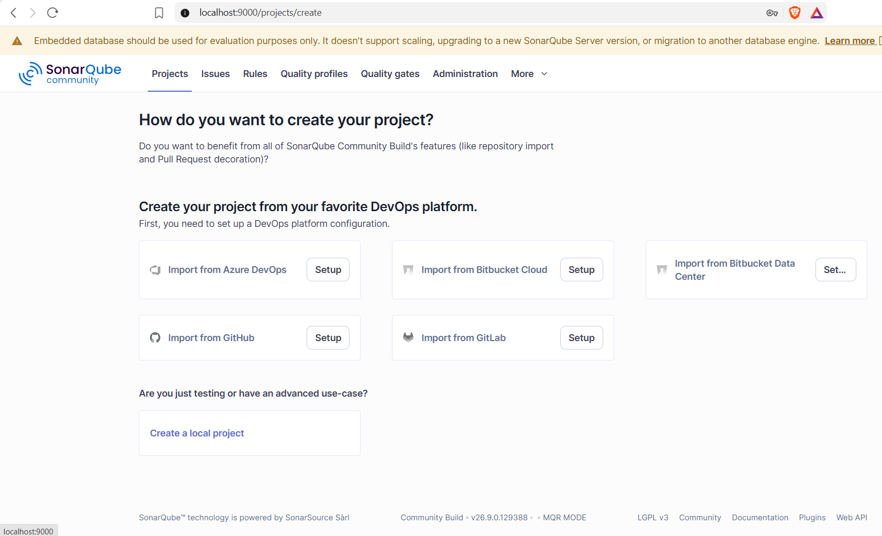
Figure 13. Choosing how to create a project
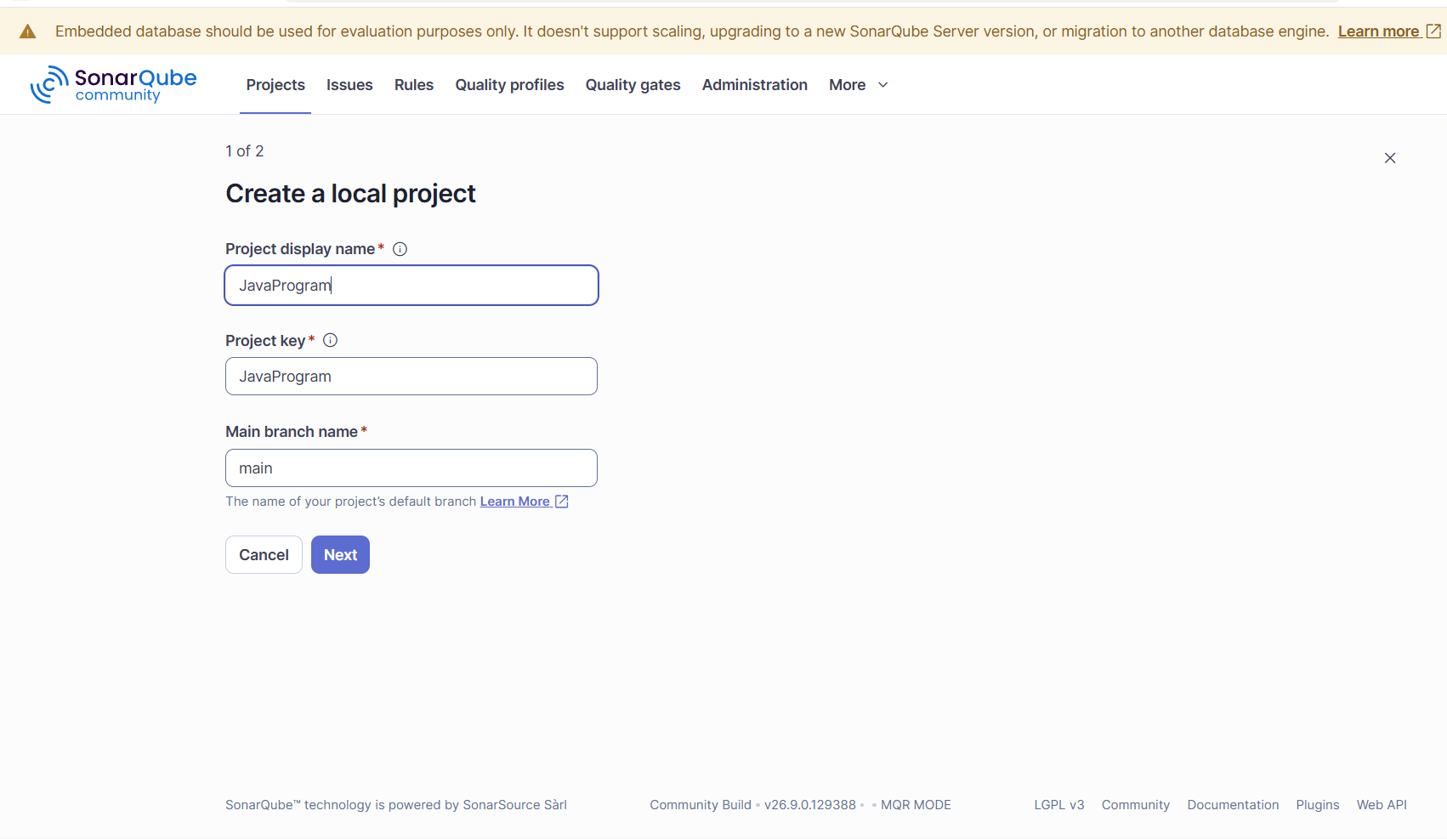
Figure 14. Entering the project name
- Select Follows the Instance’s Default and click Create project.
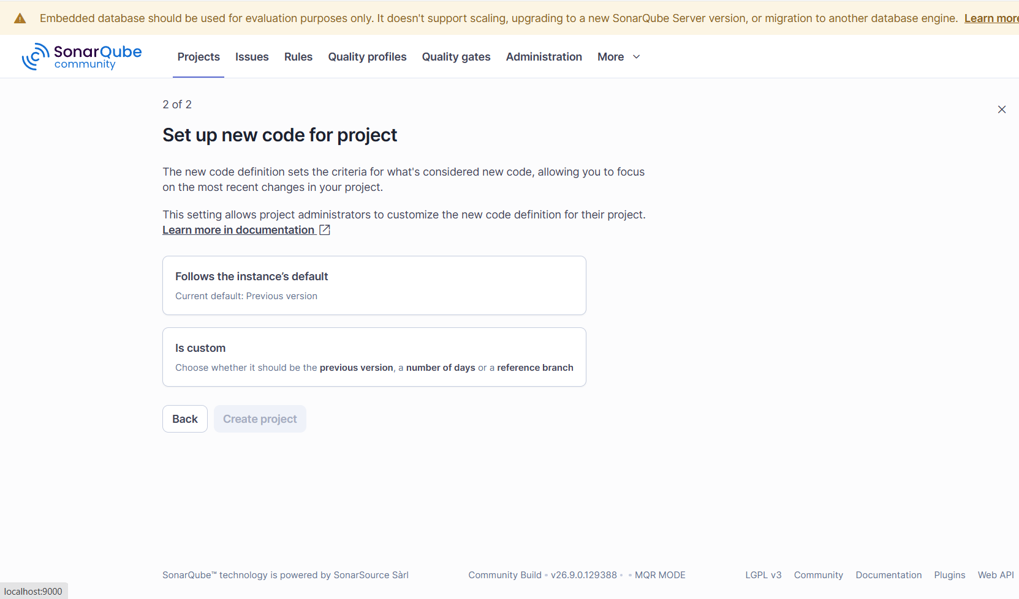
Figure 15. Setting up the new code definition
- Choose Locally as the analysis method.
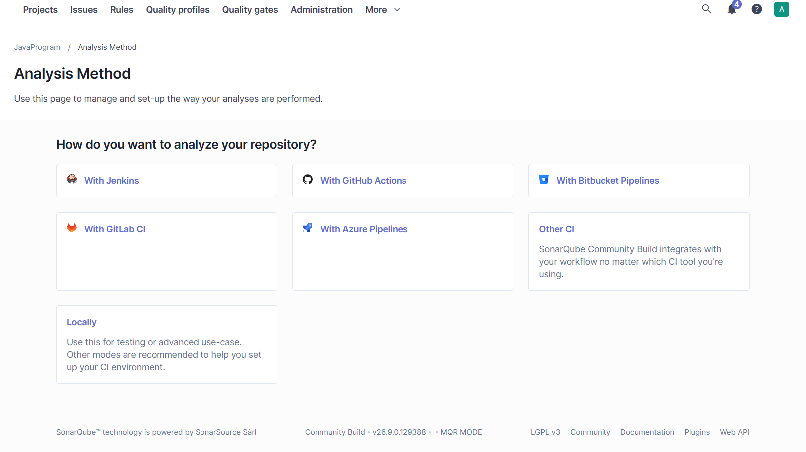
Figure 16. Analysis method selection
- Click Generate to create a token.
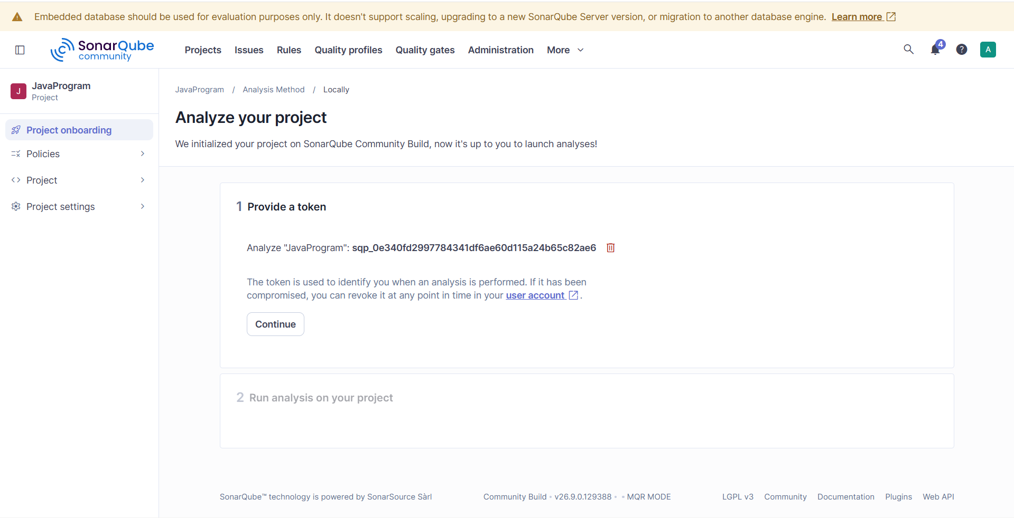
Figure 17. Generating the project token
- Copy the generated token and store it somewhere safe, since it is needed later, then click Continue.
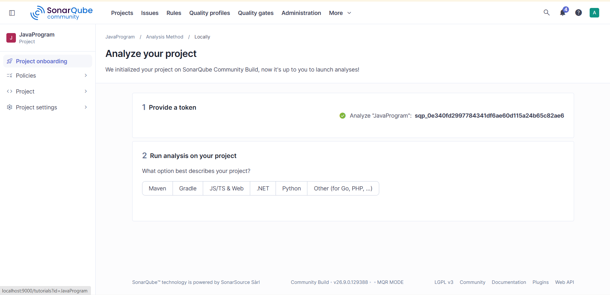
Figure 18. Token generated for the project
Token: sqp_0e340fd2997784341df6ae60d115a24b65c82ae6
Part D — Preparing the Project
- Open Command Prompt and verify that SonarScanner is installed:
sonar-scanner -v
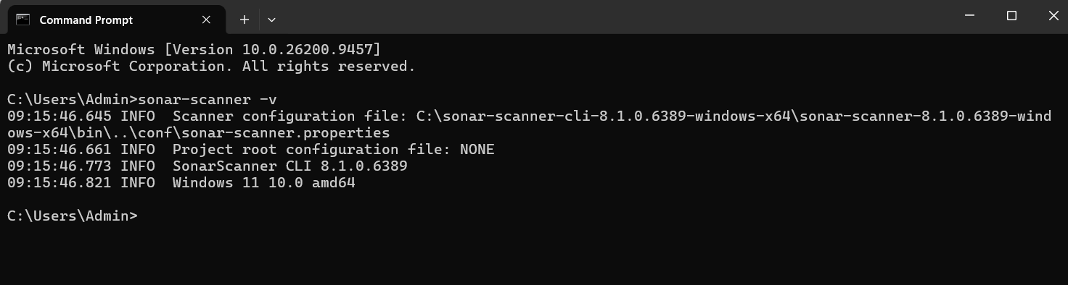
Figure 19. SonarScanner version displayed
- Create a folder named SonarQubeS11 in the C drive. Inside it, write a simple Java program and save it as Javaprogram.java.
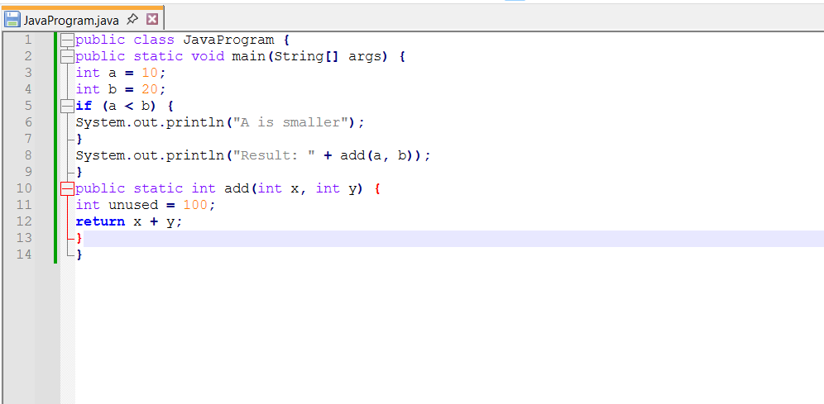
Figure 20. Sample Java program
- Save the configuration file in the same folder with the name sonar-project.properties.
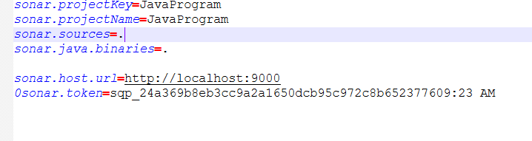
Figure 21. Contents of the sonar-project.properties file
- Copy the path of the folder where the Java program is saved, then use it in Command Prompt to move into that directory.
- Compile the program to produce the class file:
javac Javaprogram.java
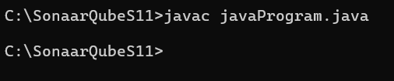
Figure 22. Compiling the Java program
Part E — Scanning and Reviewing the Report
- Run the scanner from the project folder:
sonar-scanner
When the scan is finished, the output shows EXECUTION SUCCESS.
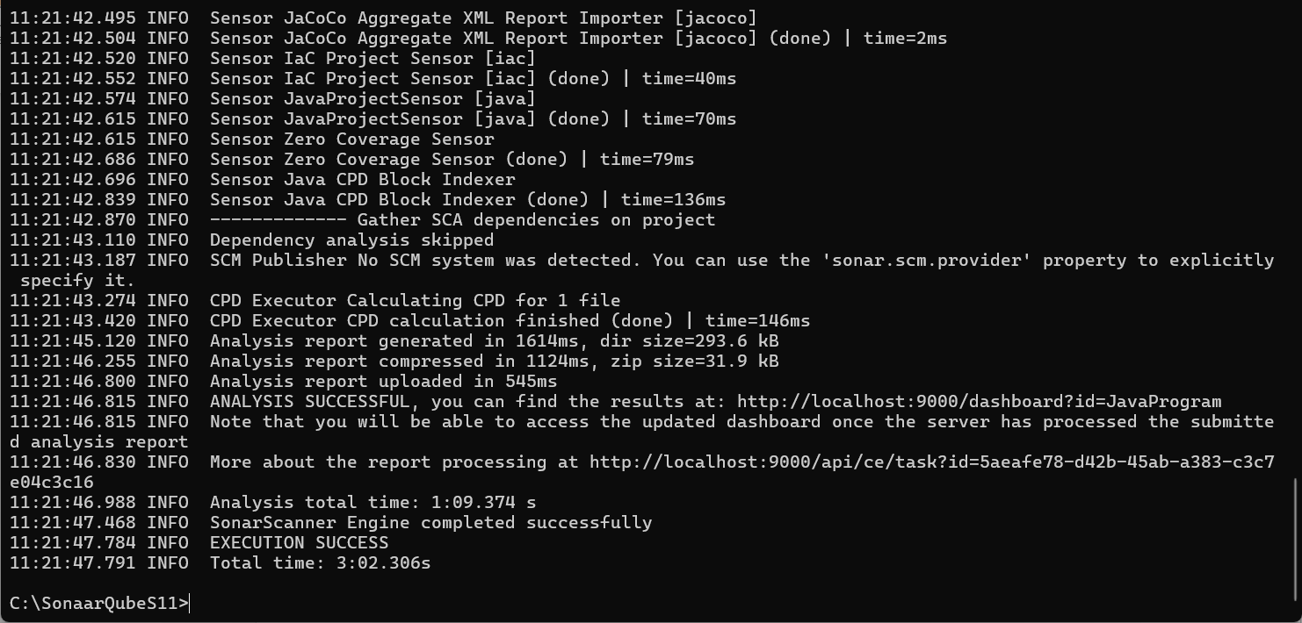
Figure 23. Scanner output ending in EXECUTION SUCCESS
- Go back to the server, click Projects at the top, and open the report.
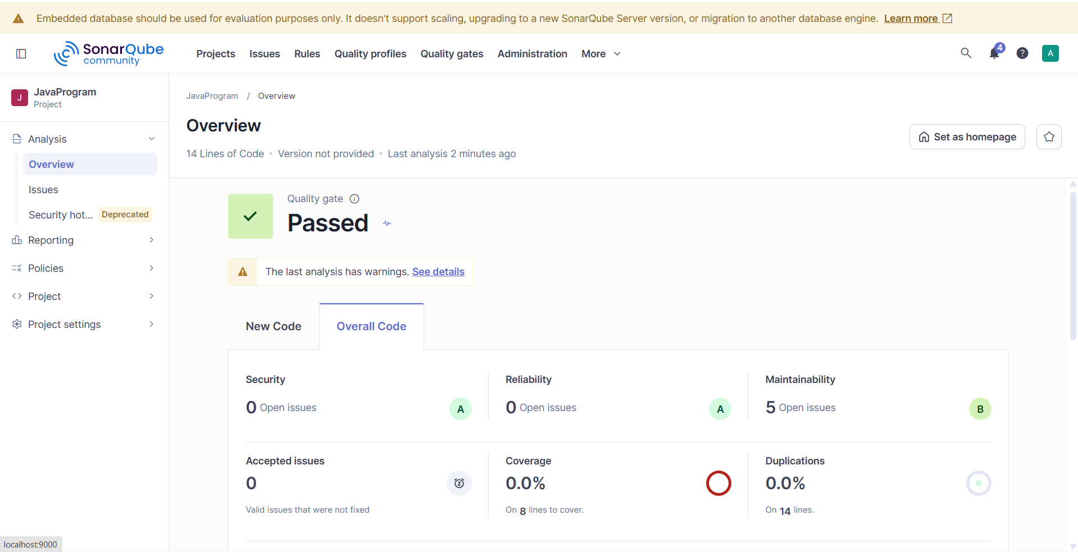
Figure 24. Project overview report
- The report shows 5 Maintainability issues. Click Issues to see the complete list.
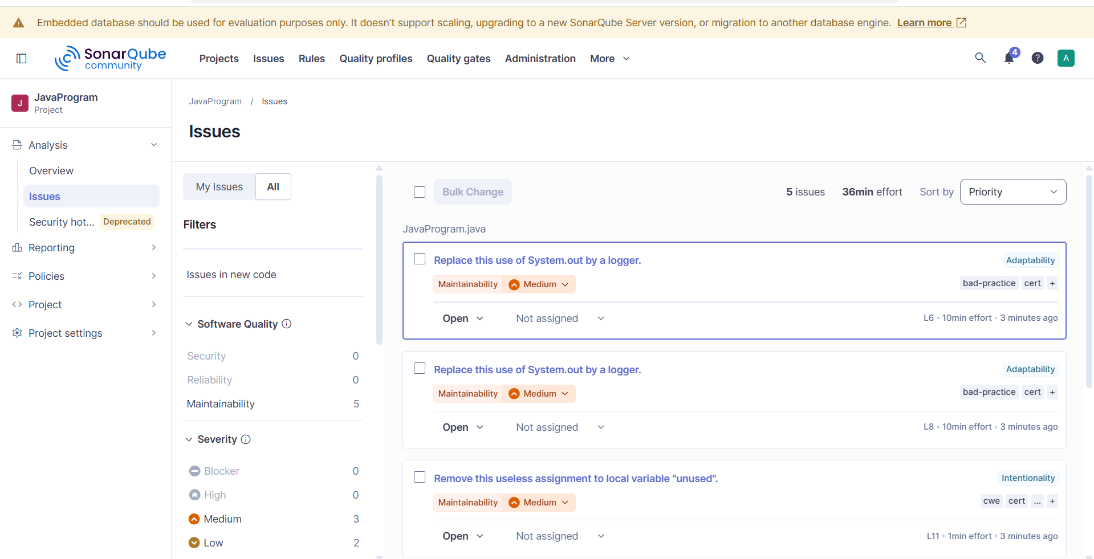
Figure 25. List of issues found in the project
Part F — Stopping the Server
- When the work is done, go to the Command Prompt window where the server is running and press Ctrl+C.
- Type exit and y when prompted.
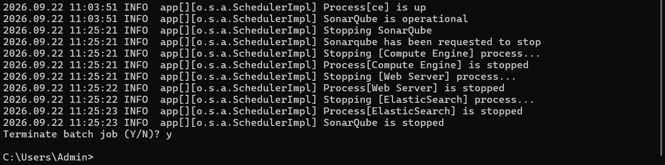
Figure 26. Server shut down from Command Prompt
- To confirm that the server has stopped, refresh the SonarQube page in the browser.
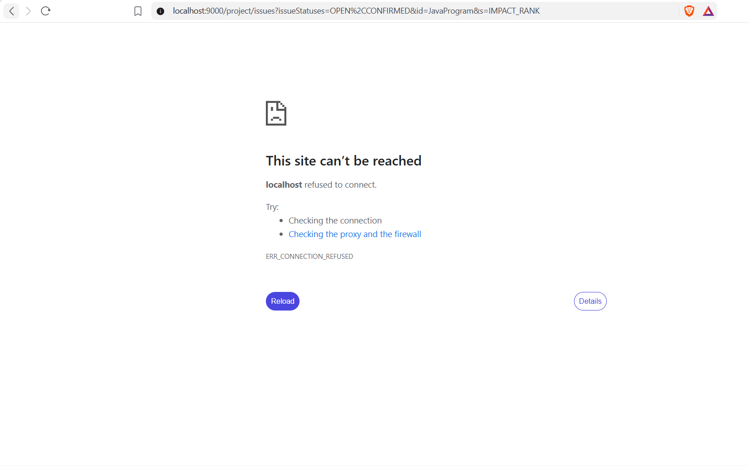
Figure 27. The server is stopped successfully

