Experiment 10 — OWASP ZAP
Installing and Configuring OWASP ZAP
Name | Roll Number | Experiment
K. Sai vardhan | 2420030095 | Section 11 — Install and configure OWASP ZAP
Part A — Installing OWASP ZAP
- Download OWASP ZAP from the official website:
https://www.zaproxy.org/download/
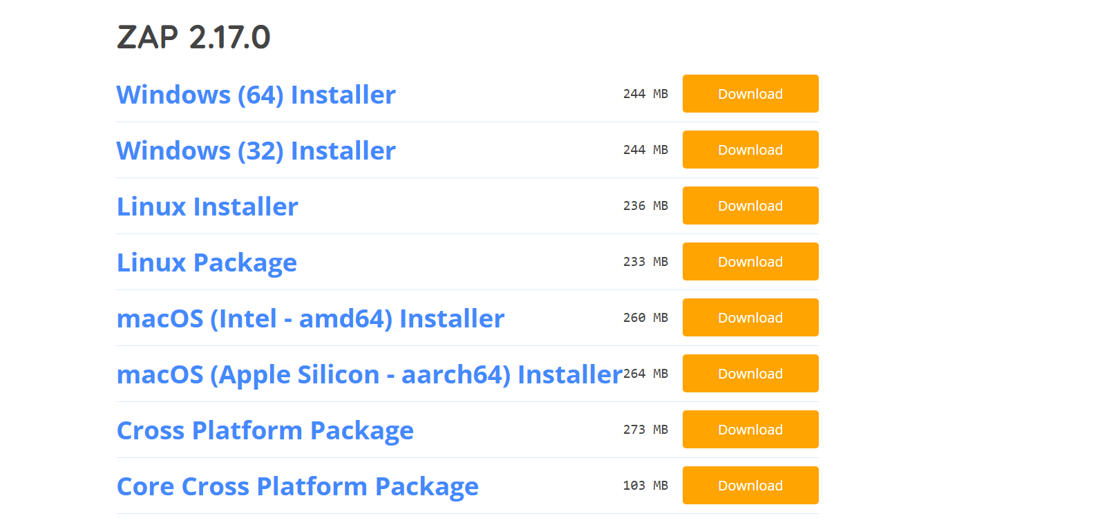
Figure 1. ZAP download options on the official website
- Run the installer and finish the installation.
- Open ZAP and begin a new session.
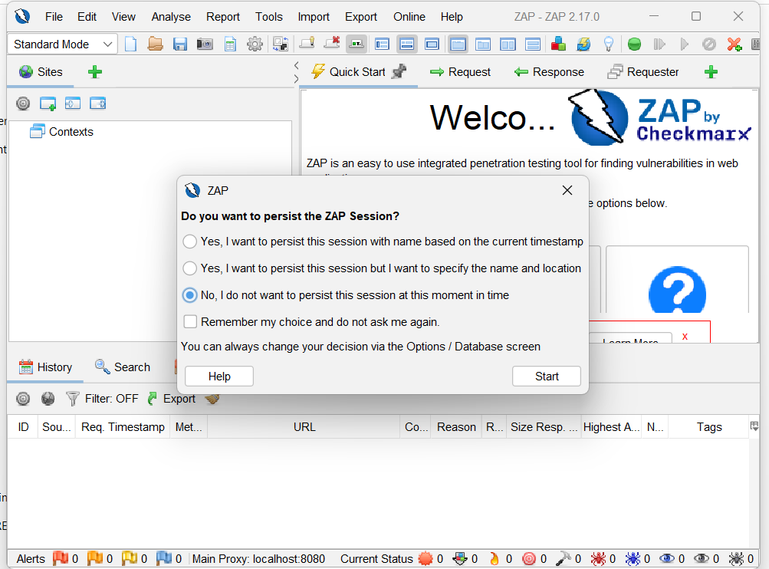
Figure 2. Session persistence prompt on first launch
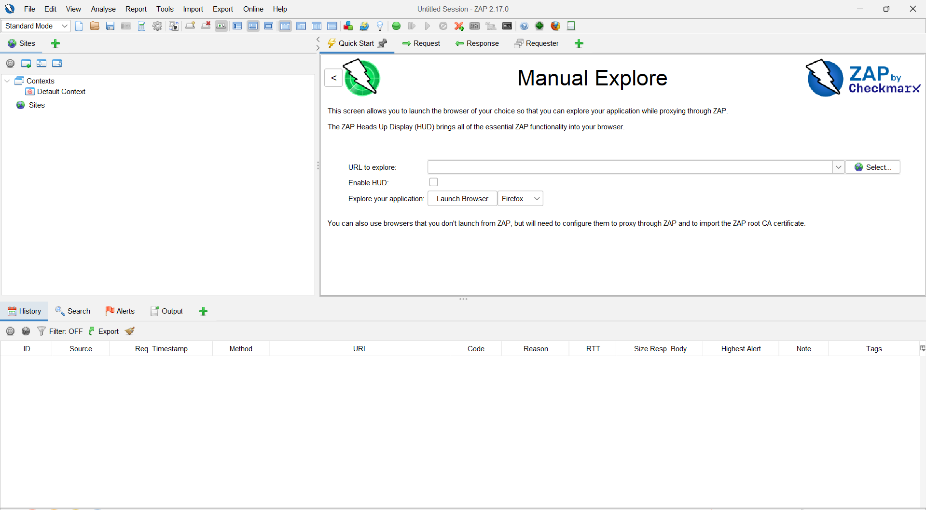
Figure 3. ZAP main window with a new session
Part B — Exploring ZAP and Setting the Proxy
- Look through the Sites, History, Request, Response, and Alerts sections.
- In the ZAP settings, check the proxy address and port.
- Configure the browser to use ZAP as its proxy.
- Open a test website that you are authorised to test in the browser.
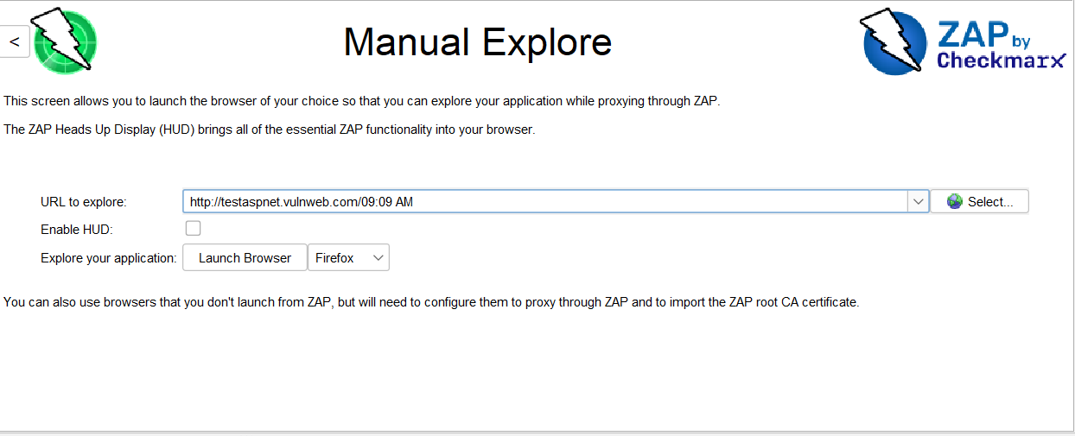
Figure 4. Manual Explore screen with the test website entered
Part C — Capturing Traffic
- Check the History section for the requests captured from the website.
- Study the HTTP requests and responses in ZAP.
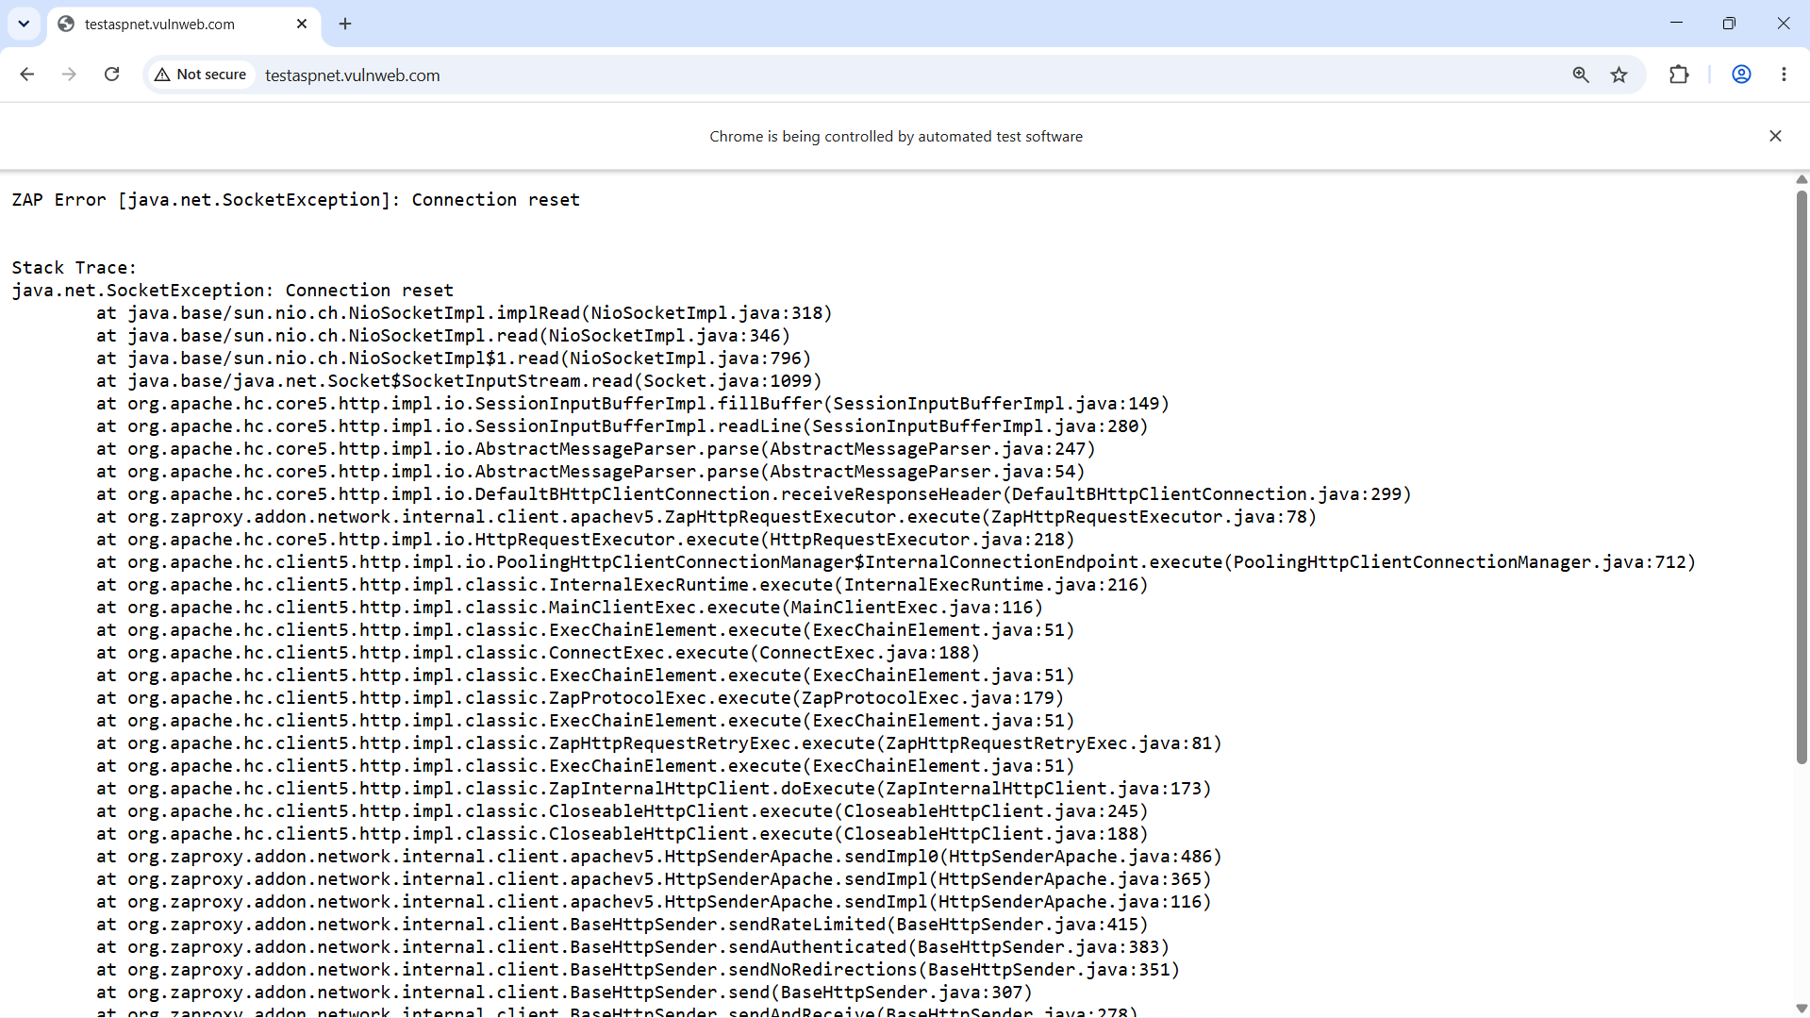
Figure 5. Test website opened in the proxied browser
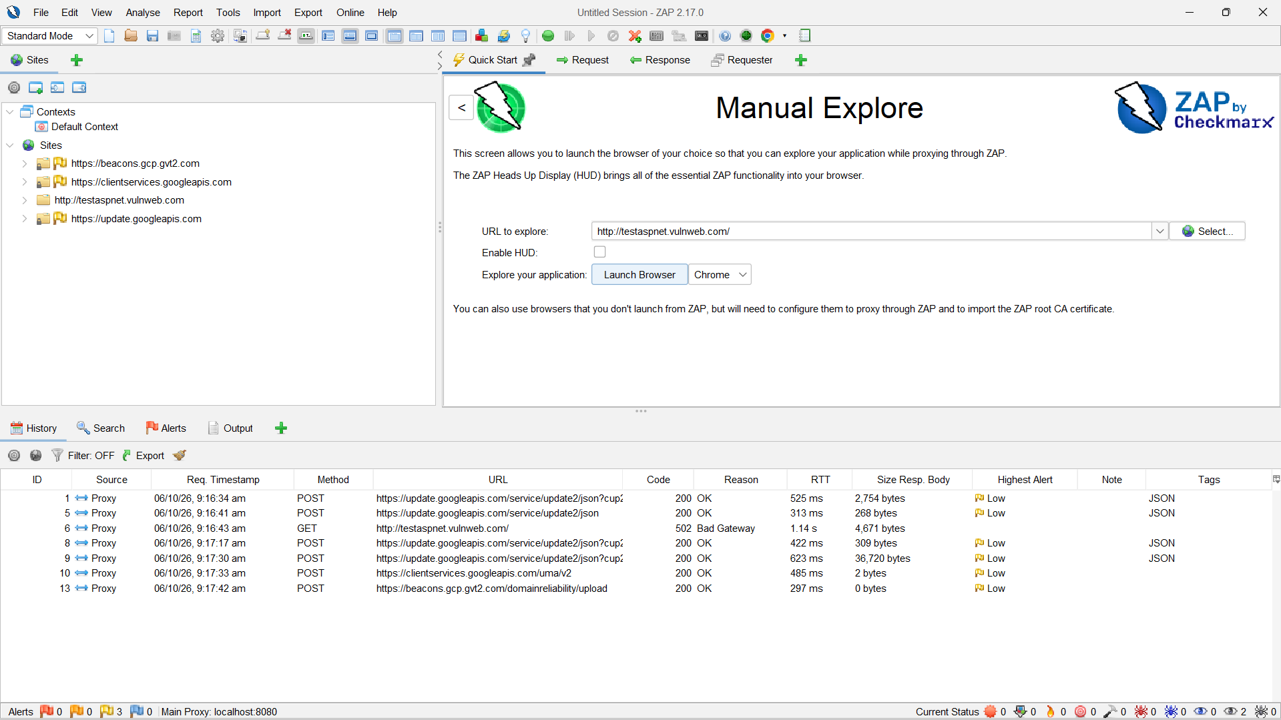
Figure 6. Captured requests listed in the History tab
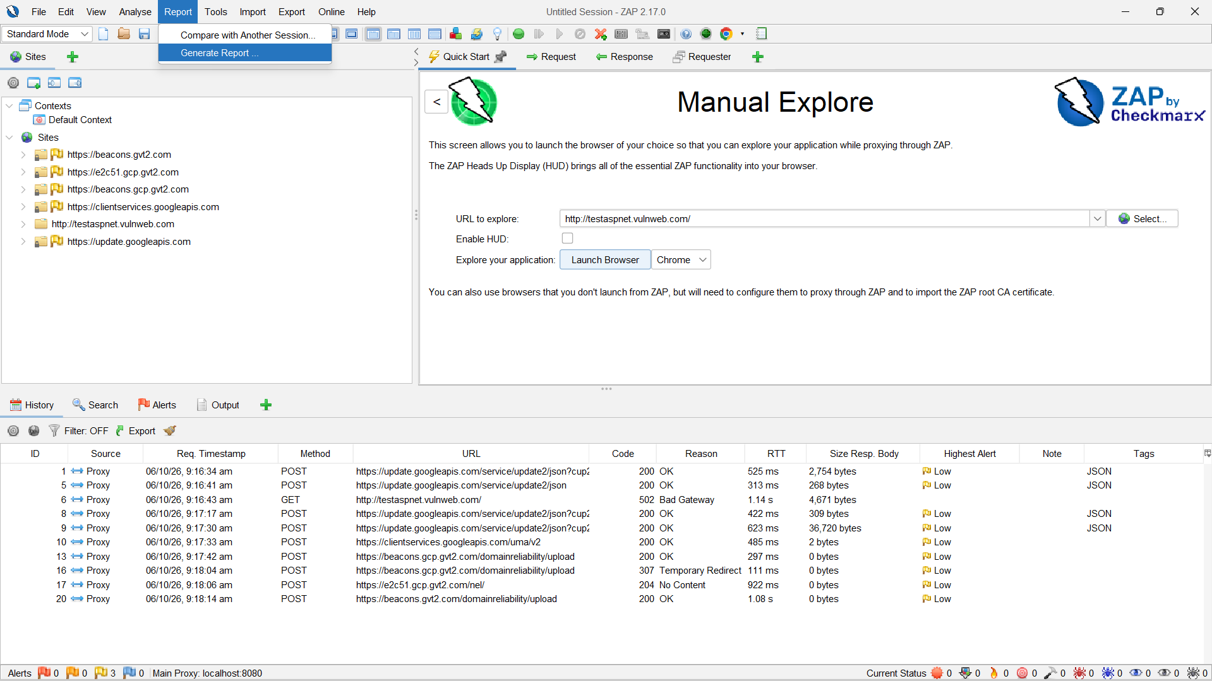
Figure 7. Report menu opened to generate the security report
Part D — Alerts and Report
- Open the Alerts section to see possible security vulnerabilities.
- Generate a security report in HTML or PDF format and save it.
- Open the report and verify the issues found and the test results.
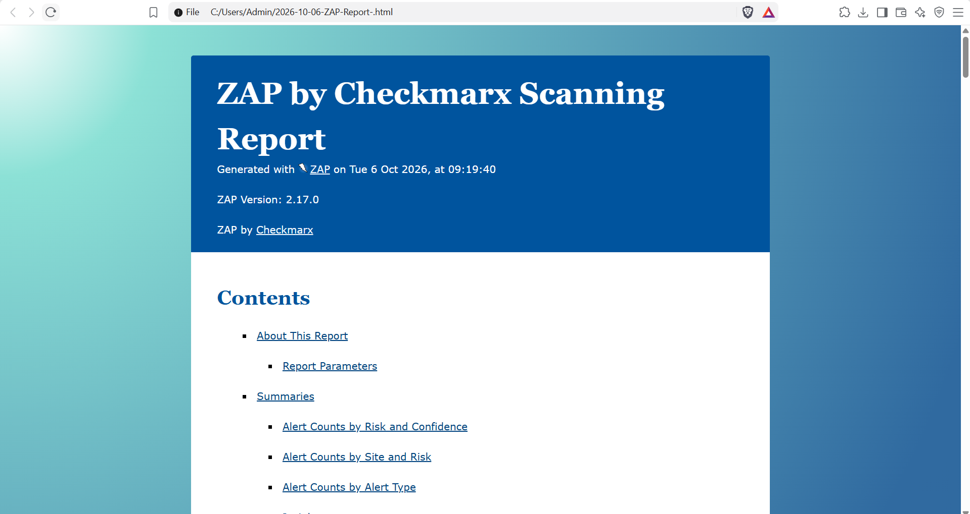
Figure 8. Generated ZAP scanning report

