Git and GitHub
Creating Commits and Uploading a Project to GitHub
Name | Roll Number | Experiment
K. Sai vardhan | 2420030095 | Create Git commits and upload a project to GitHub.
Part A — Setting Up Git
- Install Git on your system.
- Open Command Prompt or Git Bash.
- Set your username and email, then confirm the settings:
git config --global user.name "<your-username>"
git config --global user.email "<your-email>"
git config --list
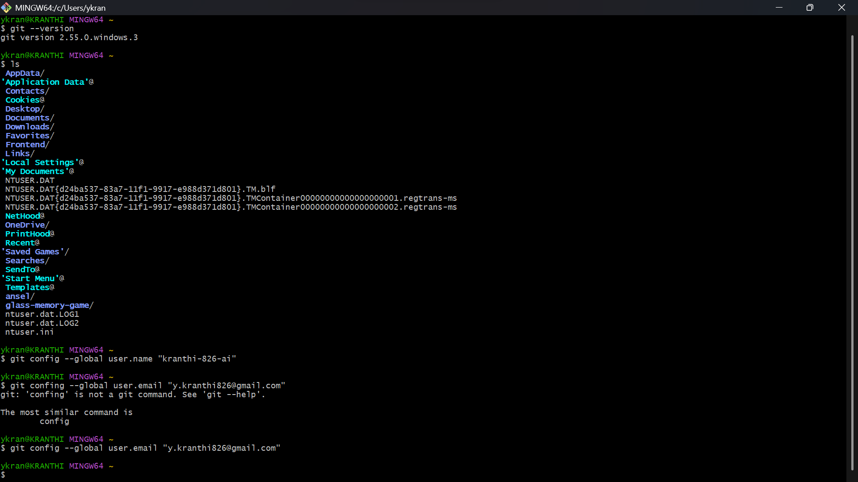
Figure 1. Setting the Git username and email
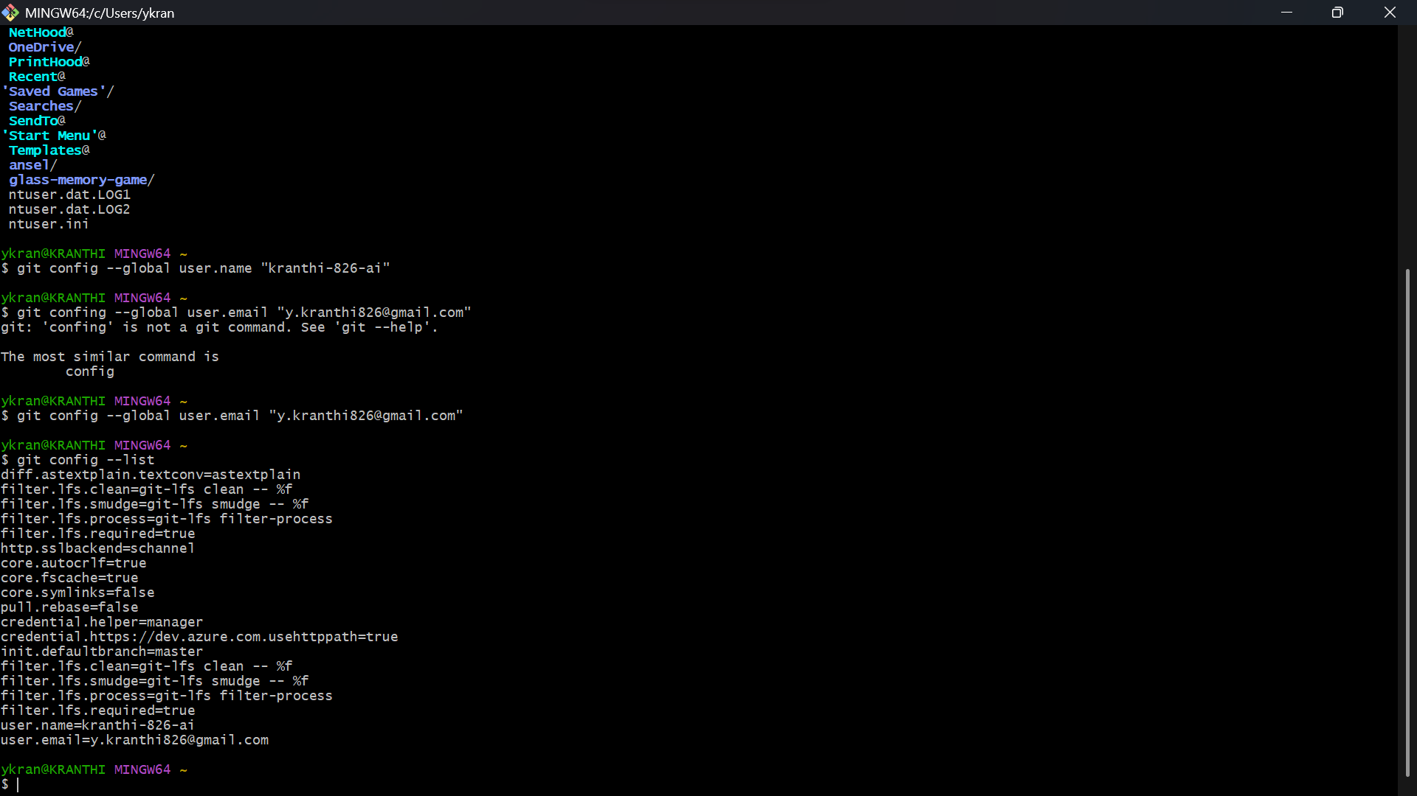
Figure 2. Git configuration listed in the terminal
Part B — Creating the Local Repository
- Create a new project folder.
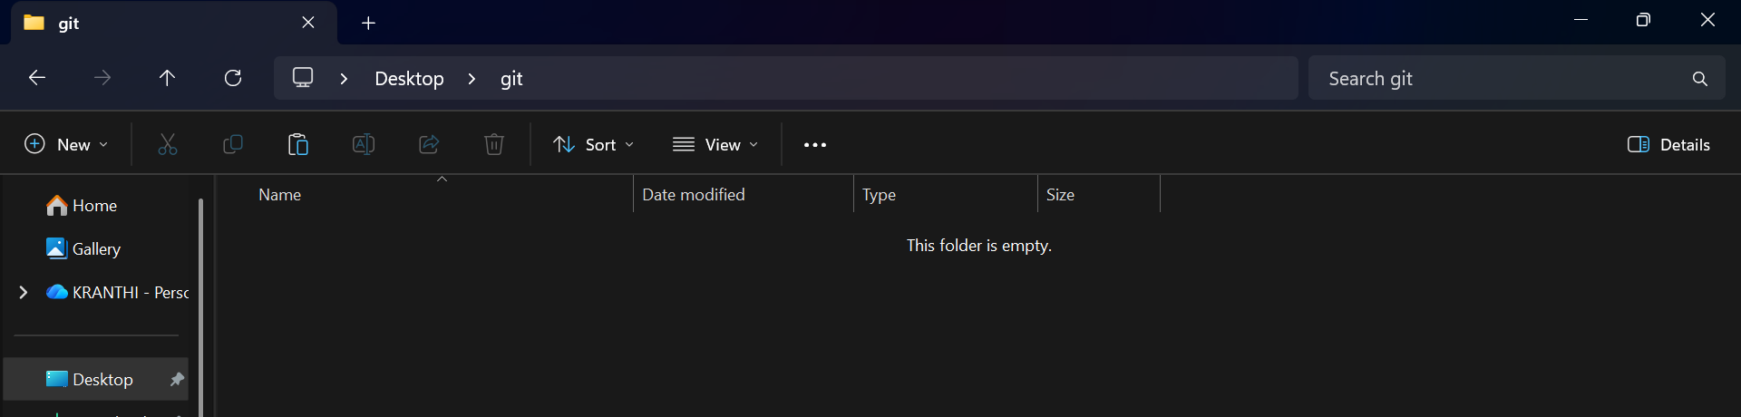
Figure 3. New empty project folder
- Open the folder in the terminal.
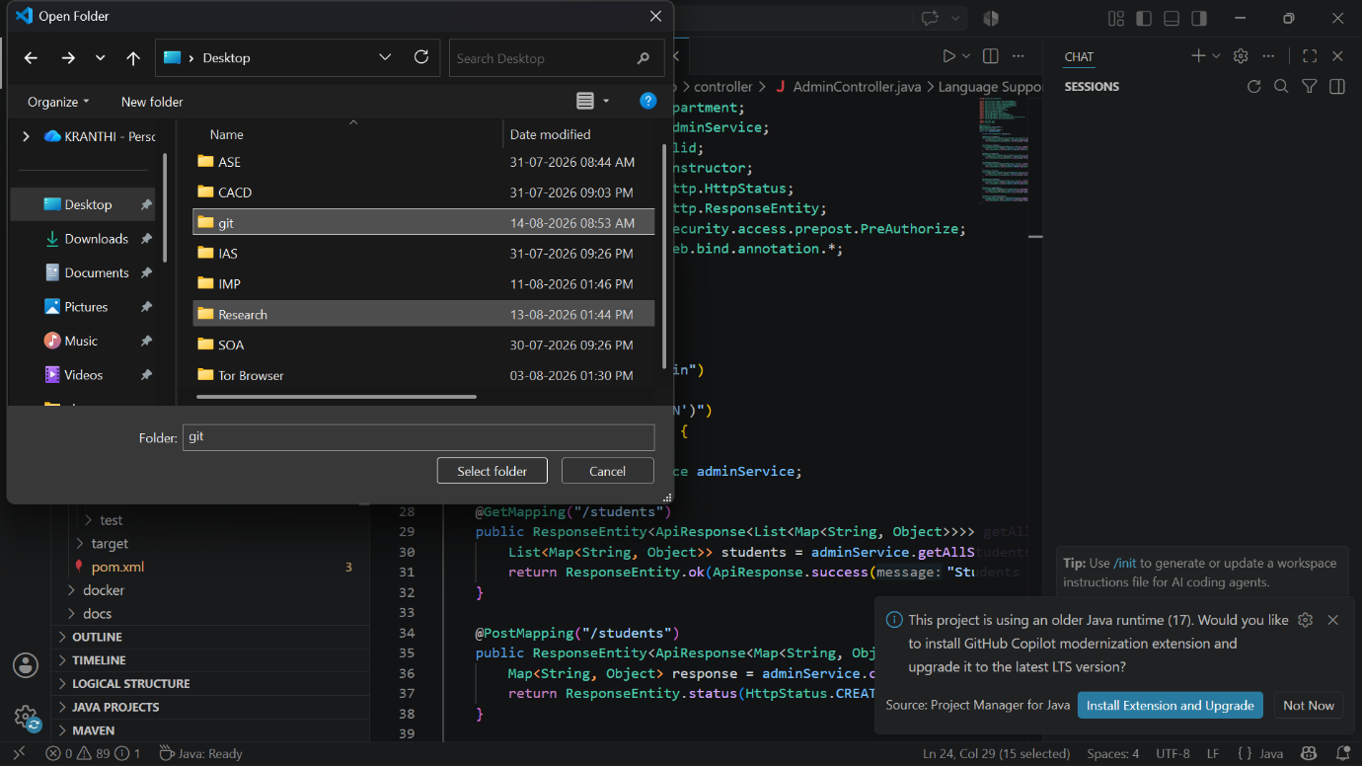
Figure 4. Selecting the project folder
- Initialise Git inside the folder:
git init
- Create or add the project files.
- Check the state of the files:
git status
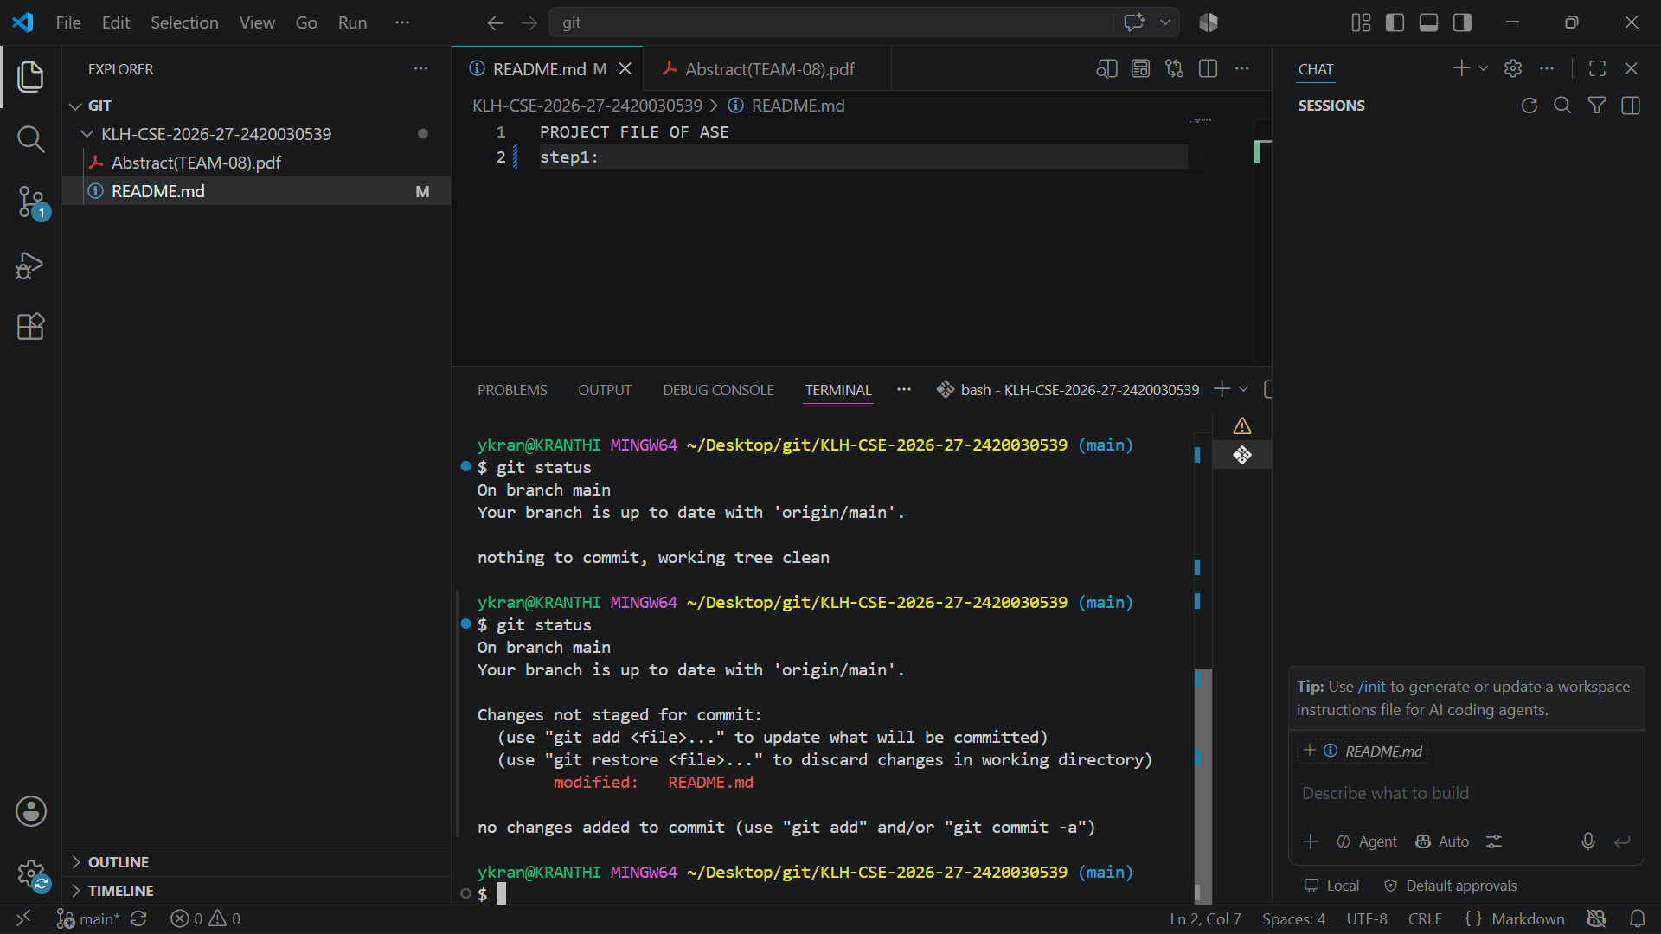
Figure 5. git status showing the modified project file
- Stage the files:
git add .
- Save them as a commit:
git commit -m "Initial commit"
Part C — Uploading to GitHub
- Create a new repository on GitHub.
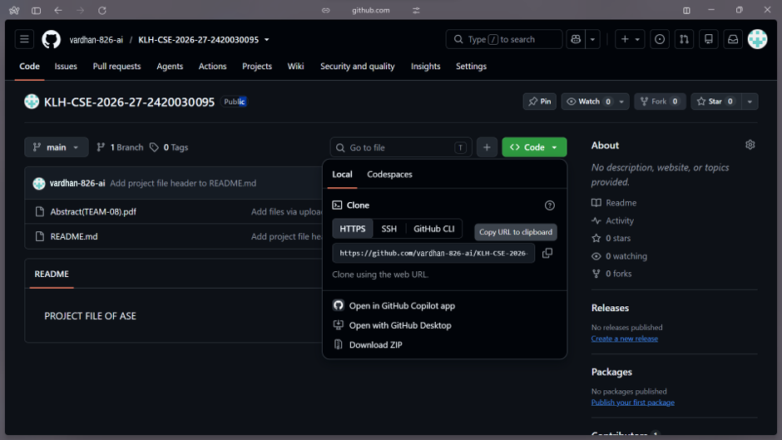
Figure 6. Repository page on GitHub with the clone options
- Connect the local repository to GitHub:
git remote add origin <repository-url>
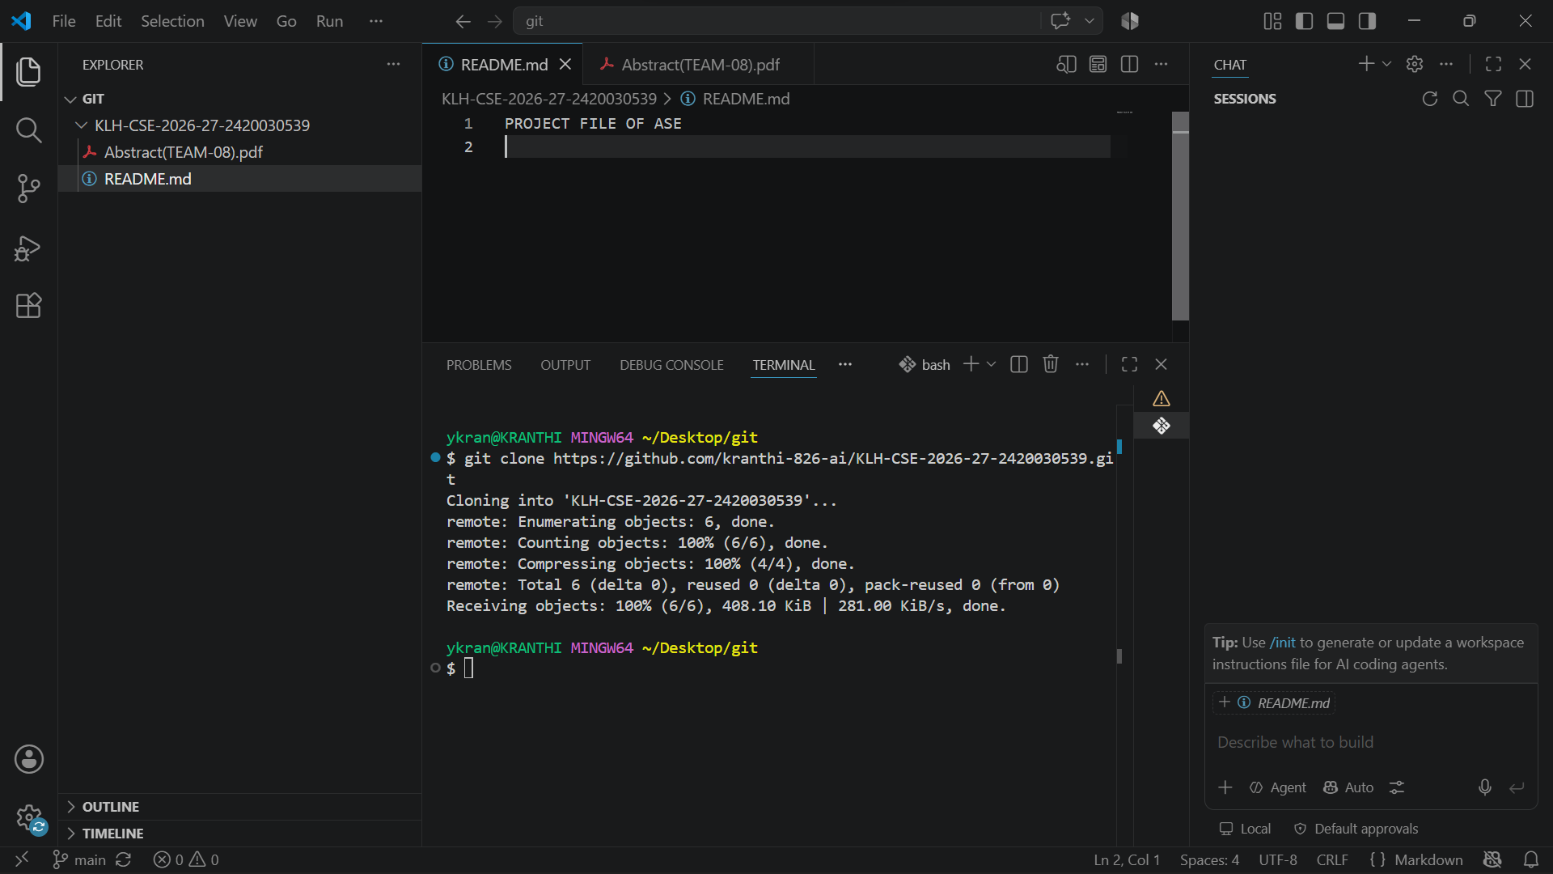
Figure 7. Repository connected and files listed in the terminal
- Push the files to GitHub:
git push
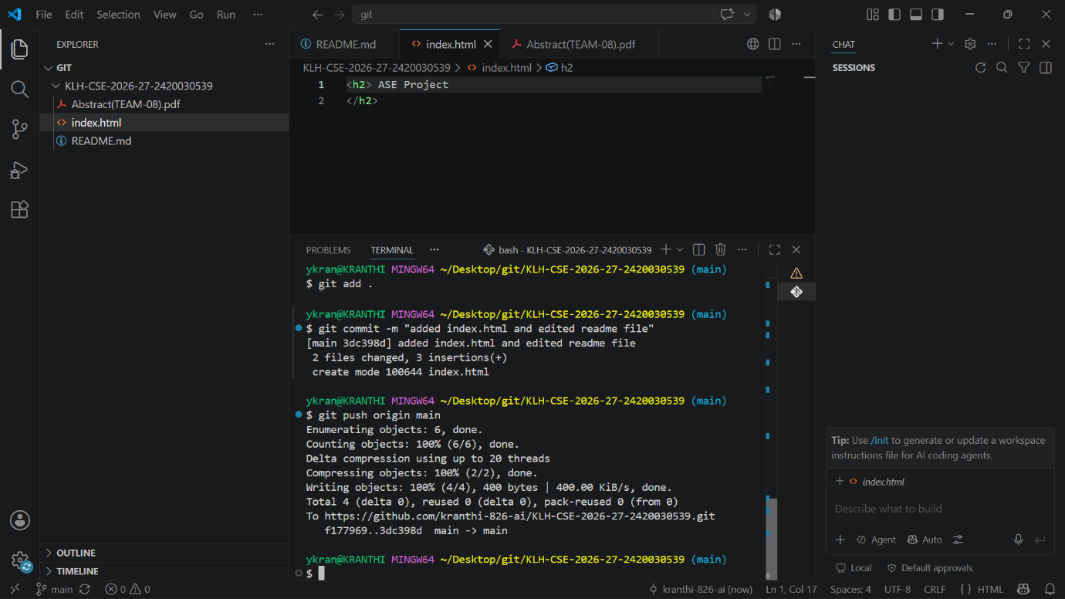
Figure 8. Files added, committed, and pushed
- Check the status again:
git status
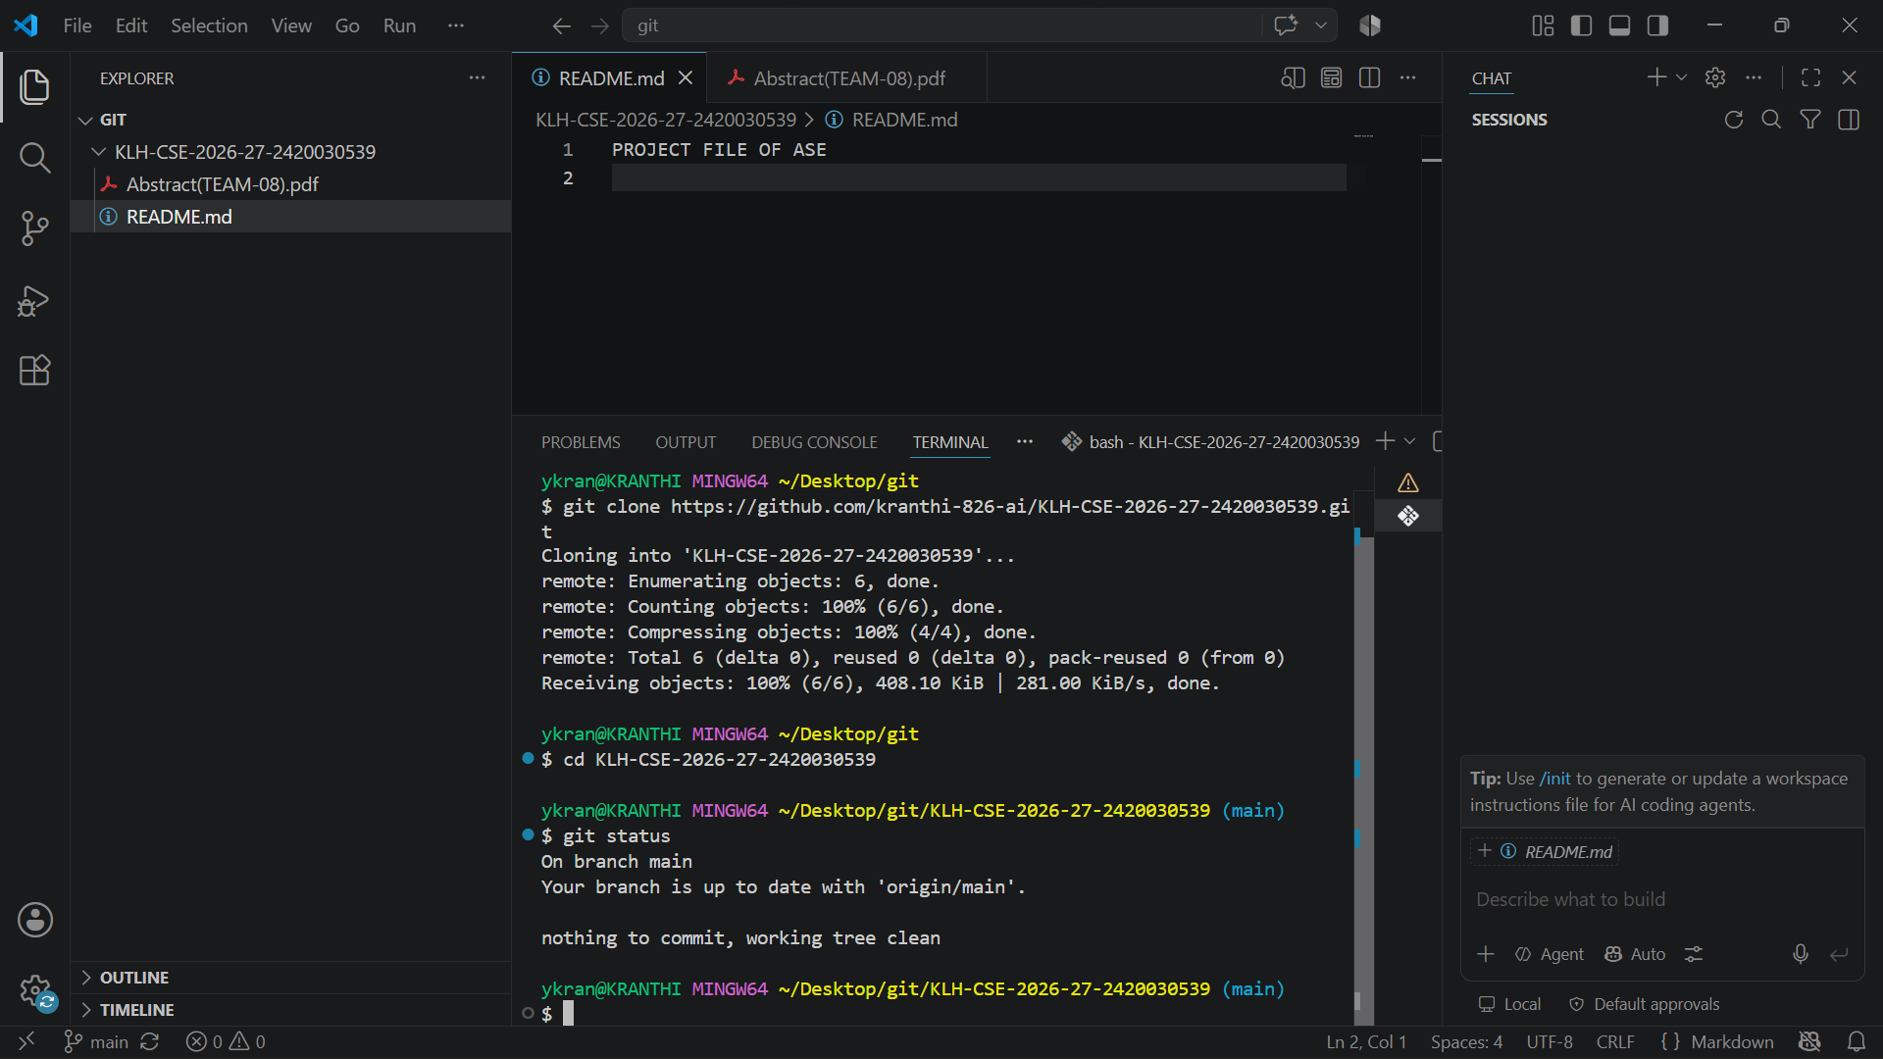
Figure 9. git status after the push
- Push once more after any further changes:
git push
- Open the repository on GitHub and check the commits.
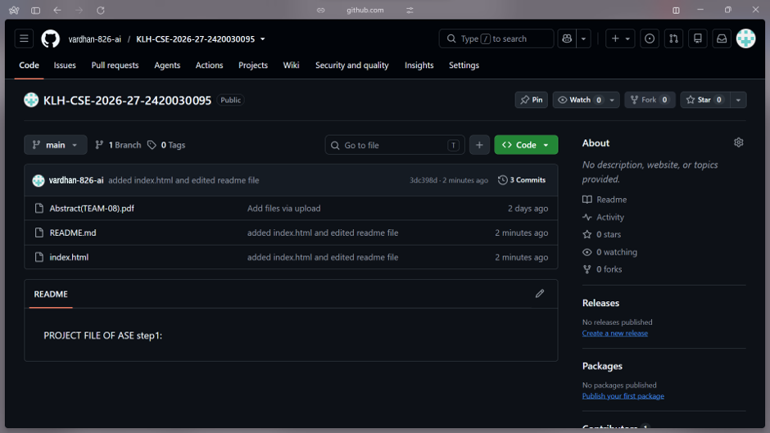
Figure 10. Commits listed on GitHub
Outcome
Successfully learned how to create Git commits and upload a project to GitHub.

