Jira Software
Sprint Planning and Task Tracking
Name | Roll Number | Experiment
K. Sai vardhan | 2420030095 | Plan a project and run a sprint using Jira Software.
Part A — Opening Jira
- Open a web browser.
- Search for Jira Software.
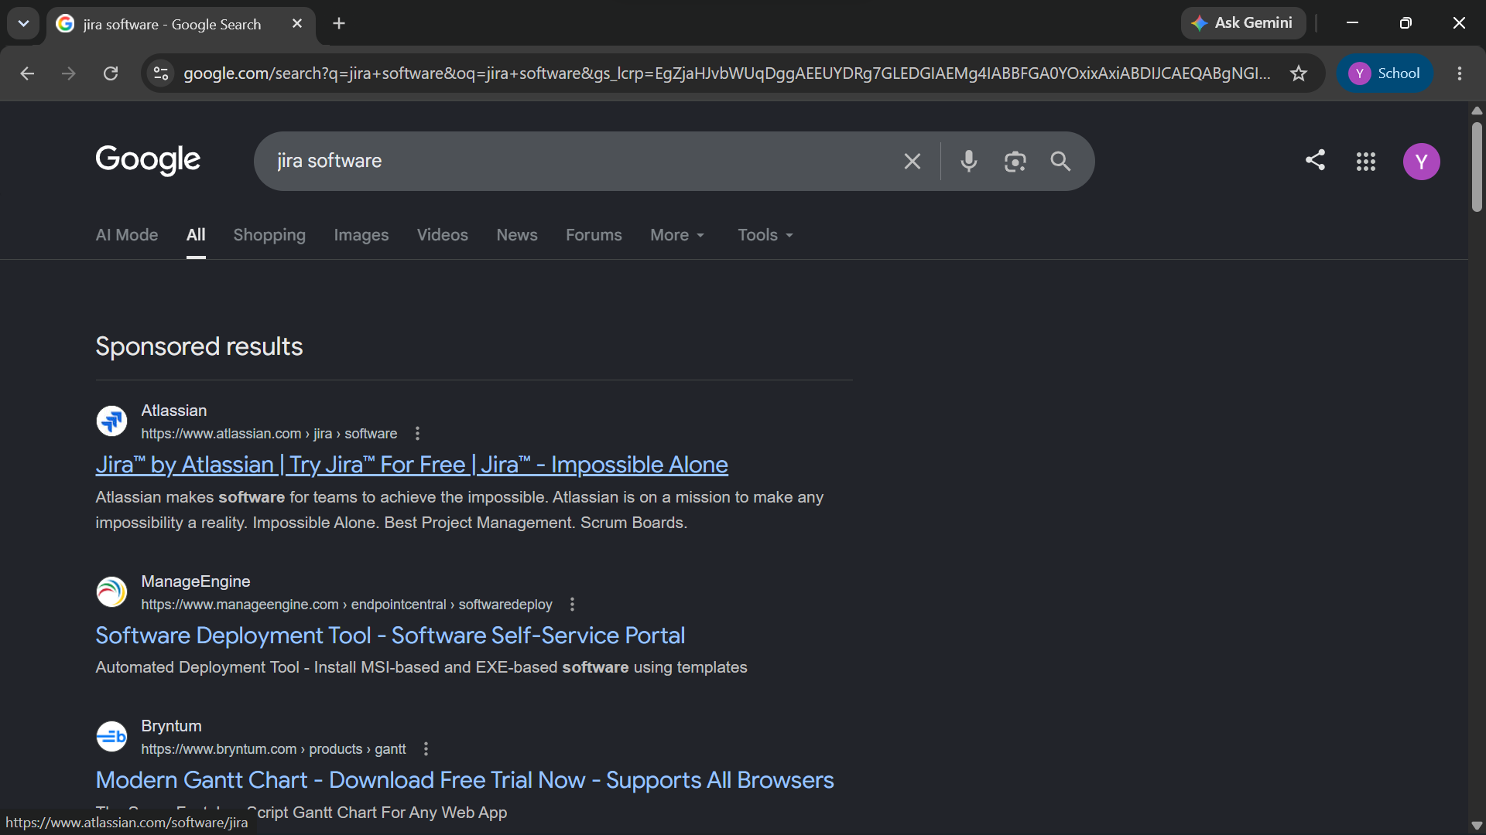
Figure 1. Searching for Jira Software in Google
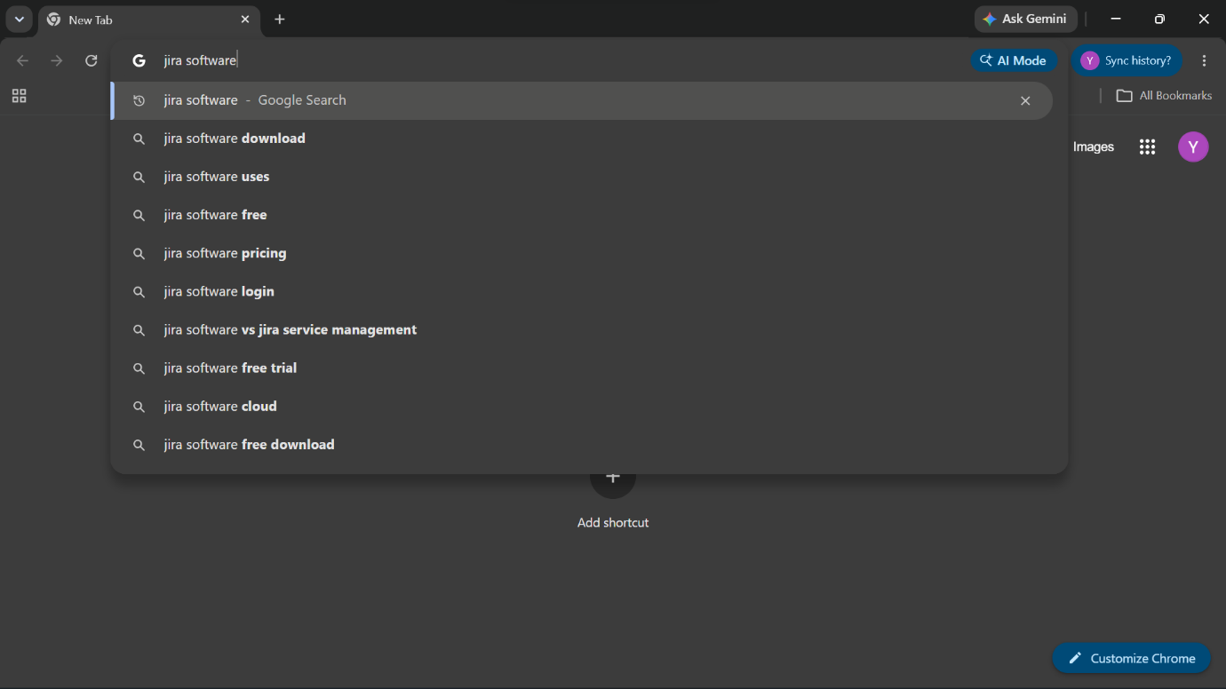
Figure 2. Search suggestions for Jira Software
- Select the Jira (Atlassian) result.
- Sign up, or log in with your Atlassian account.
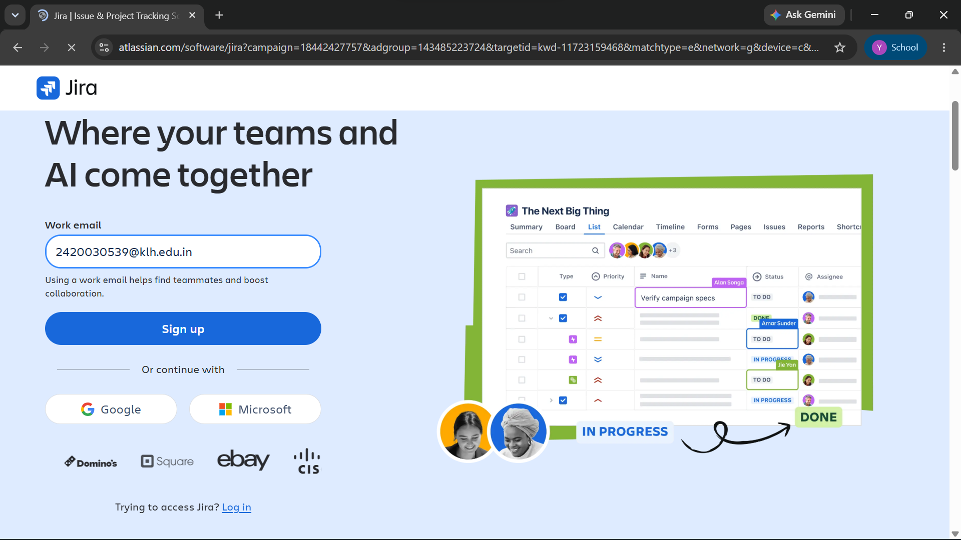
Figure 3. Jira sign-up page
Part B — Creating the Project
- Create a Software Project.
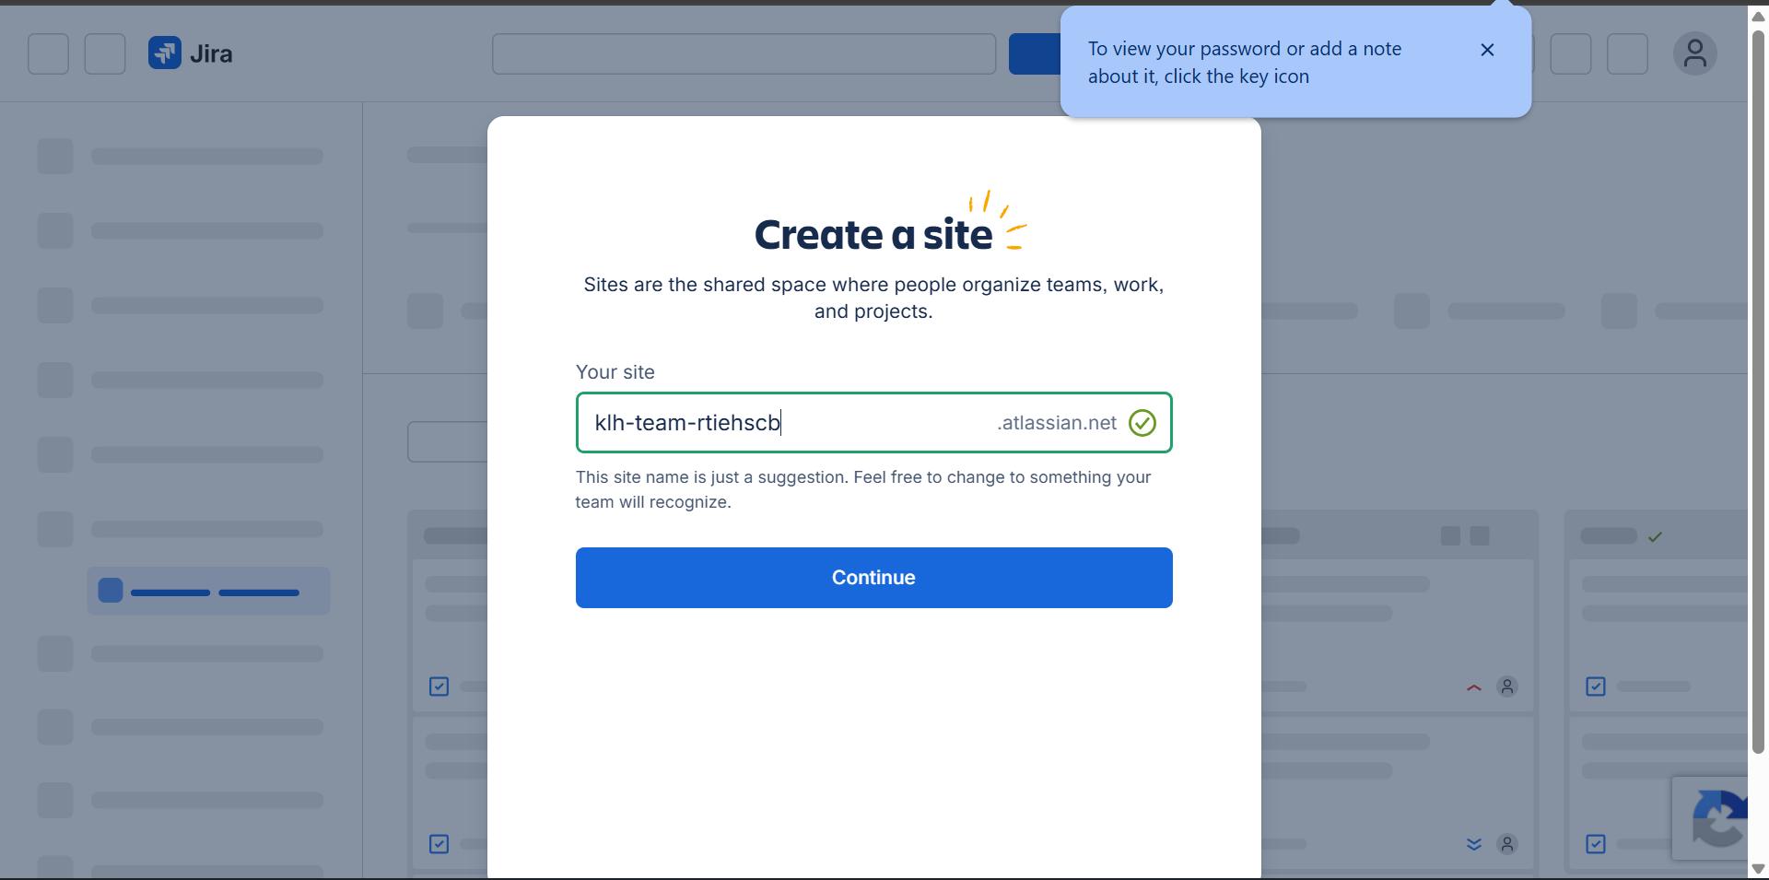
Figure 4. Creating a site for the project
- Choose the Scrum project template.
- Type a name for the project and create it.
Part C — Planning the Work
- Create Epics for the major modules.
- Add User Stories under each Epic.
- Place all the user stories in the Product Backlog.
- Create a Sprint.
- Move items from the backlog into the sprint.
Part D — Assigning and Starting the Sprint
- Assign the tasks to team members.
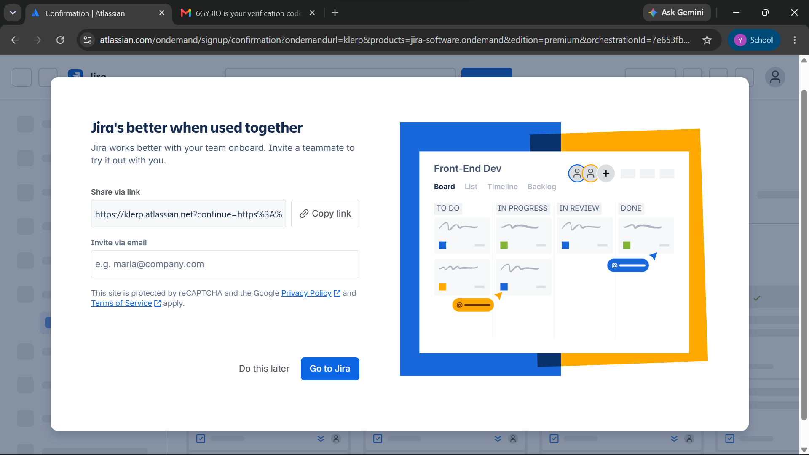
Figure 5. Inviting teammates to the project
- Set a priority for every task.
- Start the sprint.
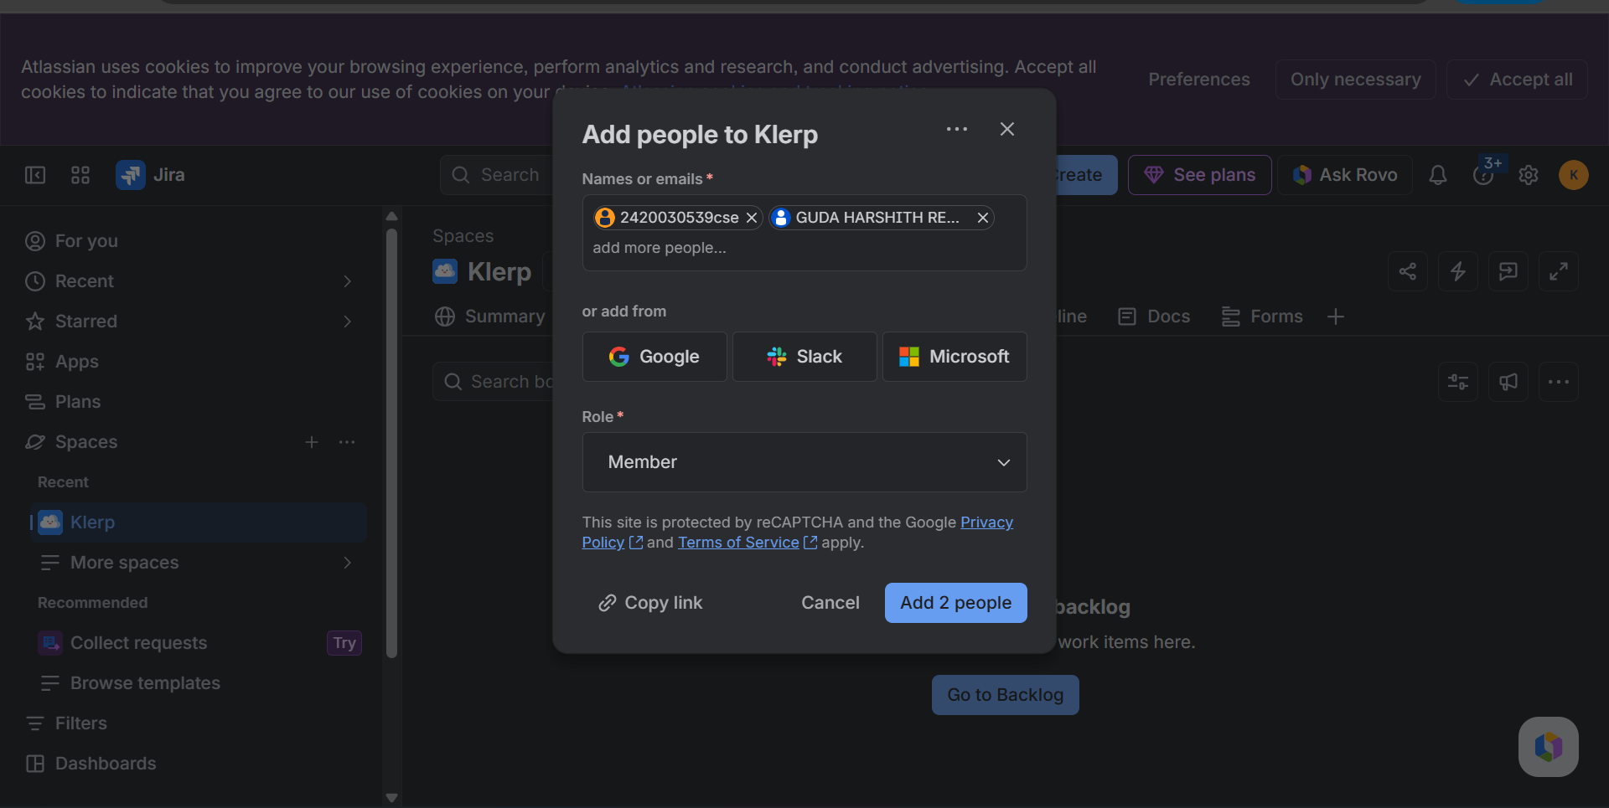
Figure 6. Adding people to the project
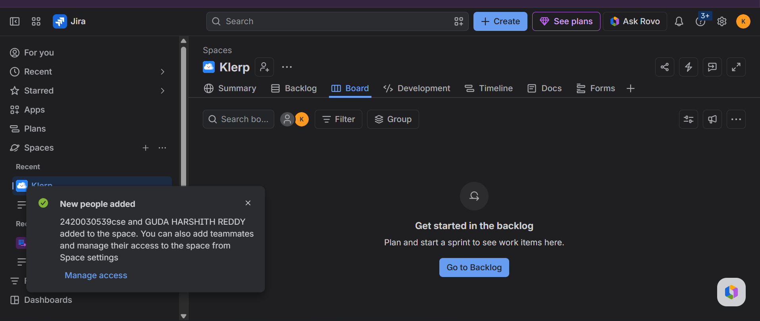
Figure 7. Project board after setup
Part E — Tracking and Closing the Sprint
- Update the status of each task: To Do → In Progress → Done.
- Follow the progress on the Scrum Board.
- Look at the sprint reports and the burndown chart.
- Complete the sprint once all the tasks are finished.
Outcome
Successfully learned how to use Jira Software for project planning, sprint management, task assignment, and progress tracking.

