AI Powered Mutual Fund Portfolio Analysis - Investment Tracking System

P Hansini
Department of Computer Science and Engineering
KLH CSE Bowrampet Campus
Hyderabad, India
ID: 2420030239
Dr. Venkateswari Ketineni
Department of Computer Science and Engineering
KLH CSE Bowrampet Campus
Hyderabad, India
G Sreevarsha
Department of Computer Science and Engineering
KLH CSE Bowrampet Campus
Hyderabad, India
ID: 2420030241
Mani Charan Chava
Department of Computer Science and Engineering
KLH CSE Bowrampet Campus
Hyderabad, India
ID: 2420030545

Abstract—Investors often find it difficult to monitor their mutual fund holdings, to judge whether a portfolio is performing well, and to understand the risk and diversification of their investments. This paper presents an AI-powered Mutual Fund Portfolio Analysis and Investment Tracking System that tracks user investments including SIPs and buy/sell transactions, analyzes portfolio performance, evaluates risk and diversification, and provides useful insights using historical mutual fund data and machine learning techniques. The system follows a service-oriented architecture in which independent User, Mutual Fund, Portfolio, Transaction, Analysis, AI and Notification services communicate through REST APIs. The backend is developed using Java, Spring Boot and JPA, and an interactive web interface built with React, Vite, Tailwind CSS and Recharts provides a portfolio overview, returns, risk analysis, fund comparison and historical trends.
Keywords—mutual funds, portfolio analysis, investment tracking, service-oriented architecture, microservices, REST API, risk analysis, SIP, machine learning

Introduction
Mutual funds are a popular investment choice, but investors who hold several funds, make regular SIP contributions and carry out buy and sell transactions find it hard to see how their overall portfolio is doing. The AI-Powered Mutual Fund Portfolio Analysis and Investment Tracking System is designed to help users monitor and understand their mutual fund investments. The system tracks the user’s investments, analyzes portfolio performance, evaluates the level of risk and diversification, and provides useful insights using historical mutual fund data and machine learning techniques.
The system helps users easily identify whether their portfolio is performing well and understand the risk associated with their investments. It is built as a set of independent services that communicate through REST APIs, which demonstrates the principles of service-oriented architecture (SOA).
The rest of this paper is organized as follows. Section II reviews related work, Section III identifies the problem gaps, and Section IV states the objectives. Section V describes the proposed system and its architecture, Section VI presents the methodology, Section VII discusses feasibility, and Section VIII shows the output screens of the implemented system. Section IX concludes the paper.

Literature Survey
Das and Jain [1] classified mutual funds and analyzed returns, fund flows and performance using different evaluation methods. They infer that fund category, returns, investor flows and risk-adjusted performance are important for portfolio evaluation. Their study covers broad methodological issues, and a practical software-based portfolio system can integrate these analyses.
Vafai and Rakowski [2] analyzed portfolio volatility using security-level variances and covariances. Their results show that portfolio volatility depends significantly on the relationships between the securities within the portfolio. The analysis can be extended to different markets and to practical investor portfolio applications.
Prasad et al. [3] analyzed daily NAV data using statistical performance measures and showed that mutual funds can be evaluated by comparing their historical NAV and performance measures. The study focused on selected funds, and future work can include more fund categories and larger datasets.
Several classic studies underpin the financial measures used in this work. Markowitz [4] established mean–variance portfolio selection, in which diversification reduces portfolio risk. Sharpe [5] proposed the reward-to-variability measure for evaluating mutual funds, now known as the Sharpe ratio and discussed further in [6], while Jensen [7] introduced a risk-adjusted alpha measure that compares fund returns with the market portfolio.

Problem Gap Identification
The reviewed work and the needs of individual investors reveal the following gaps, which the proposed system addresses:
- Limited integrated portfolio analysis.
- Difficulty in identifying underperforming funds.
- Limited risk and diversification analysis.
- Lack of benchmark-based performance comparison.
- Limited modular and scalable architecture.
- Need for centralized investment tracking and analysis.

Objectives
The objectives of the proposed system are:
- To collect and preprocess mutual fund, NAV, market, user holding and SIP transaction data for accurate analysis.
- To extract important financial features such as returns, volatility, risk, Sharpe ratio, expense ratio and asset allocation.
- To track user investments including SIPs, buy/sell transactions, units held, current NAV, portfolio value and profit/loss.
- To provide an interactive dashboard for viewing portfolio overview, returns, risk analysis, fund comparison and historical trends.
- To analyze mutual fund performance and provide fund ranking and comparison based on historical data.

Proposed System

Innovation, Creativity and Novelty
Microservices-based architecture. The system is separated into independent services such as the User, Fund, Portfolio, Analysis and Notification services [8].
Real-time portfolio insights. The system provides updated portfolio value, profit/loss, NAV and performance information.
API-based service communication. The services communicate through REST APIs [9], demonstrating SOA principles [10].

System Architecture
Fig. 1 shows the overall flow of the system. A user reaches the login page and can continue as an existing user, a new user or a demo user. An existing user signs in with an email address and password and is authenticated. A new user creates an account, which gives a fresh user profile with an empty portfolio: no holdings, no transactions and no SIPs. A demo user continues with a sample investor profile that holds a sample portfolio of about INR 1.1 lakh; the interface shows a demo account badge, and changes made in the demo do not affect registered accounts.
All three paths lead to the user dashboard, which is organized into four groups of modules. Portfolio Core contains the Dashboard, Holdings, Transactions and SIP Manager. Risk and Valuation contains Risk Metrics, Fund Rankings and Compare Funds. Market Catalog and Data contains All Funds and the Dataset Schema. Account and Insights contains the Portfolio Assistant and Profile and Settings, where the user can edit the country, currency, risk tolerance and investment horizon preferences.
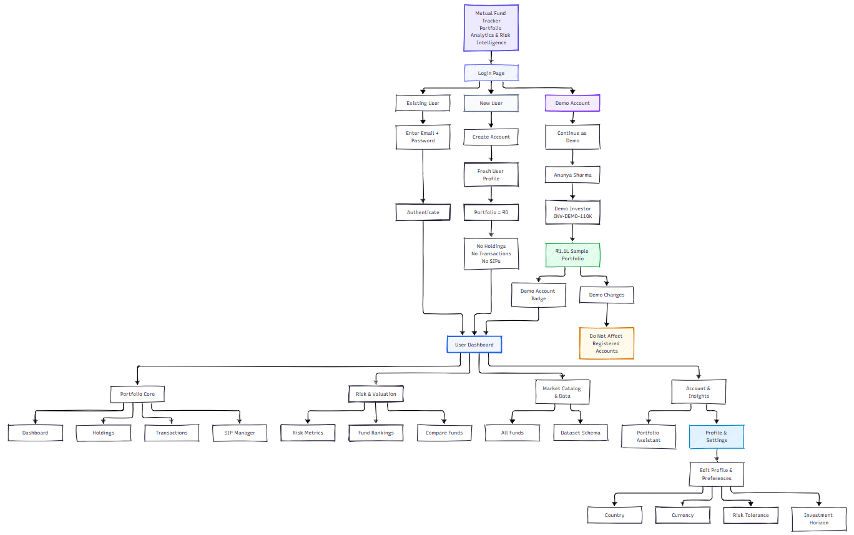
- System architecture showing the user flow from the login page to the dashboard modules.
The service-oriented design is shown in Fig. 2. The client uses a React web user interface, which calls REST controllers. The controllers delegate to independent services: the User Service with its User Repository, the Fund Service with its Fund Repository, and the Portfolio Service with its Transaction Repository. The remaining SOA services are the Transaction, Analysis, AI, Dataset and Notification services.
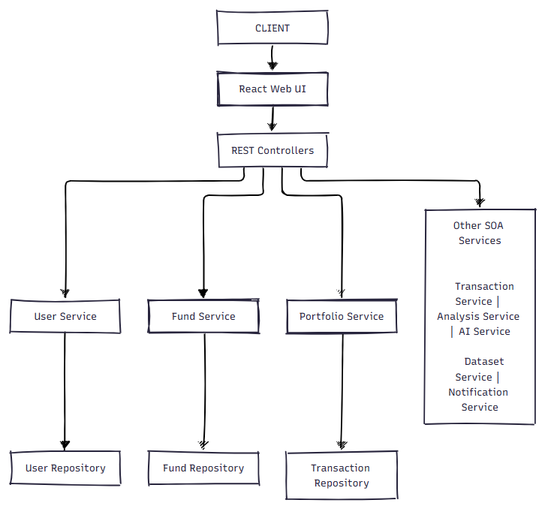
- SOA architecture of the system: React web UI, REST controllers, services and repositories.

Methodology
The project is carried out in the following phases.
Requirement analysis. Requirements are identified for portfolio tracking, mutual fund management, SIPs, transactions, analytics and AI assistance.
SOA architecture design. The system is divided into independent services: the User, Mutual Fund, Portfolio, Transaction, Analysis, AI and Notification services.
Database and backend development. The database entities are designed and the REST APIs are developed using Java, Spring Boot, JPA and H2.
Frontend development. An interactive web interface is developed using React, Vite, Tailwind CSS and Recharts for portfolio management and visualization.
Financial analysis and AI integration. Portfolio returns, risk, diversification and performance are calculated, and AI is used to generate personalized portfolio insights and recommendations.
Testing and system demonstration. All major functionalities are tested, including authentication, transactions, SIPs, analytics, AI responses and dataset processing, followed by a complete system demonstration.

Feasibility and Project Plan
Technical feasibility. Java, Spring Boot, REST APIs, MySQL and React are available and suitable for the project.
Operational feasibility. Users can easily track investments, view portfolio performance and analyze risk through the system.
Economic feasibility. The project uses mostly open-source technologies and does not require specialized hardware.

Output Screenshots
Fig. 3 shows the login screen of the Mutual Fund Portfolio Tracker. Besides signing in or creating an account, the user can launch a one-click demo that gives instant sample access to a portfolio of four mutual funds with an active SIP, allocation charts and risk scores.
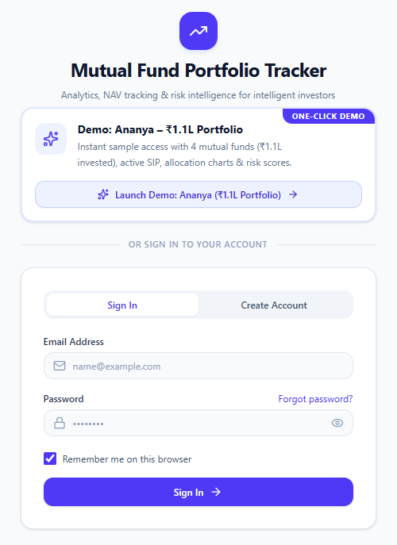
- Login page of the Mutual Fund Portfolio Tracker with one-click demo access.
Fig. 4 shows the dashboard of the demo portfolio. It presents the current valuation of INR 1,27,271.09 against an invested capital of INR 1,10,000, a total profit of INR 17,271.09 (15.70%), a monthly SIP outflow of INR 15,000 through one active mandate, and a calculated risk tier of Low with a score of 29/100 and a Sharpe ratio of 1.35. The dashboard also lists the active holdings with the units held, current NAV, valuation and returns, along with the category allocation of the portfolio.
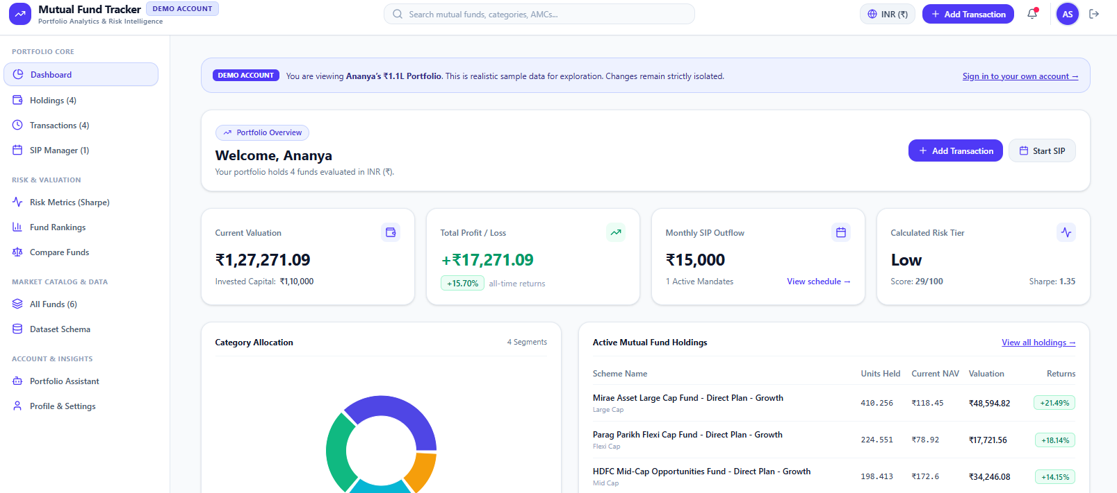
- Portfolio dashboard showing current valuation, total profit/loss, monthly SIP outflow, risk tier, category allocation and active holdings.

Conclusion
This paper presented an AI-powered mutual fund portfolio analysis and investment tracking system built on a service-oriented architecture. By combining investment tracking, performance, risk and diversification analysis, fund comparison and AI-generated insights in one interactive dashboard, the system addresses the gaps identified in the literature, namely the lack of integrated portfolio analysis, limited risk and diversification analysis, and limited modular and scalable architecture.

References
- S. R. Das and R. K. Jain, “Mutual fund performance: A synthesis of taxonomic and methodological issues.”
- N. Vafai and D. Rakowski, “The sources of portfolio volatility and mutual fund performance,” Int. Rev. Financial Anal., vol. 91, Art. no. 102985, 2024.
- S. R. S. Prasad et al., “A critical analysis of selected mutual funds in India.”
- H. Markowitz, “Portfolio selection,” J. Finance, vol. 7, no. 1, pp. 77–91, 1952.
- W. F. Sharpe, “Mutual fund performance,” J. Business, vol. 39, no. 1, pp. 119–138, 1966.
- W. F. Sharpe, “The Sharpe ratio,” J. Portfolio Manage., vol. 21, no. 1, pp. 49–58, 1994.
- M. C. Jensen, “The performance of mutual funds in the period 1945–1964,” J. Finance, vol. 23, no. 2, pp. 389–416, 1968.
- S. Newman, Building Microservices. Sebastopol, CA, USA: O’Reilly Media, 2015.
- R. T. Fielding, “Architectural styles and the design of network-based software architectures,” Ph.D. dissertation, Dept. Inf. Comput. Sci., Univ. California, Irvine, CA, USA, 2000.
- T. Erl, Service-Oriented Architecture: Concepts, Technology, and Design. Upper Saddle River, NJ, USA: Prentice Hall, 2005.

