MINI HACKATHON 2

Project Group Members
S. No | Roll No. | Student Name
1 | 2420090037 | Rithvik
2 | 2420030601 | Niharika
3 | 2420030628 | Akshya
COMPARATIVE ANALYSIS

1. Existing Models – Brief Performance Note
The baseline models considered for AgriBuddy AI are the standard machine-learning classifiers widely applied to crop recommendation: Support Vector Machine (SVM), Decision Tree, XGBoost and LightGBM. They are trained on soil and climate features (N, P, K, temperature, humidity, pH, rainfall) and are normally evaluated with Accuracy, Precision, Recall, F1-Score and inference latency. All of them perform well on the 2,200-record, 22-class crop dataset, with accuracy between 97.95% and 99.09%.
However, such models are typically built as a single-task predictor rather than a complete advisory platform. They do not cover leaf-disease detection with image validation, irrigation scheduling, yield and revenue forecasting, fertilizer dosing, a multilingual (English, Telugu, Hindi) assistant, APMC mandi prices, a farmer marketplace, or role-based access control in one system.

2. Existing (Baseline) Models:
1. Accuracy:
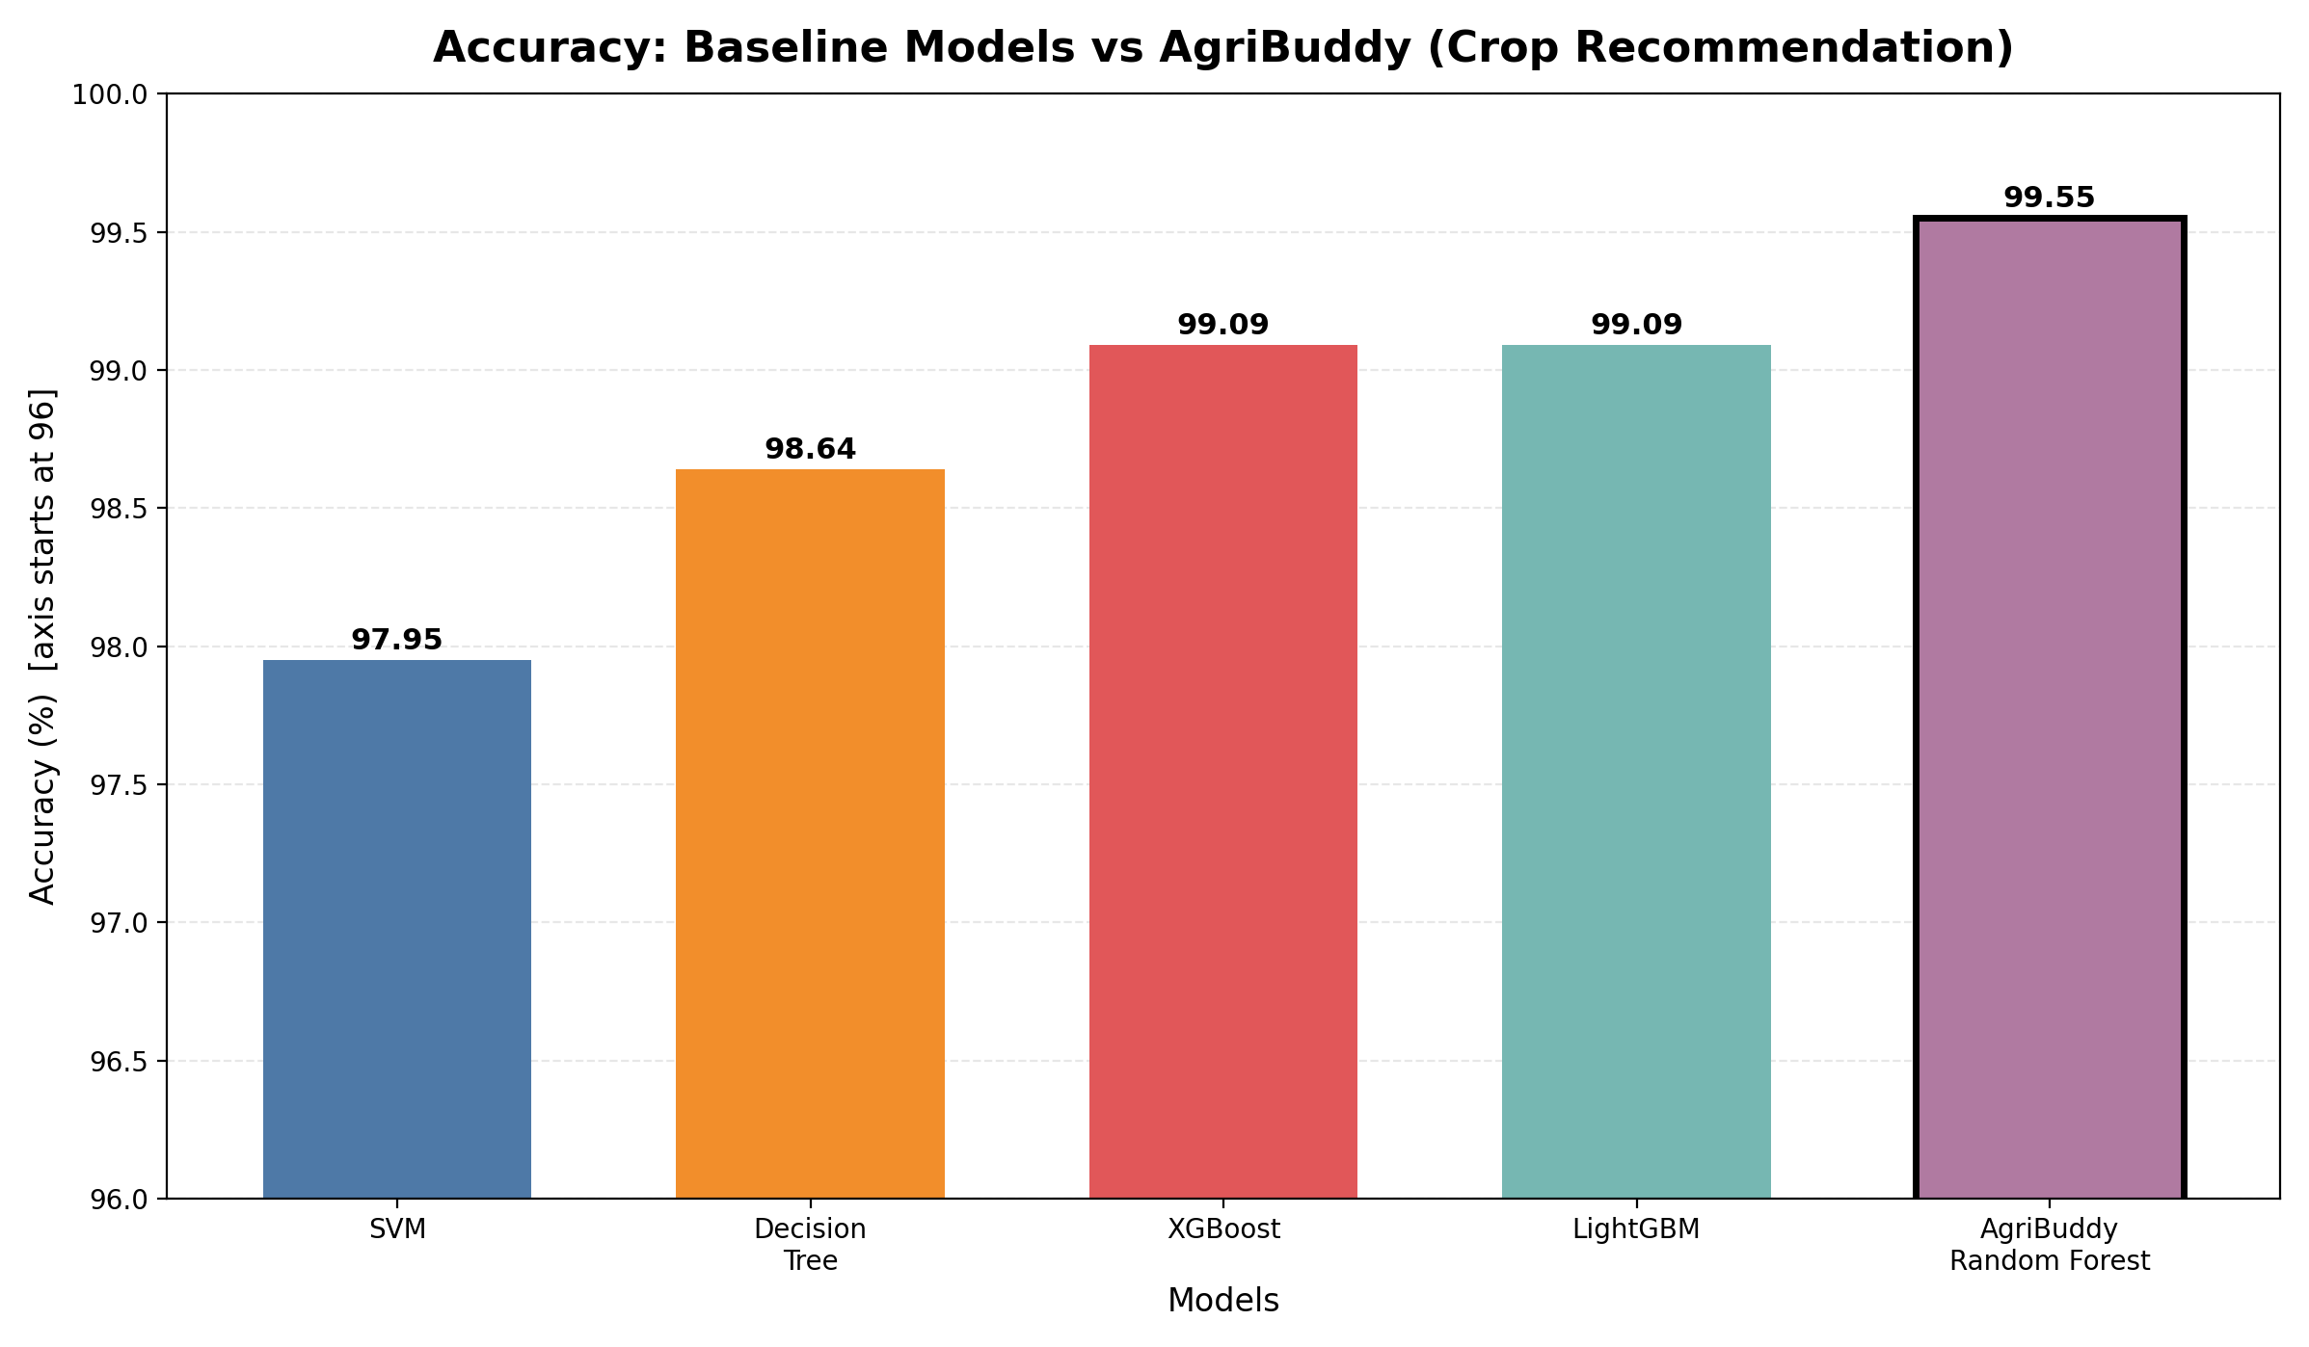

2. Precision:
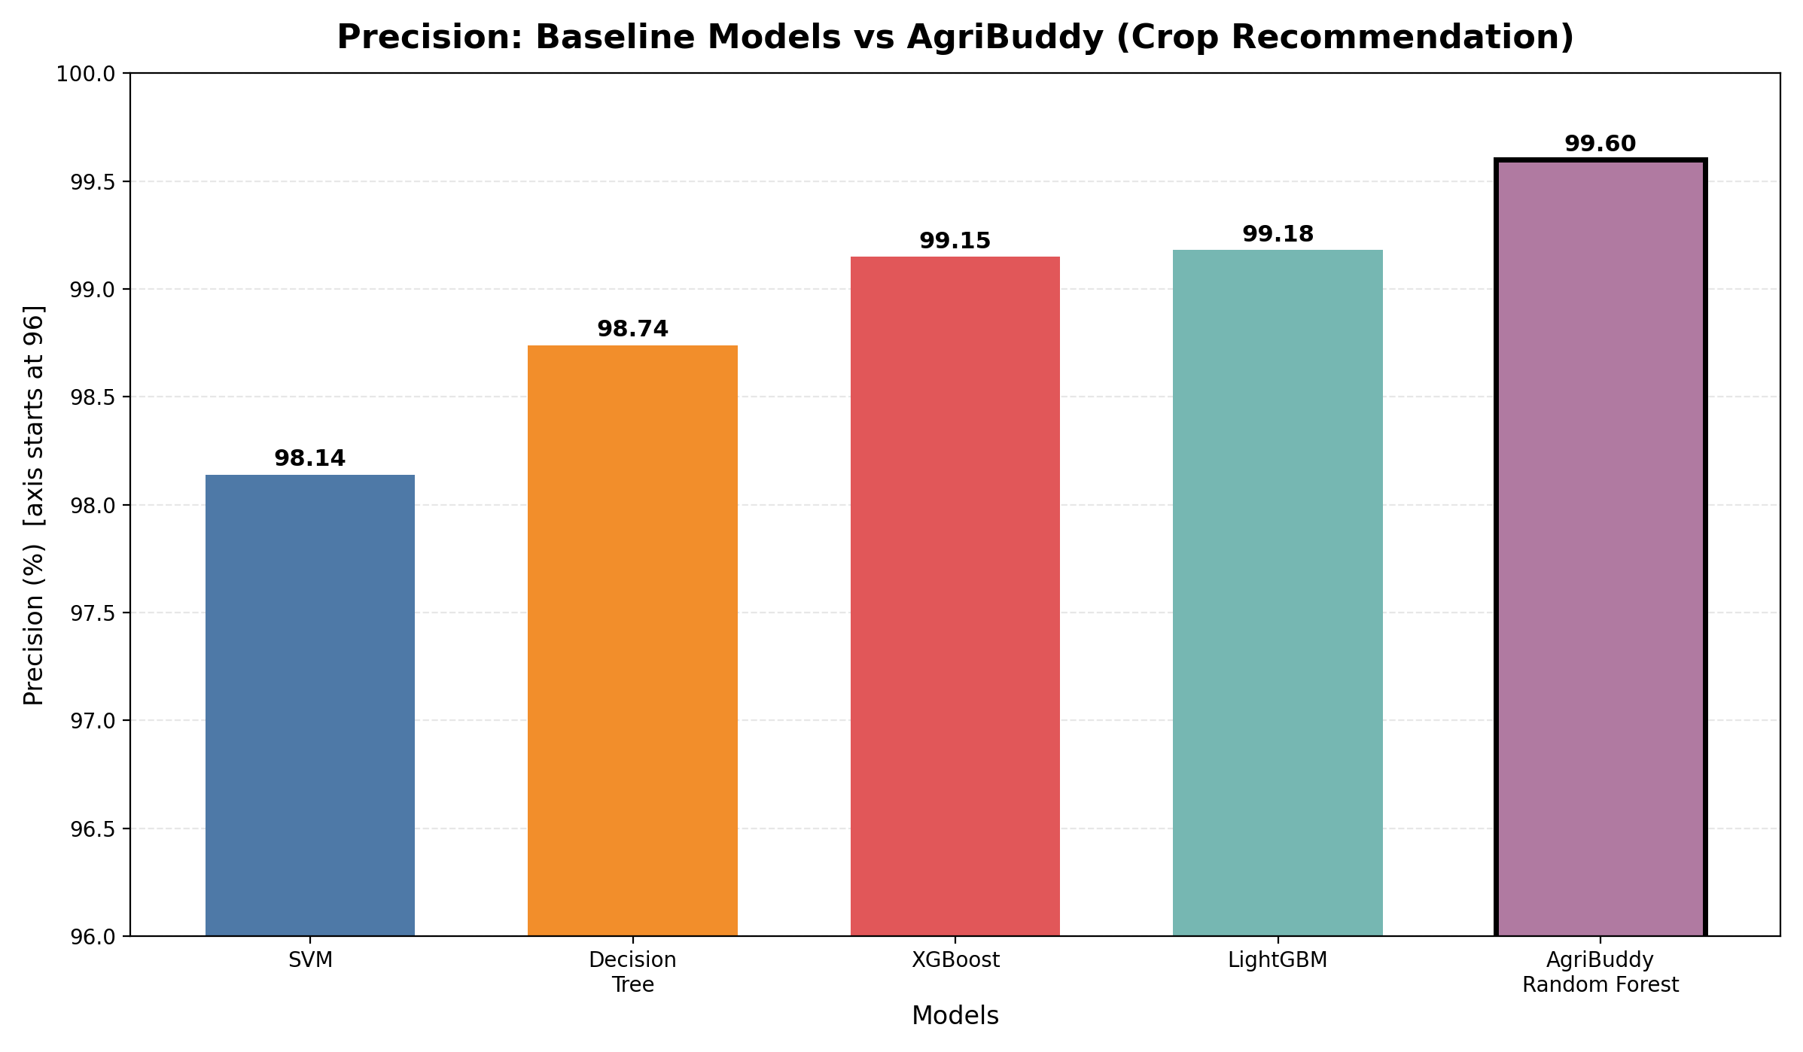
3. Recall:
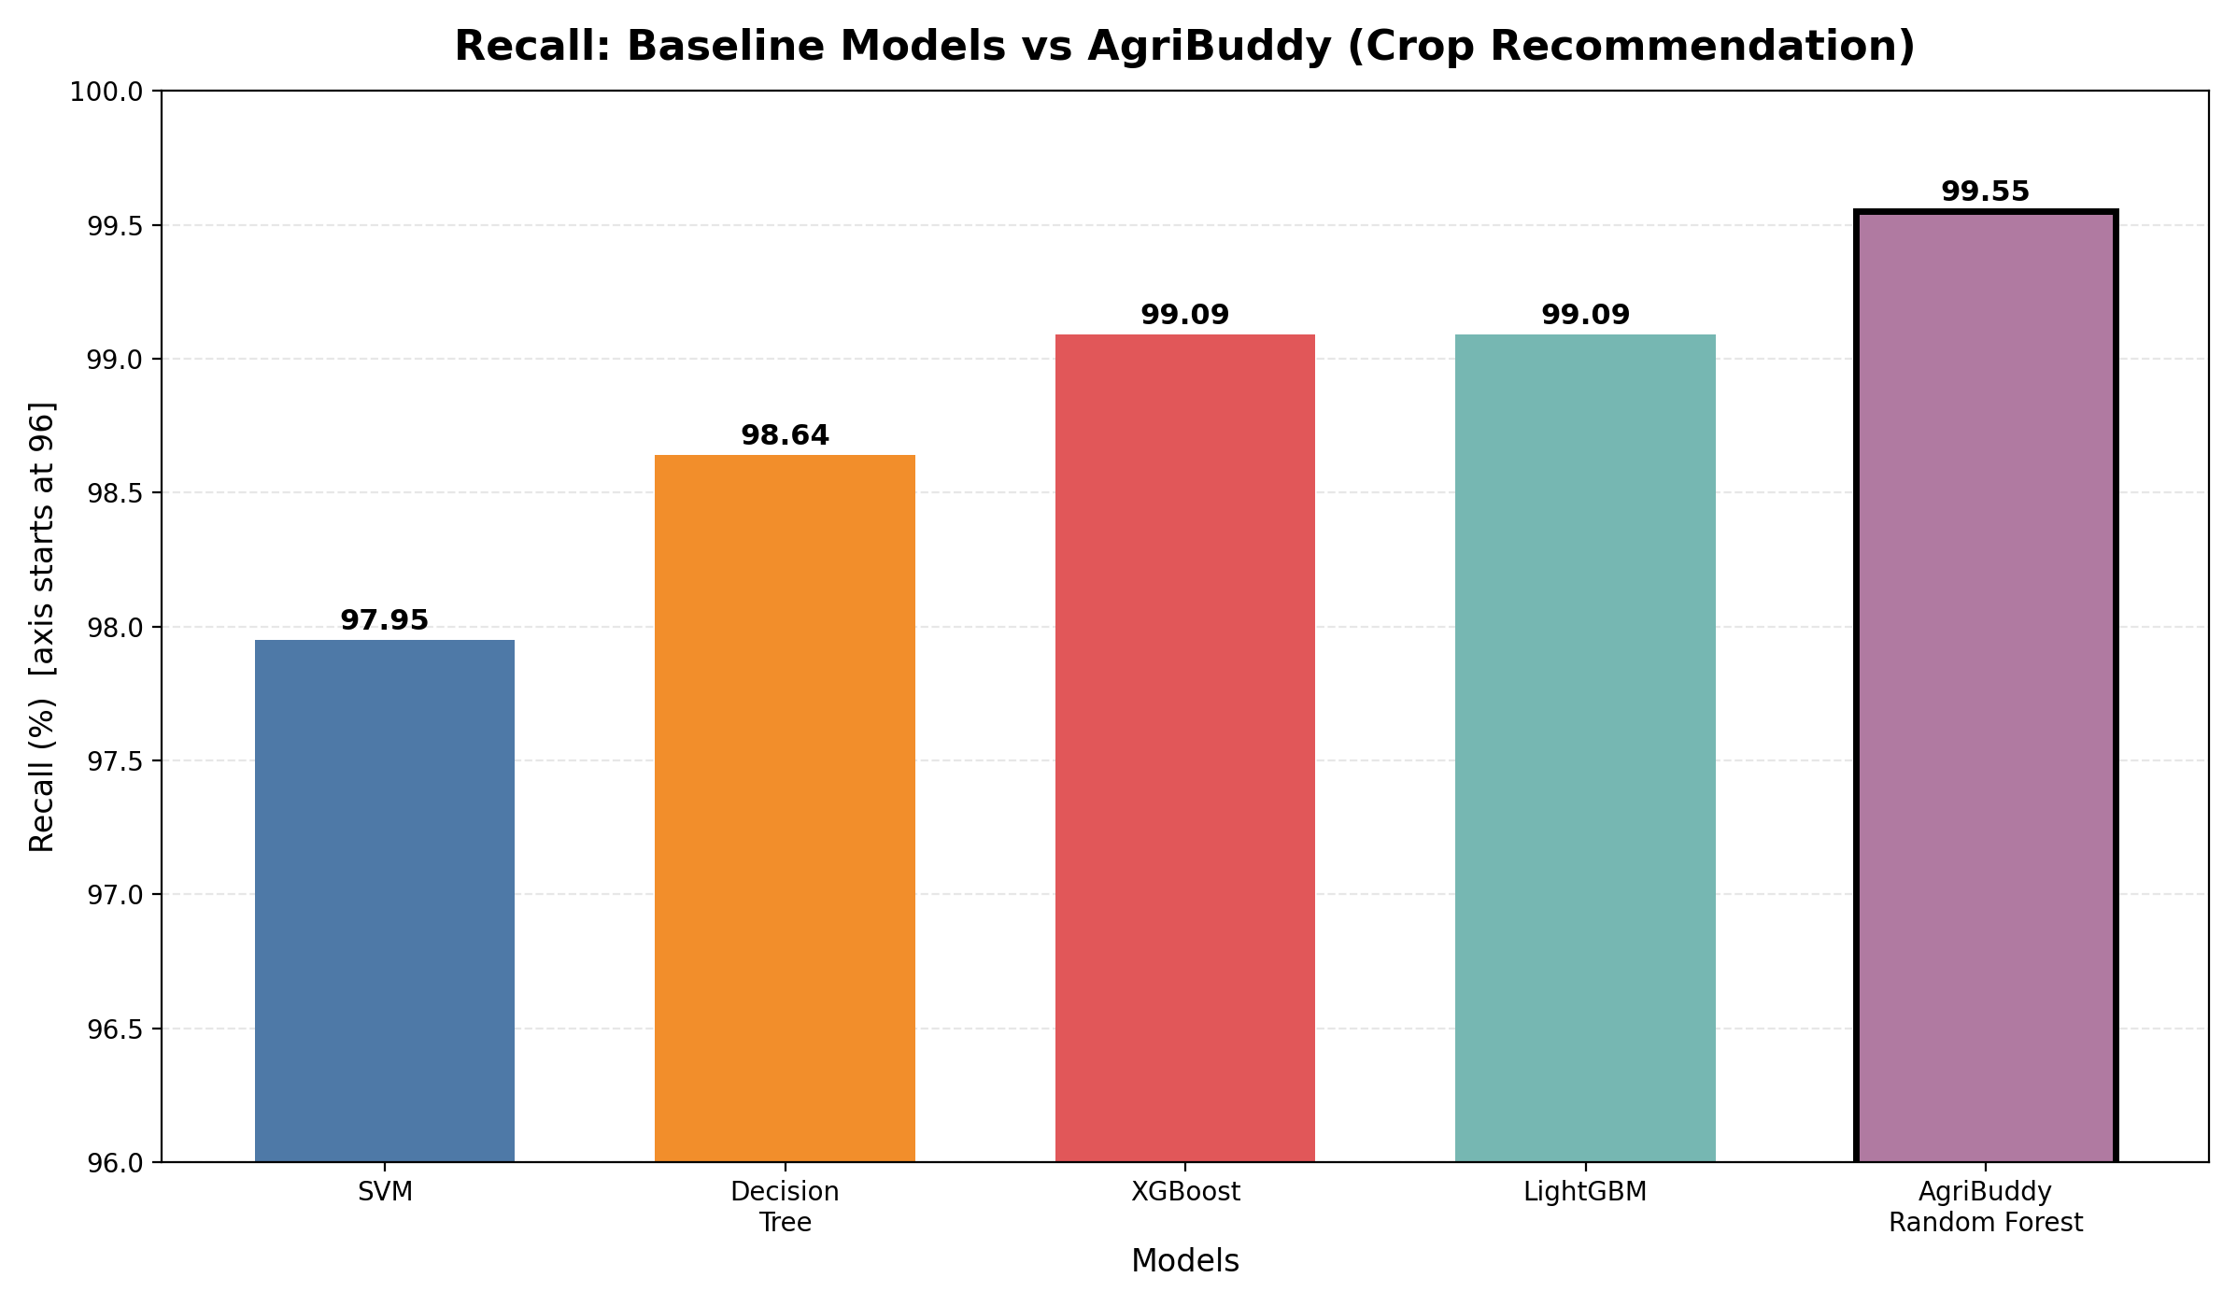

4. F1-Score:
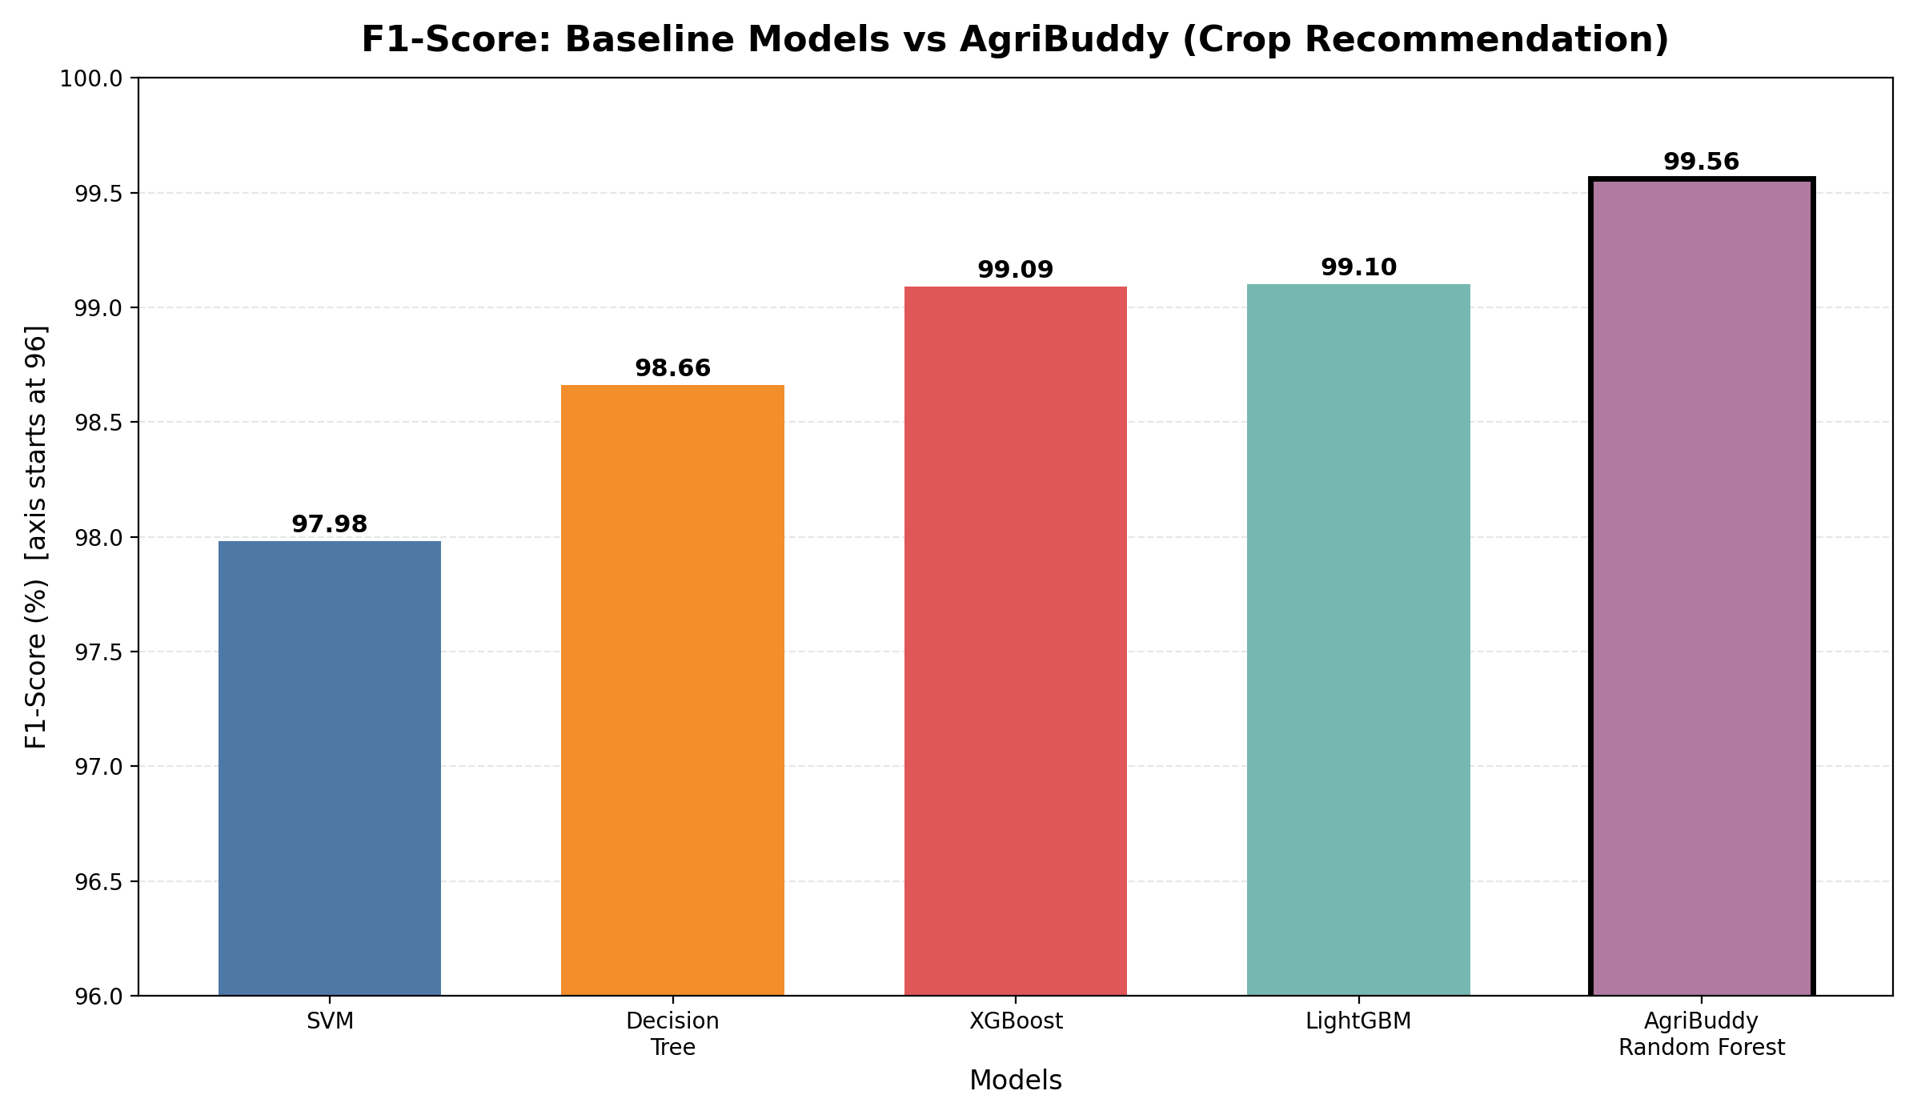

5. Inference Latency:
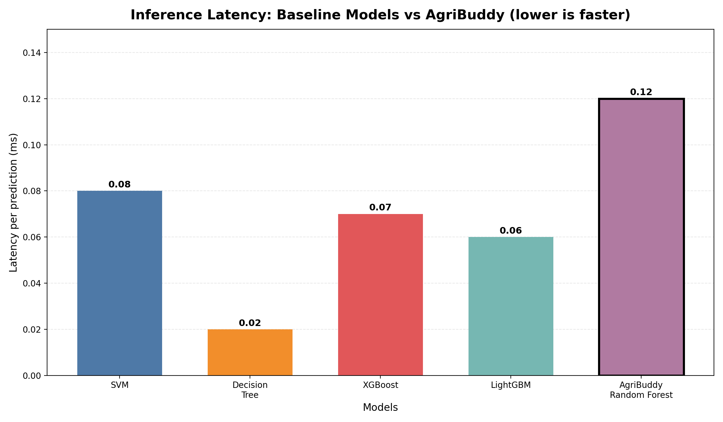

3. Our Proposed Model – Brief Evaluation Note
AgriBuddy AI is a full-stack agricultural advisory platform built with React 18 + Vite (frontend), FastAPI (backend), PostgreSQL (database) and a Scikit-Learn / XGBoost / LightGBM inference engine. It provides crop recommendation, plant leaf disease detection (32 classes) with non-plant and blurry-image rejection, FAO-56 based smart irrigation, yield and revenue forecasting, a fertilizer calculator, a trilingual AI assistant, mandi prices, a crop marketplace, weather and spray advisories, and farmer consultation tickets. Its best crop-recommendation model is the Random Forest classifier.
The proposed evaluation framework is broader than a single-model comparison. It evaluates classification quality, regression error, inference speed and end-to-end software quality using Accuracy, Precision, Recall, F1-Score, Inference Latency, MAE / RMSE / R² and a 42-scenario automated QA suite (100% passed).

4. Proposed Model – Evaluation Metrics
Metric | What It Evaluates
Accuracy | Share of correct predictions (crop, disease, irrigation, yield)
Precision | Reliability of the predicted crop / disease classes
Recall | Coverage of the true crop / disease classes
F1-Score | Balance between precision and recall
Inference Latency | Time taken for one prediction (milliseconds)
MAE / RMSE / R² | Error and fit of irrigation (mm) and yield (qtl/acre) regression
Functional QA Pass Rate | Automated E2E and integration tests passed (42 of 42)

5. Key differences:
Model | Accuracy (%) | Precision (%) | Recall (%) | F1-Score (%) | Latency (ms)
SVM | 97.95 | 98.14 | 97.95 | 97.98 | 0.08
Decision Tree | 98.64 | 98.74 | 98.64 | 98.66 | 0.02
XGBoost | 99.09 | 99.15 | 99.09 | 99.09 | 0.07
LightGBM | 99.09 | 99.18 | 99.09 | 99.10 | 0.06
AgriBuddy Random Forest | 99.55 | 99.60 | 99.55 | 99.56 | 0.12

