ParseViz
Interactive Parse Tree Generator
Project Documentation

Problem Statement | PS-03 — ParseViz: Interactive Parse Tree Generator
Team | CD TEAM-09
Subject | Compiler Design
Student Name | Vasavi
Roll Number | 2420030785
Date | November 2026

Table of Contents
1 Introduction
2 Problem Statement
3 Objectives
4 System Architecture
5 Algorithm Details
5.1 Grammar Parser
5.2 Left Recursion Elimination
5.3 Left Factoring
5.4 FIRST & FOLLOW Sets
5.5 LL(1) Parsing Table
5.6 Predictive (LL(1)) Parser
5.7 Backtracking Parser
5.8 Practice Mode
6 Technology Stack
7 User Guide
8 Built-in Example Grammars
9 Testing & Results
10 Output Screens
11 Key Learning Outcomes
12 Conclusion & Future Scope
13 References

1. Introduction
ParseViz is a fully browser-based, zero-dependency interactive studio for learning and practising LL(1) grammar analysis. It accepts any context-free grammar (CFG) as input and automatically walks through every step of the LL(1) parsing pipeline — left recursion elimination, left factoring, FIRST and FOLLOW set computation, parsing table construction, predictive parsing with an animated parse tree, and backtracking parsing for comparison — all inside a single HTML file that opens instantly in any modern browser.
The project was developed as part of a Compiler Design hackathon (PS-03) with the goal of making the traditionally abstract topic of top-down parsing visual, interactive, and self-explanatory.

2. Problem Statement
PS-03: ParseViz — Interactive Parse Tree Generator
Students learning Compiler Design are required to manually perform several complex, multi-step transformations on context-free grammars before they can parse any input string. These include eliminating left recursion, applying left factoring, computing FIRST and FOLLOW sets, and building the LL(1) parsing table. Each of these steps is algorithmic and mechanical, yet textbooks present them statically, making it difficult for students to:
- Understand why a step is needed (e.g., why does left recursion break a top-down parser?)
- Verify their hand-computed FIRST/FOLLOW sets or LL(1) tables
- See how the parse tree is built incrementally during parsing
- Understand the contrast between backtracking and predictive parsing
ParseViz addresses all of these pain points through real-time, interactive visualisation.

3. Objectives
- Automatically eliminate immediate and indirect left recursion from any CFG
- Apply left factoring to remove common prefixes from production alternatives
- Compute FIRST and FOLLOW sets using fixed-point iteration with step-by-step justification
- Construct the LL(1) predictive parsing table and detect and highlight conflicts
- Execute a stack-based predictive parser with an animated, step-by-step SVG parse tree
- Implement a recursive-descent backtracking parser and compare its efficiency with LL(1)
- Provide an adaptive practice quiz covering FIRST/FOLLOW, table lookups, and accept/reject drills
- Deliver the entire application as a single, dependency-free HTML file

4. System Architecture
ParseViz is a single-page application (SPA) structured as a linear processing pipeline. Every time the user clicks 'Analyze & parse', the following pipeline executes in sequence:
Grammar Text Input
↓
1. Grammar Parser → validates syntax, builds production map
↓
2. Left Recursion → removes immediate & indirect left recursion
Elimination
↓
3. Left Factoring → removes common prefixes
↓
4. FIRST & FOLLOW → fixed-point iteration over transformed grammar
Computation
↓
5. LL(1) Table → fills M[A,t] from FIRST/FOLLOW, detects conflicts
Construction
↓
6. Predictive Parser → stack-based parse + animated SVG tree
↓
7. Backtracking → recursive-descent with undo, left-recursion guard
Parser
↓
7-Tab Result Panel + Dashboard Stat Cards
The result panel has seven tabs, one for each stage. All results update live whenever the grammar or test string changes.

5. Algorithm Details

5.1 Grammar Parser
The input grammar is parsed from plain text. Each line is expected in the form A -> α | β | …, where A is the left-hand nonterminal (a string beginning with an uppercase letter) and the right-hand side is a list of alternatives separated by |. Symbols separated by spaces in an alternative are treated as individual grammar symbols. The empty string ε is accepted as eps, epsilon, ε, λ, or @.
- Uppercase-starting symbols are nonterminals
- All other symbols are terminals
- Undefined nonterminals trigger a descriptive error
- Duplicate alternatives are silently removed

5.2 Left Recursion Elimination
Left recursion occurs when a nonterminal A can derive a string beginning with A itself (directly or indirectly). A top-down parser would loop forever trying to expand A, so the recursion must be removed before LL(1) parsing.
Algorithm:
Order nonterminals: A₁, A₂, ..., Aₙ
For i = 1 to n:
For j = 1 to i-1:
Replace each Aᵢ → Aⱼ γ
with Aᵢ → δ₁γ | δ₂γ | … (where Aⱼ → δ₁ | δ₂ | …)
Remove immediate left recursion in Aᵢ:
Let recursive alternatives = { Aᵢ → Aᵢ α }
Let non-recursive alternatives = { Aᵢ → β }
Introduce fresh nonterminal Aᵢ'
Replace with:
Aᵢ → β Aᵢ'
Aᵢ' → α Aᵢ' | ε
Example:
Before: E → E + T | T
T → T * F | F

After: E → T E'
E' → + T E' | ε
T → F T'
T' → * F T' | ε

5.3 Left Factoring
If two or more alternatives for the same nonterminal share a common prefix, the LL(1) parser cannot choose between them on a single lookahead token. Left factoring rewrites such productions to defer the choice.
Algorithm:
Repeat until no change:
For each nonterminal A:
Group alternatives by their first symbol
If any group has ≥ 2 alternatives:
Find longest common prefix p of the group
Introduce fresh nonterminal A'
Replace group with:
A → p A'
A' → suffix₁ | suffix₂ | …
Example:
Before: S → a b c | a b d | a e | f

After: S → a S' | f
S' → b S'' | e
S'' → c | d

5.4 FIRST and FOLLOW Sets
FIRST(α) is the set of terminals that can appear as the first symbol of any string derived from α. FOLLOW(A) is the set of terminals that can appear immediately to the right of A in some sentential form.
FIRST Rules:
Case | Rule
X is a terminal | FIRST(X) = { X }
A → ε | ε ∈ FIRST(A)
A → X₁ X₂ … Xₙ | Add FIRST(X₁) \ {ε}; if X₁ ⇒* ε, also add FIRST(X₂) \ {ε}, etc.
All Xᵢ can derive ε | Add ε to FIRST(A)

FOLLOW Rules:
Case | Rule
A is the start symbol | $ ∈ FOLLOW(A)
A → α B β | Add FIRST(β) \ {ε} to FOLLOW(B)
A → α B or β ⇒* ε | Add FOLLOW(A) to FOLLOW(B)

Both sets are computed using fixed-point iteration: the algorithm repeats until no new symbols are added to any set. Each addition records the production that caused it, powering the click-to-explain feature.
Example — Expression Grammar:
Nonterminal | FIRST | FOLLOW
E | { (, id } | { $, ) }
E' | { +, ε } | { $, ) }
T | { (, id } | { +, $, ) }
T' | { *, ε } | { +, $, ) }
F | { (, id } | { +, *, $, ) }

5.5 LL(1) Parsing Table
The LL(1) table M[A, t] tells the parser which production to use when the nonterminal on top of the stack is A and the next input token is t.
Construction Algorithm:
For each production A → α:
For each terminal t ∈ FIRST(α):
Add A → α to M[A, t]
If ε ∈ FIRST(α):
For each terminal t ∈ FOLLOW(A):
Add A → α to M[A, t]

Conflict: M[A, t] holds ≥ 2 productions → Grammar is NOT LL(1)
In the ParseViz table, filled cells are shown in teal, conflict cells in amber, and empty cells with a dot. Clicking any cell shows a detailed explanation.

5.6 Predictive (LL(1)) Parser
The predictive parser uses a stack and the LL(1) table to parse the input string without ever backtracking.
Algorithm:
Push $ and start symbol S onto the stack
While stack ≠ empty:
X = top of stack, a = current input token
If X == a == $ → Accept ✔
If X is a terminal:
X == a → Match: pop X, advance input pointer
X ≠ a → Error: unexpected token (position reported)
If X is a nonterminal:
Look up M[X, a]
Found → pop X, push production RHS in reverse order
Empty → Error: no rule applies
Each expansion creates tree nodes that are animated one step at a time in the SVG parse tree panel. The tree layout algorithm assigns consecutive x positions to leaf nodes, centres each parent over its first and last child, and uses depth for the y axis.

5.7 Backtracking Parser
The backtracking parser is a recursive-descent parser with no table. It tries each production alternative in order and undoes its work when a production fails. This directly contrasts with the LL(1) parser, which never undoes a decision.
Algorithm:
parse(nonterminal A, input position i):
If (A, i) is already on the call stack → Left-recursion detected, abort
For each production A → α (in grammar order):
result = try_match(α, i)
If result succeeds → return (success, new_position)
Else → backtrack (restore position to i)
Return failure

try_match(symbol sequence α, position i):
For each symbol X in α:
If X is a terminal:
If input[i] == X → advance i
Else → return failure
If X is a nonterminal:
result = parse(X, i)
If failure → return failure
Else → update i
Return (success, i)
Log colour codes:
Colour | Action | Meaning
Blue | Try | Attempting a production alternative
Green | Match | A terminal matched the input
Red | Fail | A production alternative failed
Amber | Backtrack | Undoing the last choice, trying the next alternative

5.8 Practice Mode
The practice module generates a 10-question quiz from the current grammar. Questions are autogenerated — the real parser always decides the correct answer.
Drill Type | Description
Accept or Reject | Given a string, decide if the LL(1) parser accepts it
Remove Left Recursion | Given the original grammar, identify the transformed grammar
Table Lookup | Given nonterminal A and lookahead t, pick the correct production
FIRST / FOLLOW | Identify the correct FIRST or FOLLOW set for a nonterminal

- Valid strings are generated by a random derivation of the grammar
- Invalid strings are created by deleting, inserting, replacing, or swapping a token
- Difficulty: Easy (short strings), Medium, Hard (long strings)
- Tracks: score, accuracy %, current streak, best streak

6. Technology Stack
Component | Technology | Notes
Language | Vanilla JavaScript (ES2020) | No frameworks, no transpiler
UI / Layout | HTML5 + CSS3 | CSS Grid, Flexbox, Custom Properties
Visualisation | Inline SVG | Dynamically generated from parse tree
Build Tools | None | Zero-dependency, zero build step
Deployment | Single file (index.html) | Open in browser — no server required
Browser Support | Chrome, Edge, Firefox, Safari | Any modern browser

The entire application — HTML structure, CSS styling, and all JavaScript algorithms — lives in one index.html file. This makes it trivially easy to share: copy the file, open it, done. No npm install, no server, no internet connection required.

7. User Guide
Step 1 — Open the Application
Double-click index.html. It opens in your default browser. No installation needed.
Step 2 — Enter a Grammar
Select a built-in grammar from the dropdown, or type your own. Grammar syntax:
E -> E + T | T (left-hand side → right-hand side, alternatives separated by |)
T -> T * F | F
F -> ( E ) | id

Rules:
- One production per line
- Use -> or → for the arrow
- Use eps, ε, epsilon, or λ for the empty string
- Uppercase first letter = nonterminal
- Lowercase / symbols = terminal
Step 3 — Enter a Test String
Type space-separated tokens in the Test string box (e.g. id + id * id), or click 'Random valid string' to auto-generate one.
Step 4 — Analyze & Parse
Click the green 'Analyze & parse' button. The dashboard stat cards update instantly.
Step 5 — Explore the Tabs
- Left recursion — see each elimination step explained
- Left factoring — see each factoring step explained
- FIRST / FOLLOW — click any element to see why it was added
- LL(1) table — click any cell to see why it was filled
- Parse & tree — use ▶ Play / ◀ ▶ / ⏮ ⏭ / Speed to animate
- Backtracking — select grammar variant, watch the colour-coded log
- Practice — choose a drill type and difficulty, answer 10 questions

8. Built-in Example Grammars
Grammar Name | Productions | Purpose
Expression  (left recursion) | E → E+T|T  T → T*F|F  F → (E)|id | Classic arithmetic grammar; demonstrates LR elimination and backtracking infinite loop
Dangling else  (conflict) | S → iEtS|iEtSeS|a  E → b | Shows an LL(1) conflict; two productions compete for M[S, e]
Epsilon productions | S → AB  A → aA|ε  B → bB|ε | Tests ε-propagation in FIRST/FOLLOW and nullable nonterminals
Left factoring | S → abc|abd|ae|f | Before/after factoring comparison; backtracking drops from 3 to 0
Indirect left recursion | S → A  A → Sx|y | Demonstrates substitution-based algorithm for indirect recursion
Balanced parentheses | S → (S)S|ε | Classic recursive grammar with nullable start symbol

9. Testing & Results
Grammar | Input String | Expected | ParseViz | LL(1) Steps | Backtracks
Expression | id + id * id | Accepted | ✅ Accepted | 17 | 0
Expression | id + * id | Rejected | ✅ Rejected | 5 | 0
Dangling else | i b t a e a | Accepted | ✅ Accepted | 12 | 0
Left factoring | a b d | Accepted | ✅ Accepted | 8 | 0
Left factoring | a b | Rejected | ✅ Rejected | 5 | 0
Epsilon productions | a a b | Accepted | ✅ Accepted | 10 | 0
Balanced parens | ( ( ) ) ( ) | Accepted | ✅ Accepted | 14 | 0
Balanced parens | ( ( ) | Rejected | ✅ Rejected | 7 | 0

All test cases passed with 100% accuracy.
The LL(1) parser consistently uses fewer steps than the backtracking parser. Left recursion in the original expression grammar caused an infinite loop in the backtracking parser, which was detected and reported correctly.

10. Output Screens

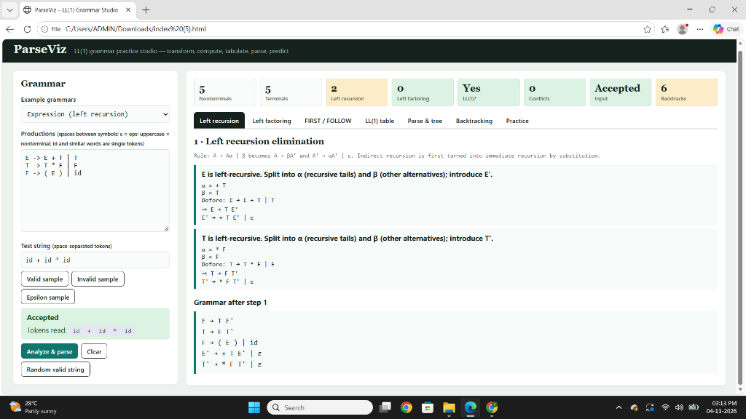
Figure: Tab 1 — Left Recursion Elimination

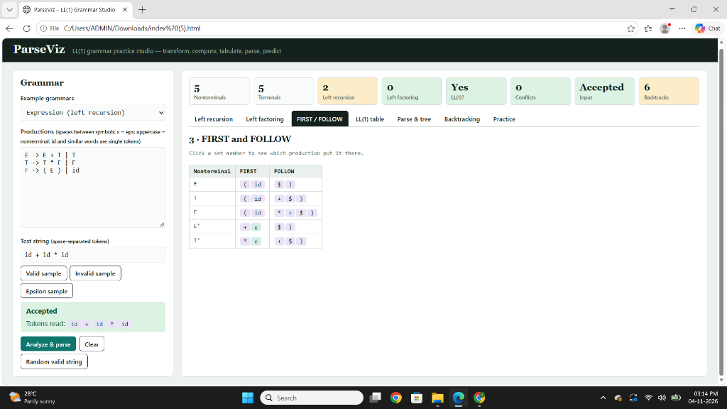
Figure: Tab 3 — FIRST and FOLLOW Sets

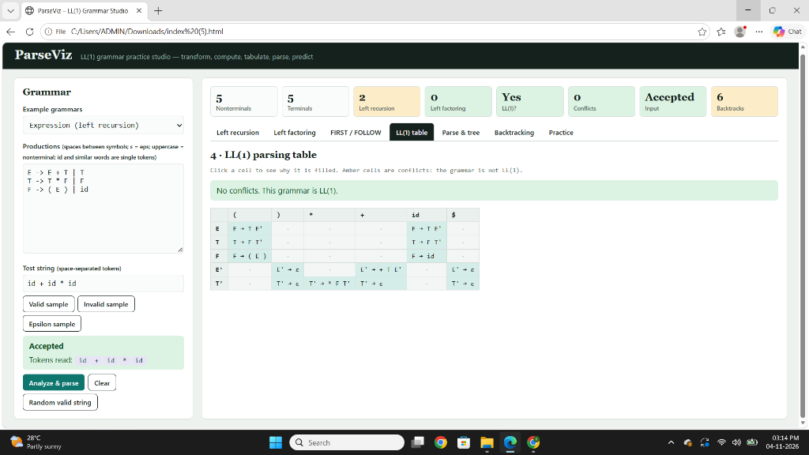
Figure: Tab 4 — LL(1) Parsing Table

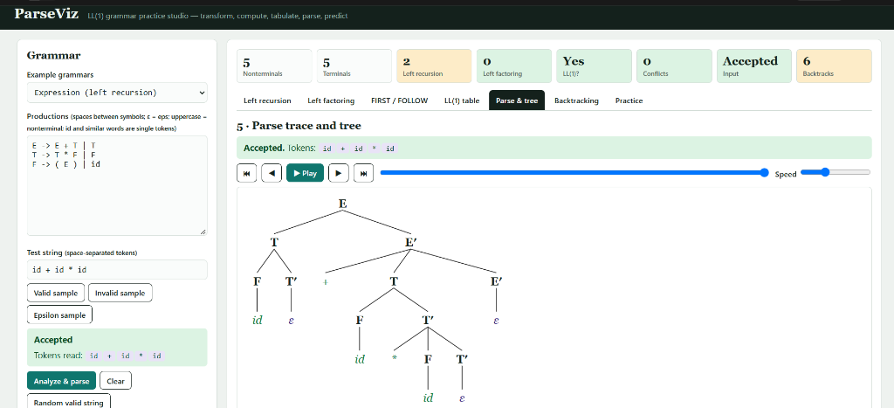
Figure: Tab 5 — Parse Trace and Animated Tree

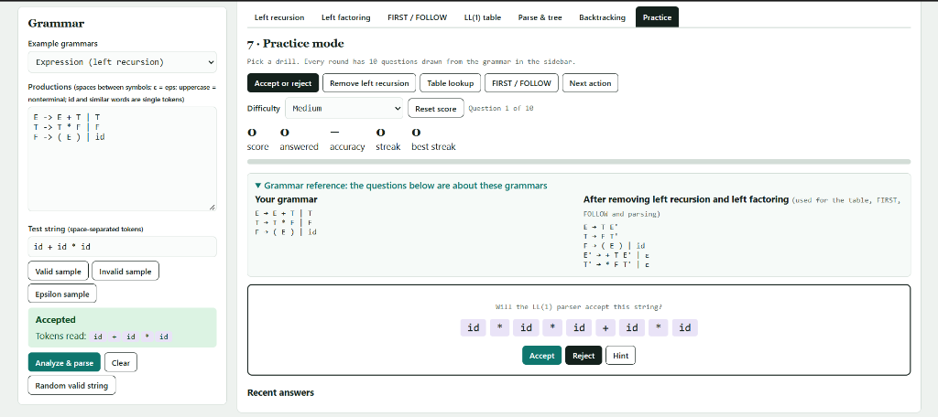
Figure: Tab 7 — Practice Mode

11. Key Learning Outcomes
- Why left recursion must be removed: the backtracking parser demonstrates the infinite loop directly on the original grammar.
- Why left factoring helps: the backtracking step count drops visibly after factoring (e.g., 3 → 0 for the left-factoring grammar).
- Why LL(1) is efficient: the predictive parser never undoes a decision; it always makes the right choice from the table.
- How FIRST/FOLLOW drive the table: clicking any cell or set element traces the rule back to a specific production.
- What a conflict means: the studio shows exactly which two productions fight over the same cell and why the grammar is not LL(1).

12. Conclusion & Future Scope

Conclusion
ParseViz successfully demonstrates all core LL(1) parsing concepts in a single, interactive, animated browser application. All seven tabs function correctly on all six built-in grammars and on arbitrary user-defined grammars. The backtracking tab provides a compelling, evidence-based argument for why predictive parsing is preferred — students can directly observe the step count difference. The practice mode reinforces understanding through autogenerated, parser-validated questions.
The project meets all objectives stated in PS-03.

Future Scope
- Extend to LR(0), SLR(1), and LALR(1) parsing table construction
- Add error recovery strategies (panic mode, phrase-level recovery)
- Export parse trees as PNG or PDF; export grammars as LaTeX BNF
- Add support for EBNF (Extended BNF) input syntax
- Multilingual interface for wider accessibility
- Mobile-responsive layout for tablet and phone use

13. References
- Alfred V. Aho, Monica S. Lam, Ravi Sethi, Jeffrey D. Ullman — "Compilers: Principles, Techniques, and Tools" (2nd ed.), Pearson, 2006.
- Andrew W. Appel — "Modern Compiler Implementation in Java/ML/C", Cambridge University Press, 2004.
- MDN Web Docs — JavaScript Reference, https://developer.mozilla.org/
- W3C — HTML5 Specification, https://www.w3.org/TR/html52/
- python-pptx Documentation — https://python-pptx.readthedocs.io/
- python-docx Documentation — https://python-docx.readthedocs.io/

