18-22

DCAAC

23-27

CCBBA

28-32

CABBA

33-37

ABBAC

38-42

ACDAB

43-

BDDB

47. 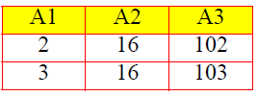

48. 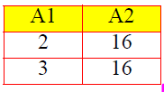

49.

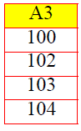

50. 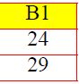

51. 