Session Check User Guide
  - Upload a session Run inference Review the result
Use this guide to test one complete event session, understand the score, record your review and download a result. The public website works independently of the research computer. You need a browser, Internet access and a CSV file; no installation or login is required.
Open Session Check

1 Start a session
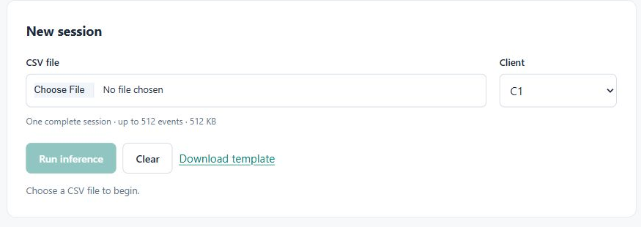
1. Open the website. If the free host is waking up, allow about a minute. If Reconnect appears, select it.
2. For a first test, unzip Session_Check_Test_Samples.zip. Use the four CSV examples supplied with this guide.
3. Select Choose File under CSV file and choose 01_below_threshold.csv.
4. Select Client C2 to reproduce the below-threshold screenshot. For your own data, select the correct original client; the selector does not calibrate a new institution.
5. Select Run inference once. Wait for Inference complete. Controls are temporarily locked while processing.
6. Read the result, inspect Event contributions if needed, and save a review. Select Download result to keep a JSON record.
7. Select Clear to start again. It resets the file, result and review and selects C1. Changing the file or client also hides the old result; run inference again.
Use synthetic or appropriately de-identified data. The public website sends the CSV over HTTPS to the hosted server for processing.
Hosting note: the free service may sleep after inactivity and take about one minute to resume. Render documentation: https://render.com/docs/free

2 Understand the result
The anomaly score is the session’s reconstruction error. Higher means poorer reconstruction under this detector. It is not a threat probability, is not a percentage and can exceed 1. The client threshold is the frozen 99th percentile of that client’s routine-validation scores.
Score compared with threshold | Screen result | What to do
Strictly greater | Review recommended | Review the session and its context.
Less than or exactly equal | Below threshold | No alert under this rule. Investigate if other evidence warrants it.
Input or service error | No new result | Correct the issue and rerun; an error is not an alert.

Displayed numbers are rounded. The decision uses full precision. The 99th-percentile rule does not guarantee a 1% false-positive rate on new data.

Verified results for the two valid samples
Sample | Client | Anomaly score | Threshold | Result
01 below | 12 events | C1 | 0.1982352 | 0.2165964 | Below threshold
01 below | 12 events | C2 | 0.1982352 | 0.2225361 | Below threshold
01 below | 12 events | C3 | 0.1982352 | 0.2050999 | Below threshold
02 above | 1 event | C1 | 1.707739 | 0.2165964 | Review recommended
02 above | 1 event | C2 | 1.707739 | 0.2225361 | Review recommended
02 above | 1 event | C3 | 1.707739 | 0.2050999 | Review recommended

Sample 01 is below all three thresholds. For C2 it spans 01:00:00 to 01:08:15 UTC on 26 October 2026. Sample 02 exceeds all three thresholds. Its start and end are both 01:00:00 UTC because it contains one event.
The same trained model scores all clients, so the same input gives the same raw score; the threshold changes. These synthetic examples exercise the interface and have no verified threat labels. Their different lengths and scores do not establish a causal effect of session length.

Four possibilities when the real label is known
Model decision | Verified real activity | Interpretation
Review recommended | Threat | True positive
Review recommended | Legitimate | False positive
Below threshold | Threat | False negative
Below threshold | Legitimate | True negative

The score alone cannot identify which of these four cases applies. Neither a high score confirms a threat nor a low score proves safety.

3 Inspect and record your review

Read the event contributions
Open Event contributions. Highest contribution lists the largest score shares first; Sequence order restores positions 0, 1, 2 and so on. Each row shows the event ID, UTC time, department and resource.
Score share is the event’s share of the reconstruction score, not its probability of being harmful. In sample 01, position 0 contributes 62.26%. In the one-event sample 02, that event contributes 100% by definition. Shares may differ slightly from a total of 100% because of rounding.

Choose a human review decision
Decision | Use when
Needs more context | You need more information before deciding.
Legitimate activity | Your review indicates an authorized explanation.
Escalate for investigation | You intend to refer the session for investigation.

Select a Decision, add a Note if useful, then select Save review. A blank note is allowed; the limit is 4,000 characters. Wait for Review saved. The Save review button then becomes disabled until you edit the decision or note.
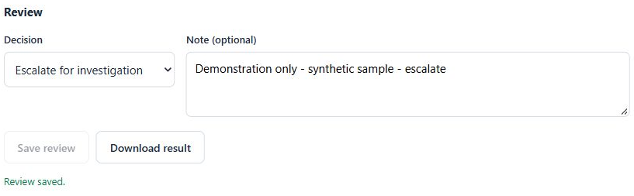
Saving records your entry in the temporary browser session. It does not change the score, threshold or model. Escalate for investigation records a selection; it does not send a message, open a ticket, block access or perform an investigation.

Download and finish
Select Download result to save a JSON file. It contains the session, client, time window, full-precision scores, alert decision, event contributions, coverage and model details, plus the last saved review. Before review, human_review.status is pending for an alert and not_triggered below threshold.
If Unsaved changes appears, select Save review before downloading to include the new text. Otherwise the export contains the earlier saved review. Keep the downloaded file as your record; this page has no result history or JSON import.

4 Prepare your own CSV
Select Download template to obtain the exact header. It is a blank header template; add your own event rows. In Excel, export as CSV UTF-8, not an Excel workbook. Preserve the column names below.
Fields | Required columns
Session and event order | session_id, event_id, sequence_position, timestamp_utc
Categorical event details | action, event_category, department, role, resource_type, source_application, device_type, network_zone, location_type, purpose_of_use, relationship_type, outcome, ward_or_location
Boolean event details | assigned_patient, break_glass, on_shift

One file must contain one complete session with 1 to 512 events and at most 512 KiB (524,288 bytes; shown as 512 KB). Do not truncate or split a session merely to bypass the limit.
Use one nonempty session_id in every row. Give every event a nonempty, unique event_id.
Set sequence_position to 0, 1, 2, ... with no gaps or duplicates. Use plain integers, not 01 or 1.0. The engine sorts by this field, so shuffled file rows are accepted when positions remain correct.
Use a valid timestamp with an explicit UTC offset, for example 2026-10-26T01:00:00Z or 2026-10-26T01:00:00+00:00. Allow at most six fractional digits. Times cannot move backwards in sequence order; equal times are allowed.
Fill all three Boolean columns with true/false or 1/0. True/False and TRUE/FALSE are also accepted. Do not leave these cells blank.
Keep categorical spelling and case consistent with the source data. Leading or trailing spaces change the value. Do not enter the reserved tokens __UNK__ or __MISSING__.
Use only the template columns for the simplest workflow. If you add client or hospital_id, it must agree with the selected client. Duplicate column names and malformed CSV rows are rejected.

If some categories are unknown or blank
Ordinary unseen or blank categorical values can be accepted. The result then shows a coverage note because those cells are excluded as reconstruction targets. This changes the score calculation; inspect the source values before interpreting the result. Missing Boolean values and invalid timestamps are still rejected.
A controlled test with one unseen action and one blank department used 154 of 156 categorical targets and produced 0.1847772 for C1, below threshold. This lower score does not establish improved safety. Correct accidental missing values and rerun the complete session.

5 Test the examples and fix input errors
Run each file separately. Use C1 initially, then choose C2 or C3 and run again to compare thresholds. The two valid samples keep their raw score across clients, as shown on page 2.
Test file | Expected outcome | Explanation or correction
01_below_threshold.csv | Below threshold | 12-event session; score 0.1982352.
02_above_threshold.csv | Review recommended | 1-event session; score 1.707739.
03_invalid_sequence.csv | Rejected without a score | Positions begin at 1. Reindex 0 to N minus 1.
04_missing_columns.csv | Rejected without a score | Required columns are absent. Use the template header.

Input problems and solutions
Message or problem | Action
Run inference is disabled | Choose a nonempty CSV; wait for connection or processing to finish.
Choose a .csv file / UTF-8 encoding error | Export as CSV UTF-8. Renaming an .xlsx file is insufficient.
File is empty / session must contain events | Add the header and at least one complete event row.
File too large / more than 512 events | Use a supported complete session within both limits.
Missing or duplicate CSV column names | Restore the exact template header and remove duplicates.
Required cells missing / extra cells / field too long | Check commas and quoted text. Remove accidentally pasted long content.
Submit exactly one nonempty session_id | Keep one session per file and fill its session ID in every row.
event_id values must be nonempty and unique | Fill missing IDs and remove or correct duplicate IDs.
sequence_position must be canonical, contiguous and start at zero | Use exactly 0, 1, ... N minus 1, without gaps, spaces or duplicates.
Timestamp error / negative elapsed time | Correct the date, UTC offset and event order.
Missing or invalid Boolean | Fill assigned_patient, break_glass and on_shift with accepted values.
Raw literal conflicts with reserved token | Use the original category value or a genuine blank categorical cell.
CSV client or hospital_id disagrees | Select the correct client or correct the optional field.
Coverage note but inference completes | Check unknown or blank categories. The note is not a threat verdict.

After correcting a CSV, select the corrected file again and select Run inference. A rejected request has no valid new score and should not be interpreted as either model decision.

6 Recover and keep your results
Status or problem | What to do
Running or Processing session | Wait. Avoid repeated clicks; controls unlock after completion.
Server unavailable or cannot connect | Check Internet access, allow the host to wake, then select Reconnect.
Your session expired | Select Reconnect. The loaded CSV remains selected; run inference again.
Result not found in your session | Rerun inference and save the review again.
The model or service is busy | Wait briefly, then retry. Reconnect if offered.
Too many inference requests | Wait one minute before trying again.
Upload timed out or unreadable server response | Check the connection and retry. Refresh if the problem persists.
Request could not be processed | Do not use it as a result. Retry once; contact the maintainer if repeated.
Review was not saved | Copy your note elsewhere, resolve the displayed error and save again.
Save review is disabled | The review is already saved, another operation is running, or Reconnect is required.
Note is too long | Shorten it to 4,000 characters or fewer, then save.
Download does not contain your latest edit | Save review, wait for Review saved, then download again.

Keep a record before leaving
The public app keeps results and reviews temporarily in server memory, with at most three retained results per visitor. Browser sessions expire after about 20 minutes without API activity; capacity limits, cookie expiry or server restarts may require an earlier rerun. Download promptly. Refreshing or closing the page clears the displayed workflow, and earlier results cannot be reopened through this interface.
Clear resets the browser workflow; it does not request immediate server deletion. An already downloaded JSON remains on your computer. The separate local and portable versions save local files; this guide describes the public website.

Model and verification
This website uses the original trained FedAvg with SecAgg+ model C, Reference condition, seed 11, selected round 30. It performs inference only. Uploads and review decisions do not retrain or recalibrate it; SecAgg+ does not run during inference.
Verified on 26 October 2026: 19 browser workflow checks and 39 backend, boundary and contract checks passed. Browser checks covered upload, both results, client changes, both event orders, all review choices, saved and pending exports, unsaved edits, Clear, input errors and controlled expiry with Reconnect. All six valid sample and client combinations were scored in an isolated copy of the public backend.
Exact threshold equality was tested through the decision function. Busy handling and some exceptional service failures were checked against the implementation rather than forced on the public service. The examples demonstrate supported behavior; they do not establish detection accuracy on new data.

