Process models:
· Mail Synchronisation
The system connects to the student's Siswamail account through Microsoft Entra ID and retrieves emails using Microsoft Graph. An LLM analyses and categorises the emails into relevant segments. The organised emails are then displayed in the student's inbox.

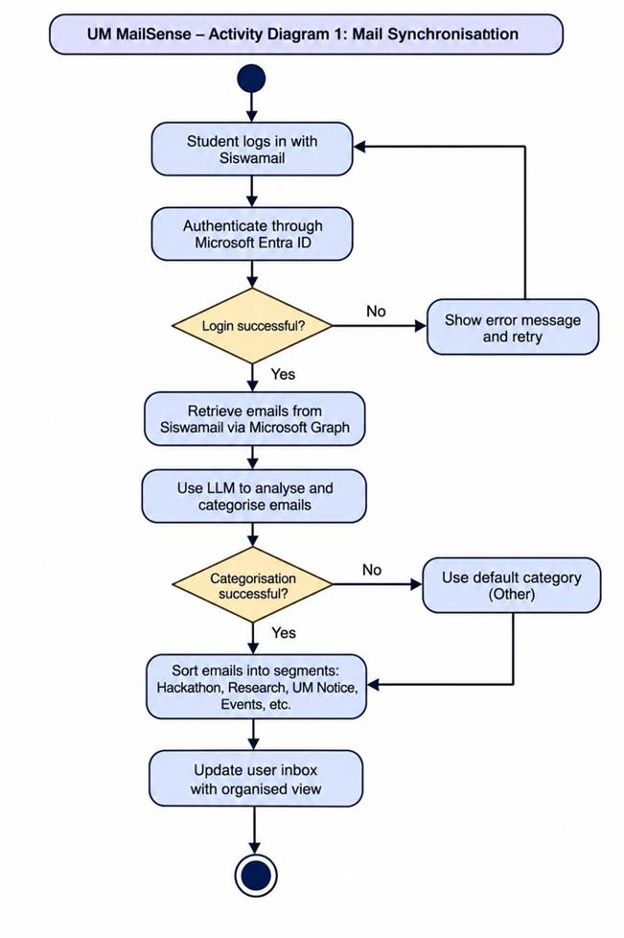

· CV Upload and Recommendations
Students upload their CVs, allowing the system to extract their skills, interests and study information. The system analyses their profiles and matches them with relevant emails and opportunities. Personalised recommendations are then displayed to the students.

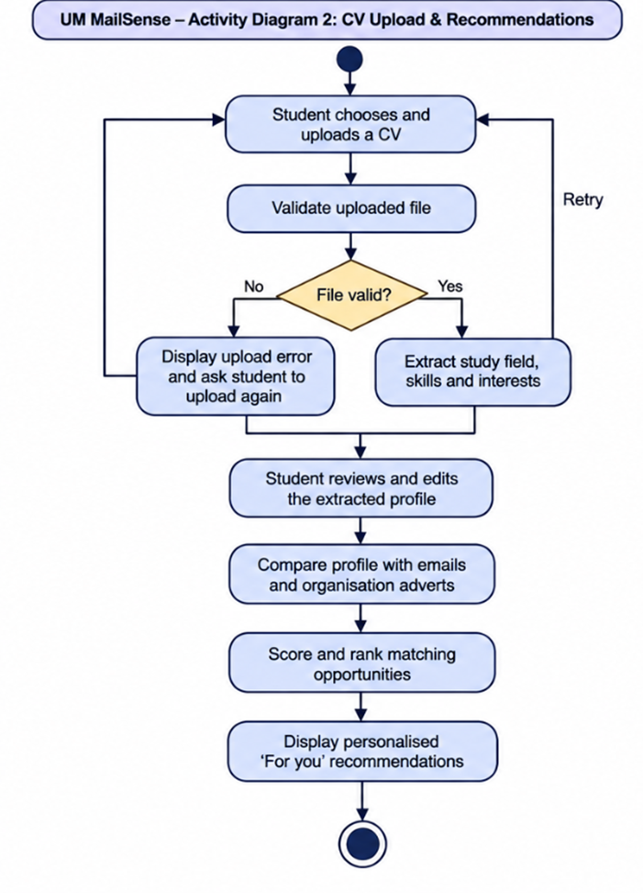

· Organisation Advertisement Posting
Organisations sign in and submit their accounts for verification before creating advertisements. Each advertisement is reviewed by an administrator before publication. Once approved, it appears on the community board, where students can browse, filter and save opportunities.



