Screenshots Grafana Dashboard

- Traffic Volume
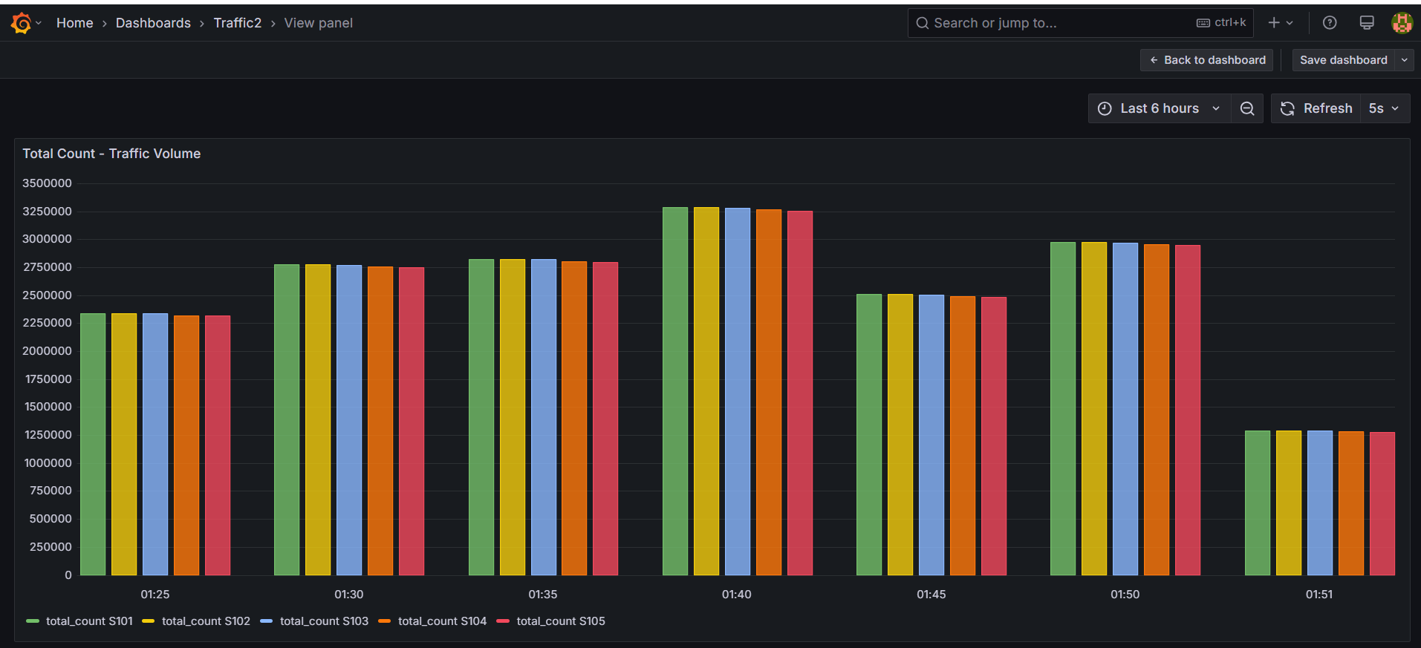

- Average Speed
