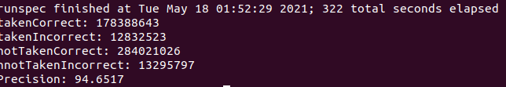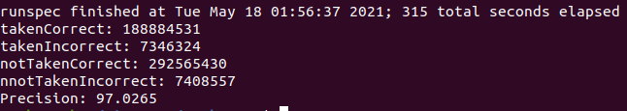

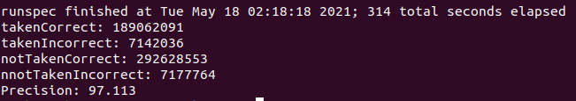

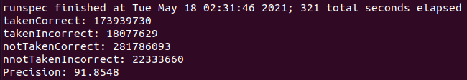

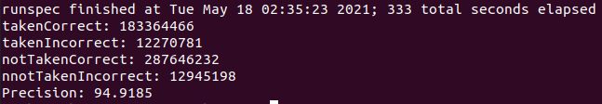

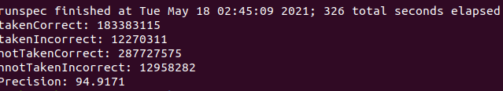

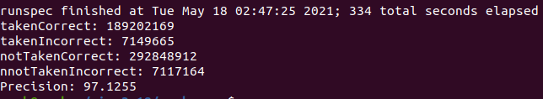

|  |  |  |  |  |
| --- | --- | --- | --- | --- |
|  | Bzip2 | Sjeng | Wrf | Sphinx3 |
| BHT(16) | 94.8356 | 94.7383 | 94.8599 | 94.965 |
| BHT(19) | 94.896 | 94.7964 | 94.9082 | 95.0089 |
| GHP | 97.891 | 97.8725 | 97.9263 | 98.0634 |
| LHP | 93.4706 | 93.2549 | 93.5066 | 94.4348 |
| TP_GSH | 98.0605 | 98.0084 | 98.0717 | 98.2393 |
| TP_LSH | 98.3395 | 98.3094 | 98.3743 | 98.5786 |
| Bi-mode | 98.1044 | 98.0842 | 98.1335 | 98.2282 |

1

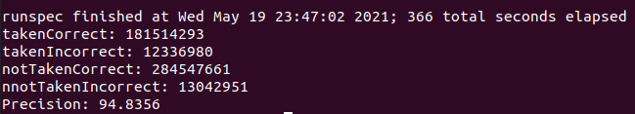

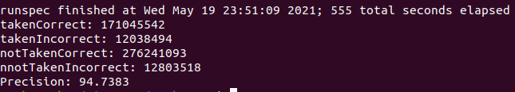

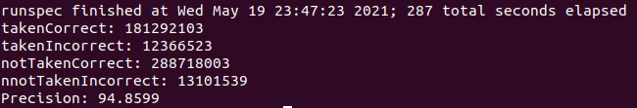

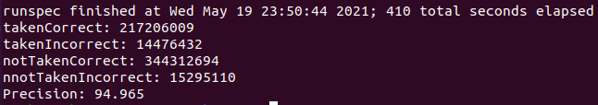

2

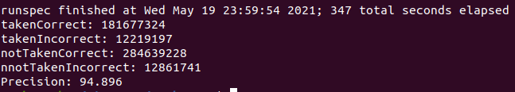

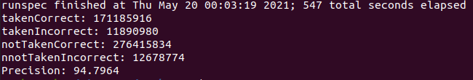

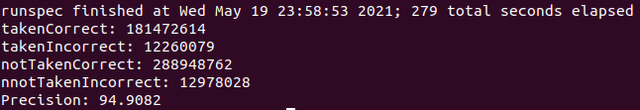

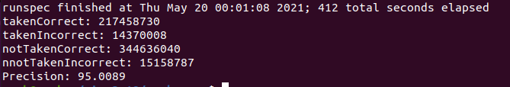

3

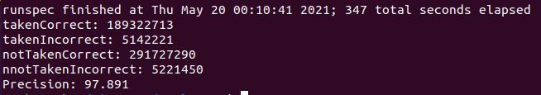

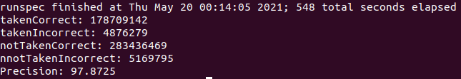

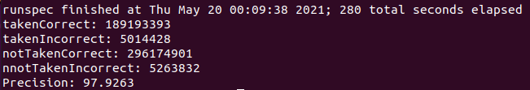

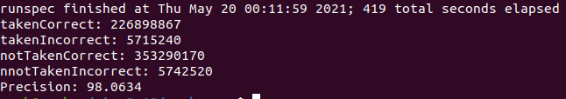

4

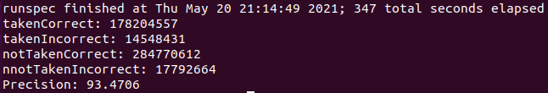

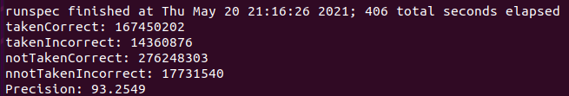

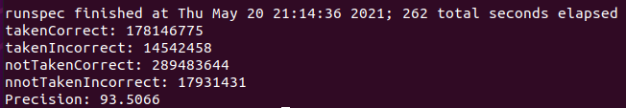

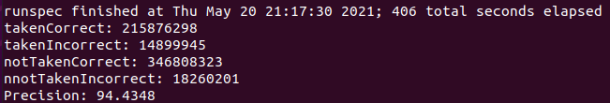

5.12

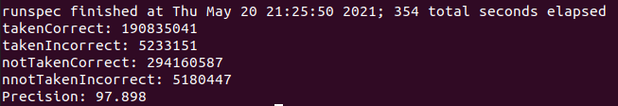

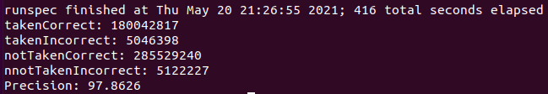

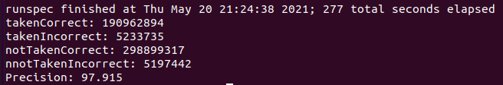

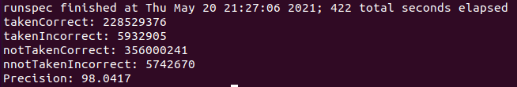

5.23

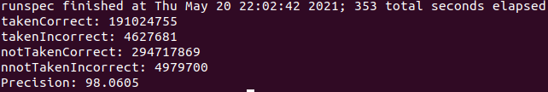

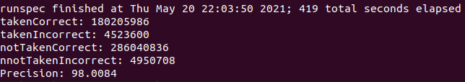

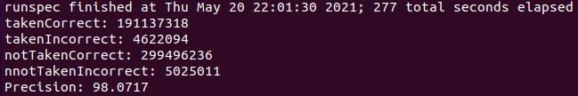

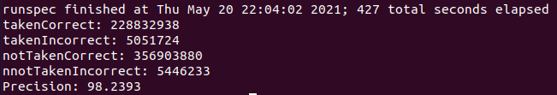

6.12

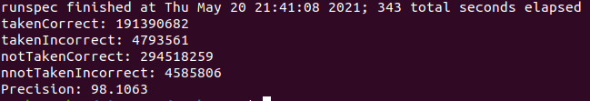

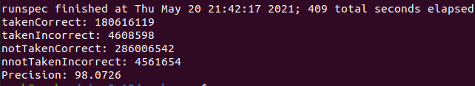

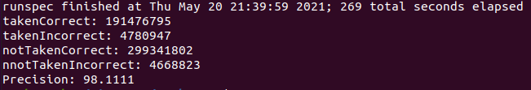

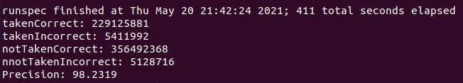

6.34

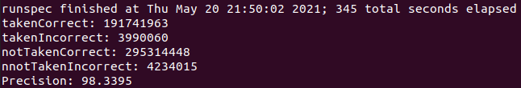

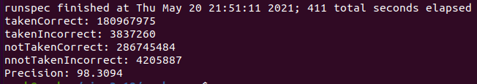

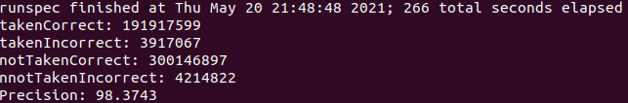

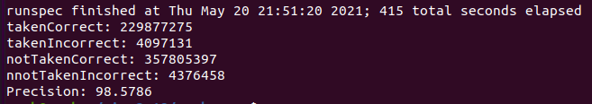

7.

