# Setup

Use click once to deploy!

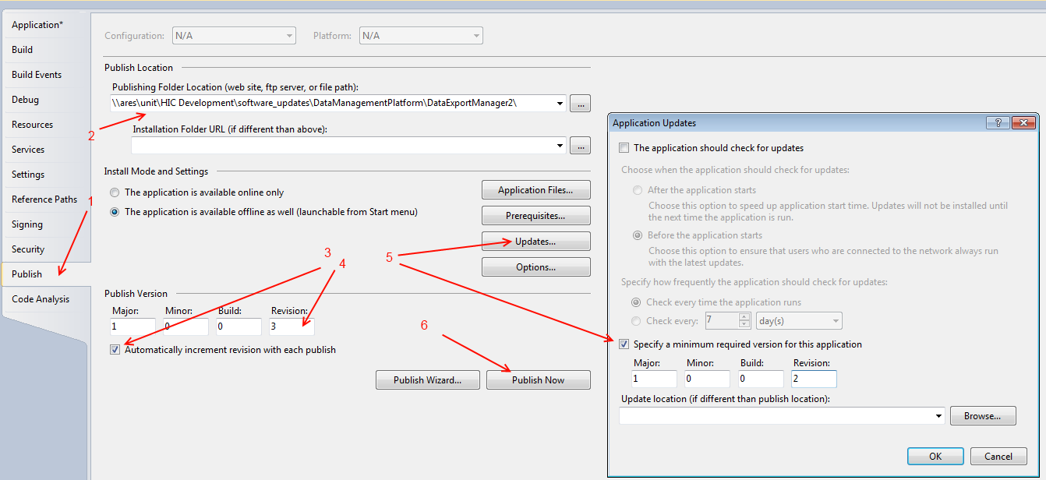

# Problems

## GAC

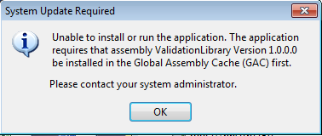

Make sure you unregister every custom dll that is used by your application from the GAC otherwise you will get an error like ‘install of X program expected dllBlah.dll to be registered in the GAC’.



## Manifest does not match

Reference in the manifest does not match the ide**n**tity of the downloaded assembly



This can be fixed by changing the dependent assembly as follows (in the dependent assembly e.g. CatalogueManager). This is not the parent project it is the child DLL (the one it is complaining about)

