Alias Handler

# Background

Sometimes you have to deal with the situation where an individual has multiple different identifiers. For example a patient has a CHI (Community Health Index) number **CHI1** in Tayside but is admitted unconscious as an A&E patient in Edinburgh. The patient is treated under a temporary identifier **CHI2**. Later on the patient recovers and a fact is announced (**CHI1** and **CHI2** belong to the same patient). This can be handled by creating an alias fact table:

|  |  |
| --- | --- |
| CHI | Alias |
| CHI2 | CHI1 |

# Functionality

The AliasHandler lets you notify the RDMP that a DataTable might contain aliased records. You must tell it where to get the list of known aliases from and what to do if it finds an alias. The options are CrashIfAliasesFound and MultiplyInputDataRowsByAliases. CrashIfAliasesFound is self-explanatory, in the event that an alias is found the entire pipeline will fatally crash (not that useful). MultiplyInputDataRowsByAliases handles the alias by replicating the input data with every known alias (see below).

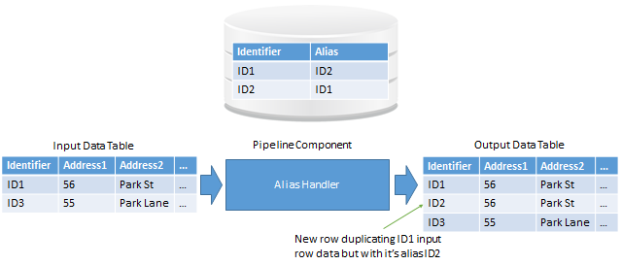

# Notes

You must create an ExternalDatabaseServer reference to the database server that contains your Alias table. The SQL AliasTableSQL will be execute verbatim and must result in 2 columns being returned (in the above this would be the columns Identifier and Alias). You cannot have records in which Identifier and Alias are the same. The Identifier column name must match the input table column name and AliasColumnInInputDataTables.

Alias resolution using this component will result in data duplication so make sure you deal with that.

# Use Case

See AliasResolutionUseCase.pptx for a worked example of alias resolution using the cohort table as the alias fact table.