Table Valued Function Support Testing

# Purpose

Test the systems ability to handle table valued functions as Catalogues, for Cohort Creation and for Data Export

# Related Unit Tests

# CatalogueLibraryTests.Integration.TableValuedFunctionTests

DataExportLibrary.Tests.TableValuedFunctionTests

# User Test

Start by creating a new table valued function (this function randomly selects people out of your cohorts table)

create view getNewID as select newid() as new_id

GO

create function GetTopXRandom (@numberOfRecords int)

RETURNS @retTable TABLE

(

chi varchar(10),

definitionID int

)

AS

BEGIN

while(@numberOfRecords >0)

begin

insert into @retTable select top 1 chi,cohortDefinition_id from cohorts..Cohort order by (select new_id from getNewID)

set @numberOfRecords = @numberOfRecords - 1

end

return

end

GO

select * from GetTopXRandom(50)

Import the function as a new Catalogue. Confirm that you can view the data extract

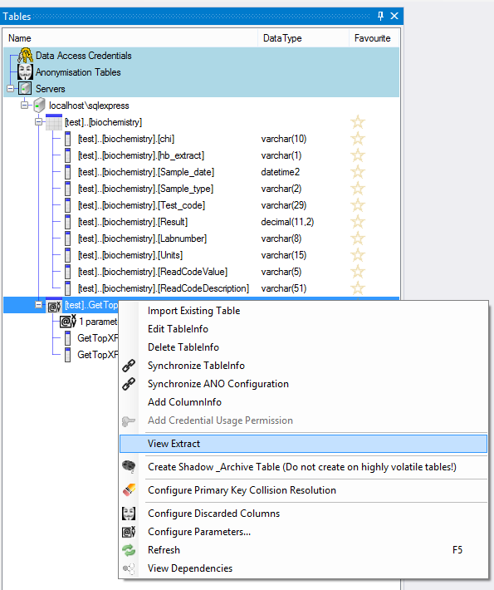

Create an Aggregate Configuration Graph with an overriden number on rows returned parameter

Create a Cohort Identification Configuration

Create a Data Export Project with the table valued function as an extractable catalogue with a nic high parameter on rows returned (to ensure intersection with extraction).