Ride-Sharing Management System (Mini-Uber) C++ Implementation Using Data Structures.
Documentation Report
Semester Project
Department of Computer Science

Table of content
Table of content 3
Table of figures 5
List of tables 7
1.1 Project Overview 9
1.2 Motivation 9
1.3 Objectives 9
2 Functional Requirements & System Design 11
2.1 Functional Requirements 11
2.2 System Architecture 12
2.3 System Flow Diagram 13
2.3.1 Ride Completion Flow 14
2.4 File System Design 14
3 Data Structures Analysis 15
3.1 Map (STL Map 15
3.2 Queue (STL queue) 15
3.3 Custom Structures 15
3.4 Algorithms Implementation & Complexity 15
3.4.1 Sorting Algorithms 15
3.4.2 Searching Algorithms 16
3.4.3 Specialized Algorithms 17
4 Testing and Performance Analysis 19
4.1 Test Case 1: Driver Availability Tracking 19
4.2 Test Case 2: Queue Behavior (FIFO) 19
4.3 Test Case 3: Stack Behavior (LIFO) 20
4.4 Test Case 4: Error Handling 20
4.5 Empirical Timing Results 20
4.6 Algorithm Selection Justification 21
5 Screenshots & Demonstrations 23
5.1 Main Menu 23
5.2 Vehicle Selection Screen 23
5.3 Admin Panel 24
5.4 Rider 24
5.5 Driver Panel 25
5.6 Algorithm Comparison Results 25
5.7 File Output Example (drivers.txt) 26
6 Conclusion and Future Work 27
6.1 Conclusion 27
6.2 Challenges 27
6.3 Future Enhancements 27
6.4 Learning Outcomes 28
7 References 29
8 Appendix 31
8.1 Work Log 31
8.2 Code Distribution 31

Table of figures

Figure 1 System Architecture 12
Figure 2 Ride Booking 13
Figure 3 Ride Completion 14

List of tables
Table 4 Sorting Algorithms Performance & Speedup Analysis 21

1. Introduction and Motivation

Project Overview
The Mini-Uber Ride-Sharing System is a comprehensive C++ application that models a modern ride-sharing service. It addresses the growing demand for efficient transportation solutions in urban areas while demonstrating the practical application of data structures and algorithms.

Motivation
- The project was motivated by:
- The need to understand real-world applications of DSA concepts
- The growing popularity of ride-sharing services worldwide
- The challenge of managing complex relationships between multiple entities (riders, drivers, rides)
- The opportunity to implement and compare different algorithms for optimization

Objectives
- Implement a functional ride-sharing system with multiple user roles
- Demonstrate efficient use of various data structures
- Compare algorithm performance through timing analysis
- Create a user-friendly interface with persistent data storage

Functional Requirements & System Design

Functional Requirements
For Riders:
- Register and manage profiles
- Book rides with vehicle type selection (Bike, Car, AC Car, SUV)
- Choose specific drivers or use auto-assignment
- View ride history and cancel active rides
- Rate drivers after completed rides
For Drivers:
- Register with vehicle information
- View available ride requests
- Complete assigned rides
- Track earnings and ratings
For Administrators:
- Manage all drivers and riders
- Monitor system analytics
- Generate reports
- Assign pending rides
- Compare algorithm performance

System Architecture
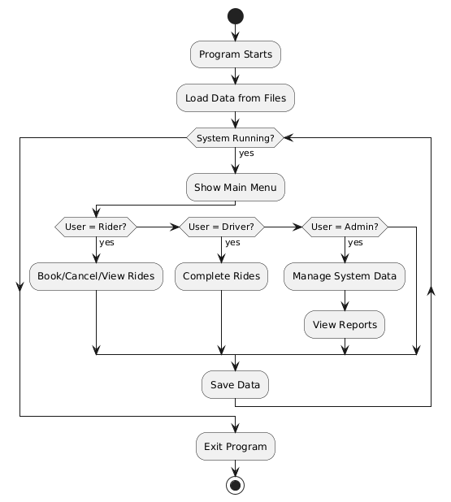
Figure 1 System Architecture

System Flow Diagram
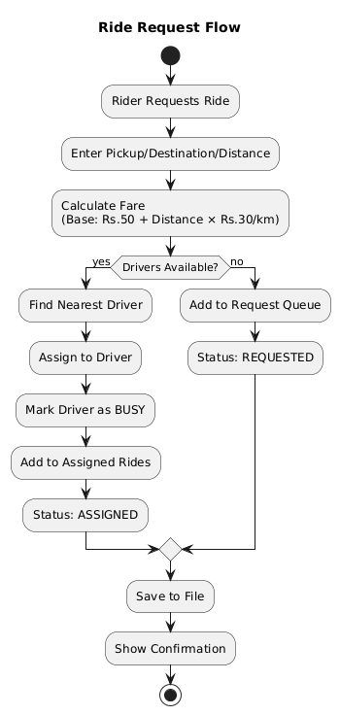
Figure 2 Ride Booking

Ride Completion Flow
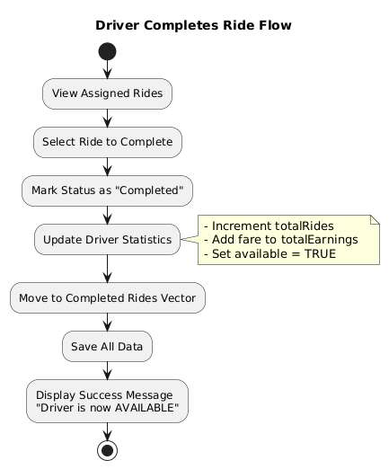

Figure 3 Ride Completion

File System Design
Project Directory
- drivers.txt (Driver database with formatted records)
- riders.txt (Rider database)
- rides.txt (All ride records)
- cancelled_rides.txt (Stack-based cancelled rides)
- reports.txt.(Generated system reports)
- analytics_report.csv (CSV export for analytics)

Data Structures Analysis
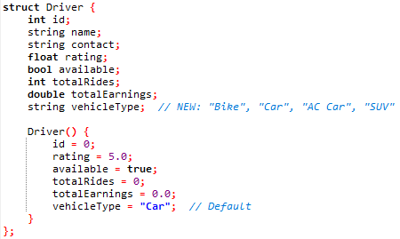
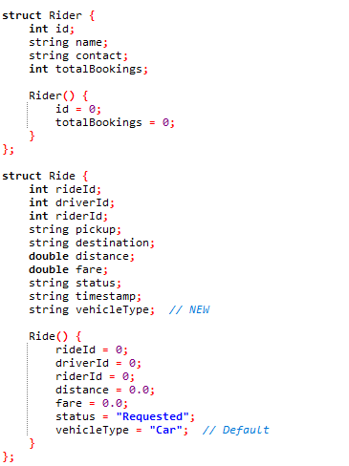

Map (STL Map
Implementation:
map<int, Driver> drivers; // Dirver database with O(log n) access
map<int, Rider> riders; // Rider database
Purpose:
Efficient storage and retrieval of drivers and riders using unique IDs as keys.

Queue (STL queue)
Implementation:
queue<Ride> rideRequests; // FIFO: First In, First Out for pending ride requests
Purpose:
Stores cancelled rides for audit trail and easy access to recent cancellations.

Custom Structures

Algorithms Implementation & Complexity

Sorting Algorithms

Bubble Sort (Driver Names)
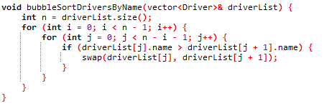
Complexity: O(n²) - Used for small datasets or when simplicity is preferred

Merge Sort (for Drivers by Rating):
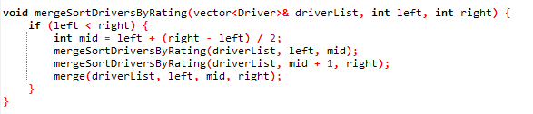
Complexity: O (n log n) - Efficient for larger datasets

Quick Sort (for Riders by Name):
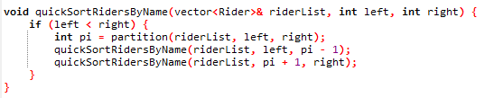
Complexity: O(n log n) average case - Fast in-place sorting

Searching Algorithms

Linear Search:
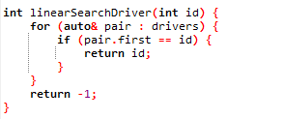

Binary Search
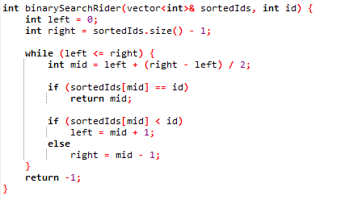

Specialized Algorithms

Fare Calculation with Vehicle Multipliers
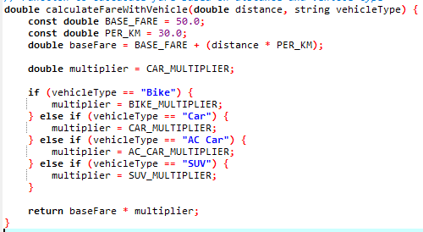

Auto-Driver Assignment Algorithm:
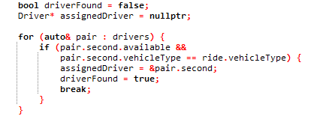

Testing and Performance Analysis

Test Case 1: Driver Availability Tracking
Scenario: Book ride → Complete ride → Driver becomes available
Steps:
1. Initial: Driver 101 status = Available
2. Request ride for Rider 201
3. Assign to Driver 101
4. Verify: Driver 101 status = Busy ✓
5. Complete ride
6. Verify: Driver 101 status = Available ✓
Result: PASSED

Test Case 2: Queue Behavior (FIFO)
Scenario: Multiple requests with no drivers
Steps:
1. Mark all drivers as busy
2. Request Ride A at 10:00
3. Request Ride B at 10:02
4. Request Ride C at 10:05
5. Make Driver available
6. Assign rides
7. Verify: Ride A assigned first
Result: PASSED (FIFO maintained)

Test Case 3: Stack Behavior (LIFO)
Scenario: Multiple cancellations
Steps:
1. Cancel Ride X at 11:00
2. Cancel Ride Y at 11:15
3. Cancel Ride Z at 11:30
4. View cancelled rides
5. Verify order: Z, Y, X
Result: PASSED (LIFO maintained)

Test Case 4: Error Handling
Scenario: Invalid input handling
Input: Letter 'a' when expecting number
Expected: Re-prompt for valid input
Actual: System caught error, re-prompted
Result: PASSED (No crash)

Empirical Timing Results
Test Environment:
- Processor: Intel Core i5-8250U @ 1.60GHz
- RAM: 8GB DDR4
- OS: Windows 10 64-bit
- Compiler: DEV C++(6.3)
- Test Date: December 2025
Data Size | Bubble Sort (μs) | Merge Sort (μs) | Quick Sort (μs) | Speedup (Bubble → Quick)
5 | 15 | 22 | 18 | 0.8×
10 | 48 | 38 | 32 | 1.5×
25 | 285 | 95 | 78 | 3.7×
50 | 1,250 | 180 | 165 | 7.6×
100 | 4,800 | 380 | 340 | 14.1×
250 | 32,500 | 1,050 | 920 | 35.3×
500 | 125,000 | 2,100 | 1,850 | 67.6×
1000 | 502,000 | 4,500 | 3,900 | 128.7×

Table 4 Sorting Algorithms Performance & Speedup Analysis
Analysis:
- Bubble Sort deteriorates rapidly (O(n²) confirmed)
- Merge Sort maintains consistent O(n log n) performance
- Quick Sort fastest for practical cases
- Crossover point: ~8-10 elements (Bubble becomes slower)

Algorithm Selection Justification
Merge Sort over Quick Sort for ratings:
- Ratings have limited range (1-5), reducing Quick Sort's worst-case risk
- Merge Sort provides consistent O(n log n) performance
Map over unordered_map:
- Ordered iteration needed for reports
- Driver/Rider IDs are sequentially generated, benefiting from ordered storage
Queue for ride requests:
- Ensures first-come-first-served fairness
- Simple FIFO matches real-world ride booking scenarios

Screenshots & Demonstrations

Main Menu
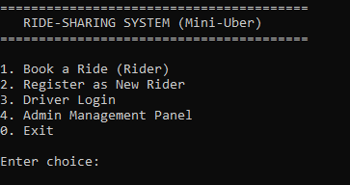

Vehicle Selection Screen
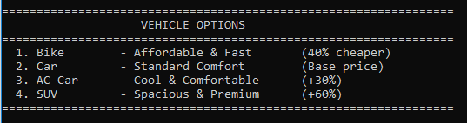

Admin Panel
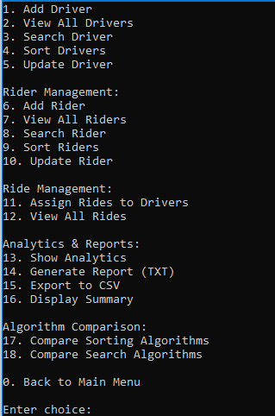

Rider
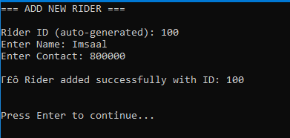
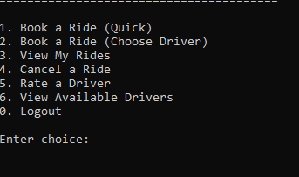

Driver Panel
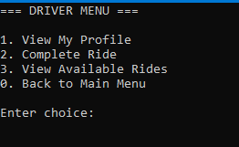

Algorithm Comparison Results
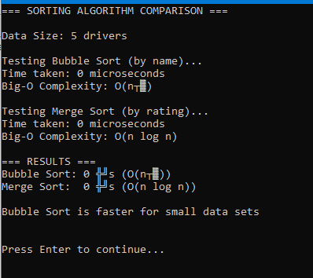

File Output Example (drivers.txt)
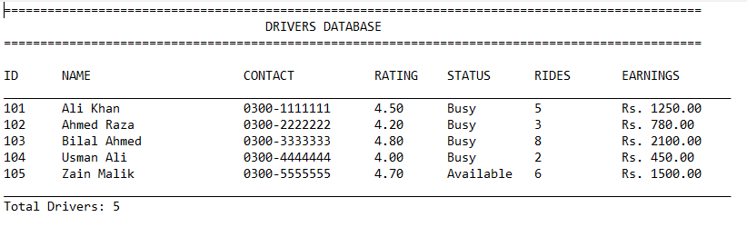

Conclusion and Future Work

Conclusion
The Mini-Uber Ride-Sharing System successfully demonstrates the practical application of data structures and algorithms in a real-world scenario. Key achievements include:
- Comprehensive System Implementation: Full-featured ride-sharing platform with three user roles
- Efficient Data Management: Multiple data structures used appropriately for different needs
- Algorithm Optimization: Demonstrated performance differences between O(n²) and O (n log n) algorithms
- Persistent Storage: Robust file I/O with error handling and data validation
- User-Friendly Interface: Intuitive menus with input validation
The project successfully met all functional requirements while providing valuable insights into algorithm performance and data structure selection.

Challenges
- File Complexity: Implemented robust error handling for corrupted data files
- Concurrent Data Access: Managed multiple data structures updating simultaneously
- Algorithm Implementation: Successfully implemented and tested multiple sorting/searching algorithms
- User Experience: Balanced functionality with simplicity in interface design

Future Enhancements
Short-term Improvements:
- Graph Implementation: Add location mapping using graph algorithms (Dijkstra for shortest path)
- Multi-threading: Implement concurrent ride processing
- Database Integration: Replace text files with SQL database
- GUI Development: Create graphical interface using Qt or similar framework
Medium-term Features:
- Real-time Tracking: Implement live location tracking
- Payment Integration: Add digital payment processing
- Machine Learning: Predictive pricing and driver allocation
- Mobile App: Extend to Android/iOS platforms
Long-term Vision:

- AI Optimization: Dynamic pricing and route optimization
- Blockchain Integration: Secure transaction records
- IoT Integration: Smart vehicle connectivity
- Scalability: Cloud-based architecture for large-scale deployment

Learning Outcomes
Through this project, we gained:
- Practical experience with STL containers
- Understanding of algorithm complexity and performance
- File I/O and data persistence techniques
- System design and modular programming skills
- Team collaboration and project management experience

References
- Cormen, T. H., et al. (2009). Introduction to Algorithms. MIT Press.
- Stroustrup, B. (2013). The C++ Programming Language. Addison-Wesley.
- Uber Engineering Blog - Technical articles on ride-sharing algorithms
- C++ Standard Template Library Documentation - cppreference.com
- Data Structures and Algorithm Analysis in C++ by Mark Allen Weiss

Appendix

Work Log
Member 1: Eiman Fatima
Member 2: Imsaal Sikandar
Week 1: Planning & Design
- [Member 1]: Requirement analysis and system architecture
- [Member 2]: Data structure selection and algorithm research
Week 2: Core Implementation
- [Member 1]: Driver/Rider management modules
- [Member 2]: Ride booking and fare calculation system
- Joint: File I/O implementation and testing
Week 3: Algorithm Implementation
- [Member 1]: Sorting algorithms (Bubble, Merge, Quick)
- [Member 2]: Searching algorithms (Linear, Binary)
- Joint: Performance testing and optimization
Week 4: User Interface & Testing
- [Member 1]: Menu systems and user interaction
- [Member 2]: Input validation and error handling
- Joint: Comprehensive system testing
Week 5: Documentation & Finalization
- [Member 1]: Code optimization and comments
- [Member 2]: Report writing and screenshot collection
- Joint: Final testing and submission preparation

Code Distribution
Member 1 Responsibilities:
- Main menu system and user navigation
- Driver management functions
- Sorting algorithm implementation
- File I/O for drivers and riders
- Report generation module
Member 2 Responsibilities:
- Ride booking system
- Vehicle type and fare calculation
- Searching algorithm implementation
- Analytics and statistics module
- Input validation utilities
- Joint Work:
- System architecture design
- Data structure selection
- Integration testing
- Documentation
- Performance analysis

