Lab 04 — Types in a file
Name: Unsa Jabeen
Roll number: 247295 (F24A-247295)
Lab title: Lab 04 — Types in a file
Section: BSCS-F24-A
What I finished
- Tasks 1–5, the sheet: heading Bus office, olive header with white shop name, array of objects, form with Add, Line (times), Note (text), NaN and undefined rows, total that skips NaN, and the kind lines under the total.
- Tasks 6–8, the till: Take button, change as paid minus bill, still owed, half of the change, function with the call above it, and null for an empty paid box with its kind.
- Tasks 9–11, who is in: Here and Out buttons, list with name and whether in, count under the list, and one starting person with no answer that shows undefined and is not counted.
- Task 12: all work committed in the repository f24a-247295-lab4, one commit per task.
Screenshots
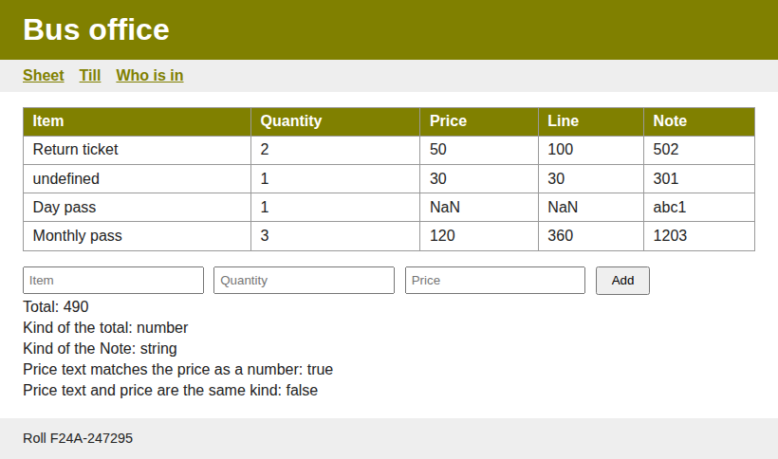
The sheet
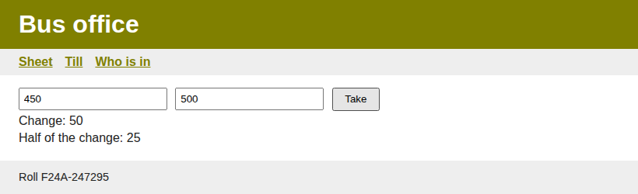
The till
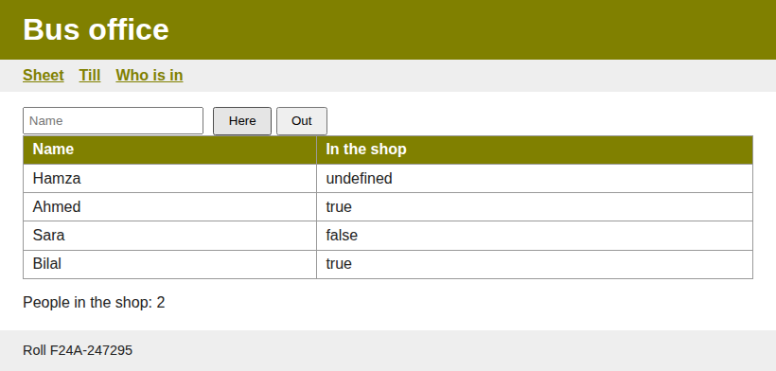
Who is in the shop

