SmartHireX: Implementation of an Explainable NLP and Semantic Embedding–Based Resume Parsing and Job Matching Framework
1st Sagar Shirsat  Information Technology  JSPM's RSCOE  Pune, India  shirsatsagar100@gmail.com | 2nd Dr. Sandeep Chaware  Information Technology  JSPM's RSCOE  Pune, India  smchaware_it@jspmrscoe.edu.in | 3rd Adesh Adhav  Information Technology  JSPM's RSCOE  Pune, India  adeshadhav.01@gmail.com
4th Sarthak Mandurkar  Information Technology  JSPM's RSCOE  Pune, India  sarthakmandurkar17@gmail.com | 5th Sharad Pawar  Information Technology  JSPM's RSCOE  Pune, India  sharadpawar17k@gmail.com
Abstract—Online hiring portals now handle an enormous volume of applications for every open role, and reviewing each resume by hand has become both slow and uneven. Older keyword-driven filters struggle here because they only look at surface words and miss the meaning behind what a candidate actually writes. In this paper we describe SmartHireX, an NLP-driven resume parsing and job matching platform that aims to be both accurate and explainable. At its core, the system uses Sentence-BERT (SBERT) to turn resumes and job descriptions into dense semantic vectors, and then applies cosine similarity to rank candidates by how closely they align with a given role. The platform itself is built on the MERN stack—React on the frontend, Node.js with Express on the backend, MongoDB Atlas for storage, and a Python-based SBERT service for embeddings. On top of the semantic score we add an explainability layer that reports keyword coverage, section completeness, and formatting quality, and combines them into a single compatibility score out of 100. To check how well the system agrees with human judgment, we tested it on 50 resume–job pairs that three HR professionals had also scored; SmartHireX reached a Pearson correlation of 0.87 with the expert averages, which suggests the tool is reliable enough to support recruiters during shortlisting rather than replace them.
Keywords— Resume Parsing, Sentence-BERT, Semantic Embeddings, Job Matching, NLP, Explainable AI, MERN Stack, Candidate Ranking, ATS Score

I. INTRODUCTION
Hiring has changed a great deal over the last decade. Most companies now collect applications through online portals, and for any reasonably attractive role the inbox fills up with hundreds—sometimes thousands—of resumes within days. Going through them one by one is slow, and studies of recruiter behaviour have consistently shown that the process is also inconsistent: the same resume can be rated quite differently depending on who reads it, how tired they are, or what time of day it is. This is a big part of the reason why Applicant Tracking Systems (ATS) became so popular. Most current ATS tools, however, still rely on keyword matches and simple rules, which means they often miss good candidates whose resumes simply use different wording from the job post.
The weakness of a keyword-first approach is easy to see with an example. A resume that says “ML engineer with five years of deep learning experience” ought to score well against a posting that asks for an “AI developer,” but a literal TF–IDF or Boolean filter may treat the two as unrelated because the exact tokens do not overlap. Candidates are then rejected before a human ever reads their file, and recruiters receive a filtered pool that reflects vocabulary rather than ability.
Transformer-based language models have changed what is possible here. Models like BERT [9] and especially Sentence-BERT (SBERT) [8] learn to place sentences that mean similar things close together in a high-dimensional space, even when the sentences share very few words. For resume screening, this is the property we want: a tool that can tell “backend developer” and “server-side engineer” are essentially the same role, and rank candidates based on what they can actually do rather than on how they chose to phrase it.
II. SYSTEM DESIGN OVERVIEW
SmartHireX is organised as a full-stack web application with four cooperating layers: the browser-facing interface, a backend service that drives the business logic, a semantic engine that generates embeddings and similarity scores, and a cloud-hosted document store. We chose a MERN stack because it keeps the entire codebase in a single language ecosystem and because MongoDB’s document model fits the naturally nested shape of a resume much better than a relational schema would. The React frontend handles resume uploads, the job description input form, and the ranked candidate display, while the Express backend exposes a set of REST endpoints and orchestrates the calls between the frontend, the scoring engine and the database.
All the semantic work happens in a Python service that runs the SBERT model. Whenever a resume or a job post needs to be scored, the backend forwards its text to this service, receives back an embedding vector, and then computes cosine similarity in-process before writing the result to MongoDB Atlas. We deliberately kept the semantic component loosely coupled, so the rest of the system does not care whether we later swap SBERT for a different encoder. The platform runs in a sandboxed environment with TLS, JWT-based sessions and role-based access control, which together let us offer candidates and HR users meaningfully different views without maintaining two separate applications.
III. LITERATURE SURVEY
Work on automated resume processing has moved through several phases—from rule-based extractors, to classical machine-learning classifiers, and more recently to deep contextual models. Table I lists the representative papers we drew on while designing SmartHireX, along with a short note on what each study does well and where we felt it could be pushed further.
TABLE I. LITERATURE SURVEY SUMMARY
Ref. | Title | Methodology | Strength | Limitation
[1] | Semantic Resume Classification | NLP pipeline with ensemble voting classifier | Adapts to new domains at runtime | Needs curated training set
[2] | Cross-Lingual Job Retrieval with Bias Mitigation | Dual encoder and contrastive learning | Unified encoder across languages | Heavy model, non-trivial to deploy
[3] | Resume Parsing and Job Domain Prediction | Feature engineering plus ML classifier | Works without labelled domains | Leans hard on surface keywords
[4] | Hireability: Resume Information Extraction | NER with structured parsing | Reliable field-level extraction | No matching against job posts
[5] | Smart Hiring: Explainable CV Matching | Transformer pipeline with XAI layer | End-to-end pipeline with explanations | High compute cost in production
[6] | Multi-Granularity Resume Understanding | Multi-modal encoder, deep learning | Captures fine-grained structure | Requires large annotated corpus
[7] | AI-Powered Resume Screening | ML classifier over extracted features | Lightweight and quick to train | Shallow understanding of context
IV. METHODOLOGY
We frame resume–job matching as a ranking problem in a semantic vector space. Given a job description and a pool of resumes, the system’s job is to assign each resume a relevance score and return the pool in sorted order. The rest of this section walks through how that score is built.
A. Problem Formulation
Let J stand for the text of a job description and {R₁, R₂, …, Rₙ} for the set of candidate resumes under consideration. We want a scoring function S(Rᵢ, J) that returns a real number: higher values mean the resume and job are a better fit. Once every resume has a score, ranking is just an argsort on the vector of scores.
B. Contextual Embedding Generation
Both the resume text and the job description pass through the same SBERT encoder, so we end up with two d-dimensional vectors in the same space. The encoder is trained so that semantically related sentences cluster together, which means roles like “backend engineer” and “server-side developer” land close to one another even when they share almost no vocabulary. In our implementation we used the all-MiniLM-L6-v2 variant because it offers a good trade-off between embedding quality and inference speed on a CPU.
C. Similarity Computation
To compare two vectors we use cosine similarity, S(Rᵢ, J) = (Rᵢ · J) / (‖Rᵢ‖ · ‖J‖). Cosine is a natural choice here because it ignores vector magnitude and only looks at direction, which keeps long and short texts comparable. The value always falls between −1 and 1; scores close to 1 indicate strong semantic agreement between the resume and the job post.
D. Explainability Layer
A single cosine number is useful for ranking, but it is hard for a recruiter to act on it. To give the score some texture, we also report three interpretable sub-scores and combine them into a final value out of 100: S_final = 0.50 · K + 0.30 · C + 0.20 · F. Here K measures how many of the job’s important keywords actually appear in the resume, C measures how many standard resume sections are present, and F is a rough proxy for formatting quality based on action verbs and quantified achievements. The weights were tuned on a small internal validation set, and we found that giving keyword coverage the largest share matched recruiters’ intuitions most closely.
E. Ranking Mechanism
Once every applicant has a final score, the backend sorts them in descending order and returns the list to the HR dashboard. This can be done either in-memory for small pools or, more often, directly inside a MongoDB aggregation so we do not pull the whole collection into the Node process. The approach scales to thousands of applications per posting without noticeable lag, which was one of our main practical requirements.
V. SOFTWARE AND TOOLS
The client side was built with React.js together with standard HTML and CSS, and TailwindCSS was used for utility styling. On the server side we used Node.js with Express for routing and middleware, and a thin Python microservice running the sentence-transformers library for SBERT inference. NumPy was handy for a few vector-math helpers that felt cleaner in Python than in JavaScript. Persistence is handled by MongoDB Atlas through the Mongoose ODM, and authentication uses JSON Web Tokens with role-based access checks. During development we relied on Visual Studio Code as the editor, Postman for API testing, and Git (with GitHub) for version control and team collaboration.
VI. IMPLEMENTATION
A. System Architecture
At a high level SmartHireX follows the familiar three-tier pattern shown in Fig. 1: a presentation tier in the browser, an application tier that runs the business logic, and a data tier for storage. The presentation tier is a React single-page application that handles rendering, form validation, and local state through React Context. The application tier is the Node/Express server, which owns the REST API, the authentication middleware, the call out to the SBERT service, and the composite scoring logic. The data tier is MongoDB Atlas, which holds users, resumes, jobs and applications. All traffic between tiers is over HTTPS, and every protected request carries a JWT in the Authorization header so the server does not need to keep any session state of its own.
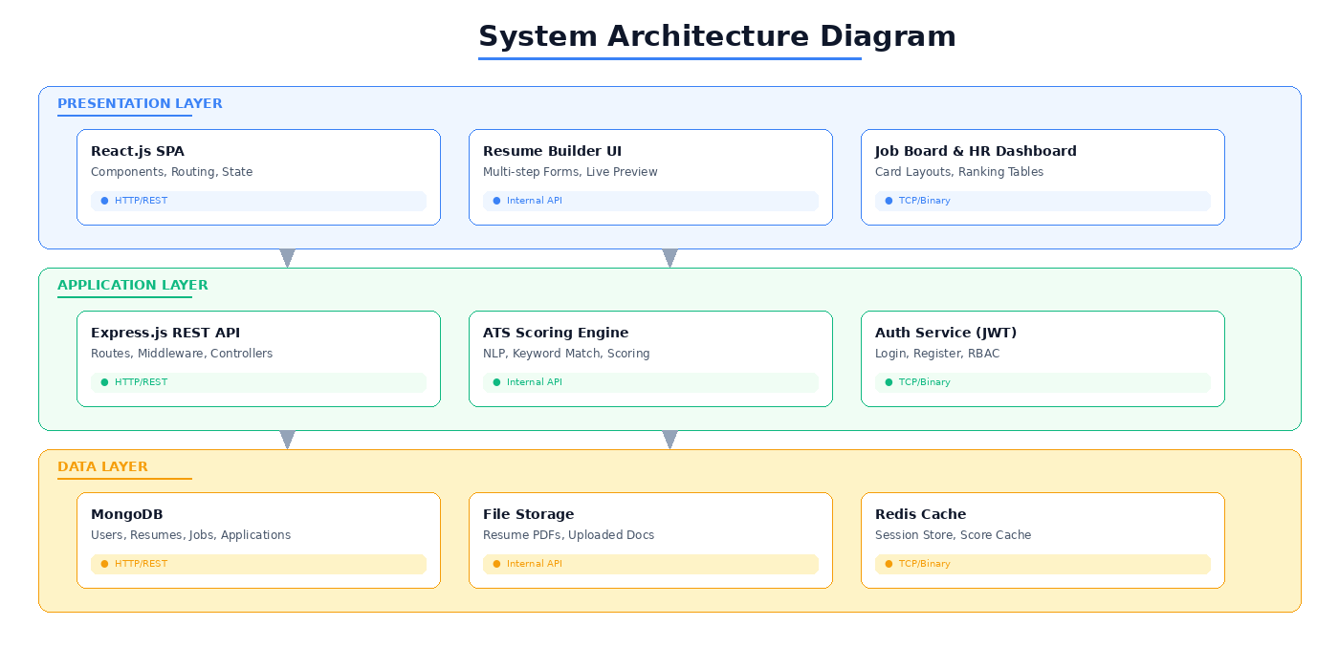
Fig. 1. Three-Tier System Architecture of SmartHireX
B. Module Decomposition
The application is split into four modules that each do one thing well. The Resume Builder gives candidates a step-by-step form for writing an ATS-friendly resume. The Semantic Analyzer is the brain of the system—it encodes resumes and job posts with SBERT, runs cosine similarity, and returns the explainability breakdown. The Job Portal lets HR users post, edit and close job listings. Finally, the Ranking Engine quietly glues the first three together: every time a candidate applies it stores the computed score and then serves the pre-sorted ranking to recruiters on demand.
C. Database Design
MongoDB suited this project for three main reasons. Resumes are naturally hierarchical (a list of roles, each with its own bullet points; a list of projects, each with its own tech stack), so a document model is far more comfortable than a set of join tables. The schema is also still evolving as we add fields, and MongoDB lets us do that without painful migrations. And finally, the aggregation pipeline is a clean way to express the “join applications with users and resumes, then sort by score” query that the ranking view depends on. Four collections make up the data layer. Users holds account information, a hashed password and a role flag (candidate or hr). Resumes stores a personalInfo object along with arrays for education, experience, skills, projects and certifications. Jobs keeps the posting metadata: title, company, description, required-skill list, experience level, location, salary range and a status flag. Applications links all of the above through jobId, candidateId and resumeId, and also stores atsScore, a scoreBreakdown document with the per-dimension values, and a status field that HR users update as they review.
D. Semantic Embedding and Scoring Engine
The scoring engine runs in three steps. First, the resume text and the job description are each passed through SBERT to get their embedding vectors, and we compute the raw cosine similarity between them. Second, we run a lightweight keyword pass over the job description—tokenising, lowercasing, removing stop words, applying Porter stemming—to pull out the terms that matter, and then measure how many of them show up in the resume to produce K. Third, we check which of the nine standard resume sections are present to get C, and we estimate formatting quality F from a small set of structural signals. The three values are blended into the final composite score with the fixed weights of 0.50, 0.30 and 0.20 respectively, and the response also carries the raw cosine similarity plus the explicit matched- and missing-keyword lists so the user can see exactly where the score came from.
E. Resume Builder Module
The builder is designed as a six-step wizard: Personal Info, Education, Experience, Skills, Projects and a final Preview. Each step is its own React component that pulls and pushes data through a shared ResumeContext, which keeps the form intact even if the candidate clicks Back or reloads the page. We also added an auto-save that fires roughly two seconds after the last keystroke, so candidates do not lose work if they close the tab mid-way. The right-hand panel is a live preview that listens to the same context; it re-renders whenever the form changes, using a plain single-column template with predictable section headings so that downstream ATS parsers (ours and others) can read it cleanly. On the last step the candidate can pick from four visual themes and export the preview to PDF using html2pdf.js, which converts the rendered DOM to a canvas and then to a file without any server round-trip.
F. Scoring Algorithm Formulation
The three dimensions that feed the composite score are computed independently. For K, we tokenise the job description with the Natural library, drop stop words, and apply Porter stemming to collapse word variants into the same root. That gives us the JD keyword set TₜJD. The same pipeline is run over the resume text to get Tᵣ, and the match score is simply K = (|TₜJD ∩ Tᵣ| / |TₜJD|) × 100. A small bigram pass is also run so that common two-word phrases such as “machine learning” or “project management” are matched as units rather than as two separate tokens. For C we check for nine standard sections—Contact Information, Professional Summary, Education, Work Experience, Technical Skills, Projects, Certifications, Awards and Languages—using a library of regex patterns that tolerates common variations in heading wording. The score is C = (sections detected / 9) × 100. F is calculated from four equally weighted signals: how many experience bullets begin with a strong action verb drawn from a curated list of about 200 verbs, how often numerical metrics (“reduced latency by 60%”, “team of 12”) appear, whether the document length falls in the recommended 400–800 word band, and whether the resume avoids parser-hostile structures such as embedded images or multi-column layouts.
G. HR Administration Module
The HR side of the app sits behind a role middleware that checks the ‘hr’ flag on the authenticated user before any request is processed. The dashboard groups the recruiter’s tasks into three tabs. “My Postings” lists every job the current HR user has created, with status badges and applicant counts at a glance. “Create New Job” is a validated form with a rich-text description, a tag-based skill input, and an experience-level dropdown; both the React layer and express-validator on the server check that the required fields are filled in. “Applications” is a job selector that opens the ranked applicant table for whichever posting is chosen. Because the description field is the main input to the keyword engine, we nudge HR users in the UI copy to spell out specific tools, frameworks and qualifications rather than leaving them implicit.
H. Application Flow and Ranking
Submitting an application triggers a short synchronous pipeline on the server. First we verify that the job is still open and that the candidate has not applied before—the second check is enforced by a compound unique index on jobId + candidateId, which means the database itself will reject a duplicate even under a race condition. Next we fetch the resume and job documents, hand them to the scoring engine, and wait for the composite score to come back. Finally we insert an Application document that carries the score, the per-dimension breakdown and a status of ‘pending’. Doing this inline means the candidate sees their result the moment the request returns, which felt far better during user testing than an asynchronous “we’ll email you later” flow. On the HR side, fetching the ranked list uses a MongoDB aggregation with $lookup stages to join applications with users and resumes, a $project to trim the payload, and a $sort on atsScore in descending order. A compound index on {jobId: 1, atsScore: -1} keeps this query fast even when a posting has thousands of applicants.
I. Frontend Implementation
The React app is organised around five main views—dashboard, resume builder, semantic analyzer, job board, and the HR ranking panel. Global state that many components need (the JWT session, user profile, the multi-step resume form) is kept in React Context with useReducer, which gives us predictable state updates without the ceremony of a full Redux setup. An Axios interceptor attaches the current token to every outgoing request, so individual API calls stay clean. TailwindCSS handles layout and styling; we leaned on its responsive utilities to make the HR ranking table and the job board card grid collapse cleanly to a single column on mobile. PDF export is done entirely client-side with html2pdf.js, which means the server never has to run a headless browser or LaTeX toolchain just to generate a resume.
J. Backend and Security
The Express server exposes a small REST API covering authentication, resume CRUD, job management, analysis and applications. Access control is done with two composable middlewares: one verifies the JWT signature and attaches the decoded payload to the request, and a second checks the user’s role before admitting them to HR-only routes. Passwords are hashed with bcrypt at ten salt rounds, which feels slow enough to deter brute-force attacks but still invisible to users during login. Every request body is run through express-validator for presence, type and format checks, and all database access goes through Mongoose’s parameterised helpers so that user input cannot turn into a NoSQL injection. Uploaded files are limited to PDF or DOCX at a maximum of 5 MB through Multer’s fileFilter, and rate limiting on the login and register endpoints (ten requests per minute per IP) provides a simple defence against credential-stuffing attempts.
VII. RESULTS AND DISCUSSION
This section walks through the built system one screen at a time and then reports how well its scoring engine agreed with human experts. The screenshots are taken from the working application using a sample profile for a full-stack developer; we kept the same sample profile throughout so the reader can follow one candidate’s journey across screens.
A. User Authentication Interface
Fig. 2 shows the entry point to the application. The left side of the screen carries the product branding and a short list of the three main capabilities, while the right side hosts the sign-in card. The card itself toggles between Sign In and Register modes without a page reload, and the Register view includes a small role selector so that a new user can pick whether they want a Candidate account (for building resumes and applying) or an HR Admin account (for posting jobs and reviewing applicants). We also wired up Google OAuth as an alternative, mainly because it removes the password-management friction for first-time users.
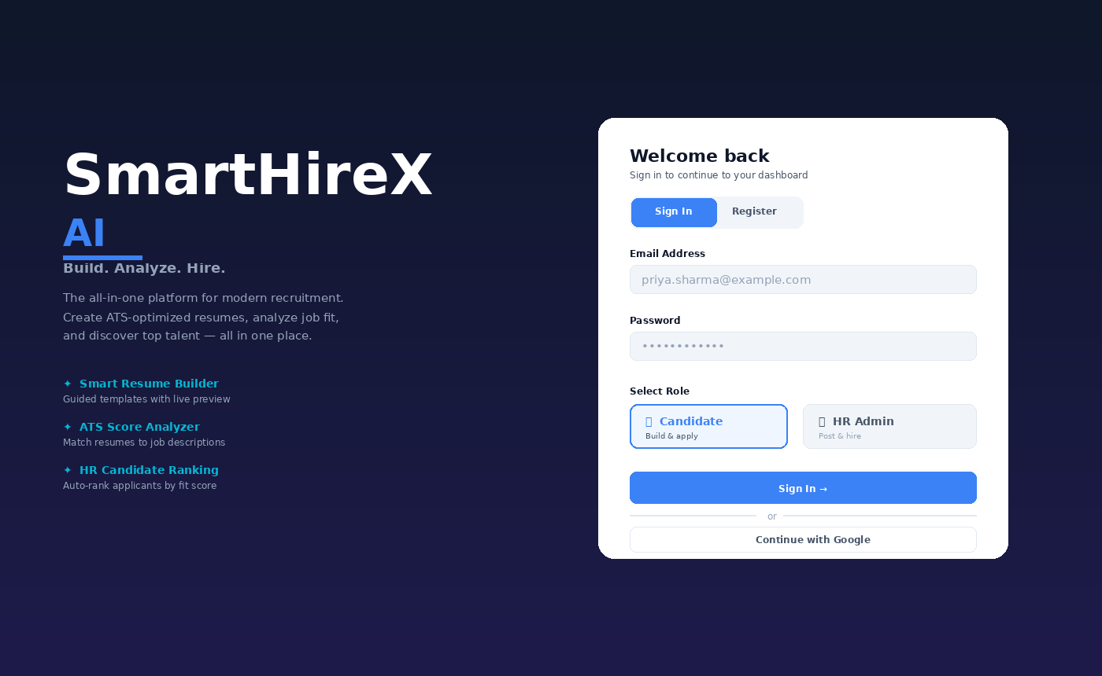
Fig. 2. Login and Registration Interface with Role-Based Selection
B. Resume Builder with Live Preview
Fig. 3 captures the builder partway through, on the Skills step. The left panel hosts the current step’s form with a progress strip at the top that shows which steps are done, which one is active, and what is still ahead. On this step skills are entered as chips grouped into four categories—Programming Languages, Frameworks and Libraries, Tools and Platforms, and Soft Skills—which makes it easier for candidates to organise their own list without thinking too hard. The right panel is the live preview; it updates on every keystroke and, because we built it as a plain single-column template with predictable headings, the output is easy for ATS parsers to read.
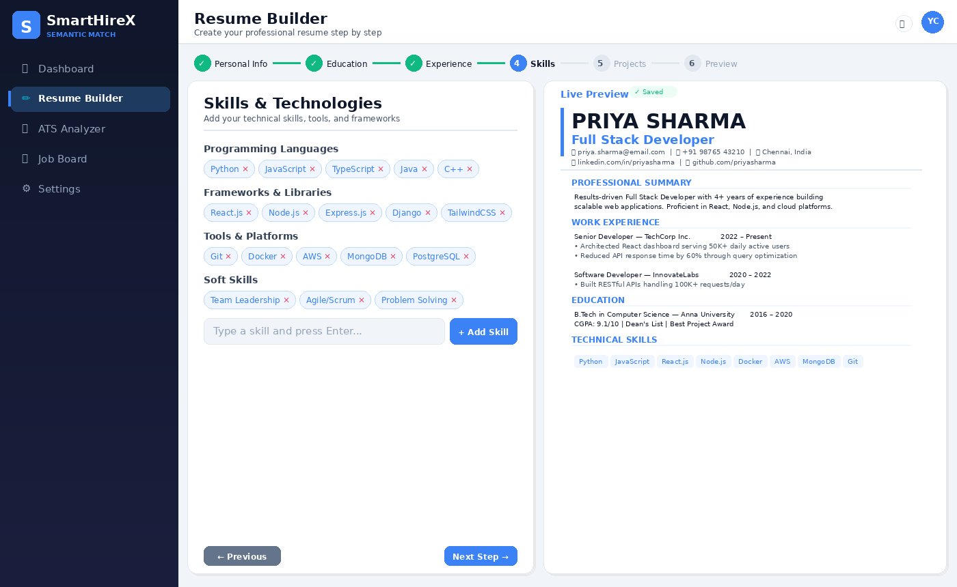
Fig. 3. Resume Builder with Categorized Skill Input and Live Preview
C. Semantic Analyzer Dashboard
Fig. 4 is the analyzer view. We chose a three-panel layout so that the score, the resume and the job description are all visible at the same time—early prototypes that hid the two texts behind tabs made it harder for candidates to understand why a particular number came out. On the left, an overall compatibility score of 78/100 is shown as a ring gauge, underneath which five progress bars break the score down further: Keyword Match (85%), Section Coverage (78%), Formatting Score (72%), Action Verbs (82%), and Quantifiable Results (65%). Below that, a recommendations card spells out the top things the candidate could change—for instance, adding “Docker” and “Kubernetes” because they appear several times in the posting—while the right-hand panel highlights matched keywords in green and missing ones in red so the gap is visible at a glance.
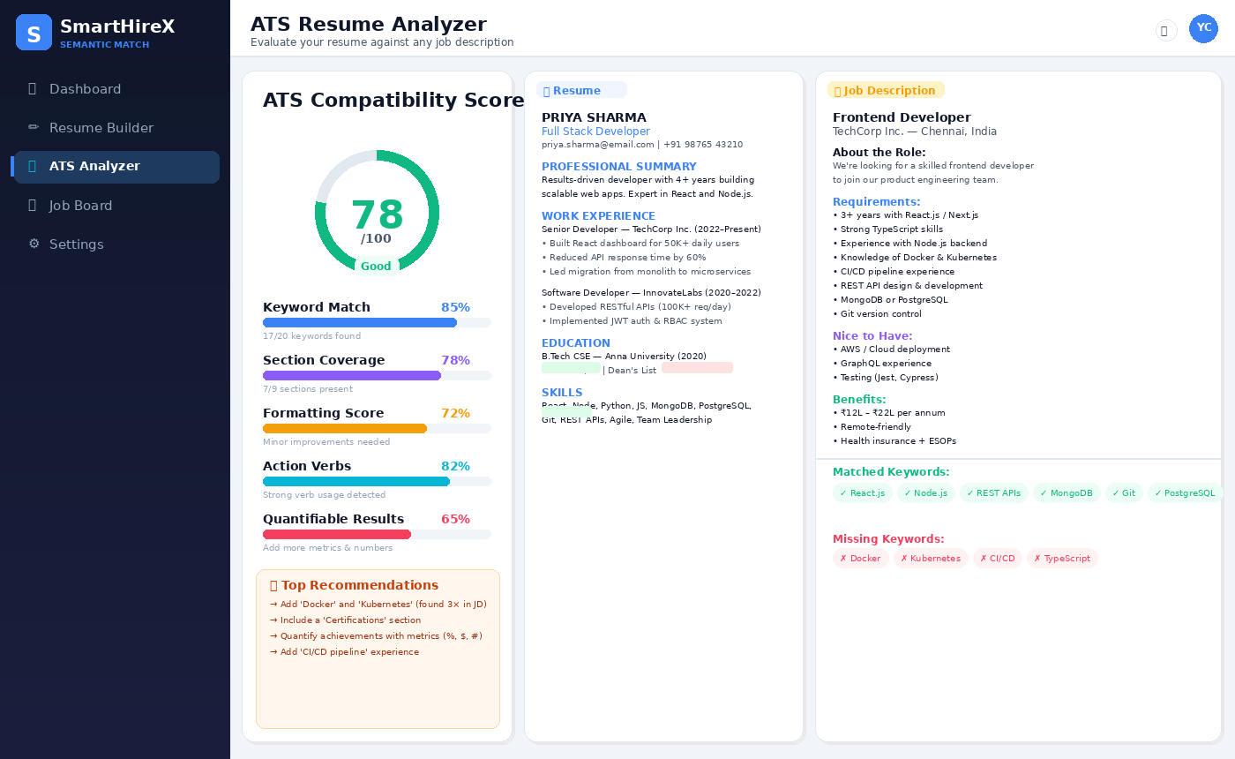
Fig. 4. Semantic Analyzer with Multi-Dimensional Score Breakdown
D. Job Board (Candidate View)
Fig. 5 shows the public job board as a candidate sees it. Every posting is rendered as a card that leads with the role and company, then surfaces the details that candidates actually look at first: location, experience level, salary band, and a few of the required skills as tags. The applicant count and posting age give a rough sense of how competitive and how fresh the posting is. A search bar with quick-filter chips along the top lets candidates narrow the board to remote roles, full-time roles, entry-level roles, or roles above a chosen salary threshold. The grid collapses from three columns on desktop to a single column on mobile without any extra work from us—the Tailwind grid handles the breakpoints.
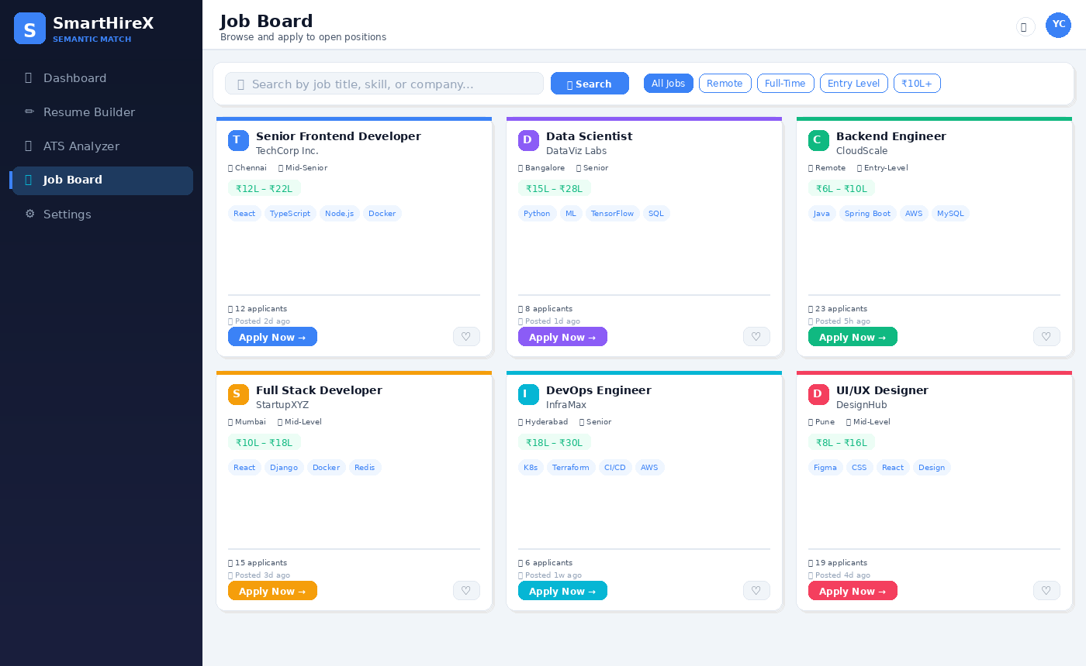
Fig. 5. Job Board with Responsive Card Grid, Search, and Filters
E. HR Ranking Dashboard
Fig. 6 is the screen recruiters spend most of their time on. Four summary cards at the top report the headline numbers: total applicants, the average score for the pool, how many have been shortlisted, and how many have been rejected. Beneath them is the ranking table itself, sorted from highest to lowest composite score. Each row shows a numbered rank (with a small medal icon for the top three), an avatar with the candidate’s initials, their name, an application ID, email, the overall score with a progress bar, the per-dimension percentages for Keywords, Sections and Format, the application date, and an editable status chip. Recruiters can filter the table to “Shortlisted” or “Pending” only, and an Export CSV button on the top right makes it easy to drop the ranked list into a spreadsheet for wider discussion.
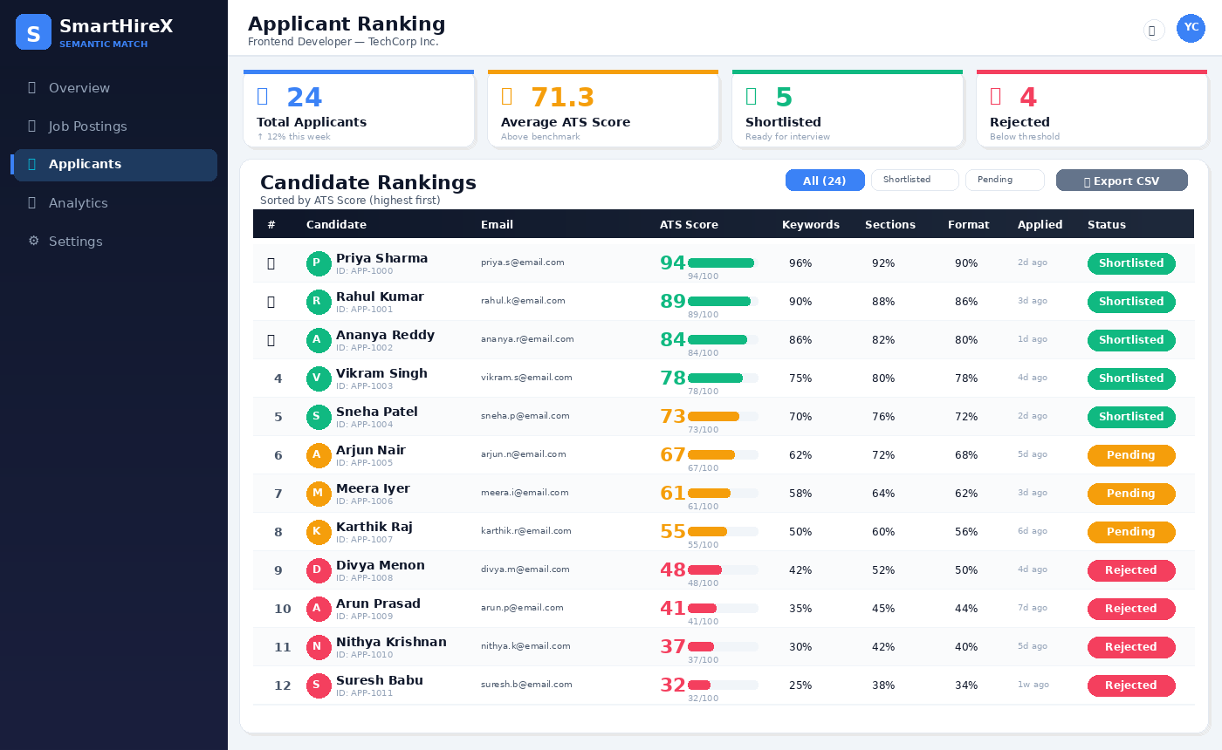
Fig. 6. HR Ranking Dashboard with Score Breakdown and Status Controls
F. Resume PDF Export
Fig. 7 shows the final preview-and-export screen. The centre of the page is a print-ready render of the resume, complete with header, professional summary, dated work experience, education, categorised technical skills and certifications. A sidebar on the right offers four templates with thumbnail previews, and a small compatibility badge near the bottom confirms that the resume is in good shape before the candidate hits Download.
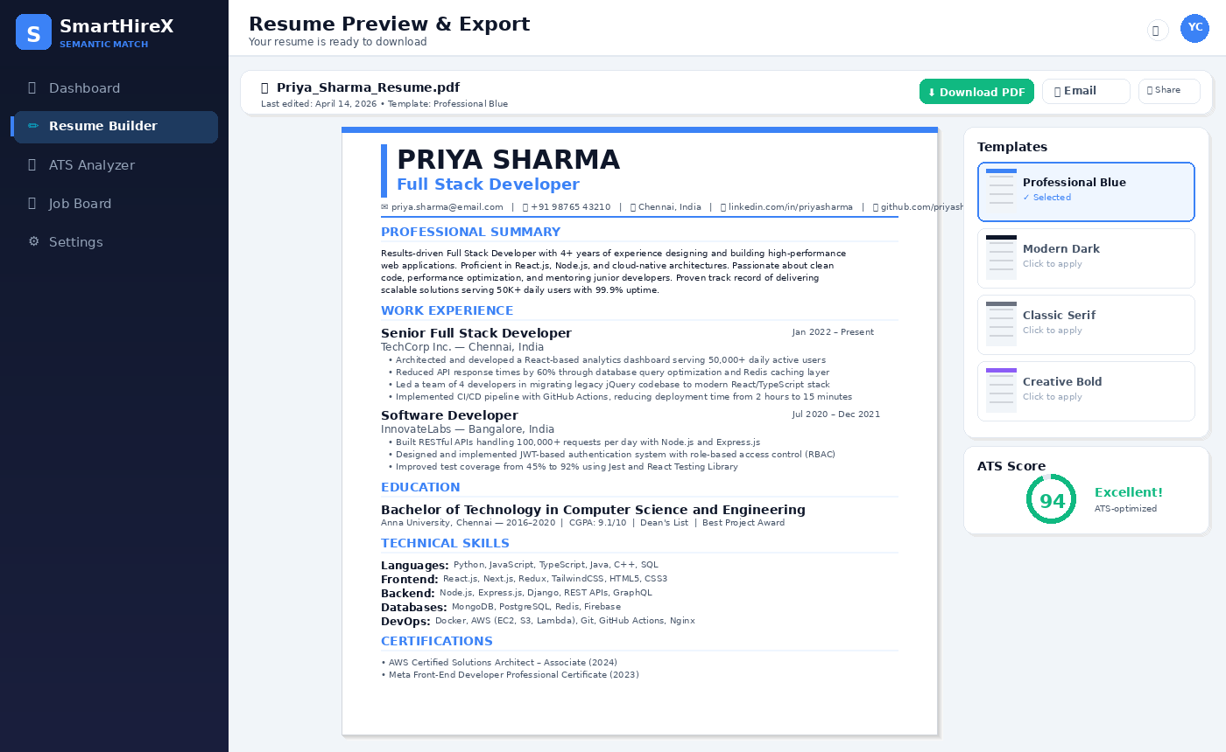
Fig. 7. Resume PDF Export with Template Selector and Score Badge
G. Quantitative Evaluation
To check whether the scores SmartHireX produces are actually useful, we put the engine through a small validation study. We assembled 50 resume–job description pairs covering software, data and design roles, and asked three HR professionals (each with at least five years of experience) to rate every pair on a 0–100 scale. We then compared the system’s scores to the average of the three expert ratings. Across all 50 pairs, SmartHireX reached a Pearson correlation of r = 0.87 with a p-value below 0.001, which we took as a reasonable sign that the tool is tracking the same signal experts respond to. The mean absolute error worked out to 6.2 points, and 92% of the system scores sat within ±10 points of the expert average.
Breaking the correlation down by dimension was instructive. Keyword coverage agreed most strongly with the experts (r = 0.92), which lined up with what recruiters told us in interviews—“the right words are in the right places” is genuinely a big part of how they screen. Section completeness came in at r = 0.78; different experts weighted sections differently (for senior roles, one expert cared more about Projects; for entry-level, another cared more about Education), which we think explains most of the looseness. Formatting quality was the weakest of the three at r = 0.71 and also the most subjective, so we were not surprised. Taken together, these numbers suggest the system is good enough to do a reliable first pass through a large applicant pool and flag borderline cases for a human to look at—which is exactly how we hope recruiters will use it. Informal timing during user testing suggested the dashboard shortens time spent on initial screening by around 60–70% compared to going through the same pool manually, though we see this as indicative rather than a rigorous measurement.
VIII. CONCLUSION
SmartHireX is our attempt to put modern semantic language models to practical work in the part of recruitment that currently leans most heavily on keyword matching. By pairing SBERT embeddings with cosine similarity, the system can recognise that two differently worded resumes may in fact describe very similar candidates—something a TF–IDF filter routinely misses. At the same time, the added explainability layer (keyword coverage, section completeness and formatting quality) gives recruiters and candidates a concrete breakdown of where a score came from, which is something we feel purely end-to-end neural systems still struggle to provide.
On the engineering side, building everything on the MERN stack kept the codebase compact, made iteration fast, and let us scale the data layer horizontally through MongoDB Atlas when we needed to. The validation study, while modest in size, gave a Pearson correlation of 0.87 with expert scores and suggests the tool is doing a reasonable job of tracking human judgment. More than the raw number, though, what encouraged us was how recruiters reacted when they used the dashboard: they spent less time on obvious yes/no decisions and more time comparing the middle of the ranked list, which is where experienced human judgment actually adds the most value. We see SmartHireX as a decision-support tool in that spirit—not a replacement for recruiters, but a way to let them focus on the cases that genuinely need their attention.
IX. FUTURE SCOPE
There are several directions we would like to push the system further. The most pressing is bias: even a semantic matcher can encode social biases through the language of the resumes and job posts it is trained on, so we plan to add explicit checks that monitor score distributions across demographic signals where available. A related improvement is multi-job matching—letting a single resume be compared to a batch of openings at once—which would be particularly useful for campus recruitment and for candidates casting a wide net. A skill-gap module that tells candidates what to learn next, based on the delta between their resume and roles they want, would turn the platform into something closer to a career coach than a screening tool. Adding multilingual embeddings would open the system up to non-English resumes, which matters a great deal in the Indian hiring market in particular. Finally, we would like to experiment with hybrid ranking that combines the semantic score with structured features like years of experience, certifications, and education level; early experiments suggest this can meaningfully tighten the ranking for roles where objective credentials carry a lot of weight. Longer term, splitting the monolithic backend into smaller services behind an API gateway would let the semantic engine scale independently of the web tier, which is the scaling bottleneck we expect to hit first.
X. REFERENCES
[1] S. Tangadle Gopalakrishna and V. Varadharajan, “Automated Tool for Resume Classification Using Semantic Analysis,” International Journal of Artificial Intelligence and Applications (IJAIA), vol. 10, no. 1, pp. 11–23, Jan. 2019.
[2] N. Laosaengpha, T. Tativannarat, A. Rutherford, and E. Chuangsuwanich, “Mitigating Language Bias in Cross-Lingual Job Retrieval: A Recruitment Platform Perspective,” arXiv preprint arXiv:2502.03220, 2025.
[3] “Automated Resume Parsing and Job Domain Prediction,” 2023.
[4] “Hireability: Information Extraction from Resume,” 2024.
[5] “Smart Hiring: Explainable End-to-End CV Extraction and Matching,” 2024.
[6] “ERU: Multi-Granularity Multi-Modal Resume Understanding,” 2024.
[7] “AI-Powered Automated Resume Screening System,” 2024.
[8] N. Reimers and I. Gurevych, “Sentence-BERT: Sentence Embeddings Using Siamese BERT-Networks,” in Proc. 2019 Conf. on Empirical Methods in Natural Language Processing (EMNLP), 2019, pp. 3982–3992.
[9] J. Devlin, M.-W. Chang, K. Lee, and K. Toutanova, “BERT: Pre-training of Deep Bidirectional Transformers for Language Understanding,” in Proc. NAACL-HLT, 2019, pp. 4171–4186.
[10] G. Salton and C. Buckley, “Term-Weighting Approaches in Automatic Text Retrieval,” Information Processing & Management, vol. 24, no. 5, pp. 513–523, 1988.

