

本科实验报告

课程名称： | 数字逻辑设计
姓 名： | 封和易
学 院： | 竺可桢学院
系： | 混合班
专 业： | 计算机科学与技术
学 号： | 3250104494
指导教师： | 马德

2026年 5 月 6 日

浙江大学实验报告

课程名称： 数字逻辑设计 实验类型： 模拟电路实验
实验项目名称： 同步时序电路设计
学生姓名： 封和易 专业： 计算机科学与技术 学号： 3250104494
同组学生姓名： 宋雨恒、张旭 指导老师： 马德
实验地点： 紫金港东4-509 实验日期： 2026 年 5 月 6 日

实验目的：
- 掌握典型同步时序电路的工作原理和设计方法
- 掌握时序电路的激励函数、状态图、状态方程的运用
- 掌握用Verilog进行有限状态机的设计、调试、仿真
- 掌握用FPGA实现时序电路功能

子实验1：原理图方式设计4位同步二进制计数器
操作方法与实验步骤
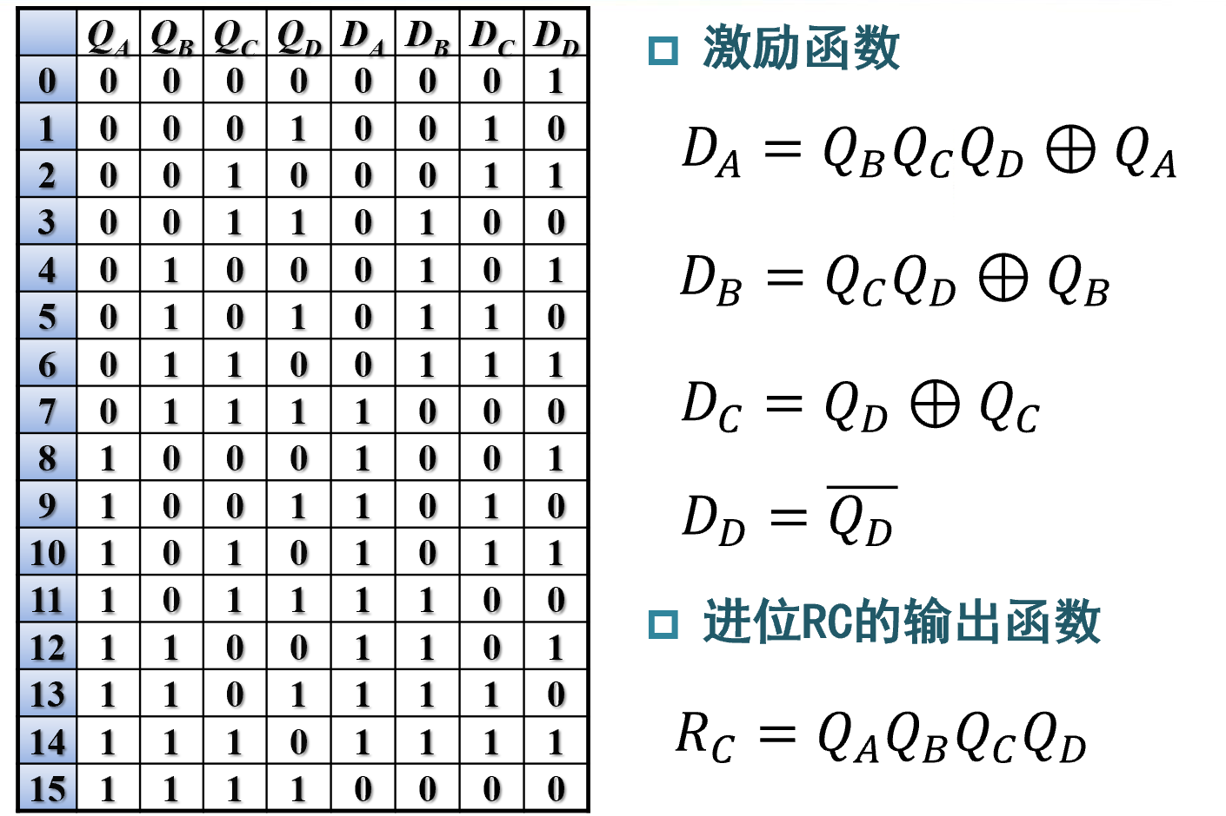

实验数据记录和处理
Logisim实现电路图如下：
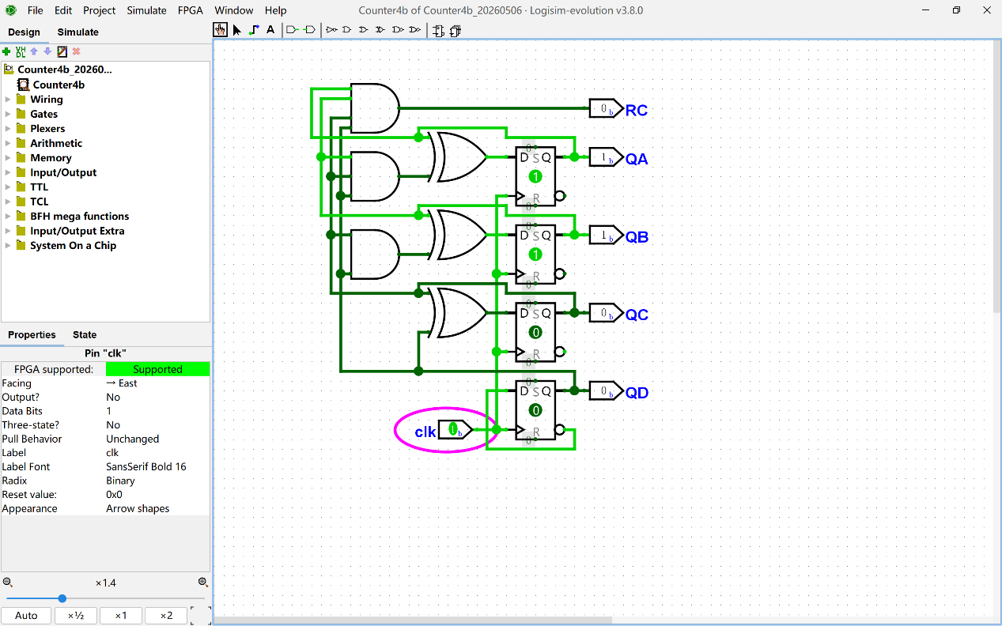
Main代码如下：
top.v
`timescale 1ns / 1ps

module top #(
parameter CNT_1S_MAX = 32'd49_999_999
)(
input wire clk,
output wire [3:0] AN,
output wire [7:0] SEGMENT,
output wire [0:0] LED
);

wire clk_1s;

wire QA;
wire QB;
wire QC;
wire QD;
wire RC;

wire [3:0] cnt4;

counter_1s #(
.CNT_MAX(CNT_1S_MAX)
) u_counter_1s (
.clk(clk),
.clk_1s(clk_1s)
);

Counter4b u_counter4b (
.QA(QA),
.QB(QB),
.QC(QC),
.QD(QD),
.RC(RC),
.clk(clk_1s)
);

assign cnt4 = {QA, QB, QC, QD};

DispNum u_disp (
.Hex(cnt4),
.AN(AN),
.SEGMENT(SEGMENT)
);

assign LED[0] = RC;

endmodule
counter_1s.v
`timescale 1ns / 1ps

module counter_1s #(
parameter CNT_MAX = 32'd49_999_999
)(
input wire clk,
output reg clk_1s
);

reg [31:0] cnt;

initial begin
cnt = 32'd0;
clk_1s = 1'b0;
end

always @(posedge clk) begin
if (cnt == CNT_MAX) begin
cnt <= 32'd0;
clk_1s <= ~clk_1s;
end
else begin
cnt <= cnt + 1'b1;
end
end

endmodule
DispNum.v
`timescale 1ns / 1ps

module DispNum(
input wire [3:0] Hex,
output wire [3:0] AN,
output wire [7:0] SEGMENT
);

assign AN = 4'b1110; // only the lowest digit is enabled
assign SEGMENT = seg7(Hex); // SEGMENT[7:0] = {p,g,f,e,d,c,b,a}

function [7:0] seg7;
input [3:0] x;
begin
case (x)
4'h0: seg7 = 8'b11000000;
4'h1: seg7 = 8'b11111001;
4'h2: seg7 = 8'b10100100;
4'h3: seg7 = 8'b10110000;
4'h4: seg7 = 8'b10011001;
4'h5: seg7 = 8'b10010010;
4'h6: seg7 = 8'b10000010;
4'h7: seg7 = 8'b11111000;
4'h8: seg7 = 8'b10000000;
4'h9: seg7 = 8'b10010000;
4'hA: seg7 = 8'b10001000;
4'hB: seg7 = 8'b10000011;
4'hC: seg7 = 8'b11000110;
4'hD: seg7 = 8'b10100001;
4'hE: seg7 = 8'b10000110;
4'hF: seg7 = 8'b10001110;
default: seg7 = 8'b11111111;
endcase
end
endfunction

endmodule
Counter4b.v
/******************************************************************************
** Logisim-evolution goes FPGA automatic generated Verilog code **
** https://github.com/logisim-evolution/ **
** **
** Component : Counter4b **
** **
*****************************************************************************/

module Counter4b( QA,
QB,
QC,
QD,
RC,
clk );

/*******************************************************************************
** The inputs are defined here **
*******************************************************************************/
input clk;

/*******************************************************************************
** The outputs are defined here **
*******************************************************************************/
output QA;
output QB;
output QC;
output QD;
output RC;

/*******************************************************************************
** The wires are defined here **
*******************************************************************************/
wire s_logisimNet0;
wire s_logisimNet1;
wire s_logisimNet10;
wire s_logisimNet11;
wire s_logisimNet12;
wire s_logisimNet13;
wire s_logisimNet14;
wire s_logisimNet15;
wire s_logisimNet16;
wire s_logisimNet17;
wire s_logisimNet18;
wire s_logisimNet19;
wire s_logisimNet2;
wire s_logisimNet3;
wire s_logisimNet4;
wire s_logisimNet5;
wire s_logisimNet6;
wire s_logisimNet7;
wire s_logisimNet8;
wire s_logisimNet9;

/*******************************************************************************
** The module functionality is described here **
*******************************************************************************/

/*******************************************************************************
** Here all input connections are defined **
*******************************************************************************/
assign s_logisimNet5 = clk;

/*******************************************************************************
** Here all output connections are defined **
*******************************************************************************/
assign QA = s_logisimNet3;
assign QB = s_logisimNet1;
assign QC = s_logisimNet2;
assign QD = s_logisimNet4;
assign RC = s_logisimNet0;

/*******************************************************************************
** Here all in-lined components are defined **
*******************************************************************************/

// Constant
assign s_logisimNet13 = 1'b0;

// Constant
assign s_logisimNet12 = 1'b0;

// Constant
assign s_logisimNet15 = 1'b0;

// Constant
assign s_logisimNet14 = 1'b0;

// Constant
assign s_logisimNet17 = 1'b0;

// Constant
assign s_logisimNet16 = 1'b0;

// Constant
assign s_logisimNet19 = 1'b0;

// Constant
assign s_logisimNet18 = 1'b0;

/*******************************************************************************
** Here all normal components are defined **
*******************************************************************************/
AND_GATE_3_INPUTS #(.BubblesMask(3'b000))
GATES_1 (.input1(s_logisimNet1),
.input2(s_logisimNet2),
.input3(s_logisimNet4),
.result(s_logisimNet7));

AND_GATE #(.BubblesMask(2'b00))
GATES_2 (.input1(s_logisimNet2),
.input2(s_logisimNet4),
.result(s_logisimNet8));

AND_GATE_4_INPUTS #(.BubblesMask(4'h0))
GATES_3 (.input1(s_logisimNet3),
.input2(s_logisimNet1),
.input3(s_logisimNet2),
.input4(s_logisimNet4),
.result(s_logisimNet0));

XOR_GATE_ONEHOT #(.BubblesMask(2'b00))
GATES_4 (.input1(s_logisimNet3),
.input2(s_logisimNet7),
.result(s_logisimNet9));

XOR_GATE_ONEHOT #(.BubblesMask(2'b00))
GATES_5 (.input1(s_logisimNet1),
.input2(s_logisimNet8),
.result(s_logisimNet10));

XOR_GATE_ONEHOT #(.BubblesMask(2'b00))
GATES_6 (.input1(s_logisimNet2),
.input2(s_logisimNet4),
.result(s_logisimNet11));

D_FLIPFLOP #(.invertClockEnable(0))
MEMORY_7 (.clock(s_logisimNet5),
.d(s_logisimNet9),
.preset(s_logisimNet13),
.q(s_logisimNet3),
.qBar(),
.reset(s_logisimNet12),
.tick(1'b1));

D_FLIPFLOP #(.invertClockEnable(0))
MEMORY_8 (.clock(s_logisimNet5),
.d(s_logisimNet10),
.preset(s_logisimNet15),
.q(s_logisimNet1),
.qBar(),
.reset(s_logisimNet14),
.tick(1'b1));

D_FLIPFLOP #(.invertClockEnable(0))
MEMORY_9 (.clock(s_logisimNet5),
.d(s_logisimNet11),
.preset(s_logisimNet17),
.q(s_logisimNet2),
.qBar(),
.reset(s_logisimNet16),
.tick(1'b1));

D_FLIPFLOP #(.invertClockEnable(0))
MEMORY_10 (.clock(s_logisimNet5),
.d(s_logisimNet6),
.preset(s_logisimNet19),
.q(s_logisimNet4),
.qBar(s_logisimNet6),
.reset(s_logisimNet18),
.tick(1'b1));

endmodule

Simulation Sources：
Counter4b_Test.v
`timescale 1ns / 1ps

module Counter4b_Test;

reg clk;
wire QA, QB, QC, QD, RC;
reg [3:0] exp;
integer i;

Counter4b uut (
.QA(QA),
.QB(QB),
.QC(QC),
.QD(QD),
.RC(RC),
.clk(clk)
);

initial begin
clk = 0;
forever #5 clk = ~clk; // 10ns period
end

initial begin
exp = 4'b0000;

#2;
$display("time\tclk\tQA QB QC QD\tRC");

for (i = 0; i < 20; i = i + 1) begin
@(posedge clk);
#1;

$display("%0t\t%b\t%b %b %b %b\t%b",
$time, clk, QA, QB, QC, QD, RC);

if ({QA, QB, QC, QD} !== exp) begin
$display("ERROR: expected %b, got %b",
exp, {QA, QB, QC, QD});
end

if (RC !== (&exp)) begin
$display("ERROR: RC expected %b, got %b",
(&exp), RC);
end

exp = exp + 1'b1;
end

$finish;
end

endmodule

top_Test.v:
`timescale 1ns / 1ps

module Counter4b_Test;

reg clk;
wire QA, QB, QC, QD, RC;
reg [3:0] exp;
integer i;

Counter4b uut (
.QA(QA),
.QB(QB),
.QC(QC),
.QD(QD),
.RC(RC),
.clk(clk)
);

initial begin
clk = 0;
forever #5 clk = ~clk; // 10ns period
end

initial begin
exp = 4'b0000;

#2;
$display("time\tclk\tQA QB QC QD\tRC");

for (i = 0; i < 20; i = i + 1) begin
@(posedge clk);
#1;

$display("%0t\t%b\t%b %b %b %b\t%b",
$time, clk, QA, QB, QC, QD, RC);

if ({QA, QB, QC, QD} !== exp) begin
$display("ERROR: expected %b, got %b",
exp, {QA, QB, QC, QD});
end

if (RC !== (&exp)) begin
$display("ERROR: RC expected %b, got %b",
(&exp), RC);
end

exp = exp + 1'b1;
end

$finish;
end

endmodule

Running Simulation结果如下：
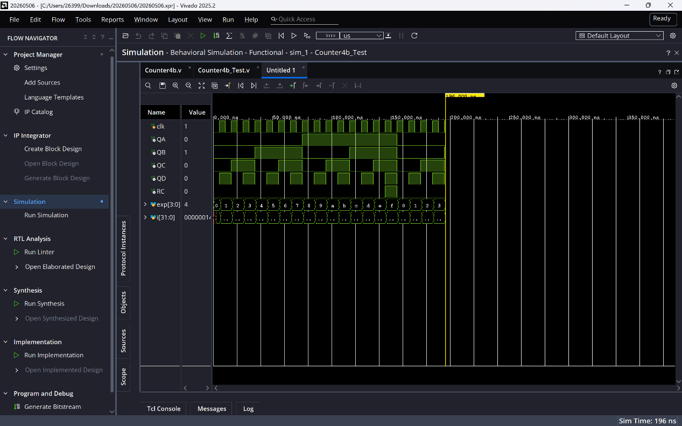
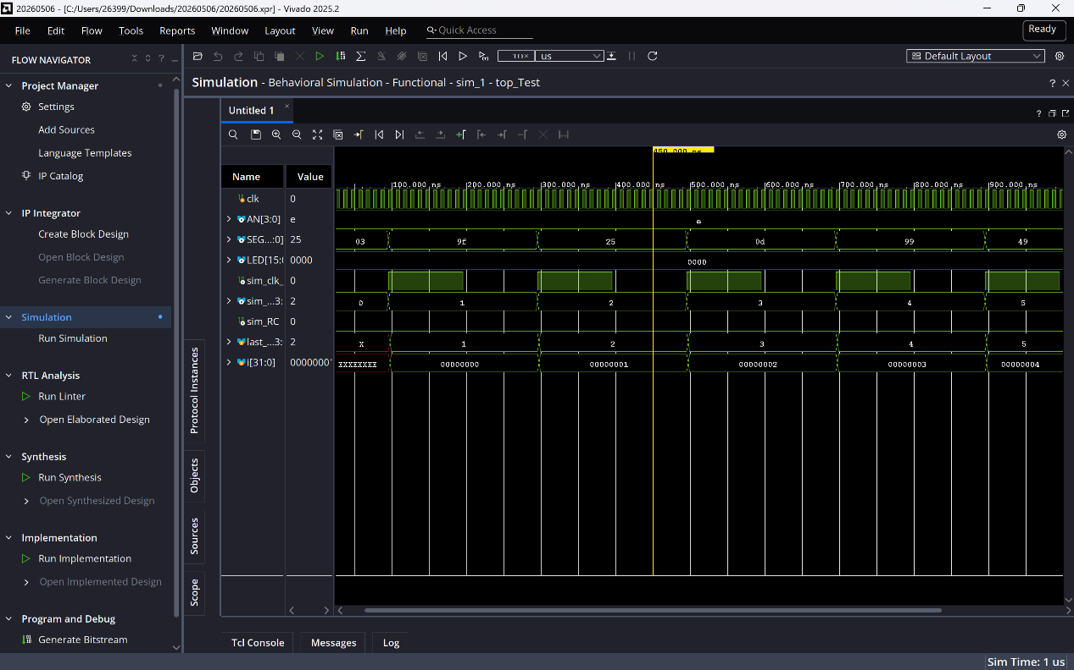
实验结果与分析
- 在 Logisim/Digital 中完成 4 位同步二进制计数器原理图设计，并导出 Counter4b.v，再在 Vivado 中调用该模块完成顶层设计。
- 仿真结果显示，{QA,QB,QC,QD} 按如下顺序变化：
0000 → 0001 → 0010 → ... → 1111 → 0000
说明 4 位同步二进制计数功能正确。
- RC 仅在：
QA QB QC QD = 1111
时为 1，其余状态为 0，说明进位输出逻辑正确。
- counter_1s.v 将 100 MHz 时钟分频为 1 Hz，使计数器每秒自增一次。DispNum.v 将计数值显示在最低位数码管上，AN = 1110，表示只选通最低位。
- 下载到 FPGA 后，数码管能够循环显示：
0 → 1 → 2 → ... → F → 0
且 LED[0] 在计数值为 F 时点亮。仿真结果与硬件现象一致，说明实验 1 设计正确。

子实验2：以行为描述方式设计16位可逆二进制同步计数器
操作方法与实验步骤
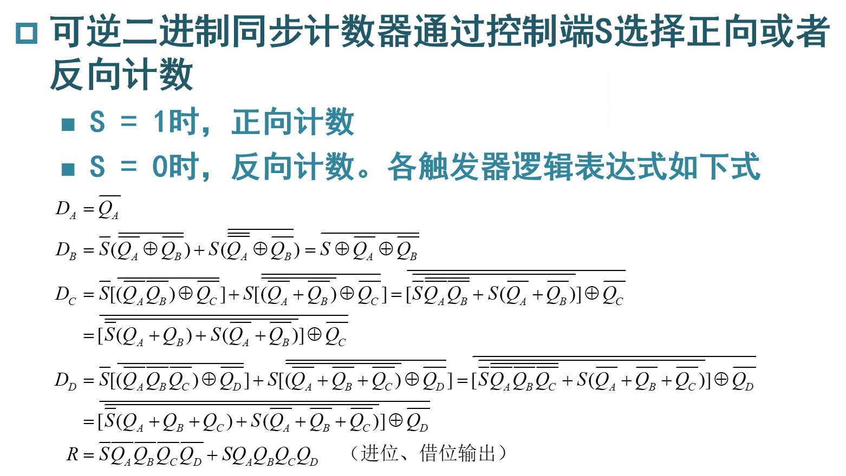
实验数据记录和处理
Main代码如下：
Top.v:
`timescale 1ns / 1ps

module top #(
parameter CLK100MS_MAX = 32'd4_999_999
)(
input wire clk,
input wire [0:0] SW,
output wire [3:0] AN,
output wire [7:0] SEGMENT,
output wire [0:0] LED
);

wire clk_cnt;
wire [15:0] cnt;
wire Rc;

clk_100ms #(
.CNT_MAX(CLK100MS_MAX)
) u_clk_100ms (
.clk(clk),
.clk_out(clk_cnt)
);

RevCounter u_counter (
.clk(clk_cnt),
.s(SW[0]),
.cnt(cnt),
.Rc(Rc)
);

DispNum u_disp (
.clk(clk),
.Hexs(cnt),
.AN(AN),
.SEGMENT(SEGMENT)
);

assign LED[0] = Rc;

endmodule
RevCounter.v:
`timescale 1ns / 1ps

module RevCounter(
input wire clk,
input wire s,
output reg [15:0] cnt,
output wire Rc
);

initial begin
cnt = 16'h0000;
end

assign Rc = (s & (&cnt)) | (~s & (~|cnt));

always @(posedge clk) begin
if (s)
cnt <= cnt + 1'b1;
else
cnt <= cnt - 1'b1;
end

endmodule
clk_100ms.v:
`timescale 1ns / 1ps

module clk_100ms #(
parameter CNT_MAX = 32'd4_999_999
)(
input wire clk,
output reg clk_out
);

reg [31:0] cnt;

initial begin
cnt = 32'd0;
clk_out = 1'b0;
end

always @(posedge clk) begin
if (cnt == CNT_MAX) begin
cnt <= 32'd0;
clk_out <= ~clk_out;
end
else begin
cnt <= cnt + 1'b1;
end
end

endmodule
DispNum.v：
`timescale 1ns / 1ps

module DispNum(
input wire clk,
input wire [15:0] Hexs,
output reg [3:0] AN,
output reg [7:0] SEGMENT
);

reg [17:0] scan_cnt;
wire [1:0] scan_sel;
reg [3:0] hex_now;

initial begin
scan_cnt = 18'd0;
AN = 4'b1110;
SEGMENT = 8'b11111111;
hex_now = 4'h0;
end

always @(posedge clk) begin
scan_cnt <= scan_cnt + 1'b1;
end

assign scan_sel = scan_cnt[17:16];

always @(*) begin
case (scan_sel)
2'b00: begin
AN = 4'b1110;
hex_now = Hexs[3:0];
end
2'b01: begin
AN = 4'b1101;
hex_now = Hexs[7:4];
end
2'b10: begin
AN = 4'b1011;
hex_now = Hexs[11:8];
end
2'b11: begin
AN = 4'b0111;
hex_now = Hexs[15:12];
end
default: begin
AN = 4'b1110;
hex_now = 4'h0;
end
endcase
end

always @(*) begin
case (hex_now)
4'h0: SEGMENT = 8'b11000000;
4'h1: SEGMENT = 8'b11111001;
4'h2: SEGMENT = 8'b10100100;
4'h3: SEGMENT = 8'b10110000;
4'h4: SEGMENT = 8'b10011001;
4'h5: SEGMENT = 8'b10010010;
4'h6: SEGMENT = 8'b10000010;
4'h7: SEGMENT = 8'b11111000;
4'h8: SEGMENT = 8'b10000000;
4'h9: SEGMENT = 8'b10010000;
4'hA: SEGMENT = 8'b10001000;
4'hB: SEGMENT = 8'b10000011;
4'hC: SEGMENT = 8'b11000110;
4'hD: SEGMENT = 8'b10100001;
4'hE: SEGMENT = 8'b10000110;
4'hF: SEGMENT = 8'b10001110;
default: SEGMENT = 8'b11111111;
endcase
end

endmodule

Simulation Sources：
`timescale 1ns / 1ps

module top_Test;

reg clk;
reg [0:0] SW;

wire [3:0] AN;
wire [7:0] SEGMENT;
wire [0:0] LED;

wire sim_clk_cnt;
wire [15:0] sim_cnt;
wire sim_Rc;

integer i;

top #(
.CLK100MS_MAX(32'd4)
) uut (
.clk(clk),
.SW(SW),
.AN(AN),
.SEGMENT(SEGMENT),
.LED(LED)
);

assign sim_clk_cnt = uut.clk_cnt;
assign sim_cnt = uut.cnt;
assign sim_Rc = uut.Rc;

initial begin
clk = 1'b0;
forever #5 clk = ~clk;
end

task show_state;
input [127:0] tag;
begin
$display("%0t %s SW0=%b cnt=%h Rc=%b LED0=%b AN=%b SEGMENT=%b",
$time, tag, SW[0], sim_cnt, sim_Rc, LED[0], AN, SEGMENT);
end
endtask

initial begin
SW[0] = 1'b1;

$display("==== Normal forward counting ====");
for (i = 0; i < 6; i = i + 1) begin
@(posedge sim_clk_cnt);
#1;
show_state("UP_NORMAL");
end

SW[0] = 1'b0;

$display("==== Normal reverse counting ====");
for (i = 0; i < 6; i = i + 1) begin
@(posedge sim_clk_cnt);
#1;
show_state("DOWN_NORMAL");
end

$display("==== Forward carry Rc test ====");
@(negedge sim_clk_cnt);
SW[0] = 1'b1;

force uut.u_counter.cnt = 16'hfffe;
#1;
release uut.u_counter.cnt;

@(posedge sim_clk_cnt);
#1;
show_state("UP_TO_FFFF");

@(posedge sim_clk_cnt);
#1;
show_state("UP_TO_0000");

$display("==== Reverse borrow Rc test ====");
@(negedge sim_clk_cnt);
SW[0] = 1'b0;

force uut.u_counter.cnt = 16'h0001;
#1;
release uut.u_counter.cnt;

@(posedge sim_clk_cnt);
#1;
show_state("DOWN_TO_0000");

@(posedge sim_clk_cnt);
#1;
show_state("DOWN_TO_FFFF");

$finish;
end

endmodule

Constraints：
## ============================================================
## Clock: 100MHz
## ============================================================

create_clock -name clk100MHZ -period 10.0 [get_ports clk]

set_property PACKAGE_PIN AC18 [get_ports clk]
set_property IOSTANDARD LVCMOS18 [get_ports clk]

## ============================================================
## Switch: SW[0]
## SW[0] = 1: count up
## SW[0] = 0: count down
## ============================================================

set_property PACKAGE_PIN AA10 [get_ports {SW[0]}]
set_property IOSTANDARD LVCMOS15 [get_ports {SW[0]}]

## ============================================================
## Seven-segment digit enable: AN[3:0]
## Active low
## ============================================================

set_property PACKAGE_PIN AD21 [get_ports {AN[0]}]
set_property IOSTANDARD LVCMOS33 [get_ports {AN[0]}]

set_property PACKAGE_PIN AC21 [get_ports {AN[1]}]
set_property IOSTANDARD LVCMOS33 [get_ports {AN[1]}]

set_property PACKAGE_PIN AB21 [get_ports {AN[2]}]
set_property IOSTANDARD LVCMOS33 [get_ports {AN[2]}]

set_property PACKAGE_PIN AC22 [get_ports {AN[3]}]
set_property IOSTANDARD LVCMOS33 [get_ports {AN[3]}]

## ============================================================
## Seven-segment segment output
## SEGMENT[0] = a
## SEGMENT[1] = b
## SEGMENT[2] = c
## SEGMENT[3] = d
## SEGMENT[4] = e
## SEGMENT[5] = f
## SEGMENT[6] = g
## SEGMENT[7] = p
## Active low
## ============================================================

set_property PACKAGE_PIN AB22 [get_ports {SEGMENT[0]}]
set_property IOSTANDARD LVCMOS33 [get_ports {SEGMENT[0]}]

set_property PACKAGE_PIN AD24 [get_ports {SEGMENT[1]}]
set_property IOSTANDARD LVCMOS33 [get_ports {SEGMENT[1]}]

set_property PACKAGE_PIN AD23 [get_ports {SEGMENT[2]}]
set_property IOSTANDARD LVCMOS33 [get_ports {SEGMENT[2]}]

set_property PACKAGE_PIN Y21 [get_ports {SEGMENT[3]}]
set_property IOSTANDARD LVCMOS33 [get_ports {SEGMENT[3]}]

set_property PACKAGE_PIN W20 [get_ports {SEGMENT[4]}]
set_property IOSTANDARD LVCMOS33 [get_ports {SEGMENT[4]}]

set_property PACKAGE_PIN AC24 [get_ports {SEGMENT[5]}]
set_property IOSTANDARD LVCMOS33 [get_ports {SEGMENT[5]}]

set_property PACKAGE_PIN AC23 [get_ports {SEGMENT[6]}]
set_property IOSTANDARD LVCMOS33 [get_ports {SEGMENT[6]}]

set_property PACKAGE_PIN AA22 [get_ports {SEGMENT[7]}]
set_property IOSTANDARD LVCMOS33 [get_ports {SEGMENT[7]}]

set_property PACKAGE_PIN W23 [get_ports {LED[0]}]
set_property IOSTANDARD LVCMOS33 [get_ports {LED[0]}]

Running Simulation结果如下：
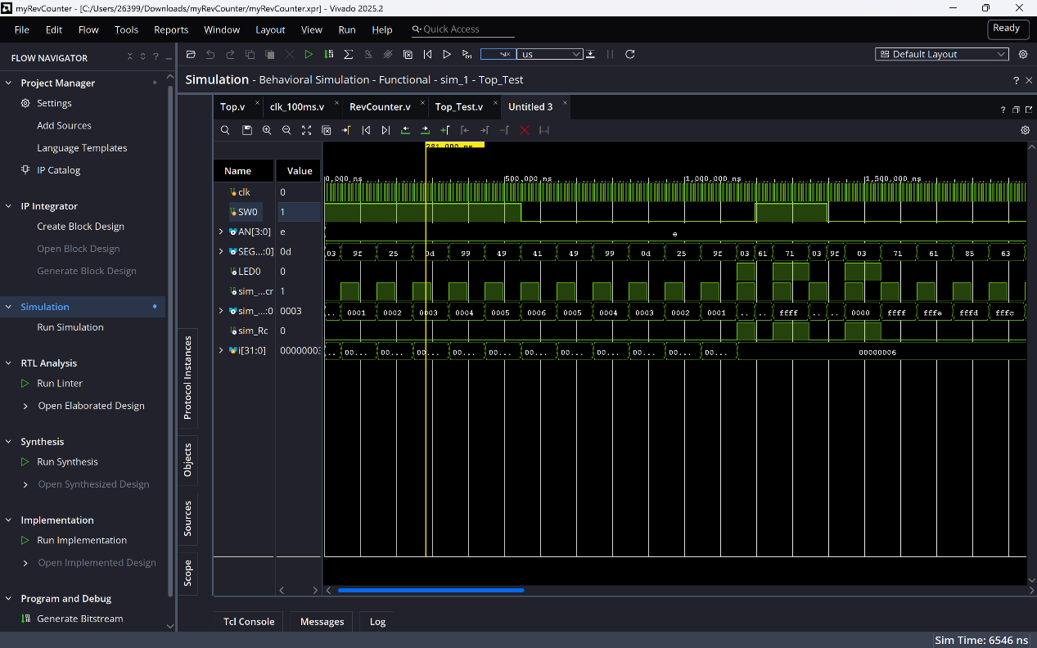

Generate Bitstream后，在Hardware上的表现符合预期：
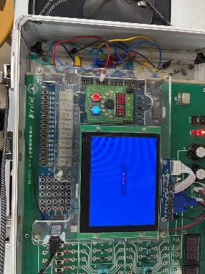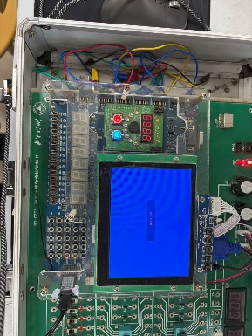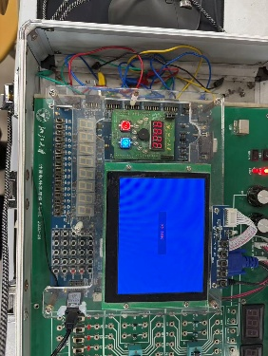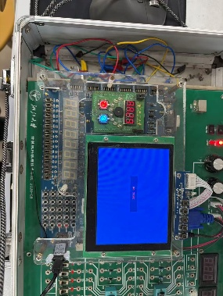

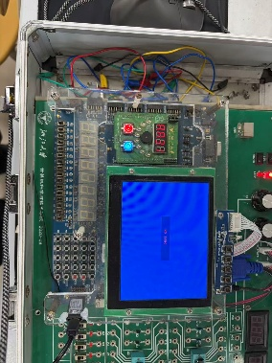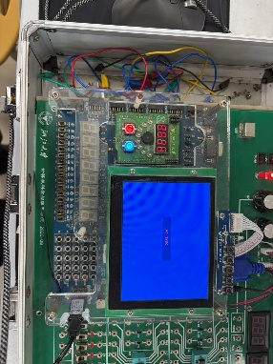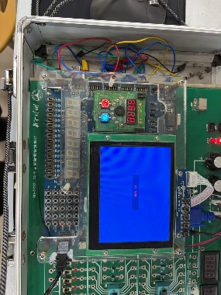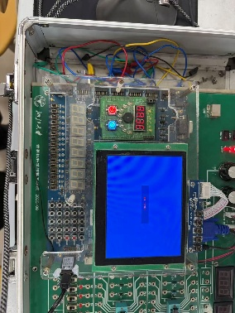

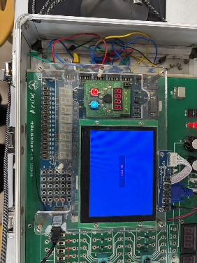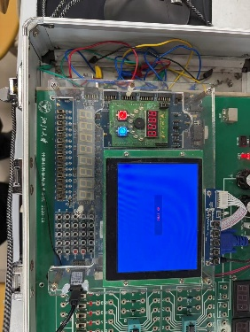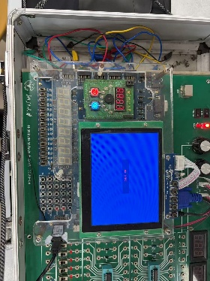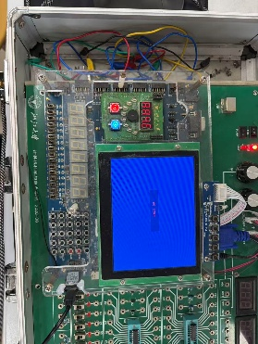

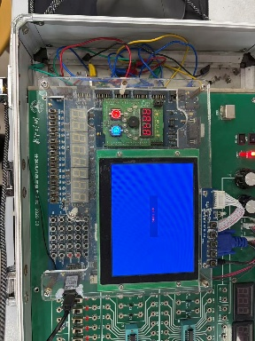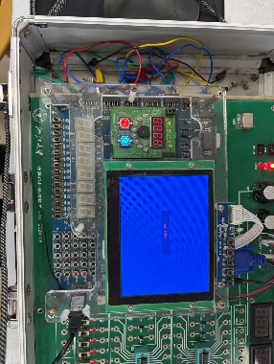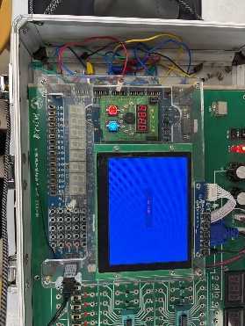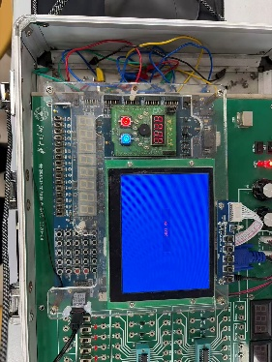

实验结果与分析
- 使用 Verilog 行为描述方式完成 RevCounter.v。SW[0] 控制计数方向：
SW[0] = 1：正向计数
SW[0] = 0：反向计数
- 仿真结果显示，正向计数时：
0000 → 0001 → 0002 → ...
反向计数时：
... → 0002 → 0001 → 0000 → FFFF
说明可逆计数功能正确。
- Rc 的仿真结果满足：
SW[0] = 1 且 cnt = FFFF 时，Rc = 1
SW[0] = 0 且 cnt = 0000 时，Rc = 1
说明正向进位和反向借位判断正确。
- clk_100ms.v 将 100 MHz 时钟分频，使计数器每 0.1 s 改变一次。DispNum.v 将 16 位计数值分为 4 个十六进制位，动态显示在四位数码管上。
- 数码管扫描位选为：
1110 → 1101 → 1011 → 0111
段选采用低电平有效，且 SEGMENT[0]~SEGMENT[7] 分别对应 a,b,c,d,e,f,g,p，与前序实验约束一致。
- 下载到 FPGA 后，拨动 SW[0] 可以切换加计数和减计数；LED[0] 与 Rc 一致，在进位或借位状态点亮。仿真结果与硬件现象一致，说明实验 2 设计正确。

