实验十三 三维对象实验

时间：2022年6月1日

地点：信息学院机房

1、实验内容

使用opengl，书写教材P300页代码，运行GLUT二次曲面程序。

2、实验目的

采用opengl生成二次曲面对象

3、实验代码

#include <GL/glut.h>

#include <windows.h>

GLsizei winWidth = 500, winHeight = 500; // Initial display-window size.

void init (void)

{

glClearColor (1.0, 1.0, 1.0, 0.0); // Set display-window color.

}

void wireQuadSurfs (void)

{

glClear (GL_COLOR_BUFFER_BIT); // Clear display window.

glColor3f (0.0, 0.0, 1.0); // Set line-color to blue.

/* Set viewing parameters with world z axis as view-up direction. */

gluLookAt (2.0, 2.0, 2.0, 0.0, 0.0, 0.0, 0.0, 0.0, 1.0);

/* Position and display GLUT wire-frame sphere. */

glPushMatrix ( );

glTranslatef (1.0, 1.0, 0.0);

glutWireSphere (0.75, 8, 6);

glPopMatrix ( );

/* Position and display GLUT wire-frame cone. */

glPushMatrix ( );

glTranslatef (1.0, -0.5, 0.5);

glutWireCone (0.7, 2.0, 7, 6);

glPopMatrix ( );

/* Position and display GLU wire-frame cylinder. */

GLUquadricObj *cylinder; // Set name for GLU quadric object.

glPushMatrix ( );

glTranslatef (0.0, 1.2, 0.8);

cylinder = gluNewQuadric ( );

gluQuadricDrawStyle (cylinder, GLU_LINE);

gluCylinder (cylinder, 0.6, 0.6, 1.5, 6, 4);

glPopMatrix ( );

glFlush ( );

}

void winReshapeFcn (GLint newWidth, GLint newHeight)

{

glViewport (0, 0, newWidth, newHeight);

glMatrixMode (GL_PROJECTION);

glOrtho (-2.0, 2.0, -2.0, 2.0, 0.0, 5.0);

glMatrixMode (GL_MODELVIEW);

glClear (GL_COLOR_BUFFER_BIT);

}

int main (int argc, char** argv)

{

glutInit (&argc, argv);

glutInitDisplayMode (GLUT_SINGLE | GLUT_RGB);

glutInitWindowPosition (100, 100);

glutInitWindowSize (winWidth, winHeight);

glutCreateWindow ("Wire-Frame Quadric Surfaces");

init ( );

glutDisplayFunc (wireQuadSurfs);

glutReshapeFunc (winReshapeFcn);

glutMainLoop ( );

}

4、实验结果

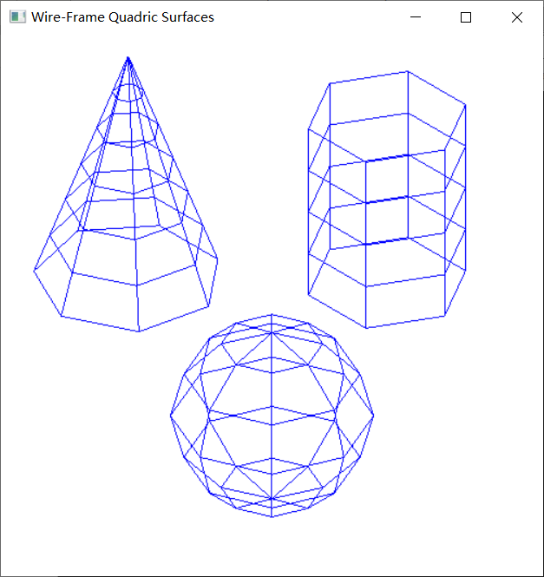

5、实验总结

1.glClearColor：red、green、blue、alpha分别是红、绿、蓝、不透明度，值域均为[0,1]。即设置颜色，为后面的glClear做准备，默认值为（0,0,0,0）。切记：此函数仅仅设定颜色，并不执行清除工作。

2.gluOrtho2D：参数分别代表（左下角x坐标，右上角x坐标，左下角y坐标，右上角y坐标）—坐标相对于窗口左下角——原点）。