实验四 填充算法实验

时间：2022年4月13日

地点：信息学院机房2202

1、实验内容

1.教材P66，填充六边形

2.使用opengl，用扫描线填充算法填充多边形

2、实验目的

验证扫描线填充算法，指定任意的多边形边数，填充多边形

3、实验代码

实验一：填充六边形实验代码

#include <windows.h>

#include <GL/glut.h>

#include <stdlib.h>

#include <math.h>

const double TWO_PI=6.2831853;

/* Initial display-window size */

GLsizei winWidth = 400,winHeight = 400;

GLuint regHex;

class screenPt{

private:

GLint x,y;

public:

/* Default Constructor:initializes coordinate position to (0.0).*/

screenPt(){

x=y=0;

}

void setCoords(GLint xCoord,GLint yCoord){

x=xCoord;

y=yCoord;

}

GLint getx()const{

return x;

}

GLint gety()const{

return y;

}

};

static void init(void)

{

screenPt hexVertex,circCtr;

GLdouble theta;

GLint k;

/*Set circle center coordinates.*/

circCtr.setCoords(winWidth/2,winHeight/2);

glClearColor(1.0,1.0,1.0,0.0);//Display-window color = white.

/*Set up a display list for a red regular hexagon.

*Vertices for the hexagon are six equally spaced

*points around the circumference of a circle.

*/

regHex = glGenLists(1); //Get an identifier for the display list.

glNewList(regHex,GL_COMPILE);

glColor3f(1.0,0.0,0.0); // Set fill color for haxagon to red.

glBegin(GL_POLYGON);

for(k=0;k<6;k++)

{

theta = TWO_PI*k/6.0;

hexVertex.setCoords(circCtr.getx()+150*cos(theta),circCtr.gety()+150*sin(theta));

glVertex2i(hexVertex.getx(),hexVertex.gety());

}

glEnd();

glEndList();

}

void regHexagon(void)

{

glClear(GL_COLOR_BUFFER_BIT);

glCallList(regHex);

glFlush();

}

void winReshapeFcn(int newWidth,int newHeight)

{

glMatrixMode(GL_PROJECTION);

glLoadIdentity();

gluOrtho2D(0.0,(GLdouble)newWidth,0.0,(GLdouble)newHeight);

glClear(GL_COLOR_BUFFER_BIT);

}

int main (int argc,char** argv)

{

glutInit(&argc,argv);

glutInitDisplayMode(GLUT_SINGLE|GLUT_RGB);

glutInitWindowPosition(100,100);

glutInitWindowSize(winWidth,winHeight);

glutCreateWindow("Reshape_Function & Display_List Example");

init();

glutDisplayFunc(regHexagon);

glutReshapeFunc(winReshapeFcn);

glutMainLoop();

}

实验二：填充任意多边形代码

//通用扫描线填充算法

#include <GL/glut.h>

#include <stdlib.h>

#include <windows.h>

#define NULL 0

#define WINDOW_HEIGHT 400

#define WINDOW_WIDTH 400

struct dcPt

{

int x;

int y;

};

typedef struct tEdge

{

int yUpper;

float xIntersect, dxPerScan;

struct tEdge * next;

} Edge;

void setPixel(GLint x,GLint y)

{

glBegin(GL_POINTS);

glVertex2i(x, y);

glEnd();

}

/* Inserts edge into list in order of increasing xIntersect field. */

void insertEdge (Edge * list, Edge * edge)

{

Edge * p, * q = list;

p = q->next;

while (p != NULL)

{

if (edge->xIntersect < p->xIntersect)

p = NULL;

else

{

q = p;

p = p->next;

}

}

edge->next = q->next;

q->next = edge;

}

/* For an index, return y-coordinate of next nonhorizontal line */

int yNext (int k, int cnt, dcPt * pts)

{

int j;

if ((k+1) > (cnt-1))

j = 0;

else

j = k + 1;

while (pts[k].y == pts[j].y)

if ((j+1) > (cnt-1))

j = 0;

else

j++;

return (pts[j].y);

}

/* Store lower-y coordinate and inverse slope for each edge. Adjust and store upper-y coordinate for edges that are the lower member of a monotically increasing or decreasing pair of edges */

void makeEdgeRec

(dcPt lower, dcPt upper, int yComp, Edge * edge, Edge * edges[])

{

edge->dxPerScan =

(float) (upper.x - lower.x) / (upper.y - lower.y);

edge->xIntersect = lower.x;

if (upper.y < yComp)

edge->yUpper = upper.y - 1;

else

edge->yUpper = upper.y;

insertEdge (edges[lower.y], edge);

}

void buildEdgeList (int cnt, dcPt * pts, Edge * edges[])

{

Edge * edge;

dcPt v1, v2;

int i, yPrev = pts[cnt - 2].y;

v1.x = pts[cnt-1].x;

v1.y = pts[cnt-1].y;

for (i=0; i<cnt; i++)

{

v2 = pts[i];

if (v1.y != v2.y) /* nonhorizontal line */

{

edge = (Edge *) malloc (sizeof (Edge));

if (v1.y < v2.y) /* up-going edge */

makeEdgeRec (v1, v2, yNext (i, cnt, pts), edge, edges);

else /* down-going edge */

makeEdgeRec (v2, v1, yPrev, edge, edges);

}

yPrev = v1.y;

v1 = v2;

}

}

void buildActiveList (int scan, Edge * active, Edge * edges[])

{

Edge * p, * q;

p = edges[scan]->next;

while (p)

{

q = p->next;

insertEdge (active, p);

p = q;

}

}

void fillScan (int scan, Edge * active)

{

Edge * p1, * p2;

int i;

p1 = active->next;

while (p1)

{

p2 = p1->next;

for (i=p1->xIntersect; i<p2->xIntersect; i++)

setPixel ((int) i, scan);

p1 = p2->next;

}

}

void deleteAfter (Edge * q)

{

Edge * p = q->next;

q->next = p->next;

free (p);

}

/* Delete completed edges. Update 'xIntersect' field for others */

void updateActiveList (int scan, Edge * active)

{

Edge * q = active, * p = active->next;

while (p)

if (scan >= p->yUpper)

{

p = p->next;

deleteAfter (q);

}

else

{

p->xIntersect = p->xIntersect + p->dxPerScan;

q = p;

p = p->next;

}

}

void resortActiveList (Edge * active)

{

Edge * q, * p = active->next;

active->next = NULL;

while (p)

{

q = p->next;

insertEdge (active, p);

p = q;

}

}

void scanFill (int cnt, dcPt * pts)

{

Edge *edges[WINDOW_HEIGHT], * active;

int i, scan;

for (i=0; i<WINDOW_HEIGHT; i++)

{

edges[i] = (Edge *) malloc (sizeof (Edge));

edges[i]->next = NULL;

}

buildEdgeList (cnt, pts, edges);

active = (Edge *) malloc (sizeof (Edge));

active->next = NULL;

for (scan=0; scan<WINDOW_HEIGHT; scan++)

{

buildActiveList (scan, active, edges);

if (active->next)

{

fillScan (scan, active);

updateActiveList (scan, active);

resortActiveList (active);

Sleep(10); //停顿10毫秒，放慢填充速度，便于观看填充过程

}

}

/* Free edge records that have been malloc'ed ... */

}

void init (void)

{

glClearColor (1.0, 1.0, 1.0, 0.0); // Set display-window color to white.

glMatrixMode (GL_PROJECTION); // Set projection parameters.

gluOrtho2D (0.0, WINDOW_WIDTH, 0.0, WINDOW_HEIGHT);

}

void myDraw (void)

{

dcPt pts[] =

{

50, 50,

300, 20,

170, 300,

20,120

};

glClear (GL_COLOR_BUFFER_BIT);

glColor3f (0.4, 0.8, 0.0);

scanFill (4, pts); // 第一个参数为填充图元的顶点数，第二个参数为顶点坐标数组

Sleep (20);

glFlush ( );

}

int main (int argc, char** argv)

{

glutInit (&argc, argv); // Initialize GLUT.

glutInitDisplayMode (GLUT_SINGLE | GLUT_RGB); // Set display mode.

glutInitWindowPosition (50, 100); // Set top-left display-window position.

glutInitWindowSize (WINDOW_WIDTH, WINDOW_HEIGHT); // Set display-window width and height.

glutCreateWindow ("通用扫描线填充"); // Create display window.

init ( ); // Execute initialization procedure.

glutDisplayFunc (myDraw); // Send graphics to display window.

glutMainLoop ( ); // Display everything and wait.

}

4、实验结果

实验一：

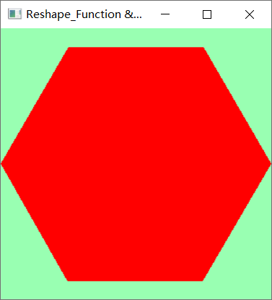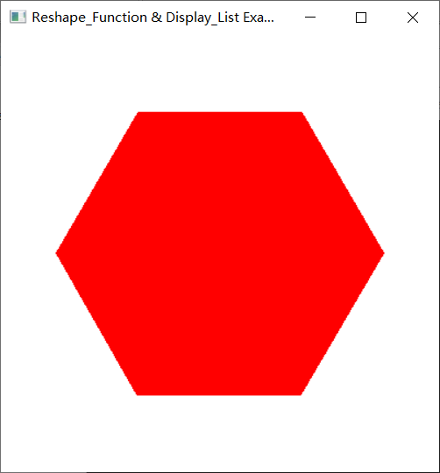实验二：

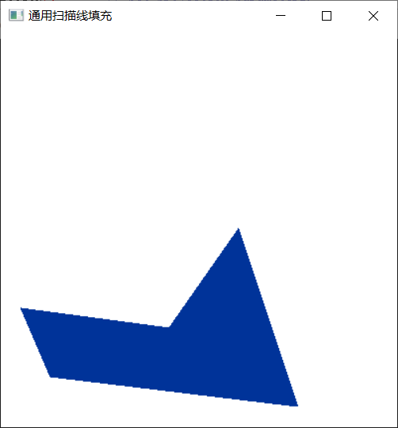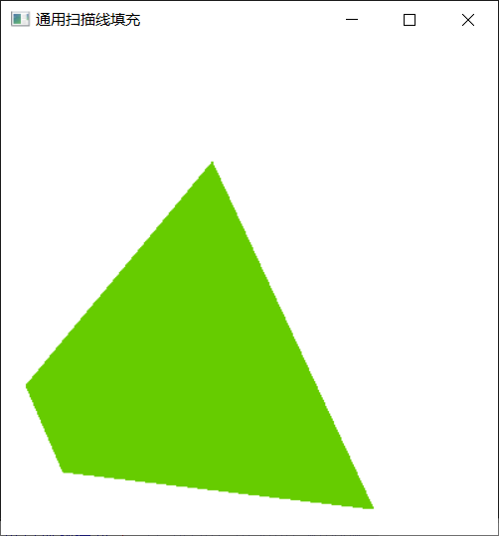

5、实验总结

填充六边形时，将课本上的代码照着抄下来，在这个过程中，本以为是个很简单的任务，但是由于自己对编译工具的不熟练，在编译运行的时候，还是出现了编译器报错的问题，通过一步一步地排查，解决了问题。

第二个实验需要使用老师给的代码，在看懂的基础上，修改相应的参数，并思考怎么才能把代码优化的更好，运行速度更快。

这次实验总体来说还是比较简单的，但见微知著，把简单的事情做好，也能很好地提高我们的能力。