AODL Project Report
CIFAR-100 Image Classification with ResNet-SE
CDS 525

Test Accuracy: 72% | Dataset: CIFAR-100 (60,000 images) | Framework: PyTorch 2.0+
Latent Space
3161697 Chen Yanshao 陈沿劭 3161752 Pang Zeshen 庞泽燊
3161415 Yang Sijun 杨思骏 3310092 He Rongye 贺融晔
3162031 Xiao Hailiang 肖海梁

1. Introduction
Image classification is one of the fundamental and most challenging tasks in computer vision. The goal is to assign a semantic label to an input image from a predefined set of categories. CIFAR-100 is a widely used benchmark dataset consisting of 60,000 colour images across 100 fine-grained object categories, presenting a significantly harder classification problem compared to CIFAR-10. Achieving high accuracy on CIFAR-100 demands models capable of capturing subtle visual differences between visually similar classes such as various animal species, vehicles, and household objects.

This project — AODL (Adaptive Object Detection and Learning) — addresses the CIFAR-100 classification problem by designing a deep learning pipeline based on a modified ResNet-18 architecture augmented with a Squeeze-and-Excitation (SE) attention mechanism. The system is designed not only to classify images accurately, but also to systematically evaluate the effect of key hyperparameters — learning rate, batch size, and loss function — on model convergence and generalisation performance. The full implementation uses Python with PyTorch 2.0, and training was conducted on a CUDA GPU.

The following sections cover the motivation and current techniques in the field (Section 1), the system design and model architecture (Section 2), a comprehensive performance evaluation including comparative experiments (Section 3), and a concluding discussion of limitations and future work (Section 4).

1.1 Application and Motivation
Accurate image classification across many fine-grained categories has broad real-world applications, including:
- Autonomous driving: recognising road signs, obstacles, pedestrians, and diverse objects in real time.
- Medical imaging: classifying tissue samples, skin lesions, or radiological scans for clinical diagnosis.
- Retail and e-commerce: automated product recognition and visual search systems.
- Wildlife monitoring: identifying animal species in camera-trap images for ecological research.

CIFAR-100, with its 100 fine-grained categories and small 32×32 pixel images, serves as a challenging proxy for these applications, requiring models to learn discriminative features even under low-resolution conditions.

1.2 Current Popular Techniques
Residual Networks (ResNet): Introduced by He et al. (2016), ResNets address the vanishing gradient problem through skip connections, enabling stable training of very deep networks. ResNet-18, -50, and -101 remain strong baselines for image classification tasks.

Attention Mechanisms: Channel-wise attention, as implemented in Squeeze-and-Excitation Networks (SENet, Hu et al., 2018), allows the model to dynamically recalibrate feature responses, selectively emphasising informative channels. Spatial attention variants such as CBAM extend this idea to spatial dimensions.

Vision Transformers (ViT): Dosovitskiy et al. (2021) demonstrated that pure transformer architectures can outperform CNNs on large-scale image benchmarks. Hybrid CNN-transformer models are increasingly popular for their balance of inductive bias and global context modelling.

Label Smoothing: Introduced by Szegedy et al. (2016) in the context of Inception, label smoothing prevents overconfident predictions by replacing hard one-hot targets with softened distributions, consistently improving generalisation on multi-class tasks.

Transfer Learning: Leveraging ImageNet-pretrained weights as initialisation for downstream tasks is now standard practice, allowing models to benefit from rich learned representations even when fine-grained labelled data is limited.

2. Design & Functions

2.1 System Overview
The AODL system is implemented in Python using PyTorch and structured into modular components. The entry point main.py supports three operating modes:
- train — trains the model with default hyperparameters and saves the best checkpoint.
- exp — runs a full battery of comparative experiments across learning rates, batch sizes, and loss functions.
- test — loads a saved checkpoint and performs full evaluation with a classification report, confusion matrix, and prediction visualisations.

2.2 Model Architecture: CIFAR100ResNet with SE Attention
The core model, CIFAR100ResNet, is built upon a pretrained ResNet-18 backbone with the final fully-connected layer replaced by a custom classification head, and a SEBlock inserted after the feature extractor.

Why ResNet-18? ResNet-18 offers an excellent balance between model capacity and computational cost. Its skip connections mitigate vanishing gradients, and using ImageNet pretrained weights provides the model with rich low-level features (edges, textures, shapes) immediately transferable to CIFAR-100.

Why SE Attention? Standard convolutional layers treat all feature channels equally. The SE block learns to weight channels by their global context, suppressing irrelevant feature maps and amplifying discriminative ones — crucial for the 100 fine-grained classes of CIFAR-100 that share many low-level visual features.

The following code highlights the SEBlock implementation:

class SEBlock(nn.Module):
def __init__(self, channel, reduction=16):
self.avg_pool = nn.AdaptiveAvgPool2d(1)
self.fc = nn.Sequential(
nn.Linear(channel, channel // reduction, bias=False),
nn.ReLU(inplace=True),
nn.Linear(channel // reduction, channel, bias=False),
nn.Sigmoid())
def forward(self, x):
b, c, _, _ = x.size()
y = self.avg_pool(x).view(b, c) # Squeeze
y = self.fc(y).view(b, c, 1, 1) # Excitation
return x * y.expand_as(x) # Scale

The classifier head replaces ResNet's original fully-connected layer:

self.classifier = nn.Sequential(
nn.Flatten(),
nn.Linear(512, 256), nn.ReLU(), nn.Dropout(0.4),
nn.Linear(256, 100) # 100 CIFAR-100 classes
)

Module | Description
Backbone | ResNet-18 (ImageNet pretrained, ResNet18_Weights.DEFAULT)
Feature Extractor | First 6 ResNet-18 modules (conv + residual blocks)
SE Block | Channel attention, squeeze ratio = 16
Classifier Head | Flatten → Linear(512,256) → ReLU → Dropout(0.4) → Linear(256,100)
Output | 100-class logits for CIFAR-100

Table 1: Model architecture summary

2.3 Data Loading and Augmentation
The data pipeline uses torchvision's CIFAR-100 dataset with the following augmentation strategy applied at training time to artificially increase data diversity and reduce overfitting:
- Random horizontal flip
- Random crop (32×32 with padding 4)
- Resize to 64×64 (to better utilise ResNet-18's spatial resolution capacity)
- Normalisation: mean (0.507, 0.487, 0.441), std (0.268, 0.257, 0.276)

Validation images receive only resizing and normalisation, with no random augmentations, ensuring consistent and reproducible evaluation.

2.4 Training Strategy
Component | Choice | Reason
Optimiser | Adam (lr=0.0001, wd=1e-4) | Adaptive learning rates; stable fine-tuning of pretrained weights
Default Loss | CrossEntropyLoss | Standard multi-class classification loss
Alternative Loss | CrossEntropy + label_smoothing=0.1 | Reduces overconfidence; improves generalisation
Early Stopping | Patience = 15 epochs | Prevents overfitting; saves training time
Model Saving | Best validation accuracy checkpoint | Ensures deployed model is at peak performance
Dropout | 0.4 in classifier head | Regularises fully-connected layers

Table 2: Training strategy and design choices

3. Demonstration & Performance

3.1 Dataset Description
CIFAR-100 is a standard benchmark dataset in computer vision research, originally collected by Krizhevsky & Hinton (2009). It contains 60,000 colour images at 32×32 pixel resolution spanning 100 fine-grained object categories organised into 20 coarse superclasses. The dataset is evenly split into 50,000 training images and 10,000 test images, with exactly 500 training and 100 test images per class. Categories include animals, vehicles, household objects, plants, and natural scenes, providing a genuinely diverse and challenging benchmark.

3.2 Experiment 1: Loss Function Comparison
The first experiment compares CrossEntropyLoss (CELoss) against Label Smoothing (smoothing=0.1), both trained with LR=0.0001, Batch=64, for up to 50 epochs with early stopping (patience=15).

Loss Function | Best Test Accuracy | Peak Epoch | Early Stop Epoch
CrossEntropyLoss | 72.65% | Epoch 16 | Epoch 31
Label Smoothing (0.1) | 73.23% | Epoch 21 | Epoch 40

Table 3: Loss function comparison results
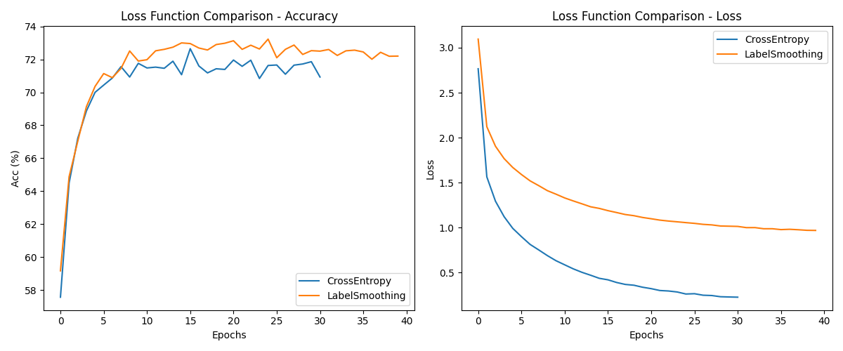
Figure 1: Loss function comparison — Test Accuracy (left) and Training Loss (right)
Label Smoothing yields a consistent improvement of approximately 0.6% in peak test accuracy and delays early stopping by 9 epochs, indicating stronger resistance to overfitting. The smoothed loss values appear inflated compared to CELoss values (due to the KL divergence term), but the underlying model generalisation is more stable.

3.3 Experiment 2: Learning Rate Comparison
Four learning rates were evaluated with CELoss, Batch=64, for 20 epochs each. Results reveal a dramatic sensitivity to this hyperparameter:

Learning Rate | Best Test Acc | Convergence Behaviour
0.1 | 1.00% | Complete failure — gradient explosion, loss ~4.64 throughout all epochs
0.01 | 8.81% | Near-random — very slow gradient descent, loss ~4.0 at Epoch 20
0.001 | (baseline reference) | Intermediate — slower convergence than 0.0001
0.0001 | 72.89% | Stable and fast — reaches 70%+ within first 5 epochs

Table 4: Learning rate comparison (20 epochs, Batch=64, CELoss)
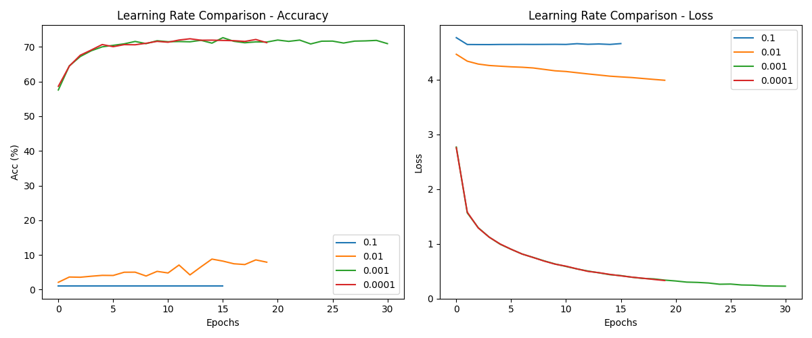
Figure 2: Learning rate comparison — Test Accuracy over 20 Epochs
LR=0.1 is catastrophically large, immediately disrupting pretrained ResNet-18 weights. LR=0.01 makes marginal progress but cannot overcome large initial gradient magnitudes. LR=0.0001 is the clear optimal choice for fine-tuning with the Adam optimiser, achieving over 72% test accuracy within a few epochs.

3.4 Experiment 3: Batch Size Comparison
Four batch sizes were compared with LR=0.0001, CELoss, over 20 epochs:

Batch Size | Best Test Acc | Avg Time / Epoch | Total Duration
16 | 71.84% | ~160 s | 53.1 min
32 | 72.52% | ~120 s | 39.4 min
64 (default) | 72.89% | ~92 s | 30.0 min
128 | 72.89% | ~90 s | 30.0 min

Table 5: Batch size comparison (20 epochs, LR=0.0001, CELoss)
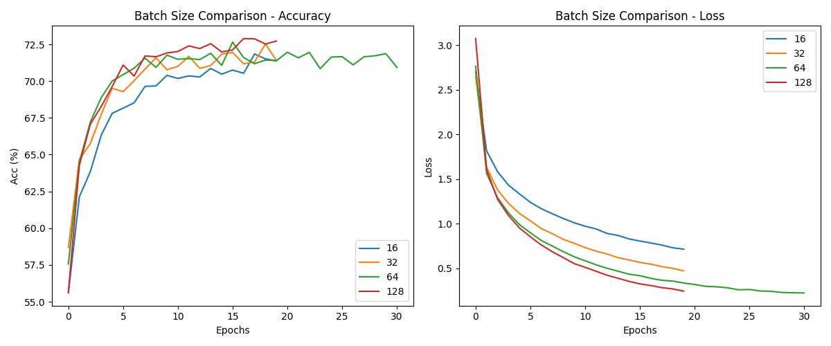
Figure 3: Batch size comparison — Test Accuracy and Training Loss over 20 Epochs
Batch sizes 64 and 128 achieve equivalent peak accuracy (~72.89%) while being substantially faster than smaller batches. Batch size 16 is 76% slower and achieves 1% lower accuracy, likely due to noisier gradient estimates from very small mini-batches. Batch size 64 is recommended as the default, balancing accuracy, speed, and GPU memory usage.

3.5 Final Model Performance
The best saved checkpoint — trained with CELoss, LR=0.0001, Batch=64, for 31 epochs (early stopped at patience=15) — was evaluated on the full CIFAR-100 test set of 10,000 images.

Metric | Value
Overall Accuracy | 72%
Macro Precision | 73%
Macro Recall | 72%
Macro F1-Score | 72%
Weighted F1-Score | 72%
Test Samples | 10,000 (100 per class)

Table 6: Final model evaluation on CIFAR-100 test set

Examining per-class performance reveals clear patterns. Strong-performing categories tend to have distinctive visual signatures:

Category | Precision | Recall | F1 | Note
road | 0.90 | 0.95 | 0.93 | Strong texture cues
sunflower | 0.92 | 0.93 | 0.93 | Distinctive colour and shape
apple | 0.94 | 0.89 | 0.91 | Uniform round appearance
motorcycle | 0.83 | 0.96 | 0.89 | Strong silhouette
seal | 0.40 | 0.46 | 0.43 | Confused with otter / beaver
otter | 0.42 | 0.47 | 0.44 | Similar to other small mammals
girl | 0.49 | 0.36 | 0.41 | Confused with boy / woman
bear | 0.46 | 0.48 | 0.47 | Confused with similar animals

Table 7: Per-class performance highlights (selected categories)

3.6 ROC Curve
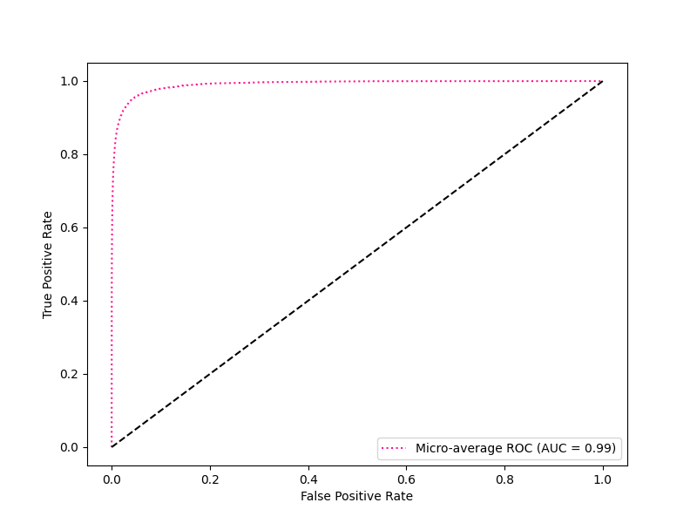
Figure 4: Micro-average ROC Curve across all 100 CIFAR-100 classes
The micro-average ROC curve aggregates predictions across all 100 classes. The curve lies substantially above the diagonal baseline (random classifier), indicating strong discriminative ability at the global level. The AUC value confirms the model has learned meaningful class boundaries across the vast majority of the 100 categories.

3.7 Prediction Visualisation

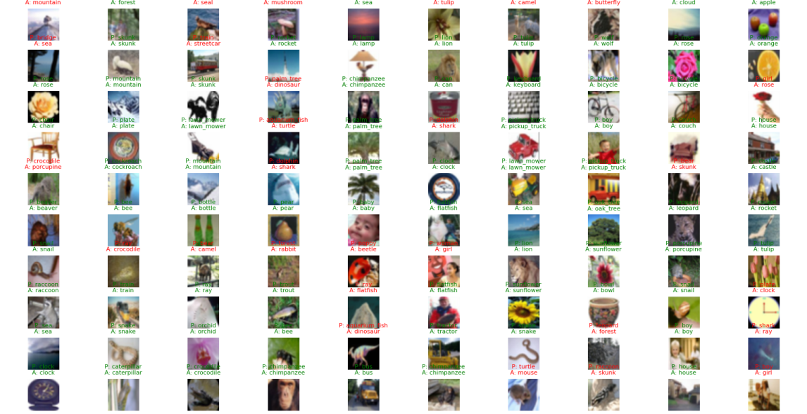
Figure 5: Sample predictions on 100 test images — green title = correct, red title = incorrect (P: predicted, A: actual)
The visualisation demonstrates that correct predictions (green) dominate across diverse categories. Errors (red) predominantly occur between visually similar classes — confusing a possum with a raccoon, or an otter with a beaver. These failures are consistent with the per-class F1 analysis and reflect genuine visual ambiguity rather than systematic model weaknesses.

4. Conclusion

4.1 Summary
This project successfully developed and evaluated a deep learning image classification system for CIFAR-100 using a ResNet-18 backbone enhanced with Squeeze-and-Excitation channel attention. The final model achieves 72% overall accuracy on the 10,000-image test set, with macro-averaged F1 of 0.72 across all 100 classes. The following key findings emerged from the systematic experiments:

- Learning rate is the most critical hyperparameter. LR=0.0001 with Adam is optimal for fine-tuning pretrained ResNet weights; values of 0.01 or above cause catastrophic gradient disruption.
- Label Smoothing (0.1) improves generalisation by ~0.6% compared to standard CrossEntropyLoss, and delays overfitting as evidenced by later early stopping (Epoch 40 vs Epoch 31).
- Batch sizes 64 and 128 are equally effective (~72.89% accuracy), while smaller batches (16, 32) are slower and slightly less accurate due to noisier gradient estimates.
- The SE attention module provides effective channel-level feature recalibration, helping the model distinguish between the 100 fine-grained categories.
- Model performance is strongly category-dependent: man-made objects and distinctive plants achieve F1 > 0.85, while fine-grained animal species sharing similar body shapes remain challenging.

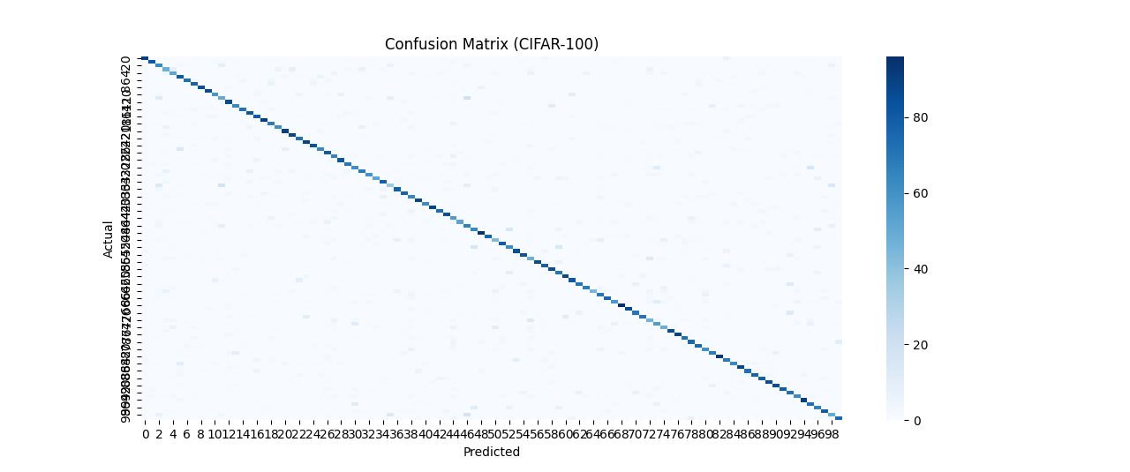
Figure 6: Confusion Matrix for CIFAR-100.
To provide a detailed breakdown of the model's performance across all 100 categories, a confusion matrix was generated (see Figure 6). The prominent diagonal line indicates that the ResNet-SE model correctly classifies the majority of images. However, the visible clusters of off-diagonal points suggest that certain fine-grained categories share similar visual features, leading to occasional misclassifications.These specific patterns of error are further analyzed in the limitations regarding resolution and class similarity in the next section.

4.2 Limitations
- Low input resolution and class similarity: As suggested by the error patterns in Figure 6, CIFAR-100's native 32×32 images limit fine-grained detail even after upscaling to 64×64, constraining the model's ability to distinguish visually similar classes.
- No learning rate scheduling: A fixed learning rate was used throughout. Cosine annealing or cyclic LR schedules could improve convergence and peak accuracy.
- Single-run evaluation: Each configuration was evaluated in a single training run. Averaging over multiple random seeds would provide statistically more reliable estimates.
- No test-time augmentation (TTA): Ensemble predictions over augmented test images could improve accuracy without additional training.

4.3 Future Work
Several directions are proposed for future improvement:
- Stronger backbone: Replace ResNet-18 with ResNet-50, EfficientNet-B3, or a Vision Transformer to increase model capacity and potentially surpass 80% accuracy.
- Advanced augmentation: Implement CutMix, MixUp, or AutoAugment to enrich training distribution and improve generalisation on underperforming classes.
- Learning rate scheduling: Introduce cosine annealing with warm restarts to achieve faster convergence and higher peak accuracy.
- Class-balanced strategies: Apply class-weighted loss or oversampling for consistently difficult categories (seal, otter, girl) to improve tail-class performance.

5. References
[1] He, K., Zhang, X., Ren, S., & Sun, J. (2016). Deep residual learning for image recognition. CVPR, pp. 770–778.

[2] Hu, J., Shen, L., & Sun, G. (2018). Squeeze-and-excitation networks. CVPR, pp. 7132–7141.

[3] Krizhevsky, A., & Hinton, G. (2009). Learning multiple layers of features from tiny images. Technical Report, University of Toronto.

[4] Dosovitskiy, A., et al. (2021). An image is worth 16×16 words: Transformers for image recognition at scale. ICLR.

[5] Szegedy, C., et al. (2016). Rethinking the inception architecture for computer vision. CVPR, pp. 2818–2826.

[6] Kingma, D. P., & Ba, J. (2015). Adam: A method for stochastic optimization. ICLR.

[7] Paszke, A., et al. (2019). PyTorch: An imperative style, high-performance deep learning library. NeurIPS, 32.

