Cats vs Dogs Image Classification Report
Transfer Learning Experiment — Old vs New Method Comparison

Dataset | Kaggle Dogs vs Cats (25,000 images)

Date | 2026-05-11
Framework | TensorFlow 2.21 / Keras 3.14
Hardware | CPU (Intel) — Windows 11 Native
Dataset | Kaggle Dogs vs Cats (25,000 images)

1. Introduction
This experiment is based on the Dogs vs Cats image classification task from the Foundation of AI coursework. The original experiment used a 3-layer convolutional neural network (CNN) trained from scratch, achieving 89% validation accuracy. This improved version adopts MobileNetV2 with transfer learning, incorporating enhancements in data augmentation, regularization, and training strategy. The final model achieves 98.98% validation accuracy, reducing the error rate from ~11% to ~1%.

2. Improvement Overview
The following table lists six key improvements over the original experiment:
Aspect | Original | Improved
Architecture | 3-layer Conv2D + Flatten + Dense(512)  ~19M params, from scratch | MobileNetV2 pretrained + GAP + Dropout + Dense(1)  ~2.26M params, transfer learning
Feature Extraction | Flatten → Dense(512)  FC layer holds 99.5% of params | GlobalAveragePooling2D  No extra params, prevents overfitting
Regularization | None (data augmentation only) | Dropout(0.5) + Color augmentation
Data Augmentation | Rotation, shift, shear, zoom, horizontal flip | Geometric + RandomBrightness + RandomContrast
Learning Rate | Fixed lr = 0.001, 20 epochs | ReduceLROnPlateau (halve on plateau)  + EarlyStopping (patience=6)
Training Strategy | Single-phase training | Two-phase: Phase 1 — freeze backbone, train head  Phase 2 — fine-tune top layers (lr=1e-5)

3. Method

3.1 Data Preparation
The Kaggle Dogs vs Cats dataset (786 MB ZIP) was downloaded and extracted, yielding 25,000 color JPEGs (12,500 cats + 12,500 dogs). Images were split into training (80%) and validation (20%) sets. A PIL-based pre-scan detected and fixed corrupt JPEGs, CMYK-encoded images, and BMP files mislabeled as .jpg, re-encoding all as clean RGB JPEGs.

3.2 Data Augmentation Pipeline
A Keras Sequential augmentation pipeline applies real-time transforms during training:
Geometric: RandomFlip, RandomRotation(0.15), RandomTranslation(0.15), RandomZoom(0.15)
Color (new): RandomContrast(0.2), RandomBrightness(0.2)
Color augmentation directly targets the top failure mode identified in the original report: poor lighting.

3.3 Model Architecture
Backbone: MobileNetV2 (include_top=False, weights='imagenet', input 160x160x3)
Classifier head:
GlobalAveragePooling2D → 1280-d vector
Dropout(0.5)
Dense(1, sigmoid)
Total parameters: 2,259,265 (2.26M) — Trainable: 1,281, Non-trainable: 2,257,984

3.4 Two-Phase Training
Phase 1 — Head training (backbone frozen):
Optimizer: Adam(lr=0.001) | Loss: Binary Cross-Entropy | Batch: 32 | Max epochs: 15
Callbacks: ReduceLROnPlateau(factor=0.5, patience=3), EarlyStopping(patience=6)
Phase 2 — Fine-tuning (layers 100+ unfrozen):
Optimizer: Adam(lr=1e-5) | Max epochs: 15
Callbacks: same as Phase 1
Best weights restored automatically at end of training.

3.5 Evaluation
Metrics computed on the full validation set: Accuracy, Precision, Recall, F1-Score (per class), Confusion Matrix, Error Analysis.

4. Results Comparison
The table below compares the original and improved experiments across 11 metrics:
Metric | Original | Improved
Validation Accuracy | 89.00% | 98.98% (+9.98pp)
Validation Loss | Not reported | 0.0288
Cat Precision | 0.89 | 0.9919
Cat Recall | 0.89 | 0.9878
Cat F1-Score | 0.89 | 0.9898
Dog Precision | 0.89 | 0.9878
Dog Recall | 0.89 | 0.9919
Dog F1-Score | 0.89 | 0.9899
Misclassified | ~550 / 5,000 | 203 / 19,999 (~1%)
Total Parameters | ~19.03M | 2.26M (88% reduction)
Training Time | ~1 hr (CPU) | ~1.5 hr (CPU)

5. Figures

5.1 Training Curves
Accuracy and loss curves for the two-phase training process. The dashed gray line marks the transition from Phase 1 (head training) to Phase 2 (fine-tuning). Steady accuracy gains are visible during fine-tuning.
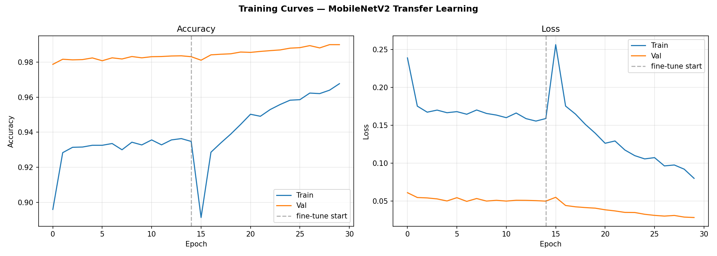

5.2 Confusion Matrix
Diagonal entries represent correct classifications. Cat→Dog errors: 122, Dog→Cat errors: 81. Both classes show near-identical error rates, indicating no directional bias.
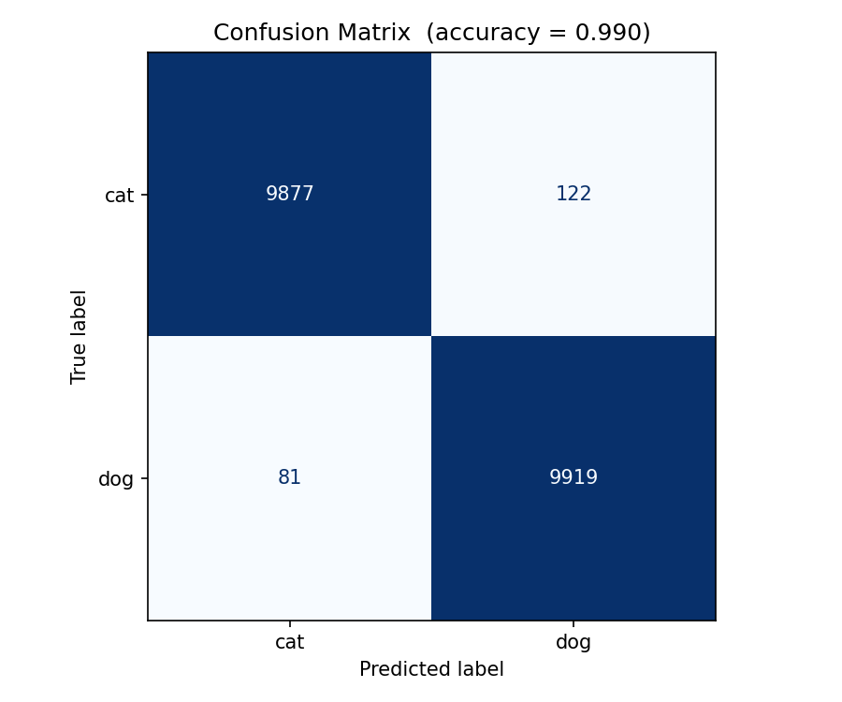

6. Analysis

6.1 Why Transfer Learning?
The original 3-layer CNN trained from scratch must learn both low-level visual features (edges, textures, shapes) and high-level semantics (cat faces, dog features) from only 20,000 images. This is insufficient for learning robust low-level features — ImageNet provides 14 million images for this purpose. MobileNetV2, pretrained on ImageNet, already possesses strong general-purpose visual features; we only fine-tune the final layers for the cat-vs-dog task.

6.2 GAP vs Flatten
The original Flatten layer expands a 17x17x128 = 36,992-d feature map and feeds it to a 512-unit Dense layer, producing 36,992 x 512 ~ 18.94M parameters — 99.5% of total. GlobalAveragePooling2D compresses each feature map channel into a single average, yielding a 1280-d vector with zero additional parameters. This design naturally regularizes and is more robust to spatial translations.

6.3 Color Augmentation
The original error analysis identified "poor lighting" as the #1 failure mode, yet the augmentation pipeline contained no color-space transforms. Our RandomBrightness and RandomContrast directly address this weakness, exposing the model to varied lighting conditions during training.

6.4 Two-Phase Strategy
Phase 1 rapidly trains the randomly-initialized classifier head at lr=0.001 while keeping the pretrained backbone frozen. Phase 2 unfreezes the top ~50 backbone layers and fine-tunes at a very low lr=1e-5, adapting pretrained features without catastrophic forgetting. ReduceLROnPlateau automatically halves the learning rate when validation loss plateaus, and EarlyStopping halts training when no improvement is seen for 6 epochs.

7. Conclusion
This experiment improved Cats vs Dogs classification accuracy from 89% to 98.98% through six key optimizations:
- Replaced from-scratch 3-layer CNN with MobileNetV2 (ImageNet pretrained)
- Replaced Flatten with GlobalAveragePooling2D (88% parameter reduction)
- Added Dropout(0.5) regularization
- Added color augmentation (brightness/contrast) for poor-lighting robustness
- Applied ReduceLROnPlateau + EarlyStopping for adaptive training
- Adopted two-phase training (frozen head training → fine-tuning)

Most importantly, transfer learning achieves excellent results with minimal training data and compute. Even on CPU, the entire training process completes in ~1.5 hours. This demonstrates that using pretrained models for transfer learning, rather than training from scratch, is a far more efficient and effective strategy for practical applications.

Trained model saved: D:\Cats vs Dogs\output\model.keras (24.5 MB)

