Dogs vs. Cats Image Classification — Project Report
Foundation of AI
3161013 Lyu Zhipeng 3161520 Shi Yunfeng
3161491 Yi Rongyang 3161415 Yang Sijun
Validation Accuracy: 89% | Dataset: 25,000 images | Framework: TensorFlow / Keras

1. Introduction
This report documents a group project completed as part of the Foundation of AI coursework. The task was to build an image classifier capable of distinguishing between photographs of cats and dogs, using a convolutional neural network (CNN) trained on the Kaggle Dogs vs. Cats dataset. Image classification is one of the most well-studied problems in computer vision and serves as a useful concrete setting for applying core supervised learning concepts including feature extraction, regularisation, generalisation, and model evaluation.
The project was divided among four team members, each responsible for a distinct stage of the machine learning pipeline: data preparation and augmentation (Member A), baseline model design and training (Member B), model optimisation (Member C), and performance evaluation with error analysis (Member D). This division mirrors the structure of a real-world ML project and allowed each member to focus on one area while producing outputs that integrated cleanly with the next stage.
The full implementation uses Python with TensorFlow and Keras, and training was run on CPU throughout due to hardware constraints. This limited the number of training epochs and the range of architectures the team could test within a reasonable time frame, but it also made the project a practical exercise in working efficiently under real resource limits. The final model achieves 89% accuracy on a held-out validation set of 5,000 images, with symmetric performance across both classes. The web demo for the project is available at the YouTube link in Section 5.

2. Problem Statement / Description

2.1 Task Definition
The task is binary image classification: given a colour photograph, determine whether it contains a cat or a dog. This is a supervised learning problem in which each training example consists of an image and a ground-truth label from the set {cat, dog}. The model must learn a function that maps raw pixel values to one of these two categories, generalising well enough to correctly classify images it has never seen during training. Convolutional neural networks are well-suited to this type of task because their shared weight filters can detect local visual patterns such as edges, textures, and shapes regardless of where they appear in the image.
While the task sounds straightforward, it presents genuine difficulty in practice. Cats and dogs span a very wide range of breeds, body sizes, fur colours, and facial structures. Images in the dataset vary considerably in background complexity, lighting quality, camera distance, and subject pose. Some images are low resolution, some show only a partial view of the animal, and a small number appear to carry incorrect labels from the original crowdsourced annotation process. Any classifier must cope with all of this variation to reach high accuracy, and these factors are the main driver of the errors that remain in the final model.

2.2 Dataset
The dataset used is the Kaggle Dogs vs. Cats dataset, which contains 25,000 colour JPEG images sourced from the internet. Each filename is prefixed with either 'cat.' or 'dog.', which provides the ground-truth label without requiring a separate annotation file. The class distribution is exactly balanced at 12,500 images per class, and the images vary considerably in size, aspect ratio, and quality. After downloading and sorting the images by label, the dataset was split into training and validation sets at an 8:2 ratio:
- Training set: 20,000 images (10,000 cats, 10,000 dogs)
- Validation set: 5,000 images (2,500 cats, 2,500 dogs)
The 8:2 split gives the model a large enough training set to learn meaningful features while keeping 5,000 examples as a held-out set for stable evaluation. Because both splits are perfectly balanced, accuracy is a fair metric and no class weighting is required during training or evaluation.

3. Proposed Approach

3.1 Data Preprocessing and Augmentation
Member A wrote data_loader.py, which uses TensorFlow's ImageDataGenerator to build separate data pipelines for training and validation via a shared get_data_generators interface. All images are resized to 150x150 pixels with a batch size of 32. The input size was chosen to balance spatial detail against computational cost under the CPU-only constraint. For the validation pipeline, only pixel normalisation is applied, rescaling values from [0, 255] to [0, 1] to ensure consistent and reproducible evaluation.
For the training pipeline, a set of random augmentation operations is applied at load time to artificially increase data diversity and reduce overfitting. The augmentations were chosen to reflect the real variation present in the dataset:
- Random rotation up to 40 degrees
- Random horizontal and vertical translation (shift range = 0.2)
- Random shear transformation (shear range = 0.2)
- Random zoom (zoom range = 0.2)
- Random horizontal flip
Because these transformations are applied randomly each epoch, the model sees a slightly different version of each training image on every pass, which acts as a form of implicit regularisation without requiring additional data collection.

3.2 Model Architecture
Member B designed the baseline CNN using the Keras Sequential API. The architecture follows a standard pattern: three blocks of Conv2D and MaxPooling2D layers extract spatial features at increasing abstraction levels, with filter counts doubling at each stage (32, 64, 128). After flattening, a 512-unit dense layer maps the extracted features to the output neuron.

Layer Type | Output Shape | Parameters | Activation
Conv2D (32, 3x3) | (148, 148, 32) | 896 | ReLU
MaxPooling2D | (74, 74, 32) | 0 | -
Conv2D (64, 3x3) | (72, 72, 64) | 18,496 | ReLU
MaxPooling2D | (36, 36, 64) | 0 | -
Conv2D (128, 3x3) | (34, 34, 128) | 73,856 | ReLU
MaxPooling2D | (17, 17, 128) | 0 | -
Flatten | (36,992) | 0 | -
Dense (512) | (512) | 18,940,416 | ReLU
Dense (1) | (1) | 513 | Sigmoid
Table 1: CNN architecture (total parameters: ~19,034,179 / 72.61 MB)
All convolutional layers use ReLU activation to introduce non-linearity while keeping gradients manageable during backpropagation. The output layer uses Sigmoid, mapping the raw score to a probability between 0 and 1, with 0.5 as the classification threshold at inference time. The total parameter count of roughly 19 million sits mostly in the Dense (512) layer, which in hindsight could have been paired with a dropout layer from the outset to limit the overfitting that became visible in the later training epochs.

3.3 Training Configuration
The model was compiled with the Adam optimiser at default learning rate (0.001) and binary cross-entropy loss. Adam was chosen over plain SGD because it maintains per-parameter adaptive learning rates, which generally leads to faster and more stable convergence without requiring a manually tuned schedule. Binary cross-entropy is the standard loss for two-class problems with a Sigmoid output, as it directly penalises the divergence between the predicted probability and the true binary label. Training ran for 20 epochs with validation checked at the end of each epoch, allowing the team to monitor whether generalisation was improving or overfitting was setting in.
- Optimiser: Adam (lr = 0.001), Loss: binary_crossentropy
- Epochs: 20, Batch size: 32, Input size: 150x150
- Hardware: CPU only (approximately 1 hour total training time)
After Member B produced the baseline model at 87% validation accuracy, Member C ran a series of optimisation experiments including dropout regularisation, learning rate adjustment, and additional data augmentation. The best configuration from those experiments was then handed to Member D for final evaluation.

4. Performance Evaluation

4.1 Classification Report
The final model was evaluated on the full 5,000-image validation set. Precision, recall, and F1-score were computed for each class, along with overall accuracy:

Class | Precision | Recall | F1-Score | Support
Cat | 0.89 | 0.89 | 0.89 | 2500
Dog | 0.89 | 0.89 | 0.89 | 2500
Macro Avg | 0.89 | 0.89 | 0.89 | 5000
Weighted Avg | 0.89 | 0.89 | 0.89 | 5000
Table 2: Classification report on the validation set
Both classes achieved 0.89 across all three metrics, giving an overall accuracy of 89%. The fact that precision and recall are equal for both classes indicates the model is not biased toward generating more false positives than false negatives in either direction. The macro and weighted averages are identical, as expected for a perfectly balanced validation set. The full terminal output is shown in Figure 1:
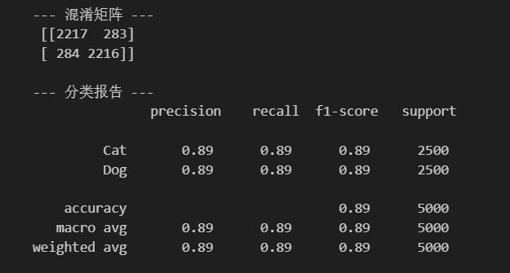
Figure 1: Classification report output (precision / recall / F1-score)

4.2 Confusion Matrix
The confusion matrix provides a more granular breakdown of where predictions succeed and where they fail across all 5,000 validation images:
- True Cat, Predicted Cat: 2,217 out of 2,500 (88.7% recall)
- True Cat, Predicted Dog: 283 misclassified (11.3% error rate)
- True Dog, Predicted Cat: 284 misclassified (11.4% error rate)
- True Dog, Predicted Dog: 2,216 out of 2,500 (88.6% recall)
The off-diagonal values of 283 and 284 are nearly identical, confirming that the model has no directional bias between the two classes. This symmetry suggests the model is not exploiting a spurious class-level shortcut and that the training data was well-balanced throughout.
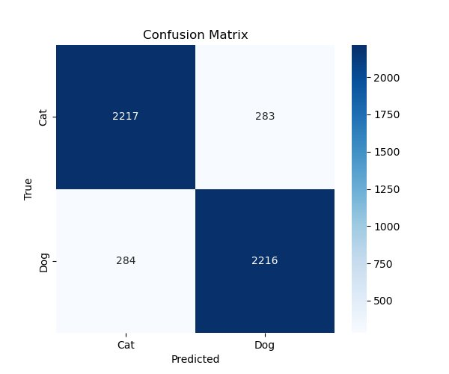
Figure 2: Confusion matrix on the 5,000-image validation set

5. Discussion

5.1 Error Analysis
Member D manually reviewed a sample of misclassified images to identify recurring failure patterns. Nine categories were found across the reviewed cases:
- Poor lighting or heavy shadows obscuring key features
- Cluttered or noisy backgrounds drawing attention away from the subject
- Severe occlusion where only part of the animal is visible (e.g. just the head)
- Unusual postures such as an animal curled up tightly
- Fur colour that blends closely with the background
- Breed-specific features that differ significantly from typical appearances
- Extreme close-up shots that crop out most of the body
- Very low image resolution producing blurry 150x150 inputs
- Cases where the original Kaggle ground-truth label appears to be incorrect
Figure 3 shows a selection of misclassified samples, all labelled as cat but predicted as dog:
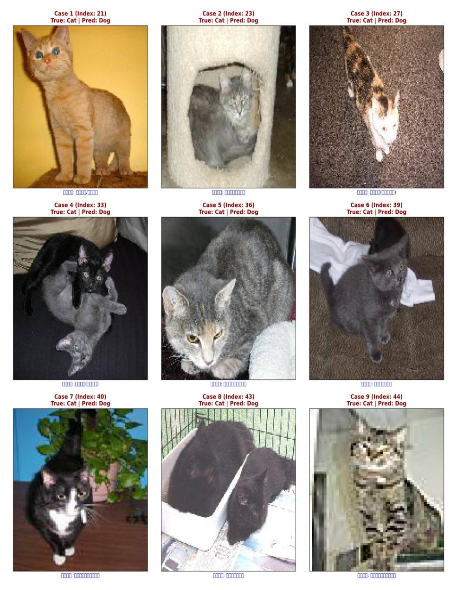
Figure 3: Sample misclassified images (True: Cat, Predicted: Dog)
Looking at individual cases makes the failure modes concrete. Case 4 shows two kittens in a very dark frame where body outlines are barely distinguishable from the background. Case 9 is heavily pixelated, having been upscaled from a much smaller original. Case 2 shows a cat sitting inside a cat tower structure, with the surrounding object dominating the frame. These are genuinely difficult samples rather than straightforward classification failures. The label noise category is also worth singling out: a small number of errors appeared to involve images that were simply mislabelled in the original dataset, which sets an irreducible floor on accuracy that no architectural change can overcome.

5.2 Limitations and Future Improvements
The main limitation of the current approach is that the CNN was trained from scratch without any pretrained weights. Transfer learning from a pretrained backbone such as VGG16 or MobileNetV2 would give the model access to feature representations learned from millions of images, which would be particularly helpful for low-quality and edge-case samples. A second limitation is the CPU-only training environment, which restricted the number of epochs and configurations we could test. Running on a GPU would allow for longer training runs and more systematic hyperparameter search.
Several specific improvements would be worth pursuing going forward:
- Fine-tuning a pretrained backbone (VGG16, ResNet, or MobileNetV2) for substantially better feature extraction
- Adding more aggressive dropout regularisation to the dense layers to reduce the overfitting observed from epoch 12 onwards
- Experimenting with Mixup or CutMix augmentation to improve robustness to occlusion and unusual poses
- Running a label-cleaning pass on the training data to remove images with incorrect ground-truth annotations
- Increasing input resolution above 150x150, which would help on the low-resolution failure cases once GPU training is available

5.3 Web Demo
The team built an interactive web page to present the project. It includes a dataset overview with sample images from both classes, a visual breakdown of the model architecture, training curves from both the baseline and optimised runs, and an error analysis gallery where visitors can browse misclassified examples alongside their assigned failure category. The page is a self-contained HTML file that runs without a server. The walkthrough video is available here:
Demo video: https://youtu.be/lTcGDM3vsRc

6. Conclusion
This project applied the supervised learning concepts from Foundation of AI to a real image classification task, building a CNN-based cat vs. dog classifier from scratch using the Kaggle Dogs vs. Cats dataset. The work covered the full pipeline: data preparation and augmentation, baseline model design and training, optimisation experiments, and systematic performance evaluation with error analysis.
The baseline CNN achieved 87% validation accuracy after 20 epochs of CPU training, and the optimised model reached 89%. The confusion matrix confirmed that both classes are handled with near-identical error rates of around 11%, showing no directional bias toward either label. The manual error analysis revealed that most remaining mistakes are attributable to identifiable image quality issues — poor lighting, occlusion, unusual poses, low resolution, and label noise — rather than fundamental weaknesses in the model architecture. This finding is useful because it tells us where effort would be best spent in future iterations: improving input data quality and model regularisation is likely to yield more gains than redesigning the network topology.
The most impactful next step would be switching to a pretrained backbone, which would likely push accuracy well above 90% without requiring significantly more training data or compute. Additional regularisation, stronger augmentation strategies, and a label-cleaning pass on the training set would address the remaining failure categories more directly. Overall, the project was a practical end-to-end exercise in applying machine learning to a concrete problem, and the 89% result is a solid baseline given the CPU-only constraint and training-from-scratch approach. The modular team structure also proved effective: having clearly defined handoff points between stages kept the work manageable and made it straightforward to test each component independently.

Github link: https://github.com/2499146834-arch/Foundation-of-AI.git

Appendix: Project File List
Files produced over the course of the project:
- data_loader.py - Data loading and augmentation pipeline (Member A)
- visualize_augmentation.py - Augmentation visualisation script (Member A)
- train_baseline.py - Baseline CNN training script (Member B)
- baseline_cnn.h5 - Saved baseline model weights, ~72.6 MB (Member B)
- baseline_training_curves.png - Training accuracy and loss curves (Member B)
- confusion_matrix.png - Validation set confusion matrix (Member D)
- detailed_error_analysis.png - Misclassified sample visualisation (Member D)
- classification_report.png - Precision / recall / F1 report screenshot (Member D)

