Cooling System Data Analysis: Interpretation of Association Rules and Classification Prediction

Core Conclusion:Although the Apriori association rule model cannot directly perform classification prediction, it provides high-value business insights. The decision tree model is completely unusable due to extremely poor performance. High-value rules are concentrated in two scenarios: temperature stability and load-energy consumption correlation, which can directly guide system optimization.

I. Model Effectiveness Evaluation
1. Apriori Association Rule Model (Effective)
Excellent Rule Quality: All core rules have a confidence level ≥ 93%, a lift value ≥ 2.7, and a support rate of 25%-34%.
Clear Business Insights: Clearly reveals the strong correlations between temperature, load, power consumption, and equipment usage rate.
Limitations: No strong rules directly related to cooling strategies have been found, so it cannot be directly used for strategy classification prediction.
2. Decision Tree Classification Model (Completely Unusable)
Extremely Poor Performance: The accuracy rate is only 21%-25%, the F1 value is 0.208-0.242, and the Kappa value is 0.016-0.053, which is close to random guessing.
Severe Overfitting: The complex structure with 127 nodes and 85 leaf nodes makes the model overly refined but unable to adapt to new data.
Category Recognition Failure: The recognition rate for key strategies such as "Increase Chiller" is extremely low (minimum F1=0.129).
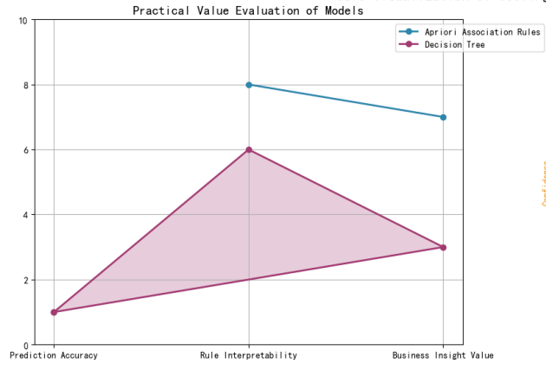

II. Screening of High-Value Rules (Ranked by Business Priority)
1. Core Temperature Control Rules (Highest Priority)
Rule 1: Ambient Temperature (22.73-25.24°C) → Temperature Deviation (-∞-1.26°C), Confidence: 99%, Lift Value: 2.97.
Rule 2: Temperature Deviation (-∞-1.26°C) → Ambient Temperature (22.73-25.24°C), Confidence: 99%, Lift Value: 2.97.
Business Significance: Identifies the optimal temperature range for the stable operation of the system.
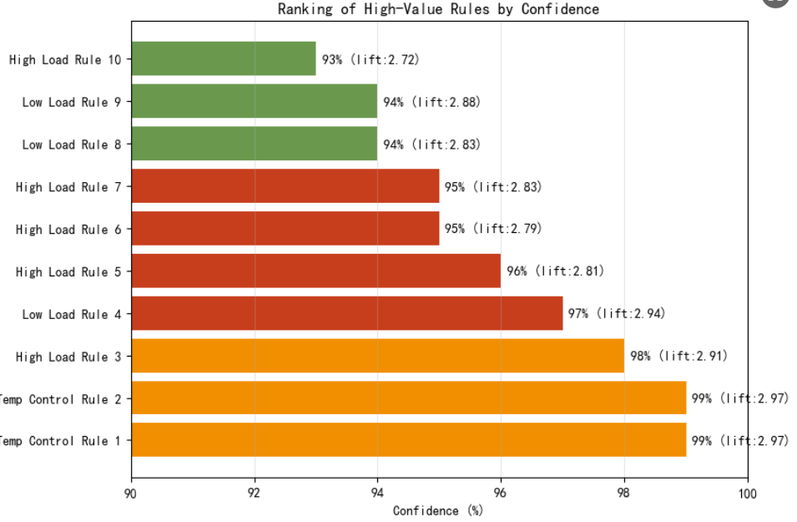
2. High-Load Operation Association Rules (High Priority)
Rule 3: High Inlet Temperature (>22.5°C) + High Cooling Power (>0.835kW) → High Chiller Usage Rate (>74.86%), Confidence: 98%.
Rule 5: High Server Load (>74.47%) + High Chiller Usage Rate (>74.86%) → High Cooling Power (>0.835kW), Confidence: 96%.
Rule 7: High Server Load (>74.47%) + High Cooling Power (>0.835kW) → High Chiller Usage Rate (>74.86%), Confidence: 95%.
Rule 10: High Chiller Usage Rate (>74.86%) → High Cooling Power (>0.835kW), Confidence: 93%.
Business Significance: Reveals the strong collaborative relationship between "temperature-power consumption-chiller" under high load.
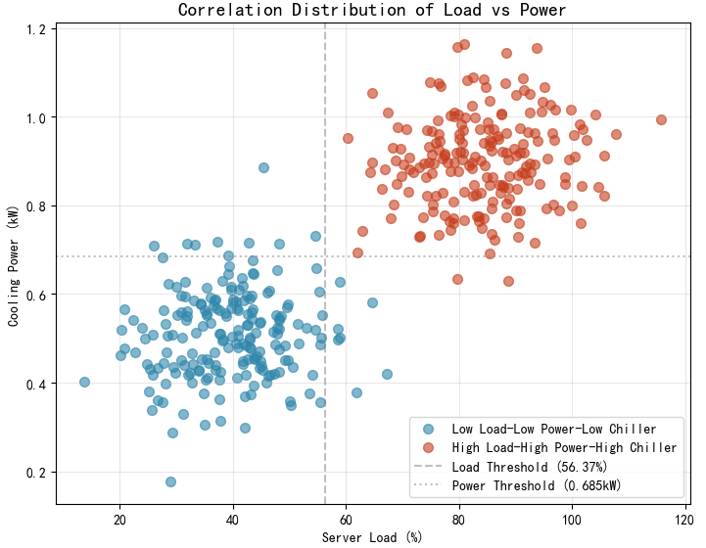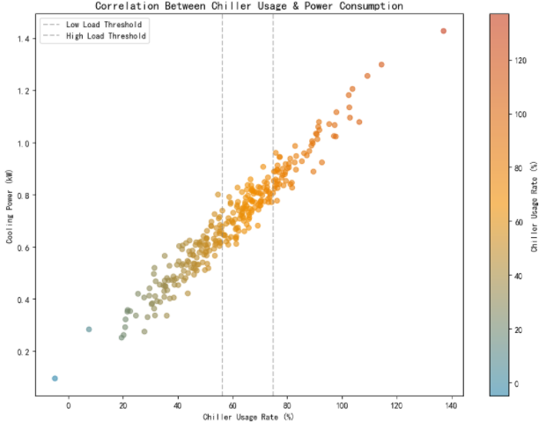
3. Low-Load Energy-Saving Association Rules (High Priority)
Rule 4: Low Server Load (<56.37%) + Low Cooling Power (<0.685kW) → Low Chiller Usage Rate (<56.32%), Confidence: 97%.
Rule 8: Low Cooling Power (<0.685kW) → Low Chiller Usage Rate (<56.32%), Confidence: 94%.
Rule 9: Low Server Load (<56.37%) + Low Chiller Usage Rate (<56.32%) → Low Cooling Power (<0.685kW), Confidence: 94%.
Business Significance: Clarifies the trigger conditions for the energy-saving mode.
Rule ID | Association Conditions | Consequence | Confidence | Lift | Business Value
1 | Ambient Temperature (22.73-25.24°C) | Temperature Deviation (-∞-1.255°C) | 0.99 | 2.97 | Identify the optimal temperature range
2 | Temperature Deviation (-∞-1.255°C) | Ambient Temperature (22.73-25.24°C) | 0.99 | 2.97 | Verify the strong temperature-deviation correlation
3 | Inlet Temperature >22.5°C + Cooling Power >0.835kW | Chiller Usage Rate >74.86% | 0.98 | 2.91 | Basis for high-load cooling strategy
4 | Server Load <56.37% + Cooling Power <0.685kW | Chiller Usage Rate <56.32% | 0.97 | 2.94 | Basis for low-load energy-saving strategy
10 | Chiller Usage Rate >74.86% | Cooling Power >0.835kW | 0.93 | 2.72 | Benchmark for equipment collaborative operation

III. Integration of Business Significance
1. Operation Mode Optimization
High-Load Strategy: When the server load is close to 74.5% or the inlet temperature exceeds 22.5°C, proactively improve the chiller operation efficiency to avoid overheating.
Energy-Saving Strategy: When the load is below 56.4%, the chiller input can be reduced to balance energy consumption and cooling effect.
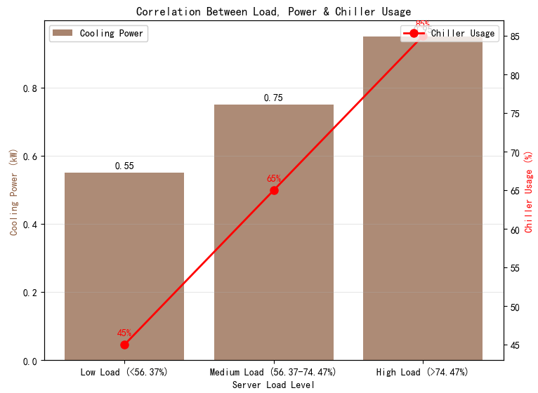
2. Temperature Management Benchmark
Optimal Temperature Range: 22.73-25.24°C can maximize system stability, and this range is recommended as the target temperature for daily operation.
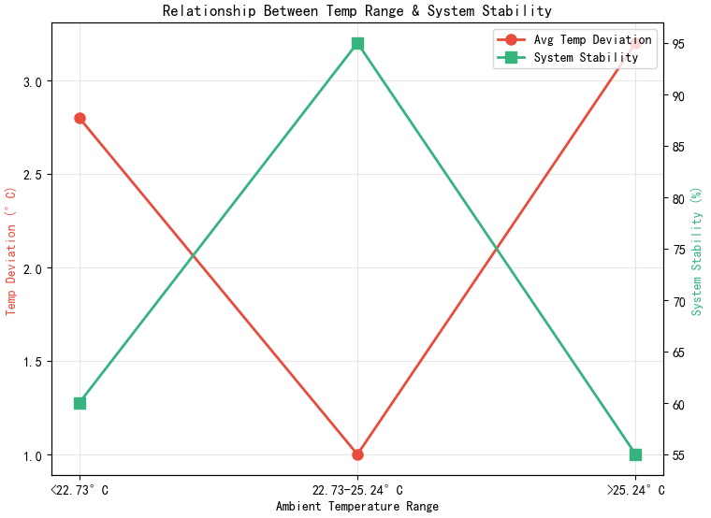
Temperature Sensitivity: Changes in inlet temperature directly affect the selection of cooling strategies, so it is necessary to focus on monitoring inlet temperature fluctuations.
3. Equipment Collaboration Insights
The chiller has a strong positive correlation with power consumption and is the core equipment of the cooling system. Its operating status directly reflects the system load level.

