Section 1: Dataset Overview & Sourcing
- Dataset Chosen: IMDb Dataset of 50K Movie Reviews.
- Where it comes from: Originally compiled by AI researchers at Stanford University, downloaded from Kaggle.
- What is inside: It holds 50,000 text reviews. 25,000 are labeled as positive and 25,000 are labeled as negative.
- Why we chose it: Movie reviews are a perfect example of noisy text data. They contain web clutter, typos, and varying sentence lengths, making them ideal for testing cleaning methods.
Section 2: Exploratory Data Analysis (EDA)
- Class Balance: Our dataset is perfectly balanced with a 50/50 split (25,000 positive and 25,000 negative reviews). This means our future model won't be biased toward just one emotion.
- Review Lengths: Our code analyzed the word distribution across all 50,000 reviews. The math shows that the average movie review is 231.2 words long.
- Visual Chart: 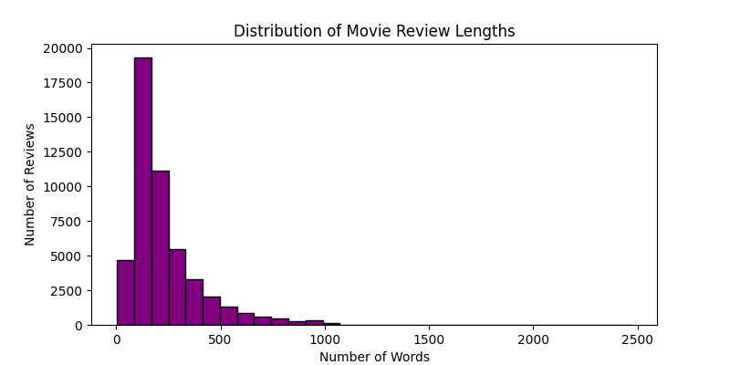
- Section 3: Preprocessing Methodology
To prepare this text for machine learning, we built a data-cleaning pipeline to standardize the text.
Operational Step | Action Taken | Why It Is Crucial
1. Lowercasing | Standardized all characters to lowercase. | Stops the computer from thinking "One" and "one" are different words.
2. HTML Stripping | Cleaned layout clutter like <br /> breaks. | Layout tags carry zero linguistic meaning and mess up patterns.
3. Punctuation Removal | Cleared out all non-alphanumeric elements. | Isolates pure words and drastically shrinks processing memory.
Real Pipeline Example:
- Raw Text Clutter: "One of the other reviewers has mentioned that after watching just 1 Oz episode you'll be hooked..."
- Cleaned Text Output: "one of the other reviewers has mentioned that after watching just 1 oz episode youll be hooked..."
Section 4: System Challenges & Reflections
- The Sarcasm Blindspot: Basic word counting will struggle with sarcasm. For example, a user writing, "What a masterpiece, I lasted ten whole minutes before turning it off," uses positive keywords like "masterpiece" to deliver a highly negative review.
- The Negation Trap: Blindly dropping words during advanced processing can ruin meaning. If a system handles the phrase "not horrible" and accidentally drops the word "not", the computer parses the token "horrible", completely reversing the intent of the review.

