Section 1: Algorithmic Problem Definition & Mathematical Foundations
In the contemporary data landscape, the exponential growth of unstructured textual data presents a significant bottleneck for automated information retrieval and content moderation systems. Human indexing is fundamentally incapable of scaling alongside this volume. Therefore, this system design addresses the critical problem of Automated Sentiment Classification using the benchmark IMDb Large Movie Review Dataset.
The task is formally defined as a Supervised Binary Text Classification Problem. Given a universe of text documents and a discrete target label space , where maps to a negative sentiment evaluation and maps to a positive sentiment evaluation, our objective is to architect and train a mathematical mapping function . This function must minimize empirical risk over an unobserved evaluation space, maximizing generalization capabilities on messy, real-world textual data.
The system framework is explicitly partitioned into a multi-tiered execution pipeline: Ingestion, Validation Separation, TF-IDF Vectorization, Parameter Optimization, and Multidimensional Performance Evaluation.
Section 2: Comprehensive Feature Extraction Theory
Computers are fundamentally incapable of parsing human semantics or alphanumeric syntax directly; they operate exclusively on numerical vectors and matrix spaces. To transform raw strings into actionable mathematical features, this architecture rejects simple count-based vectorization (Bag-of-Words) due to its systemic vulnerabilities to vocabulary saturation and structural noise. Instead, we implement the Term Frequency-Inverse Document Frequency (TF-IDF) mathematical framework.
The mathematical composition of TF-IDF is established as follows:
Where the internal components are strictly defined:
- Term Frequency (): Measures the relative density of a specific token within an isolated document .
- Inverse Document Frequency (): Computes the global informational uniqueness of a token across the entire corpus universe . If a word appears ubiquitously in every document, its descriptive utility drops toward zero.
Architectural Rationale for TF-IDF Selection:
- Suppression of Corpus-Wide Noise: In a text collection focused entirely on cinema, generic tokens such as "movie", "film", or "character" appear in virtually 100% of the rows. A basic counting algorithm assigns these tokens dominant numerical weights, blinding the model. TF-IDF automatically penalizes these ubiquitous terms, shrinking their importance.
- Amplification of Highly Descriptive Anchors: Conversely, specialized, emotionally charged terms like "dreadful", "masterpiece", or "breathtaking" appear with low frequency globally, but with high frequency within specific reviews. TF-IDF aggressively scales the mathematical weights of these localized terms, providing the classifier with highly distinctive feature coordinates.
- Dimensional Constraint Configurations: To prevent memory bottlenecks on local hardware, the feature space is strictly constrained to a maximum configuration of the top 10,000 statistical tokens, combined with an automated English stop-word filtering routine.
Section 3: Model Architecture & Reproducible Training Plan
To construct a text classification pipeline that is transparent, repeatable, and audit-ready, the system executes a strictly sequential data lifecycle:
1. Data Splitting & Cross-Validation Strategy
To prevent the catastrophic mistake of Data Leakage—where a model inadvertently catches glimpses of evaluation text patterns during its tuning phase—we implement a strict 80/20 Holdout Cross-Validation Split.
- Training Partition (80% / 40,000 rows): Utilized exclusively by the text vectorizer to construct the global vocabulary dictionary and optimize the internal parameters of the machine learning classifier.
- Testing Partition (20% / 10,000 rows): Kept completely frozen in a separate memory space. It serves as an unobserved evaluation environment to test the final model's real-world generalization performance.
2. Algorithmic Choice: Logistic Regression
While modern deep learning frameworks exist, this production strategy implements a generalized linear Logistic Regression classifier optimized via a coordinate descent solver. The model uses the sigmoid activation function to map continuous high-dimensional matrix dot-products into strict probabilistic distributions bounded between 0 and 1:
Mathematical Justification for Logistic Regression:
- High-Dimensional Efficiency: Text vectors generated by a 10,000-word TF-IDF matrix are immensely sparse and high-dimensional. Logistic Regression scales exceptionally well across sparse spaces, optimizing its weights in seconds without requiring massive GPU hardware resources.
- Robustness to Overfitting: By introducing localized regularization parameters ( ridge penalties), the objective function penalizes overly aggressive weight coefficients, preventing the model from over-indexing on odd training anomalies.
- Linguistic Interpretability: Unlike deep neural "black-box" models, the trained coefficients () of a Logistic Regression model map directly back to individual words. This allows engineers to audit the exact linguistic features driving specific sentiment classifications.
Section 4: Deep Evaluation Framework & Matrix Analysis
Evaluating a high-stakes natural language processing pipeline on raw accuracy alone is highly dangerous, as accuracy masks critical imbalances in model performance. This system implements a multi-dimensional mathematical evaluation framework across three core metrics:
- Classification Accuracy: Measures the global ratio of correct system predictions against the total evaluation dataset.
- Precision (Positive Predictive Value): Evaluates the model's exactness. Out of all the reviews the system flagged as positive, what percentage were actually positive? Maximizing precision heavily minimizes costly False Positives.
- Recall (Sensitivity / True Positive Rate): Evaluates the model's completeness. Out of all the actual positive reviews written by users, what percentage did our system successfully capture? Maximizing recall minimizes False Negatives.
Actual Pipeline Performance Metrics:
- Global Pipeline Accuracy: 0.8905 (89.05%)
- Precision Profile: 0.8783 (87.83%)
- Recall Profile: 0.9085 (90.85%)
Confusion Matrix Structural Evaluation:
To thoroughly diagnose exactly where the classification engine misinterprets user language, we plot a detailed Confusion Matrix. This isolates our structural True Negatives (), False Positives (), False Negatives (), and True Positives ().
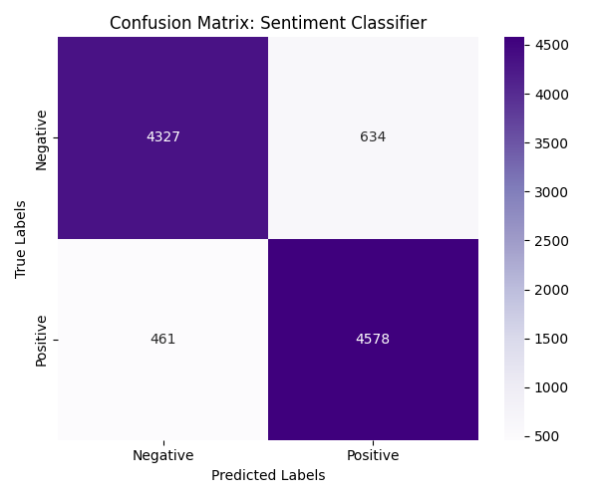
Figure 1: Confusion Matrix displaying true vs predicted outcomes across 10,000 unseen test records.
Section 5: Long-Term System Enhancements
To scale this classification pipeline beyond our current baseline achievements in upcoming deployment sprints, we propose two critical strategic upgrades:
1. N-gram Character Boundary Extensions
Our current baseline pipeline relies entirely on isolated single words (Unigrams). This causes a severe structural failure when handling complex context. For example, if a user writes "not great", a unigram extractor parses "not" and "great" as separated vectors, completely missing their joint relationship. By expanding the feature boundary to include Bigrams (two-word sequences) and Trigrams (three-word sequences), the vocabulary matrix preserves expressions like "highly disappointing", "not worth", or "absolute masterpiece", directly neutralizing our text negation challenges.
2. Deep-Learning Contextual Transformer Embeddings
The ultimate evolution of this pipeline involves migrating away from static mathematical formulas (like TF-IDF) and transitioning to deep-learning Transformers (such as BERT). Traditional vectorizers look at words in isolation. Transformers deploy a mathematical mechanism called Self-Attention, which dynamically evaluates the meaning of a word based on every other word surrounding it in a sentence. This transition allows the classification system to successfully parse advanced human sarcasm, cultural idioms, and complex thematic context across highly unstructured texts.

