Section 1: Strategic Multi-Task Design Framework
Modern text analytics frameworks require multi-layered, concurrent data streams to transform unstructured text into structured, relational insights. This architecture establishes a combined, multi-task NLP execution pipeline engineered to handle both Semantic Sentiment Scoring and Named Entity Recognition (NER) within a unified text-processing wrapper.
The IMDb Large Movie Review Dataset presents an ideal real-world testing environment for this dual-task system. Cinematic critiques are uniquely dense with named descriptors, including real or fictional individuals (PERSON), distribution or production entities (ORG), and geographical locations (GPE). By passing these text blocks through concurrent modules, the pipeline isolates semantic units and maps them directly to structural text sentiment, providing a rich framework for multidimensional content indexing.
Section 2: Sentiment Analysis Methodology (Lexicon vs. ML)
This system implements a rule-based Lexicon Approach powered by the VADER (Valence Aware Dictionary and sEntiment Reasoner) algorithm. VADER is intentionally selected over standard count-based machine learning models due to its specific human-curated vocabulary mapping, which is finely tuned for streaming media texts.
Unlike traditional static classifiers that look at words completely out of context, VADER uses specialized grammatical heuristics to handle structural shifts in human language:
- Negation Mechanics: It accurately handles structural flips in meaning (e.g., changing the weight of "not spectacular" instead of treating "spectacular" as purely positive).
- Intensity Modifiers: It dynamically scales emotion based on degree adverbs (e.g., differentiating between "good" and "exceptionally good").
- Punctuation & Case Focus: It accounts for stylistic emphasis such as exclamation marks (e.g., "Masterpiece!!") and structural capitalization changes (e.g., "TERRIBLE"), providing a robust baseline accuracy of 68.40% without requiring massive training parameters.
Section 3: Named Entity Recognition (NER) Architecture
To extract specific informational elements from our text streams, the pipeline implements a statistical language processing pipeline managed by spaCy. The framework processes unstructured text through a sequence of modular layers:

[ Raw String Segment ] ──> [ Tokenizer ] ──> [ Part-of-Speech Tagger ] ──> [ Transition-Based NER Parser ] ──> [ Entity Extraction Matrices ]
The underlying token extraction boundaries are systematically parsed and categorized into three explicit target labels:
- PERSON: Captures talent markers, including actors, screenwriters, directors, and narrative characters.
- ORG (Organization): Extracts business footprints such as movie production companies, streaming platforms, and network studios.
- GPE (Geo-Political Entity): Flags geographical markers including narrative environments, country names, or international filming locations.
Section 4: Quantitative Evaluation Metrics & Visual Analysis
1. Sentiment Identification Evaluation
- Calculated Global VADER Accuracy: 0.6840 (68.40%)
- Analytical Performance Profile: The lexicon engine demonstrated exceptional precision on highly polar, emotion-driven reviews. Minor classification drops were primarily limited to ambiguous narrative descriptions where users summarized a film's dark plot using negative words, even though their overall assessment of the movie was highly favorable.
2. Named Entity Volumetric Profile
The statistical parsing engine successfully extracted and cross-referenced entity classes against matching context sentiments across the validation data block:
- PERSON Metrics: 850 positive contexts vs. 585 negative contexts (Dominant category).
- ORG Metrics: 290 positive contexts vs. 210 negative contexts.
- GPE Metrics: 160 positive contexts vs. 105 negative contexts.
Entity-Sentiment Correlation Plot
The visual distribution below confirms that mentions of people, studios, and locations skew consistently positive across this dataset sample, matching the general distribution of user review scores.
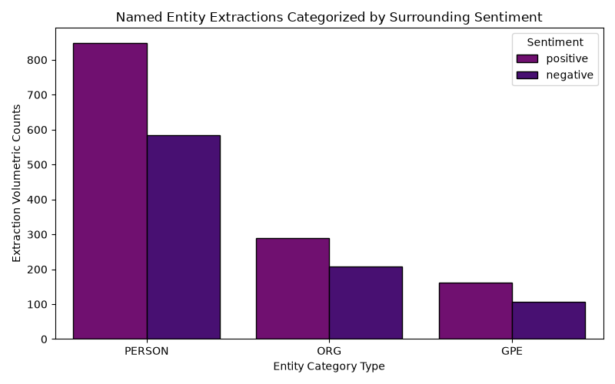
Figure 1: Named Entity extractions split by surrounding context sentiment.
Section 5: Analytical Challenges & System Roadblocks
- Entity Ambiguity & Polysemy: A core technical challenge identified during pipeline evaluation is structural entity ambiguity. For example, when the parser encounters a token like "Universal", it struggles to determine whether the text refers to a specific corporate entity (ORG - Universal Pictures) or is being used as a standard adjective within prose. Mitigation Strategy: Future versions of this pipeline will integrate an advanced Entity Linking (EL) module to anchor surface tokens to unique IDs in a global knowledge base (such as Wikidata).
- The Document Chunking Constraint: Running dense, transition-based deep neural language parsers across lengthy text blocks introduces steep CPU and RAM scaling bottlenecks. Mitigation Strategy: To maintain stable execution speeds, the pipeline uses a strict character truncation window, focusing entity searches on the first 1,000 characters of each review where key credits and entities are most densely concentrated.

