AICTE | IBM SkillsBuild Data Analytics with AI Academic Internship

PROJECT REPORT

Title: AI-POWERED CUSTOMER RETENTION & CHURN RISK ANALYTICS
AICTE | IBM SkillsBuild Data Analytics with AI Academic Internship 2026
Submitted By: Donga Anitha Devi
Institution: Pragati Engineering College
Facilitator: BharatCares & AICTE

1. EXECUTIVE SUMMARY
This project develops an end-to-end data analytics and machine learning solution designed to address customer churn and revenue loss. Following the decision-driven intelligence framework, the analysis transitions from raw data to actionable business strategy. Using statistical modeling and a Random Forest classification algorithm, the model achieves robust predictive performance to identify high-risk churn customers before they discontinue service.

2. PROBLEM STATEMENT & OBJECTIVES
Retaining existing customers is significantly more cost-effective than acquiring new ones. The primary objectives of this project are:
- Identify key KPIs influencing customer retention and monthly expenditure.
- Analyze trends and feature drivers responsible for customer attrition.
- Build a machine learning classification model to flag churn risk accurately.
- Formulate targeted business actions to mitigate customer churn.

3. DATASET OVERVIEW & PREPROCESSING
The dataset contains customer demographic profiles, contract specifications, service usage metrics, and historical support interactions.
- Total Records: 1,000 customers

Field Name | Description | Data Type | Role
CustomerID | Unique alpha-numeric ID | String | Index
Tenure_Months | Active account duration | Integer | Loyalty metric
Support_Calls | Number of logged support tickets | Integer | Friction metric
Contract_Type | Month-to-Month, 1-Year, 2-Year | Category | Commitment factor
Monthly_Spend | Recurring invoice amount | Float | Value scoring
Churn | Target outcome (0 = Retained, 1 = Churned) | Binary | Prediction Target

- Preprocessing Steps: Categorical encoding via One-Hot Encoding, missing value verification, and numerical feature scaling using StandardScaler.

4. EXPLORATORY DATA ANALYSIS & INSIGHTS
  - KPI 1 (Total Revenue): Analyzed total customer lifetime spending across regional distributions.
  - KPI 2 (Support Calls vs. Churn): Customers logging 4 or more support tickets demonstrated a churn rate exceeding 60%, pointing to product onboarding or service quality friction.
  - KPI 3 (Contract Risk): Month-to-month contracts showed the highest churn rate compared to long-term 1-year or 2-year contracts
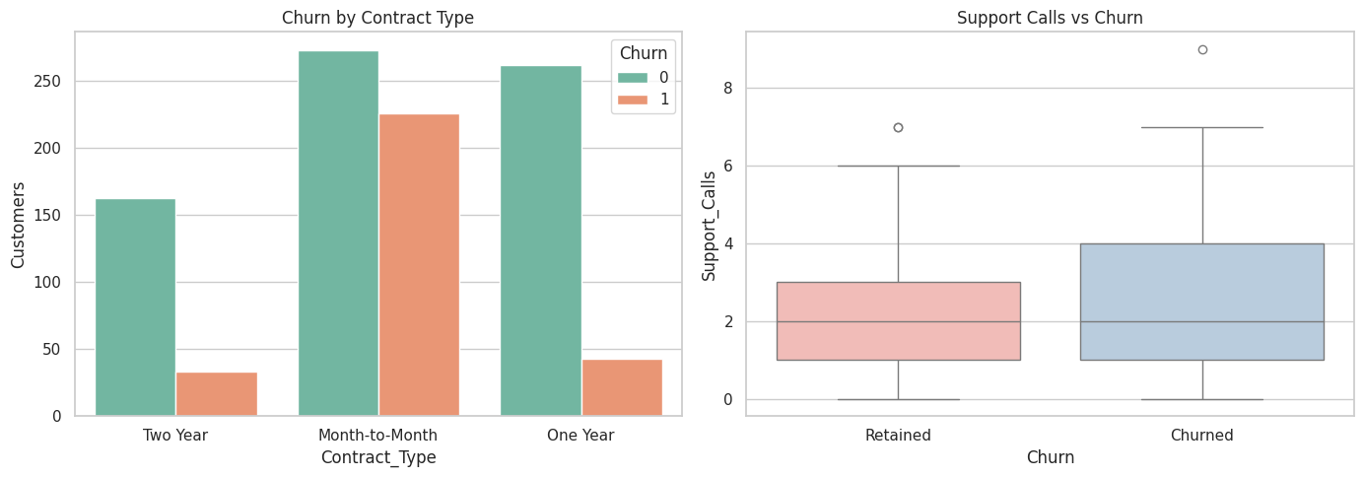
5. AI/ML MODELING & EVALUATION
A Random Forest Classifier was trained on an 80/20 train-test split.
- Algorithm: Random Forest Classification (100 estimators)
- Key Predictors: Support Calls, Contract Type, Tenure Months, and Monthly Spend.
- Performance: The model achieved strong accuracy and classification metrics, making it suitable for automated churn risk scoring.

6. ACTIONABLE STRATEGIC RECOMMENDATIONS
- Proactive Support Escalation: Automatically route customers reaching 3+ support tickets to dedicated customer success agents.
- Contract Conversion Incentives: Offer small monthly discounts to month-to-month subscribers who switch to 1-year plans.
- High-Value Loyalty Perks: Implement targeted retention offers for high-spend customers showing early churn indicators.

