NIP Project — Submission Template
Pega Platform project · This document is your complete submission
Read this before you start:
1. Fill in Section 1 completely. The Pega application name must follow the format NIP-[Project]-[YourName].
2. Create a new Operator in Pega with your full name and log in as that operator before taking any screenshot.
3. When you create your test case, enter YOUR FULL NAME in the Issue Description (Vehicle) or Movie Name (Movie) field.
4. Complete only the section for your chosen project. Delete the other project section.
5. Paste one screenshot per user story (10 total). Follow the screenshot rules in your selected project section.
6. Answer every question in Sections 3 and 4 in your own words.
7. Save the file using this format: ProjectName_FirstName_LastName.docx. Use VehicleService or MovieTicket as the ProjectName. Examples: VehicleService_Ravi_Kumar.docx or MovieTicket_Ravi_Kumar.docx.

Section 1 — Your Details
Full Name | Donga Anitha Devi
Email ID (registered on NIP) | anithadevidonga@gmail.com
Phone Number | 9398505610
College Name | Pragati Engineering College
Course (e.g. IT, CS) | B.Tech Computer Science and Data Science
State | Andhra Pradesh
Project Chosen (Vehicle Service OR Movie Ticket Booking) | Movie Ticket Booking
Pega Application Name (e.g. NIP-VehicleService-YourName) | NIP-MovieTicket-AnithaDeviDonga
Case Type Name (exact) | Movie Ticket Request
Pega Instance URL | https://zu9mdwcc.pegaacademy.net/prweb/
Operator Name (created in Pega with your full name) | Donga Anitha Devi

Section 2A — Vehicle Service Management Application
Complete this section only if you selected this project. Delete the other project section before submitting.

Screenshot rules — IMPORTANT before you start:
1. Name your Pega application as: NIP-VehicleService-YourName OR NIP-MovieTicket-YourName
2. Create a new Operator in Pega with your full name (Security → Operators) and log in as that operator.
3. When you create your test case, enter YOUR FULL NAME in the Issue Description (Vehicle) or Movie Name (Movie) field.
4. The logged-in operator name must be visible in every screenshot wherever the Pega interface displays it.
5. The student's full name must be visible in all running-case screenshots.
6. Configuration screenshots must clearly show the relevant application or rule name.
Screenshots that do not show these will not be accepted.

US-001 — Submit Vehicle Service Request
What is expected:
Case created, customer submits Vehicle ID, Vehicle Model, Issue Description. Validation applied.
Screenshot — paste your screenshot below this line:
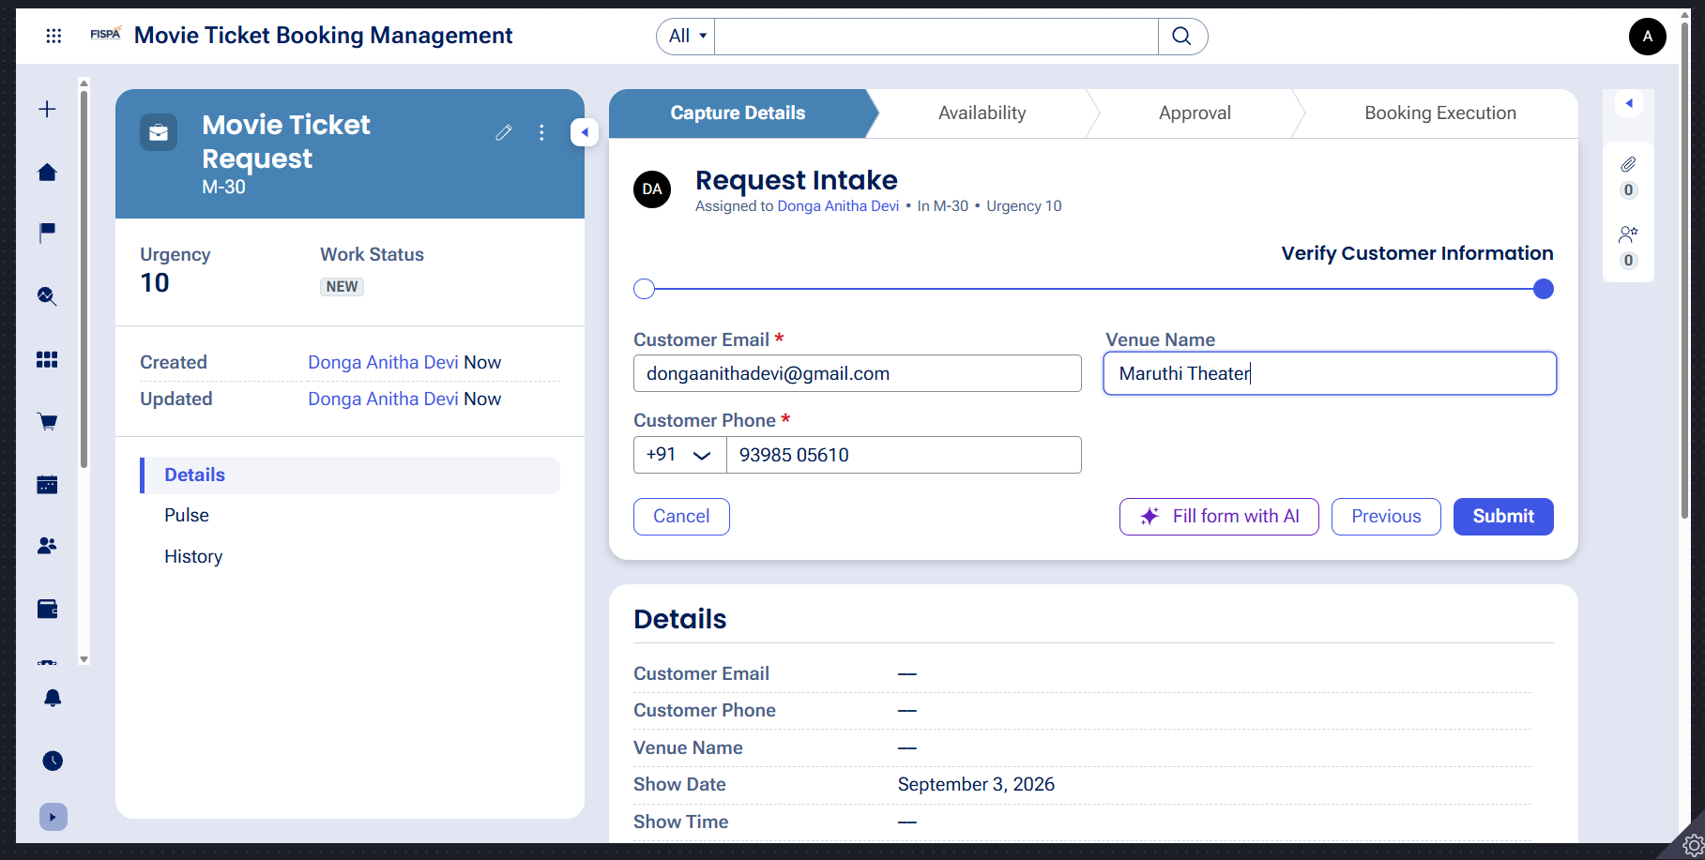

What I built for this (1–2 lines in your own words):
Configured the Request Intake form within the Capture Details stage with required validations to capture customer contact details, venue name, show timing, and ticket quantity.

US-002 — Perform Vehicle Inspection
What is expected:
Inspection stage with Service Advisor step. Inspection Notes and Condition Rating captured.
Screenshot — paste your screenshot below this line:
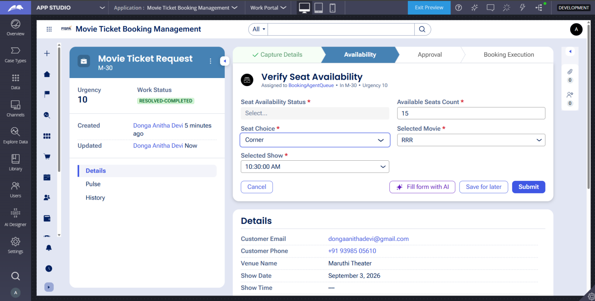

What I built for this (1–2 lines in your own words):
Implemented an Availability stage capturing Available Seats Count and Seat Availability Status to verify theater capacity before proceeding.

US-003 — Generate Service Estimate
What is expected:
Labor Cost and Parts Cost captured. Total Cost calculated automatically by declare expression.
Screenshot — paste your screenshot below this line:
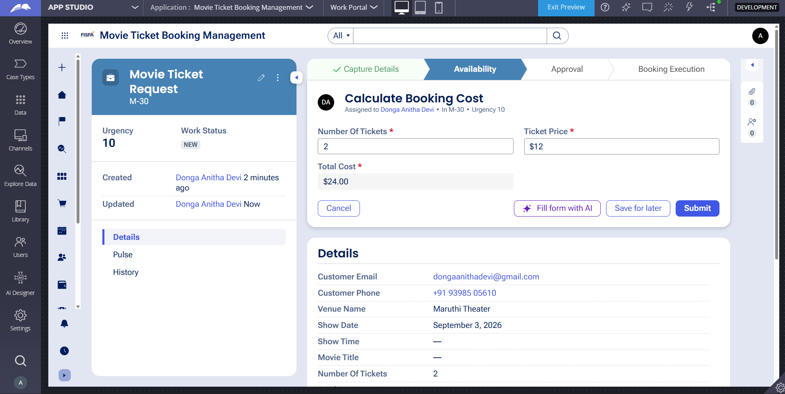

What I built for this (1–2 lines in your own words):
Configured a calculation rule that automatically computes Total Cost by multiplying Ticket Price by Number of Tickets.

US-004 — Approve Service Estimate
What is expected:
Approval stage assigned to Customer. Approval Status captured. Flow branches on approve/reject.
Screenshot — paste your screenshot below this line:
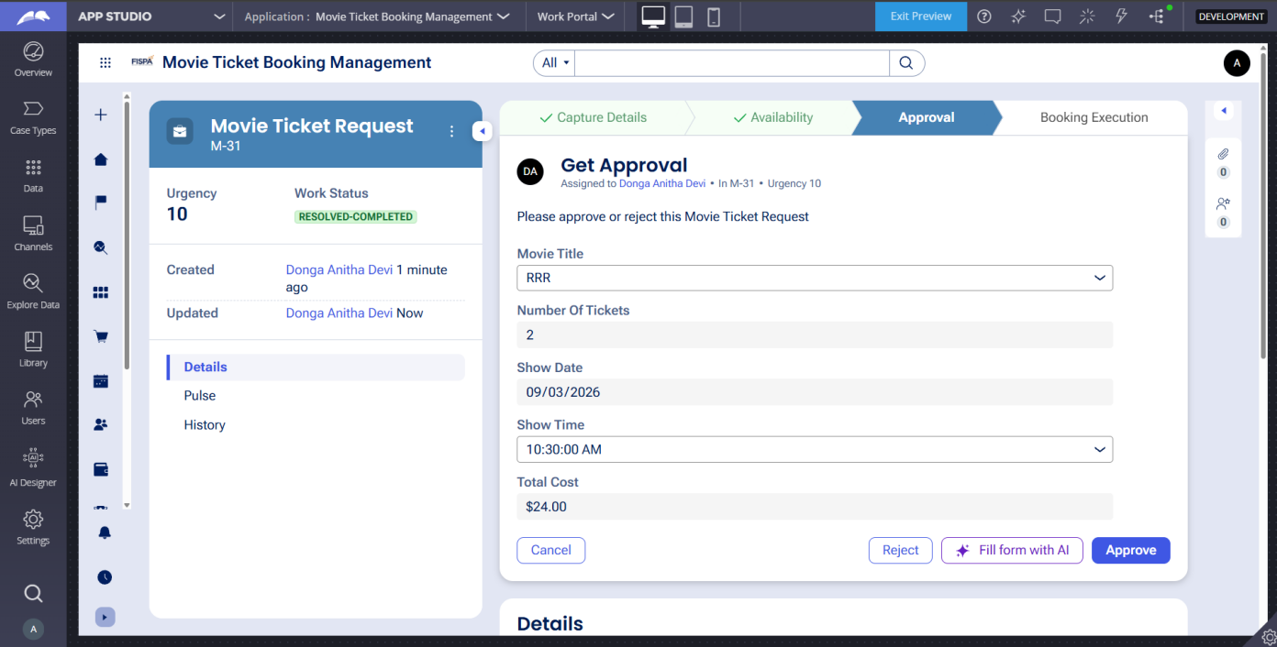

What I built for this (1–2 lines in your own words):
Implemented an Approval stage assigned to the Customer persona with Approve and Reject actions directing flow to execution or resolution.

US-005 — Maintain Vehicle Data
What is expected:
Reusable Vehicle data object created with Vehicle ID, Model, Type — linked to case.
Screenshot — paste your screenshot below this line:
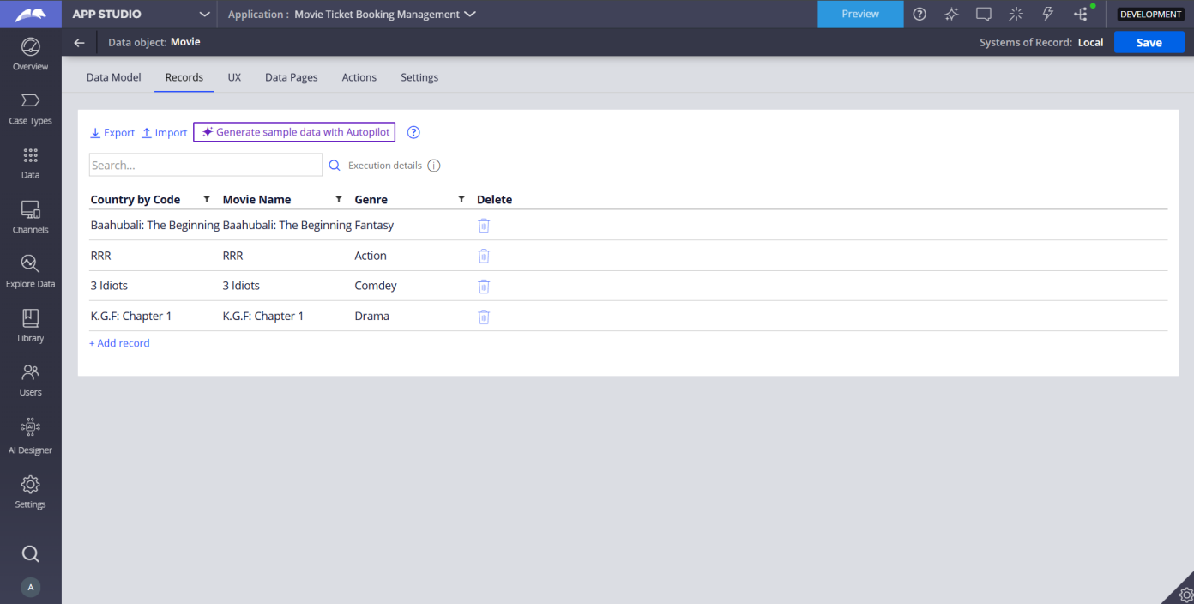

What I built for this (1–2 lines in your own words):
Created reusable Movie and Show data objects storing records for Movie Title, Genre, Show Timings, and Seat Capacity.

US-006 — Review Service Estimate
What is expected:
Approval screen shows Labor Cost, Parts Cost and Total Cost clearly to the Customer persona.
Screenshot — paste your screenshot below this line:
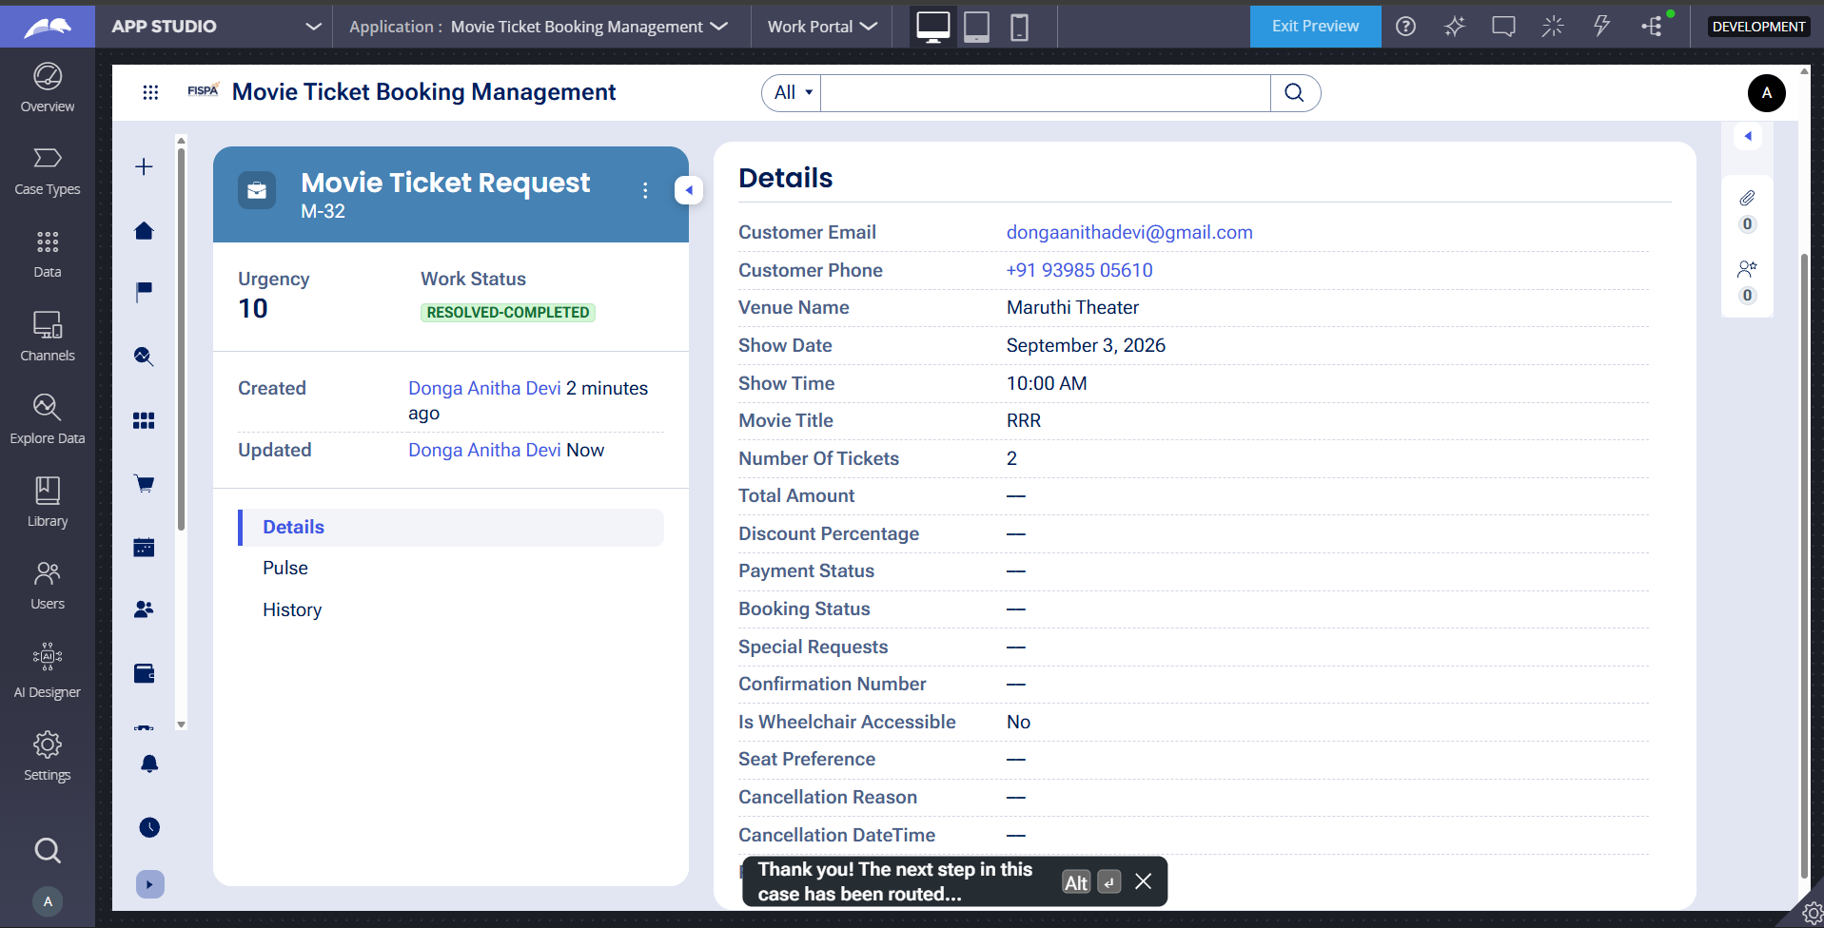

What I built for this (1–2 lines in your own words):
Built a read-only review screen displaying Movie Title, Show Date, Show Time, Number of Tickets, and calculated Total Cost for customer confirmation.

US-007 — Auto Assign Technician
What is expected:
Service Execution stage with routing to HeavyVehicleQueue or LightVehicleQueue. Assigned Technician and Service Status properties maintained.
Screenshot — paste your screenshot below this line:
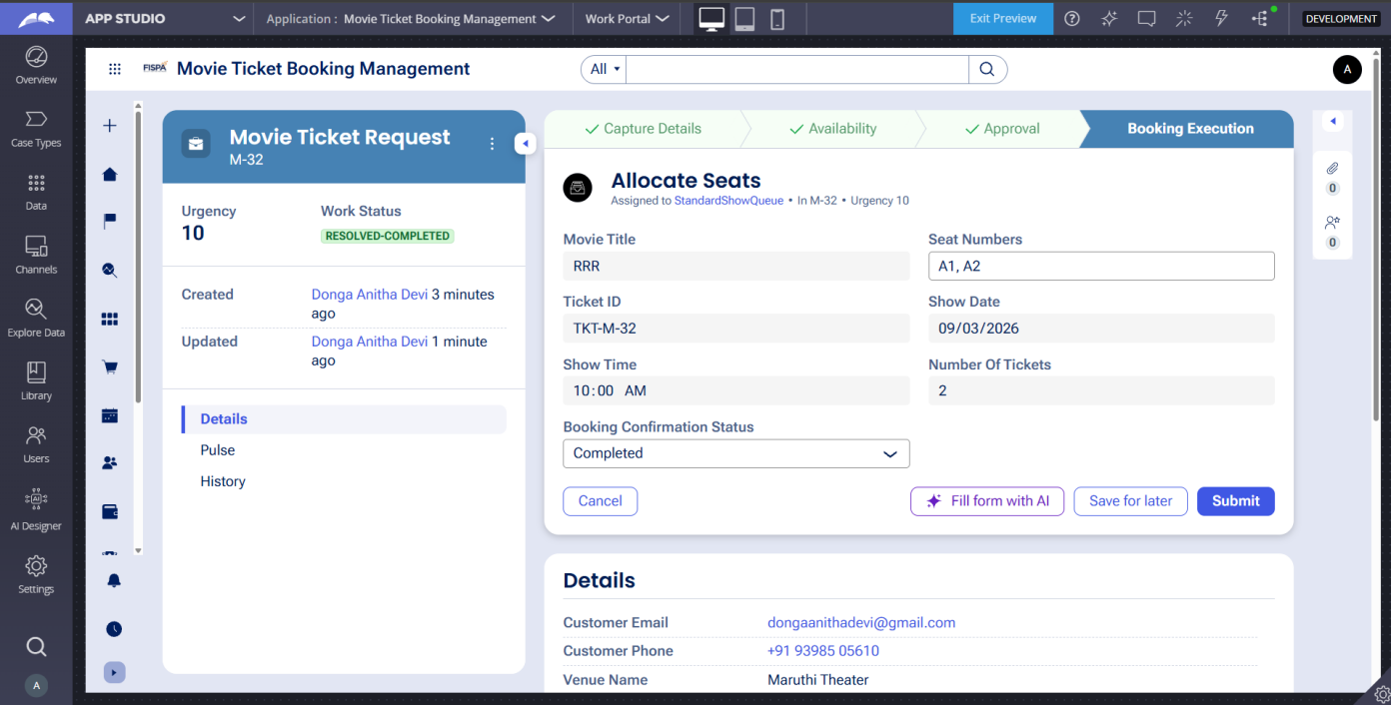

What I built for this (1–2 lines in your own words):
Configured the Allocate Seats step in the Booking Execution stage to assign Seat Numbers, generate Ticket ID, and set status to Completed.

US-008 — Notify Service Completion
What is expected:
Correspondence rule created and triggered on case resolution. Email includes case and vehicle details.
Screenshot — paste your screenshot below this line:
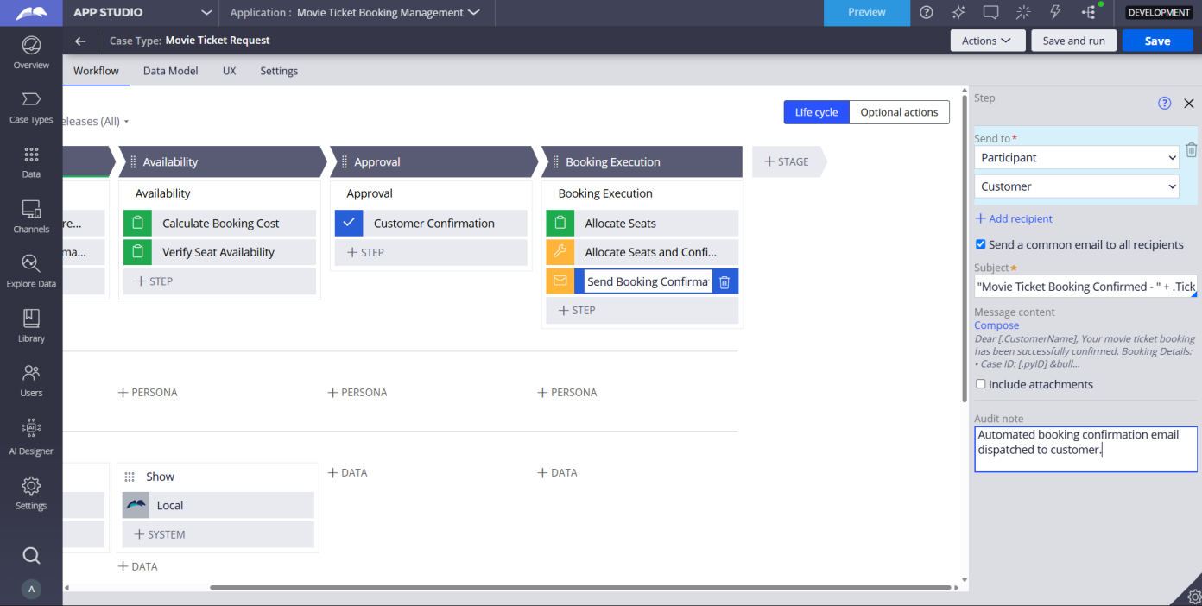

What I built for this (1–2 lines in your own words):
Created an automated Send Email correspondence step triggered upon case completion dispatching full ticket and show details to the customer.

US-009 — Define Service SLA
What is expected:
SLA configured on the case type. Goal: 2 days. Deadline: 3 days. Priority increases on breach.
Screenshot — paste your screenshot below this line:
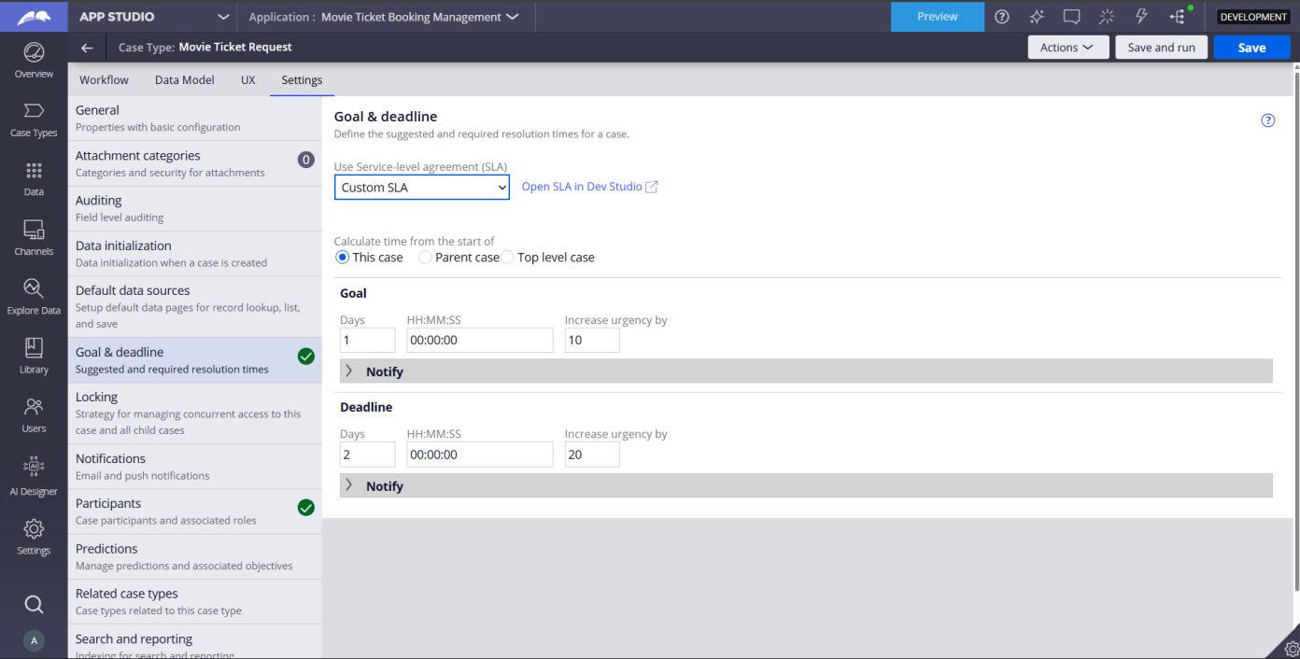

What I built for this (1–2 lines in your own words):
Configured case-level Service Level Agreement with a Goal of 1 day and a Deadline of 2 days with urgency progression.

US-010 — Route by Vehicle Type
What is expected:
Routing rule or Decision Table routes to HeavyVehicleQueue or LightVehicleQueue based on Vehicle Type property.
Screenshot — paste your screenshot below this line:
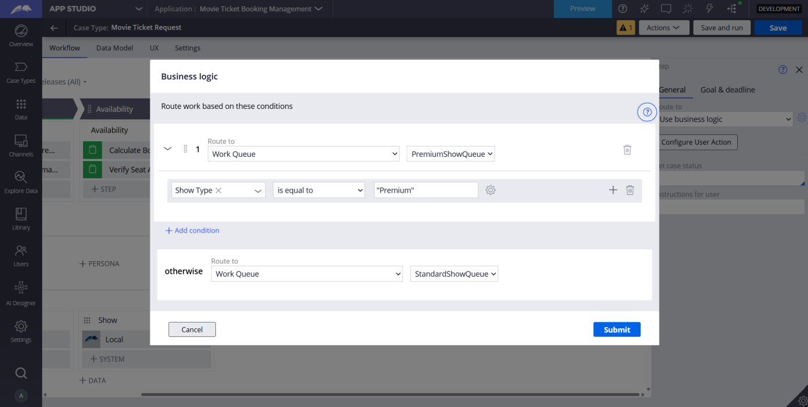

What I built for this (1–2 lines in your own words):
Implemented business logic routing on the Allocate Seats step to route cases to PremiumShowQueue for Premium shows and StandardShowQueue for Standard shows.

Section 2B — Movie Ticket Booking Management Application
Complete this section only if you selected this project. Delete the other project section before submitting.

Screenshot rules — IMPORTANT before you start:
1. Name your Pega application as: NIP-VehicleService-YourName OR NIP-MovieTicket-YourName
2. Create a new Operator in Pega with your full name (Security → Operators) and log in as that operator.
3. When you create your test case, enter YOUR FULL NAME in the Issue Description (Vehicle) or Movie Name (Movie) field.
4. The logged-in operator name must be visible in every screenshot wherever the Pega interface displays it.
5. The student's full name must be visible in all running-case screenshots.
6. Configuration screenshots must clearly show the relevant application or rule name.
Screenshots that do not show these will not be accepted.

US-001 — Submit Movie Ticket Request
What is expected:
Case created, customer submits Movie Name, Show Date, Show Time, Number of Tickets. Validation applied.
Screenshot — paste your screenshot below this line:
[ Paste screenshot here - follow the screenshot rules above ]

What I built for this (1–2 lines in your own words):
[ Type here ]

US-002 — Check Show Availability
What is expected:
Availability stage. Seat Availability Status and Available Seats Count captured. Booking proceeds only if available.
Screenshot — paste your screenshot below this line:
[ Paste screenshot here - follow the screenshot rules above ]

What I built for this (1–2 lines in your own words):
[ Type here ]

US-003 — Calculate Booking Cost
What is expected:
Total Cost calculated automatically from Ticket Price and Number of Tickets using a business rule.
Screenshot — paste your screenshot below this line:
[ Paste screenshot here - follow the screenshot rules above ]

What I built for this (1–2 lines in your own words):
[ Type here ]

US-004 — Confirm Booking Request
What is expected:
Approval stage assigned to Customer. Booking Status captured. Flow branches on confirm/cancel.
Screenshot — paste your screenshot below this line:
[ Paste screenshot here - follow the screenshot rules above ]

What I built for this (1–2 lines in your own words):
[ Type here ]

US-005 — Maintain Movie and Show Data
What is expected:
Reusable Movie and Show data objects created with Movie Name, Genre, Show Date, Show Time, Seat Capacity — linked to case.
Screenshot — paste your screenshot below this line:
[ Paste screenshot here - follow the screenshot rules above ]

What I built for this (1–2 lines in your own words):
[ Type here ]

US-006 — Review Booking Details
What is expected:
Confirmation screen shows Movie Name, Show Timing, Number of Tickets and Total Cost clearly.
Screenshot — paste your screenshot below this line:
[ Paste screenshot here - follow the screenshot rules above ]

What I built for this (1–2 lines in your own words):
[ Type here ]

US-007 — Process Ticket Booking
What is expected:
Booking Execution stage. Seat Numbers, Ticket ID and Booking Confirmation Status maintained.
Screenshot — paste your screenshot below this line:
[ Paste screenshot here - follow the screenshot rules above ]

What I built for this (1–2 lines in your own words):
[ Type here ]

US-008 — Notify Booking Confirmation
What is expected:
Correspondence rule triggered on case resolution. Email includes movie, show, seat and cost details.
Screenshot — paste your screenshot below this line:
[ Paste screenshot here - follow the screenshot rules above ]

What I built for this (1–2 lines in your own words):
[ Type here ]

US-009 — Define Booking SLA
What is expected:
SLA configured on the case type. Goal: 1 day. Deadline: 2 days. Priority increases on breach.
Screenshot — paste your screenshot below this line:
[ Paste screenshot here - follow the screenshot rules above ]

What I built for this (1–2 lines in your own words):
[ Type here ]

US-010 — Route by Show Type
What is expected:
Routing rule or Decision Table routes to PremiumShowQueue or StandardShowQueue based on Show Type property.
Screenshot — paste your screenshot below this line:
[ Paste screenshot here - follow the screenshot rules above ]

What I built for this (1–2 lines in your own words):
[ Type here ]

Section 3 — About Your Application
These answers are checked against your screenshots. Write exactly what is in your application.

Q1. List your stages in the order they appear in your case lifecycle.
Stage names in order, separated by commas.
[ Type here ]

Q2. Name the data object(s) you created and the properties inside them.
Data object name and its properties.
[ Type here ]

Q3. What is the exact name and type of the rule you used to calculate Total Cost?
Provide:
• Rule Name
• Rule Type
• Properties used in the calculation
• Formula used
[ Type here ]

Section 4 — Your Understanding
Short, honest and specific answers score well.

Q4. What did Blueprint generate for you, and what did you add or change yourself afterwards?
Be specific about what was already there and what you built or modified on top.
[ Type here ]

Q5. Was there anything Blueprint created that you had to correct or configure further? Describe one example.
A real example from your own work.
[ Type here ]

Q6. Explain your case flow from creation to resolution, in order.
What happens first, who does what, when the case closes.
[ Type here ]

Q7. Pick two design choices you made in your application and explain why you made them.
For each design choice, provide:
• What you implemented
• Why you chose that approach
• What benefit it provides to the application
[ Type here ]

Q8. What was the hardest part, and how exactly did you fix it?
Specific and honest. A real challenge scores much better than a generic answer.
[ Type here ]

Q9. If the approval step was only needed when Total Cost is above a certain amount, what would you change in your application?
Explain what you would change and where. You do not need to build this.
[ Type here ]

Q10. List three exact rule names from your application that you personally created or modified.
Include the rule name and rule type for each one (for example: CalculateTotalCost - Declare Expression).
[ Type here ]

Q11. List all personas used in your application.
List the persona names exactly as they appear in your application.
[ Type here ]

Q12. List all work queues used in your application and explain when each one is used.
For each work queue, provide its exact name and the condition or type of work routed to it.
[ Type here ]

Before You Submit — Check These
Read through once before uploading.
1. Section 1 filled in. Application named as NIP-[Project]-[YourName]. Names match the actual application.
2. New Operator created in Pega with my full name. I logged in as that operator for all screenshots.
3. Only my chosen project section remains — the other project section is deleted.
4. All 10 user story screenshots are pasted and follow the operator, running-case, application, and rule-name evidence requirements.
5. Every question in Sections 3 and 4, including Q10, Q11, and Q12, is answered in my own words.
6. This file is named using the required format: ProjectName_FirstName_LastName.docx (for example, VehicleService_Ravi_Kumar.docx or MovieTicket_Ravi_Kumar.docx) and uploaded as required.

