1. What is VCS (Version Control System)?
A Version Control System (VCS) is a tool that helps developers track changes in source code over time. It allows multiple people to work on a project simultaneously without conflicts.

Types of VCS

1. Local Version Control System
- Stores versions on a local machine.
- Example: RCS
- Risk: Data loss if system fails.

2. Centralized Version Control System (CVCS)
- Uses a central server to store all versions.
- Developers commit changes to the central repository.
- Example: Subversion (SVN)
- Risk: If server fails, work is lost.

3. Distributed Version Control System (DVCS)
- Every developer has a full copy of the repository.
- Works offline and is more secure.
- Example: Git
- Faster and safer.

2. What is Git and GitHub?

What is Git?
- Git is a distributed version control system.
- Created by Linus Torvalds in 2005.
- Tracks changes in files and coordinates work among developers.
- Works locally on your machine.

What is GitHub?
- GitHub is a cloud-based platform that hosts Git repositories.
- Provides collaboration features like pull requests, issues, and actions.
- Owned by Microsoft.
Difference:
- Git = Tool
- GitHub = Platform that uses Git

3. Git 3-Tree Architecture

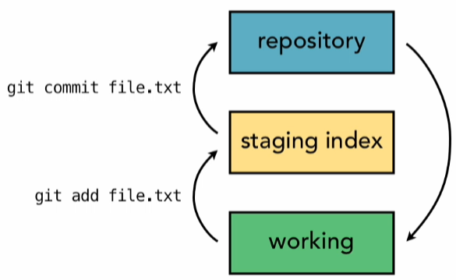
Git works with a 3-tree architecture, meaning it manages files in three areas:

1. Working Directory
- Your project folder.
- Where you create/edit files.

2. Staging Area (Index)
- Temporary area to prepare changes before commit.
- Files are added using git add.

3. Repository (Local Repo)
- Stores committed changes permanently.
- Managed by Git.

Flow:

Working Directory → Staging Area → Repository
(edit) (add) (commit)

4. Git Commands

Basic Commands

Initialize Repository
git init

Clone Repository
git clone <repo_url>

Check Status
git status

Add Files to Staging
git add <file_name>
git add .

Commit Changes
git commit -m "message"

Branching Commands

Create Branch
git branch branch_name

Switch Branch
git checkout branch_name

Create & Switch
git checkout -b branch_name

Remote Repository Commands

Add Remote
git remote add origin <repo_url>

Push Code
git push origin main

Pull Changes
git pull origin main

Fetch Changes
git fetch

Other Useful Commands

View Commit History
git log

Undo Changes
git reset --hard HEAD

Remove File
git rm file_name

