KUMARAGURU COLLEGE OF TECHNOLOGY

DEPARTMENT OF ARTIFICAL INTELGINCE AND DATA SCIENCE

24AD1204 – DATA SCIENCE AND VISULIZATION

NAME | ROLLNO
GOKULNAATH M | 24BAD026
JAYARAKSHA REGURAJ | 24BAD044
KAMALESH N | 24BAD054
NISHANTH P | 24BAD405

Submitted to
Mrs. E Shriaarthy

Week No: 1 Team Formation & Data Hunting

Objectives:
Selection of dataset. Setting up GitHub. Introduction to Pandas/NumPy.

Team Composition:
NAME | ROLES
GOKULNAATH M | DATA ENGINEER
JAYARAKSHA REGURAJ | STORYTELLER
KAMALESH N | DATA ANALYST
NISHANTH P | DATA VISUALIZATION
Work done:
1. Domain Selection and Problem Statement Abstract
Team Contribution:
1. Dataset Selection & Evaluation
Gokulnaath M – 24BAD028
Dataset 1
Heart Attack Prediction Dataset
https://www.kaggle.com/datasets/iamsouravbanerjee/heart-attack-prediction-dataset
Characteristics
- Low / limited attributes
- Low object (record) count
- Semi-structured data
Pros
- Uncleaned dataset – ideal for demonstrating data preprocessing, handling missing values, and noise reduction
- Simple structure, easy to understand feature relationships
- Good for baseline model development
Cons
- Limited number of attributes restricts deep risk factor analysis
- Small dataset size reduces model generalization
- Not suitable alone for dimensionality reduction showcase
Jayaraksha Reguraj – 24BAD044
Dataset 2
Heart Disease Dataset
https://www.kaggle.com/datasets/johnsmith88/heart-disease-dataset
Characteristics
- Already cleaned and pre-processed
- Low / limited object count
Pros
- Clean and ready for quick model training
- Good for algorithm comparison
- Minimal preprocessing effort required
Cons
- Already cleaned – not ideal for project requirements that demand full preprocessing pipeline
- Less opportunity to demonstrate data cleaning skills
- Limited data volume

Kamalesh N – 24BAD054

Dataset 3 (Finalized Dataset)
Heart Disease Prediction using Logistic Regression
https://www.kaggle.com/datasets/dileep070/heart-disease-prediction-using-logistic-regression
Characteristics
- Good number of attributes
- Dataset is not pre-processed
Pros
- Uncleaned dataset – perfectly aligned with project requirement to perform:
Data cleaning
Feature scaling
Dimensionality reduction (PCA)
- Balanced attribute set supports risk score generation
- Suitable for end-to-end ML pipeline
Cons
- Requires significant preprocessing effort
- Noise and missing values may affect initial model performance
- Needs careful feature engineering

Nishanth P – 24BAD405

Dataset 4
Framingham Heart Study Dataset
https://www.kaggle.com/datasets/amanajmera1/framingham-heart-study-dataset
Characteristics
- Long-term cardiovascular study data
- Moderate to high attribute count
- Includes demographic, behavioural, and medical risk factors
Pros
- Raw / uncleaned dataset – excellent for showcasing:
Missing value handling
Outlier detection
Feature transformation
- Rich clinical depth enables strong risk factor interpretation
- Ideal for dimensionality reduction & risk score modeling
Cons
- Requires extensive preprocessing
- Some attributes may need domain understanding
- Higher complexity compared to smaller datasets

Summary Comparison Table
Dataset | Pre-processed | Attribute Count | Object Count | Suitability
Dataset 1 | No | Low | Low | Basic preprocessing demo
Dataset 2 | Yes | Low | Low | Model testing only
Dataset 3 (Final) | No | High | Medium | Best fit for project
Dataset 4 | No | High | Medium | Advanced analysis

2. Setting up GitHub
All *
Procedure
- Create GitHub Repositories with name “24ADI204_DSV_Team14”
- Add Description of
"Heartbeats & Habits" combats the silent threat of cardiovascular disease by applying rigorous cleaning and dimensionality reduction to noisy clinical data. This approach transforms complex biomarker and lifestyle interactions into a unified "Risk Score," visualizing a clear path to improved cardiac health
- Add README.md

3. Introduction to Pandas/NumPy
All *
Procedure
- Research and learn the basic concept of NumPy
- Research and learn the basic concept of Pandas

Resources and References
- Dataset
  - https://www.kaggle.com/datasets/iamsouravbanerjee/heart-attack-prediction-dataset
  - https://www.kaggle.com/datasets/johnsmith88/heart-disease-dataset
  - https://www.kaggle.com/datasets/dileep070/heart-disease-prediction-using-logistic-regression
  - https://www.kaggle.com/datasets/amanajmera1/framingham-heart-study-dataset

- GitHub
  - https://github.com/Gokulnaath-gif/24ADI204_DSV_Team14

- Learns
  - https://numpy.org/doc/stable/user/index.html#user
  - https://www.w3schools.com/python/numpy/numpy_intro.asp
  - https://pandas.pydata.org/docs/user_guide/index.html
  - https://www.w3schools.com/python/pandas/default.asp

Week No: 2 Know Your Data

Objectives:
Loading data, checking types, inspecting the structure.

Work done:
1. Load Data and Analyses Dataset

Gokulnaath M – 24BAD028, Nishanth P – 24BAD405

Procedure
1. Load the Dataset

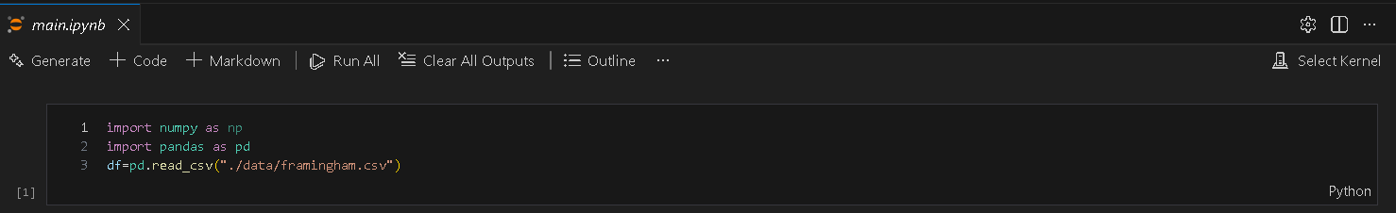

2. Data Structure
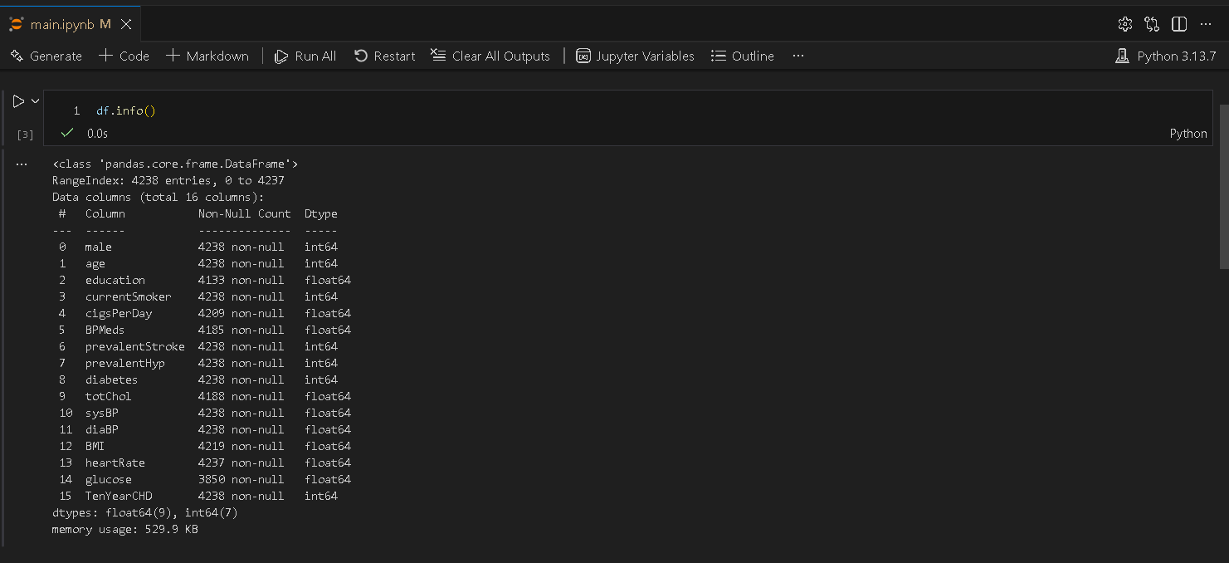

3. Data Statistical Information
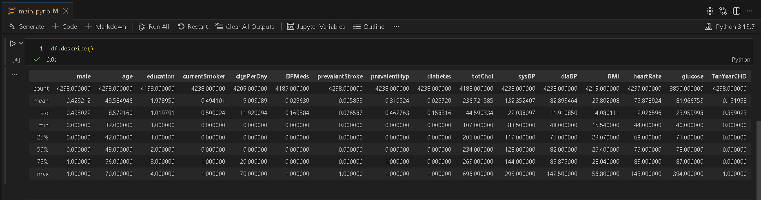

4. Data Structure and Inspecting Null Values
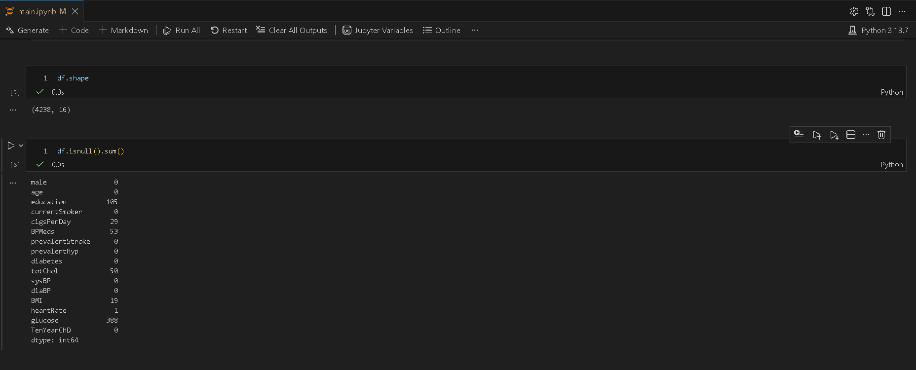

2. “First Impression” report.

Jayaraksha Reguraj – 24BAD044, Kamalesh N – 24BAD054

Report

1. Dataset Overview
The dataset used for this analysis is the Framingham Heart Study dataset, which contains medical and lifestyle information of patients. The primary objective of the dataset is to predict the 10-year risk of coronary heart disease (CHD).
- Number of records: 4,240
- Number of features: 16
- Target variable: TenYearCHD (binary: 0 = No CHD, 1 = CHD)

2. Data Structure
- The dataset consists of numerical features (both integer and float types).
- Variables include:
Demographic features: age, sex
Behavioural features: smoking status, cigarettes per day
Medical history: blood pressure medication, diabetes, stroke history
Clinical measurements: cholesterol, systolic & diastolic BP, BMI, heart rate, glucose

3. Data Types
- Most features are of type int64 or float64.
- The target variable TenYearCHD is an integer categorical variable representing a binary outcome.
- No categorical string variables are present, reducing the need for encoding at this stage.

4. Missing Values
- Several columns contain missing values, including:
    - education
    - cigsPerDay
    - BPMeds
    - totChol
    - BMI
    - heartRate
    - glucose

5. Initial Observations
- The dataset appears realistic and noisy, which is expected in medical data.
- Feature scales vary significantly (e.g., age vs. cholesterol vs. glucose), suggesting the need for feature scaling before modeling.
- The target variable is imbalanced, with fewer positive CHD cases compared to negative ones, which may affect model performance.

6. Data Quality Assessment
- No duplicate rows were observed.
- No obvious data corruption or invalid values were detected during initial inspection.
- Presence of missing values is the main data quality concern.

7. Overall, First Impression
The dataset is:
- Well-structured
- Relevant for classification tasks
- Contains missing values
- Requires preprocessing and scaling
- Potential class imbalance in the target variable
Resources and References
- Dataset
  - https://www.kaggle.com/datasets/dileep070/heart-disease-prediction-using-logistic-regression

- GitHub
  - https://github.com/Gokulnaath-gif/24ADI204_DSV_Team14

Week No: 3 The Cleaning Sprint

Objectives:
Handling Missing Values (Imputation strategies) and Outlier Detection (Boxplots/Z-score).

Work done:
1. Handling Null Values

Gokulnaath M – 24BAD028, Nishanth P – 24BAD405

- Attributes Contains Null Values
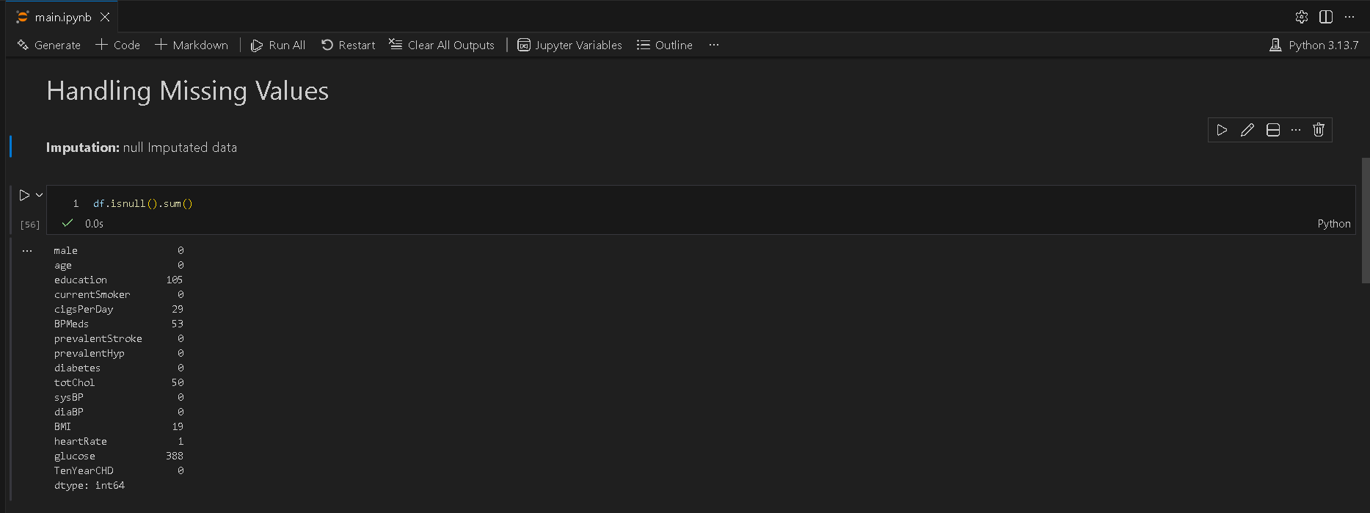

- Selecting Categorical and Numerical Attributes
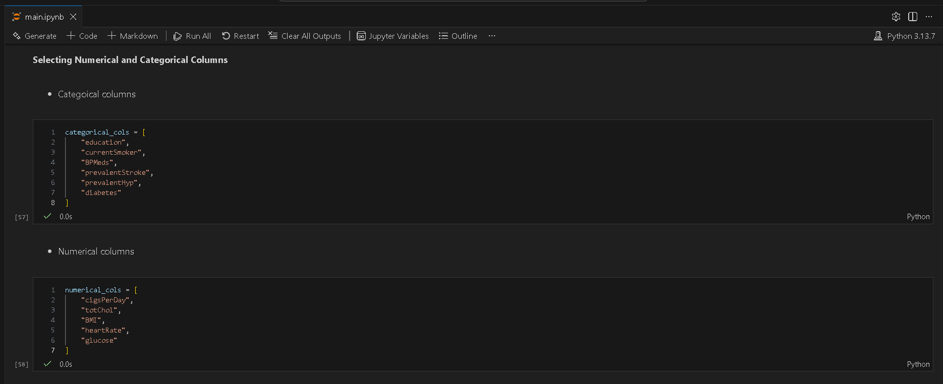

- Imputation of Categorical Attributes (Mode)
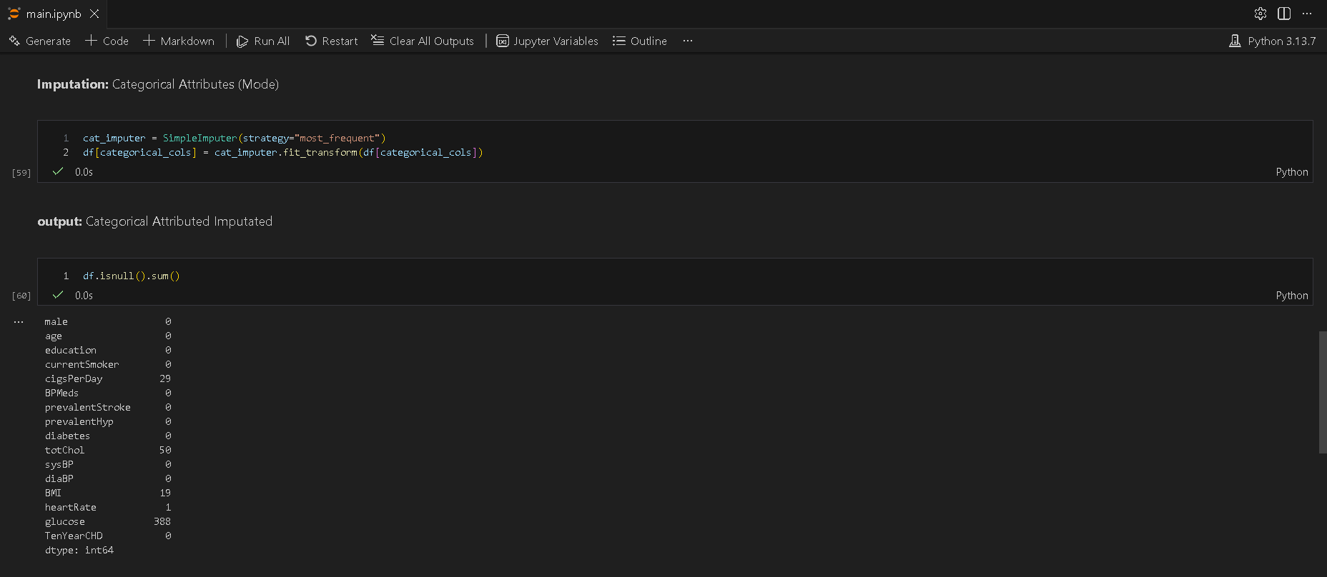

- Imputation of Numerical Attributes (Median)
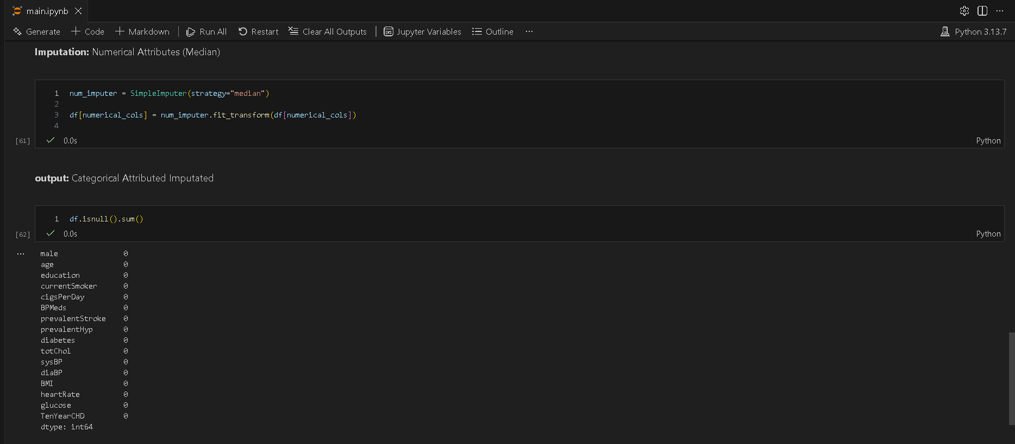

2. Handling Outliers values
Jayaraksha Reguraj – 24BAD044, Kamalesh N – 24BAD054

- Outlier Detections using Boxplot
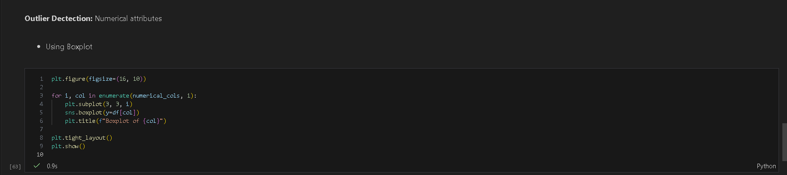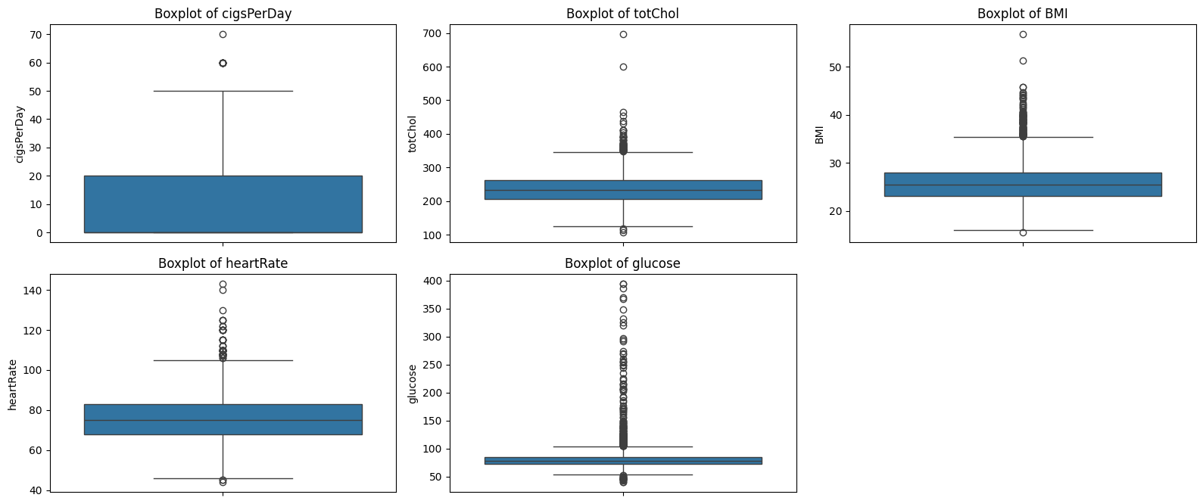

- Outlier Detections using Z-Score
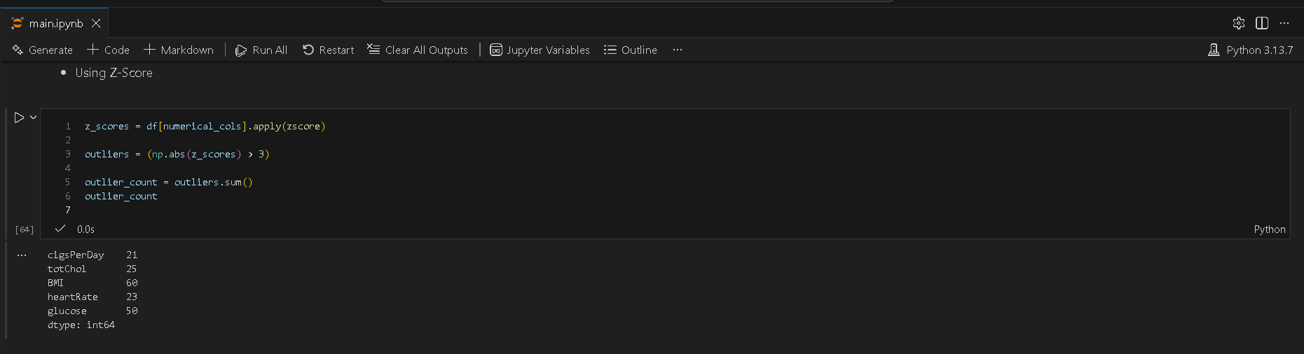

- Outlier Fixing
- Select Outlier Columns
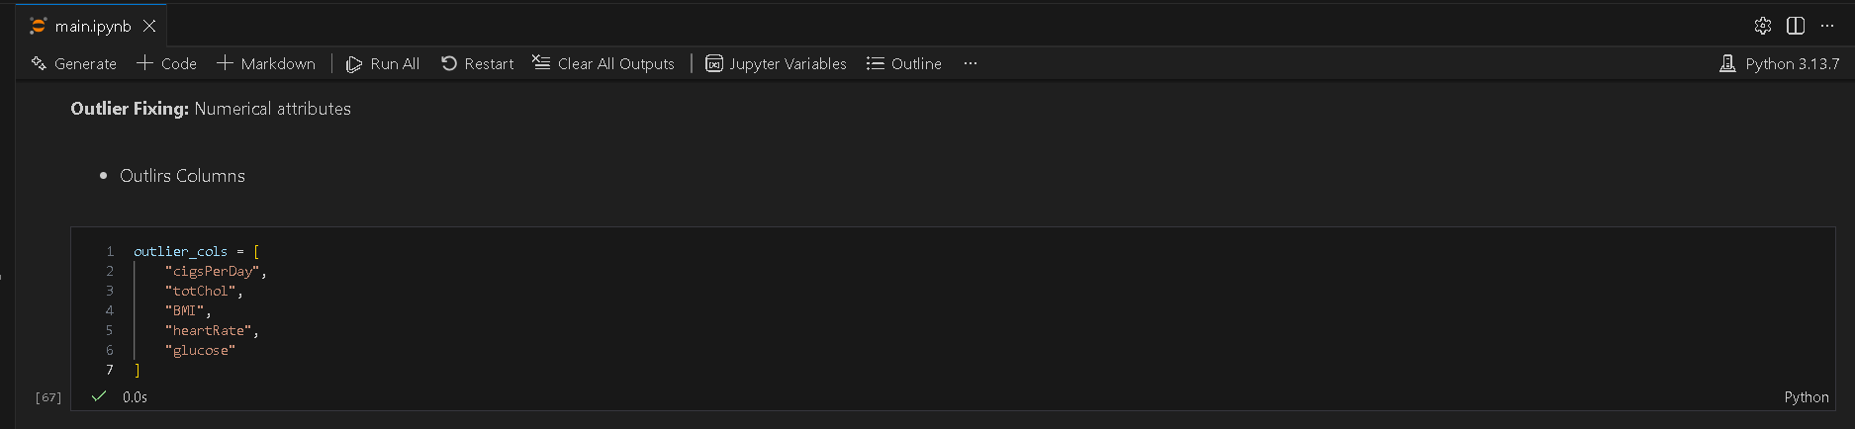
- IQR Capping Function
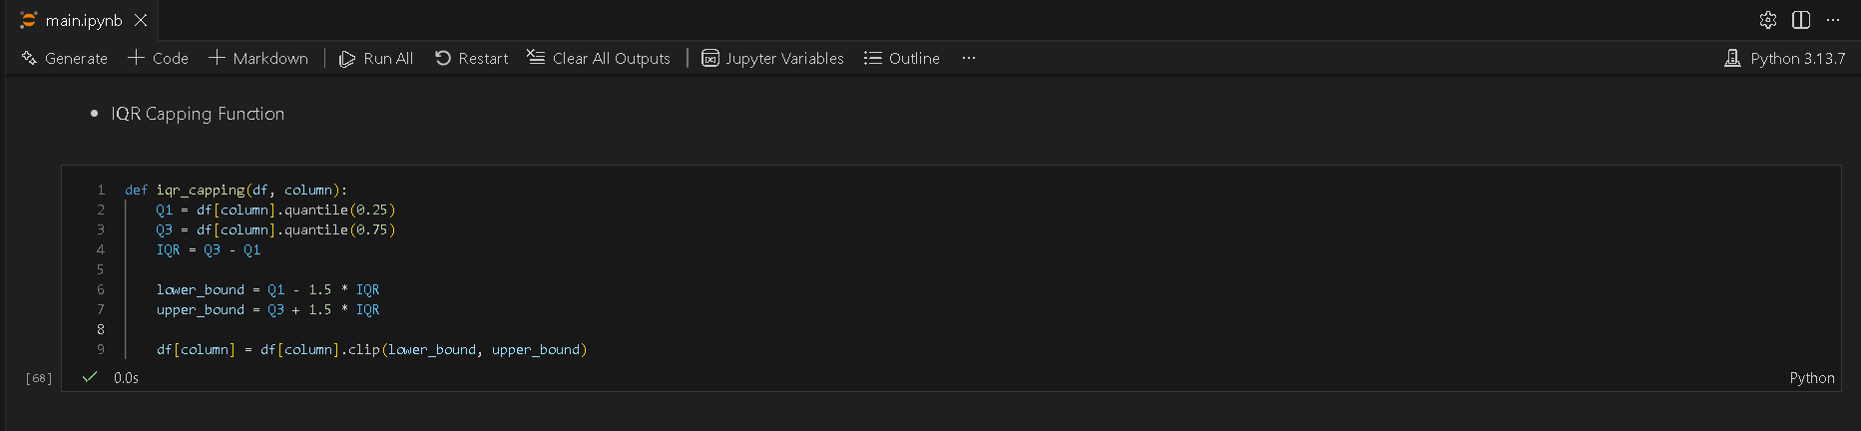
- Apply Capping to Each Attribute
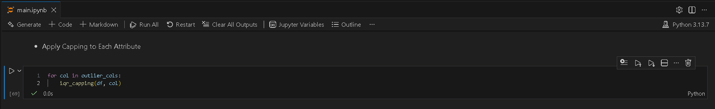

- Verify Outliers After Treatment
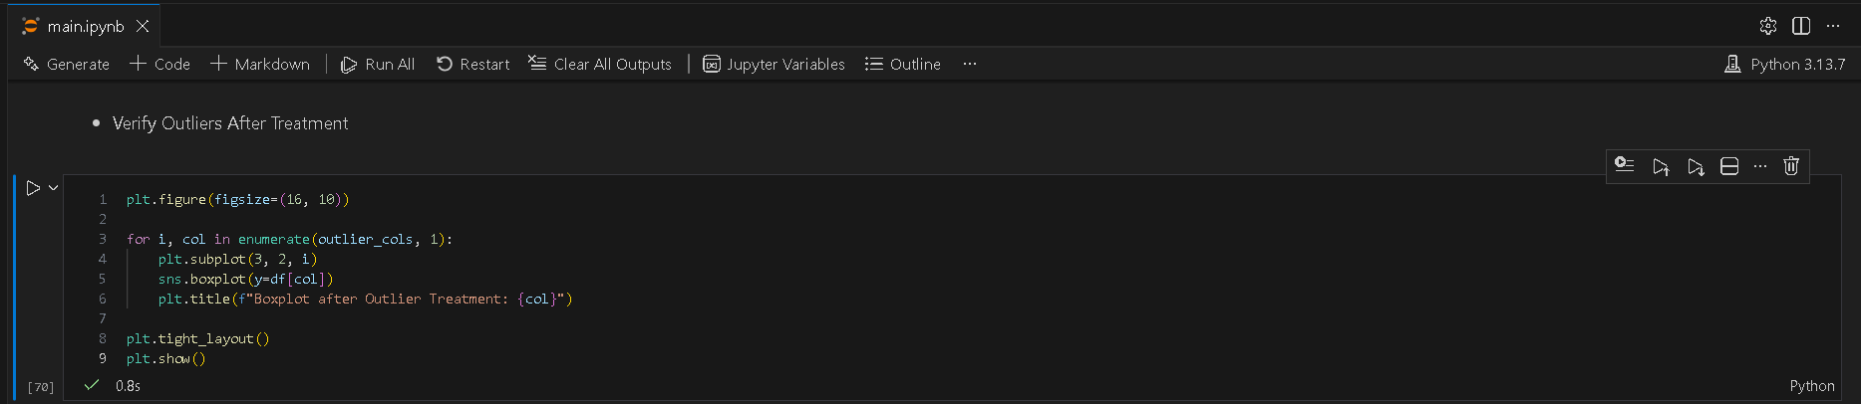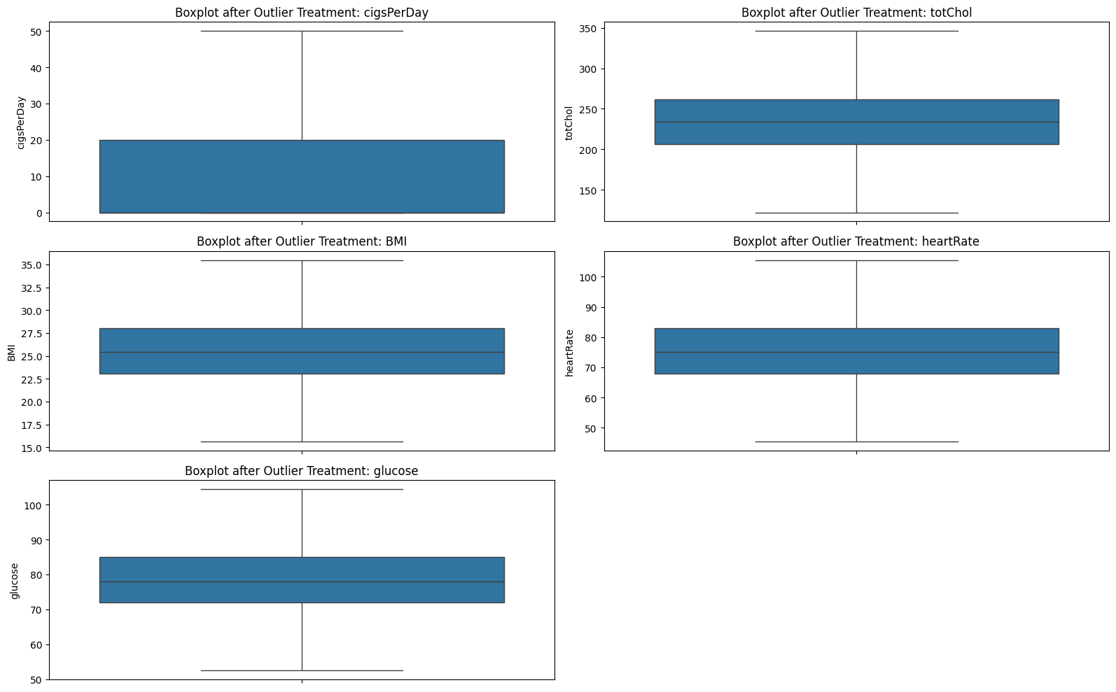

Resources and References
- Dataset
  - https://www.kaggle.com/datasets/dileep070/heart-disease-prediction-using-logistic-regression

- GitHub
  - https://github.com/Gokulnaath-gif/24ADI204_DSV_Team14

- Resources
  - https://www.geeksforgeeks.org/data-analysis/working-with-missing-data-in-pandas/
  - https://medium.com/@punya8147_26846/dataframes-handling-missing-values-in-pandas-11f7702afaf7
  - https://www.geeksforgeeks.org/data-science/detect-and-remove-the-outliers-using-python/
  - https://www.geeksforgeeks.org/pandas/handling-outliers-with-pandas/
  - https://llego.dev/posts/outlier-detection-handling-python-guide/
  - https://x.ai/grok
  - https://openai.com/chatgpt

Week No: 4 EDA Deep Dive

Objectives:
Variant analysis and Visualizing distributions.

Work done:

1. Variant Analysis

Kamalesh N 24BAD054 - Nishanth P 24BAD405

1. Univariate

1. TenYearCHD Distribution
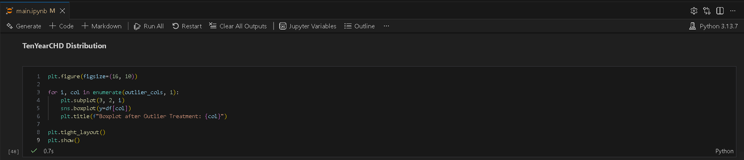

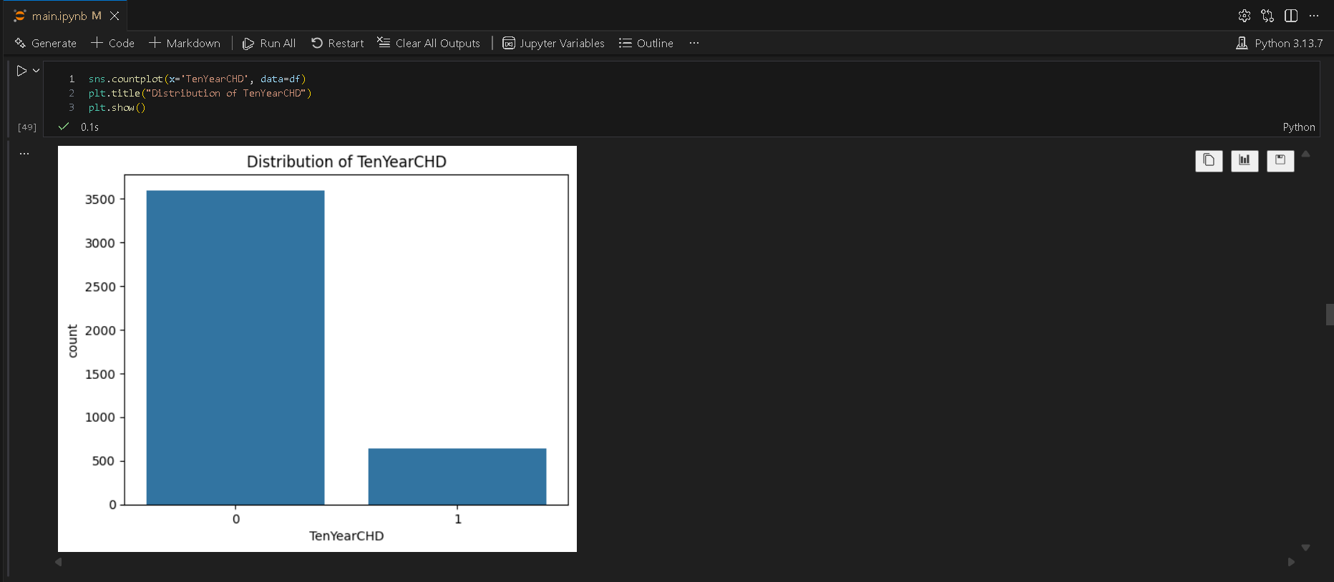

2. Continuous Variable Distribution
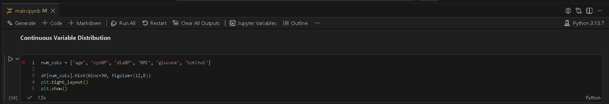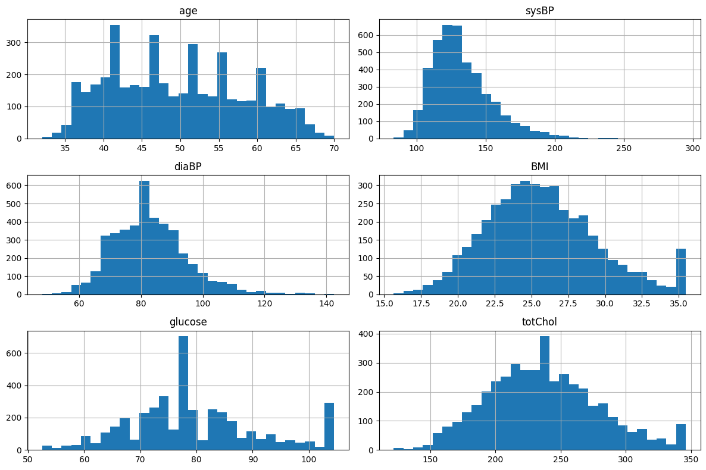

Why Histogram?
- Shows distribution shape (Normal / Skewed)
- Helps identify skewness
- Helps check extreme values

Univariate Observations

- age, BMI, glucose show right-skewed distributions
- sysBP and diaBP are approximately normal
- Outliers present in glucose and cholesterol

2. Bivariate

1. Numerical Feature vs Target
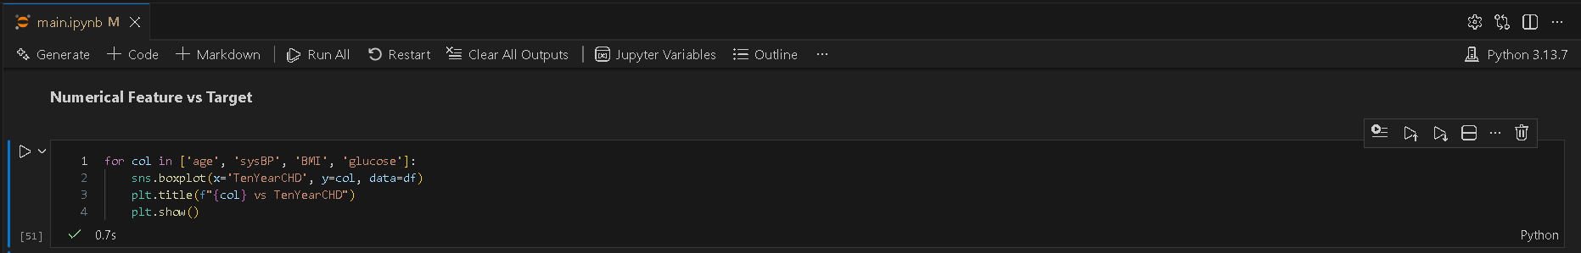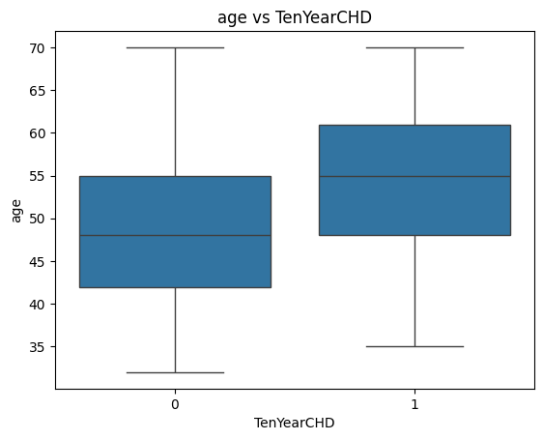
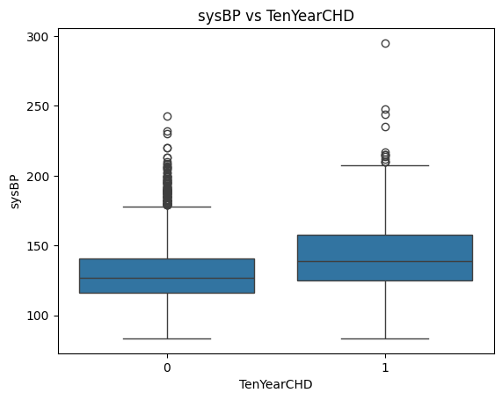

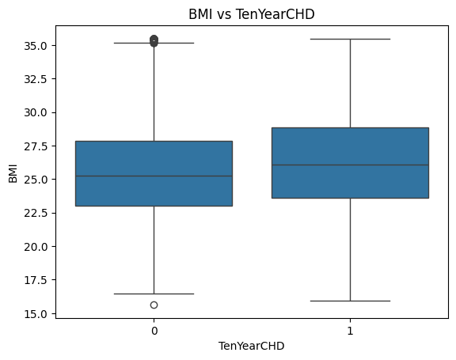
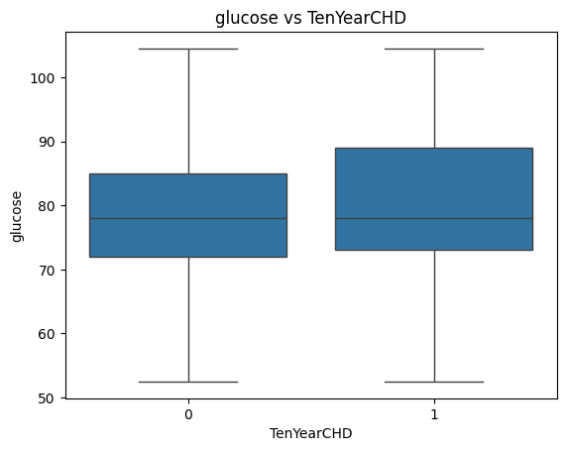

2. Categorical Features vs Target
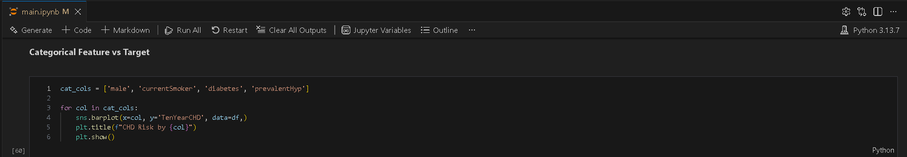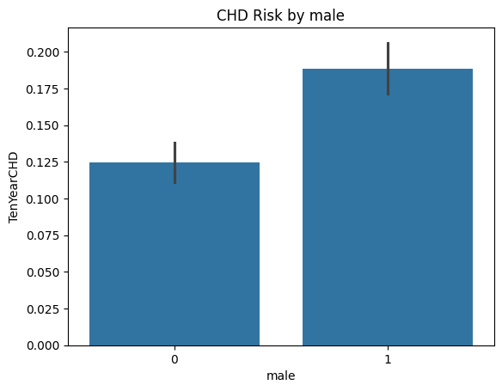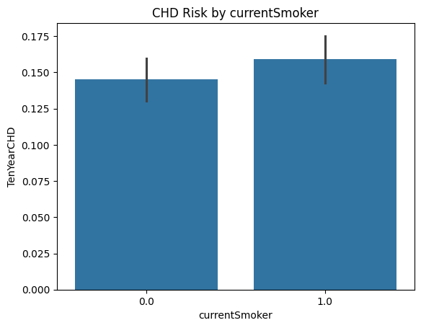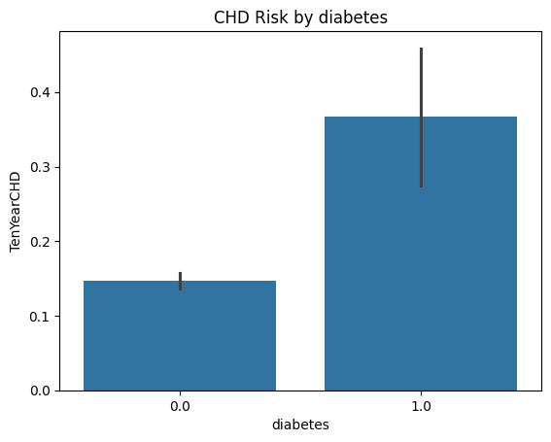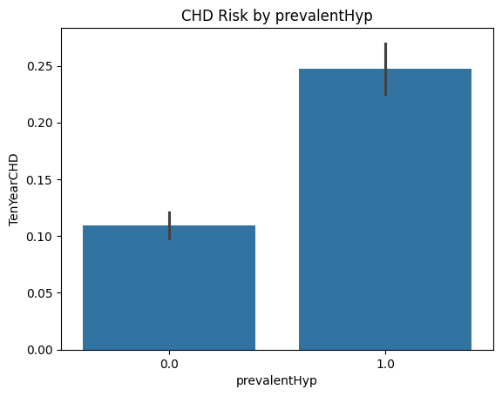

Bivariate Observations
- CHD patients have higher median age and blood pressure
- Diabetes and hypertension show strong association with CHD
- Smoking increases CHD probability

4. Multivariate Analysis

1. Correlation Matrix
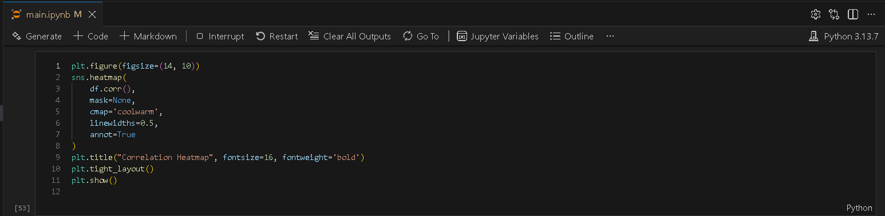
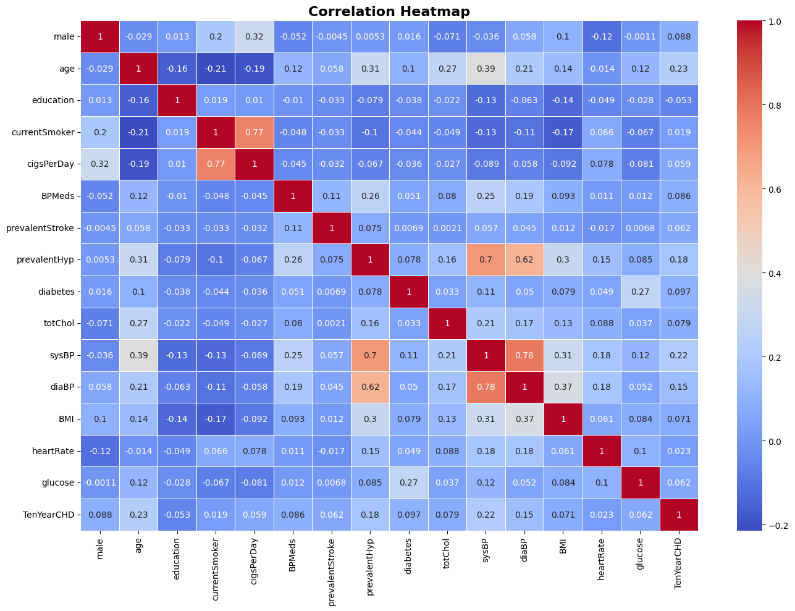

Multivariate Observations
- Strong correlation between sysBP and diaBP
- BMI and glucose are positively correlated
- Multicollinearity exists and affects linear models

2. Visualizing distributions

Gokulnaath M 24BAD028 - Jayaraksha Reguraj 24BAD044

1. KDE Distribution by Target
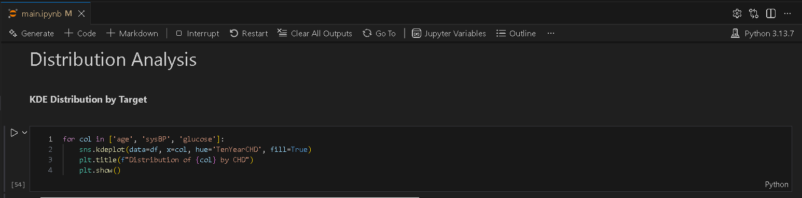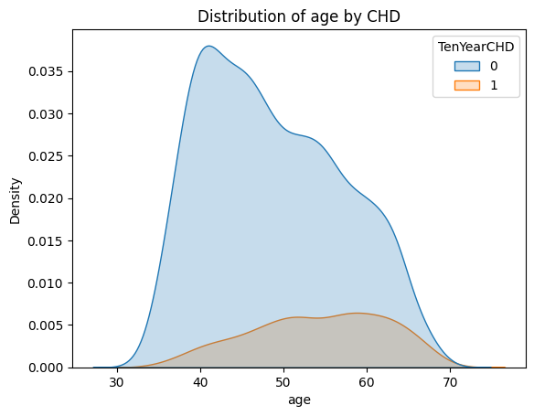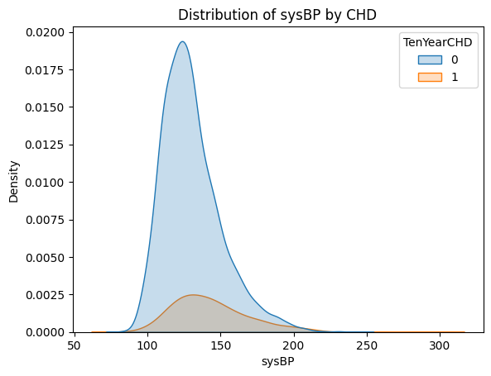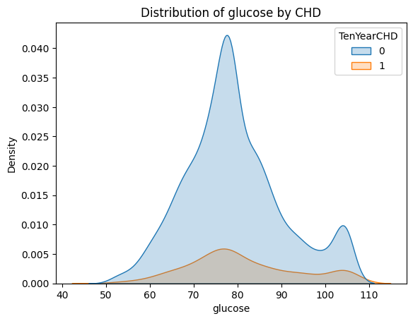
2. PCA Distribution by Target
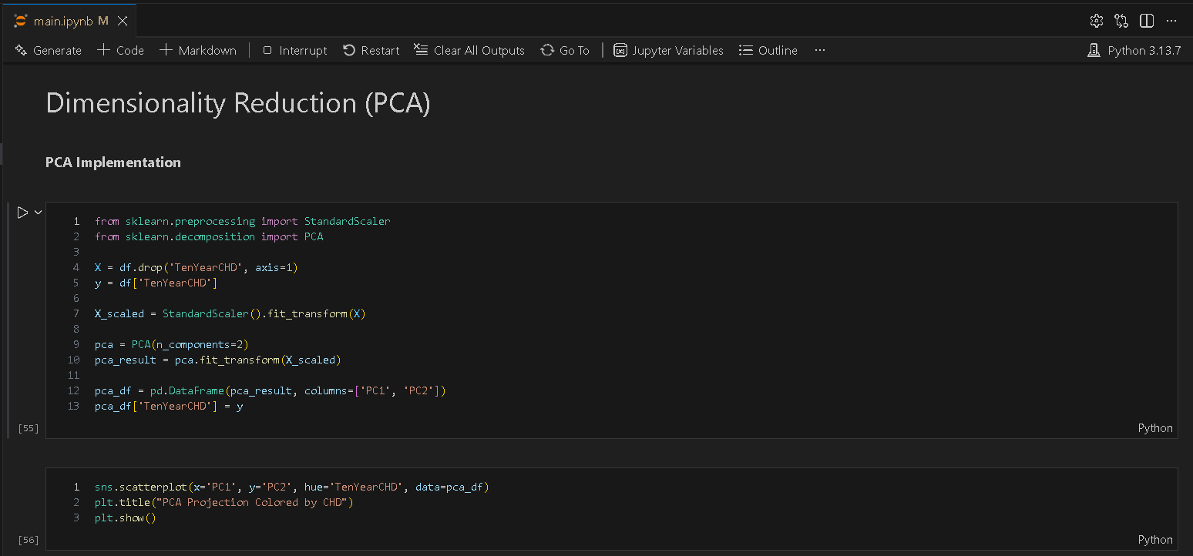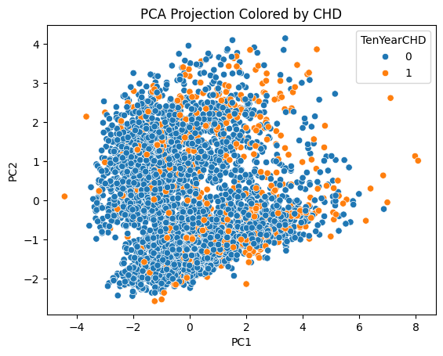

Resources and References
- Dataset
  - https://www.kaggle.com/datasets/dileep070/heart-disease-prediction-using-logistic-regression

- GitHub
  - https://github.com/Gokulnaath-gif/24ADI204_DSV_Team14

- Resources
  - https://www.geeksforgeeks.org/data-analysis/what-is-exploratory-data-analysis/
  - https://www.ibm.com/think/topics/exploratory-data-analysis
  - https://www.kaggle.com/code/imoore/intro-to-exploratory-data-analysis-eda-in-python
  - https://x.ai/grok
  - https://openai.com/chatgpt
  - https://google.com/gemini

