LAB MST
NAME: MOHD REHAN KHAN
UID:24BAI70004
SECTION: 24AIT_KRG_1(A)
SUBJECT: ADBMS
DATE: 9/10/26
SOLUTION 1:
FROM customer c
JOIN orders o ON c.customer_id=o.customer_id
GROUP BY c.customer_id, c.customer_name, c.city
HAVING SUM(o.amount)=(
SELECT MAX(x.total)
FROM (
SELECT c2.city,SUM(o2.amount) as total
FROM customer c2
JOIN orders o2 on c2.customer_id=o2.customer_id
GROUP BY c2.customer_id, c2.city
) x
WHERE x.city=c.city
)
ORDER BY c.city, c.customer_name;
OUTPUT 1:
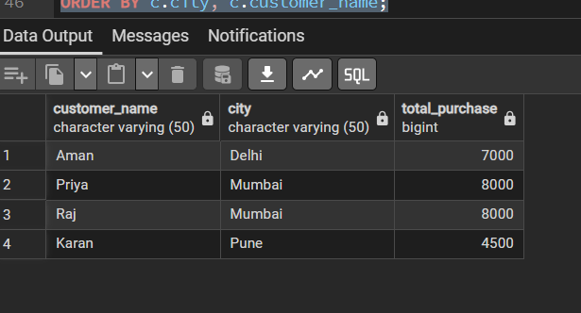
SOLUTION 2:
CREATE TABLE product_audit (
audit_id SERIAL PRIMARY KEY,
product_id INT,
product_name VARCHAR(100),
action VARCHAR(20),
action_time TIMESTAMP DEFAULT CURRENT_TIMESTAMP
);
CREATE OR REPLACE FUNCTION log_product_changes()
RETURNS TRIGGER AS $$
BEGIN
IF TG_OP = 'INSERT' THEN
INSERT INTO product_audit (product_id, product_name, action)
VALUES (NEW.product_id, NEW.product_name, 'PRODUCT ADDED');
RETURN NEW;
ELSIF TG_OP = 'DELETE' THEN
INSERT INTO product_audit (product_id, product_name, action)
VALUES (OLD.product_id, OLD.product_name, 'PRODUCT REMOVED');
RETURN OLD;
END IF;
END;
$$ LANGUAGE plpgsql;
CREATE TRIGGER trg_product_audit
AFTER INSERT OR DELETE ON product_inventory
FOR EACH ROW
EXECUTE FUNCTION log_product_changes();
INSERT INTO product_inventory VALUES (101, 'Laptop', 65000), (102, 'Mobile', 30000);
TRUNCATE product_audit RESTART IDENTITY;
INSERT INTO product_inventory VALUES (103, 'Tablet', 20000);
DELETE FROM product_inventory WHERE product_id = 101;

SELECT audit_id, product_id, product_name, action FROM product_audit;
OUTPUT 2:
