Experiment 9

Student Name: Mohd Rehan Khan UID: 24BAI70004
Branch: CSE - AIML Section/Group: 24AIT_KRG G1
Semester: 4 Date of Performance: 1/4/26
Subject Name: DBMS Subject Code: 24CSH-298

Aim
To understand and implement database triggers in PostgreSQL to automate data validation and computational logic, ensuring data integrity by enforcing business rules during DML operations.

Software Requirements
- Database Management System:
  - Oracle Database Express Edition (Oracle XE)
  - PostgreSQL Database
- Database Administration Tool / Client Tool:
  - Oracle SQL Developer (for Oracle XE)
  - pgAdmin (for PostgreSQL)

Objectives
- To create a trigger function that performs automatic calculations on row-level data.
- To define a BEFORE INSERT trigger that intercepts data entry for validation.
- To implement custom exception handling using the RAISE EXCEPTION command.
- To verify trigger behaviour by testing both valid and invalid data scenarios within a transaction.

Practical/Experiment Steps
- Schema Provisioning: Established the employee table with dedicated columns for base data (hours and rate) and a calculated column for the final payable amount.
- Trigger Function Development: Authored a PL/pgSQL function designed to calculate the product of working hours and hourly rates dynamically.
- Automated Validation Logic: Embedded a conditional check within the function to prevent the insertion of records where the calculated amount exceeds a predefined limit.
- Trigger Binding: Configured a row-level trigger to execute the function specifically BEFORE any INSERT operation occurs on the table.
- Operational Stress Testing: Utilized anonymous DO blocks to simulate data entry and verify that the system correctly identifies and blocks prohibited transactions.

Procedure
- Accessed the PostgreSQL console and created the employee table structure.
- Defined the CALCULATE_AMOUNT() function using the NEW keyword to access and modify incoming row data before it is written to the disk.
- Integrated a mathematical formula to populate the total_payable_amount field automatically.
- Created the CAL_PAYABLE_AMOUNT trigger, ensuring it was set to FOR EACH ROW to evaluate every individual record.
- Executed a successful INSERT test case where the calculated result was below 25,000 to confirm normal operations.
- Ran a SELECT query to verify that the trigger correctly computed and stored the total amount despite it not being provided in the INSERT statement.
- Attempted an invalid INSERT with values resulting in an amount over 25,000 to trigger the custom exception.
- Implemented exception handling in the test blocks to capture and display the SQLERRM (error message) generated by the trigger.
- Analysed the final table state to confirm that the invalid record was successfully blocked by the trigger logic.

Input/Output Analysis
SQL Input Queries
CREATE TABLE employee (
emp_id INT PRIMARY KEY,
emp_name VARCHAR(50),
working_hours INT,
perhour_salary NUMERIC,
total_payable_amount NUMERIC
);

Output

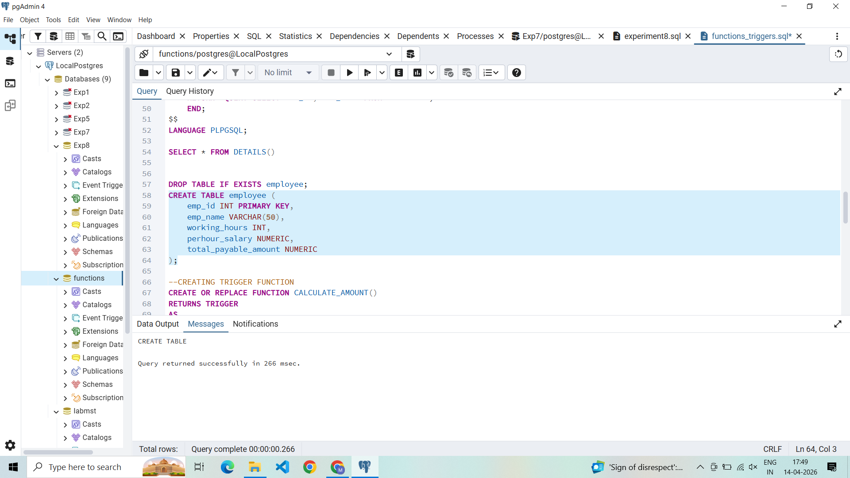

SQL Input Queries
CREATE OR REPLACE FUNCTION CALCULATE_AMOUNT()
RETURNS TRIGGER
AS
$$
BEGIN
NEW.total_payable_amount=NEW.perhour_salary*NEW.working_hours;
IF NEW.total_payable_amount>25000 THEN
RAISE EXCEPTION 'AMOUNT IS GREATER THAN 25000';
END IF;
RETURN NEW;
END;
$$
LANGUAGE PLPGSQL;

Output
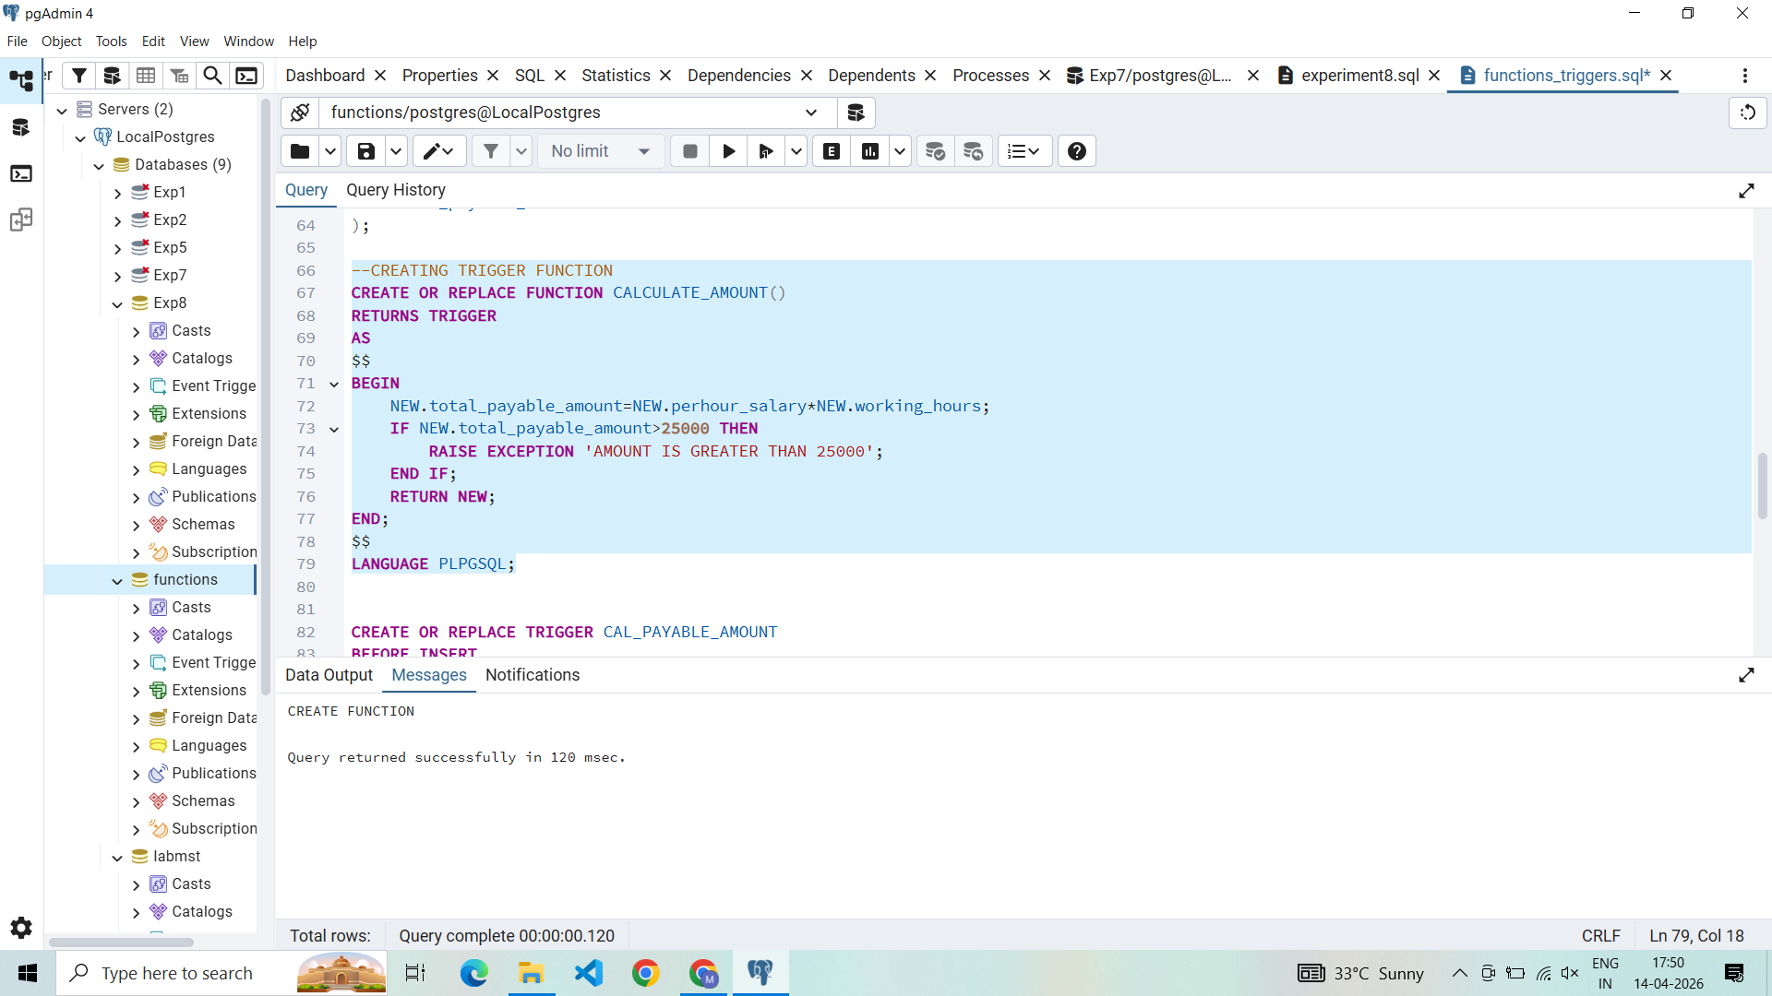
SQL Input Queries
CREATE OR REPLACE TRIGGER CAL_PAYABLE_AMOUNT
BEFORE INSERT
ON EMPLOYEE
FOR EACH ROW
EXECUTE FUNCTION CALCULATE_AMOUNT();

Output
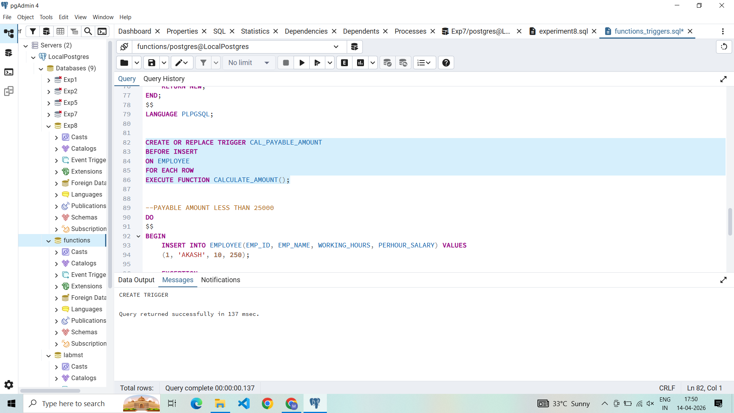

SQL Input Queries
DO
$$
BEGIN
INSERT INTO EMPLOYEE(EMP_ID, EMP_NAME, WORKING_HOURS, PERHOUR_SALARY) VALUES
(1, 'AKASH', 10, 250);

EXCEPTION
WHEN OTHERS THEN
RAISE NOTICE '%', SQLERRM;
END;
$$;

SELECT * FROM EMPLOYEE;

Output
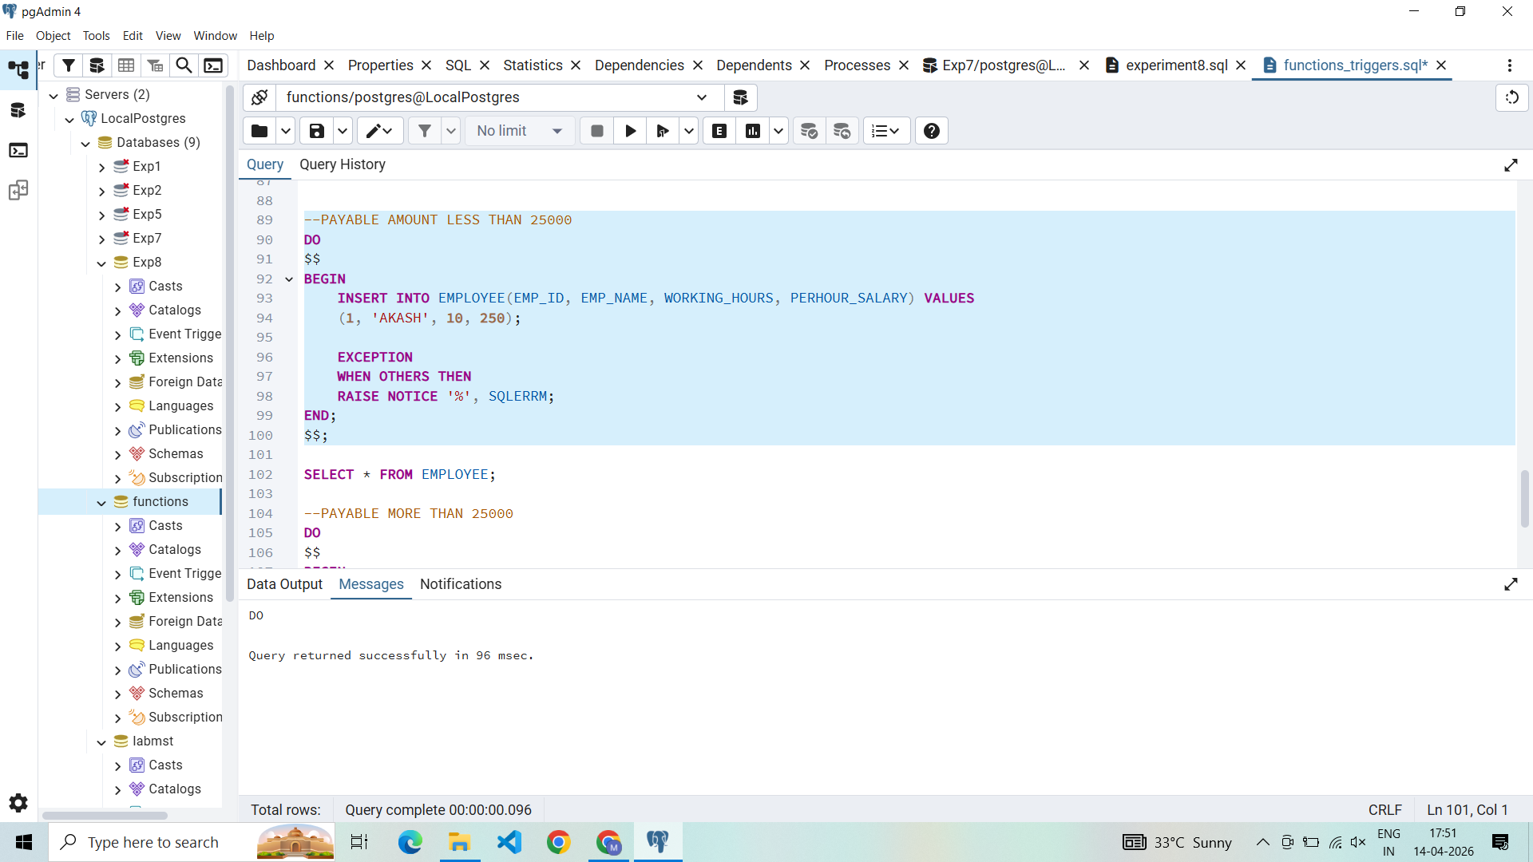

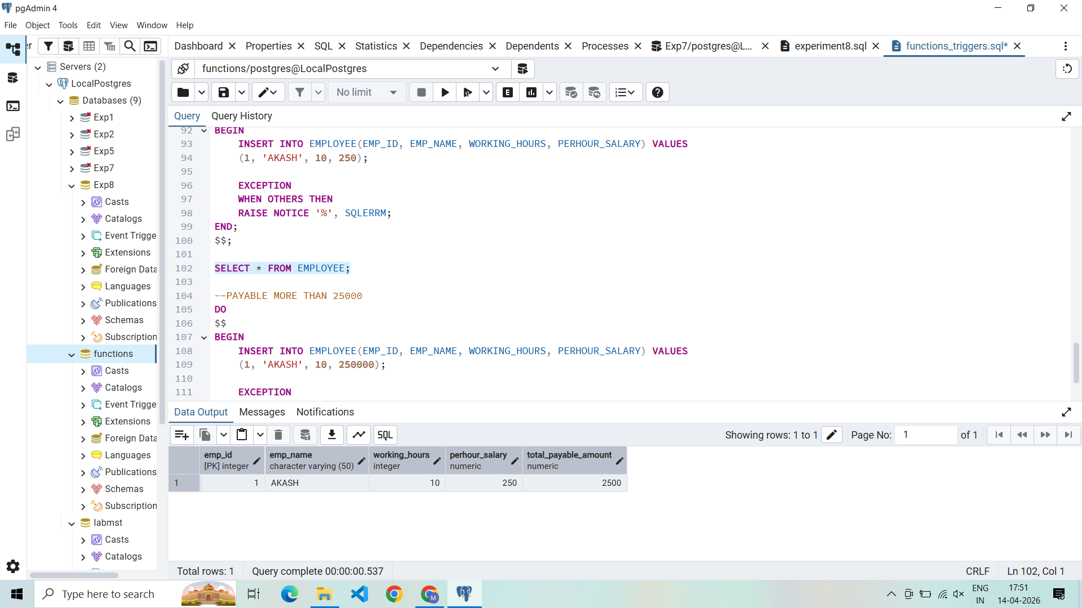

SQL Input Queries
DO
$$
BEGIN
INSERT INTO EMPLOYEE(EMP_ID, EMP_NAME, WORKING_HOURS, PERHOUR_SALARY) VALUES
(1, 'AKASH', 10, 250000);

EXCEPTION
WHEN OTHERS THEN
RAISE NOTICE '%', SQLERRM;
END;
$$;

SELECT * FROM EMPLOYEE;

Output
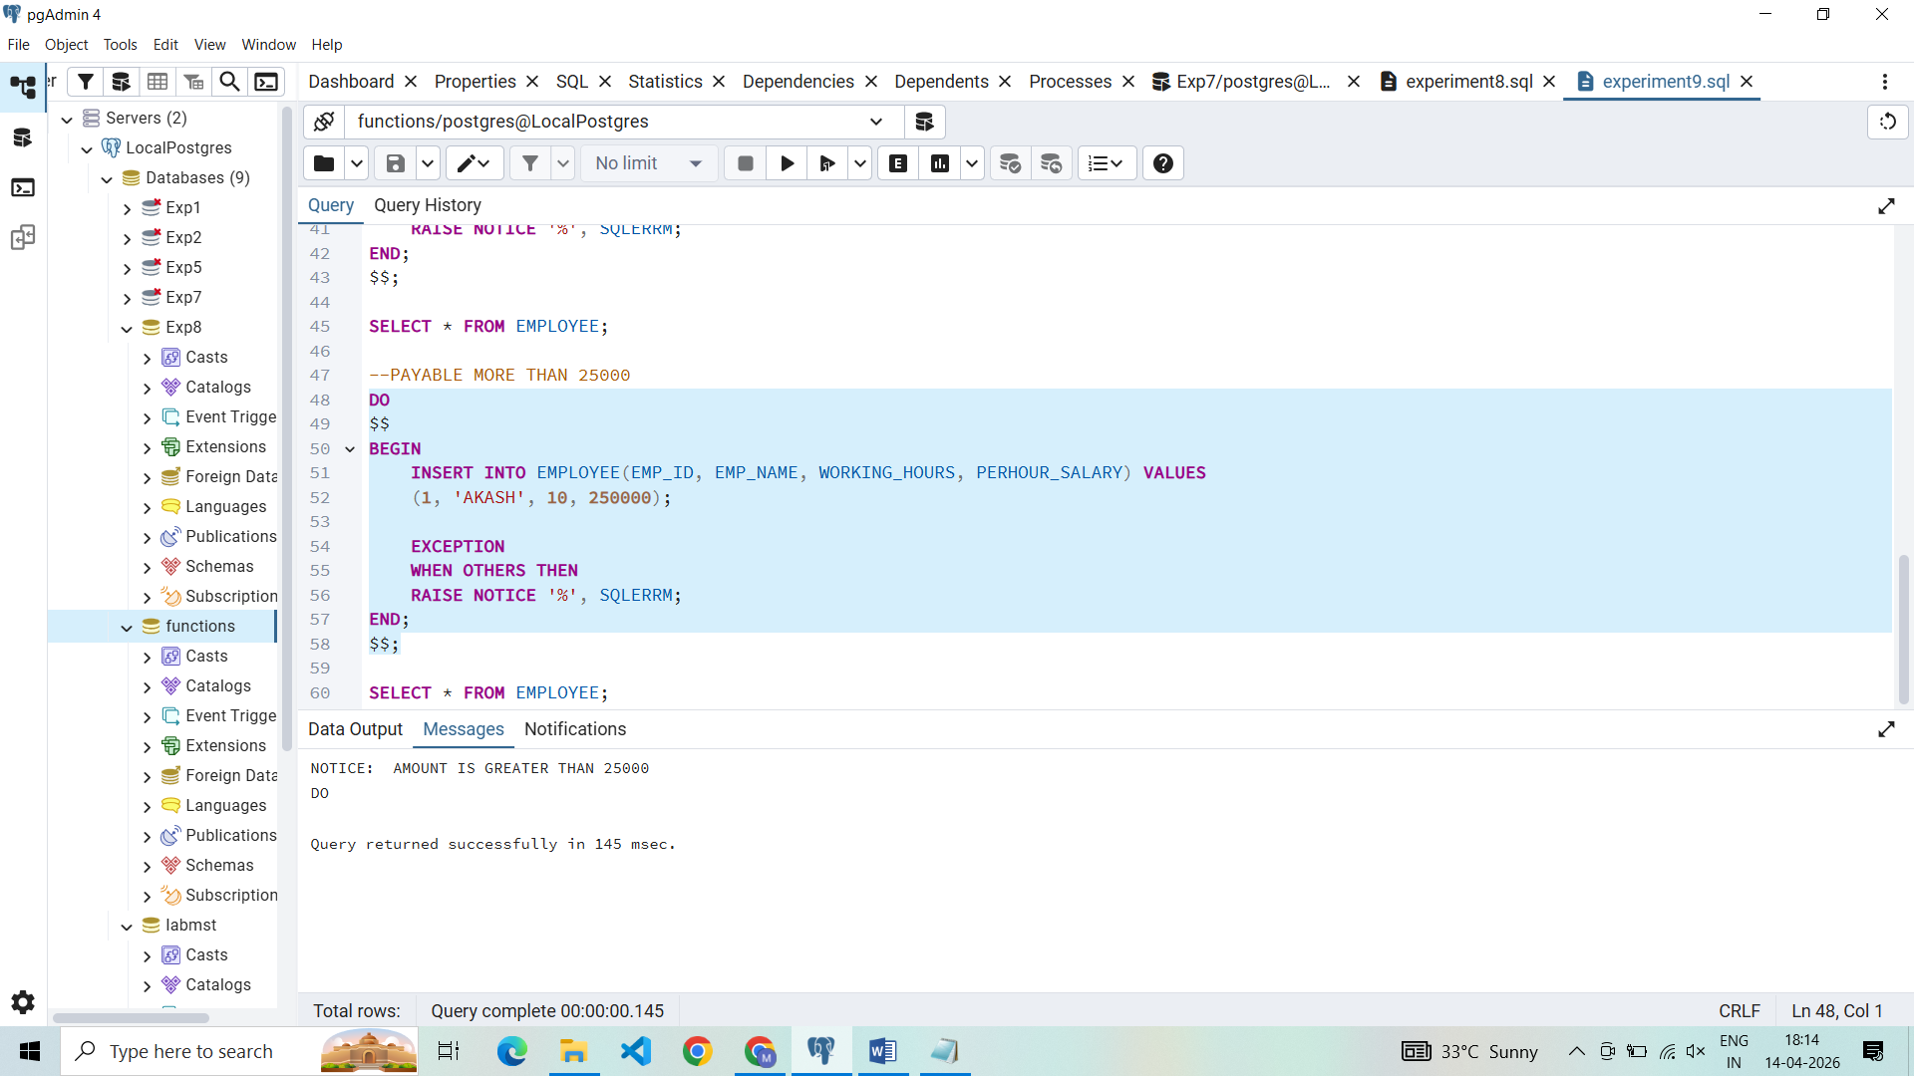
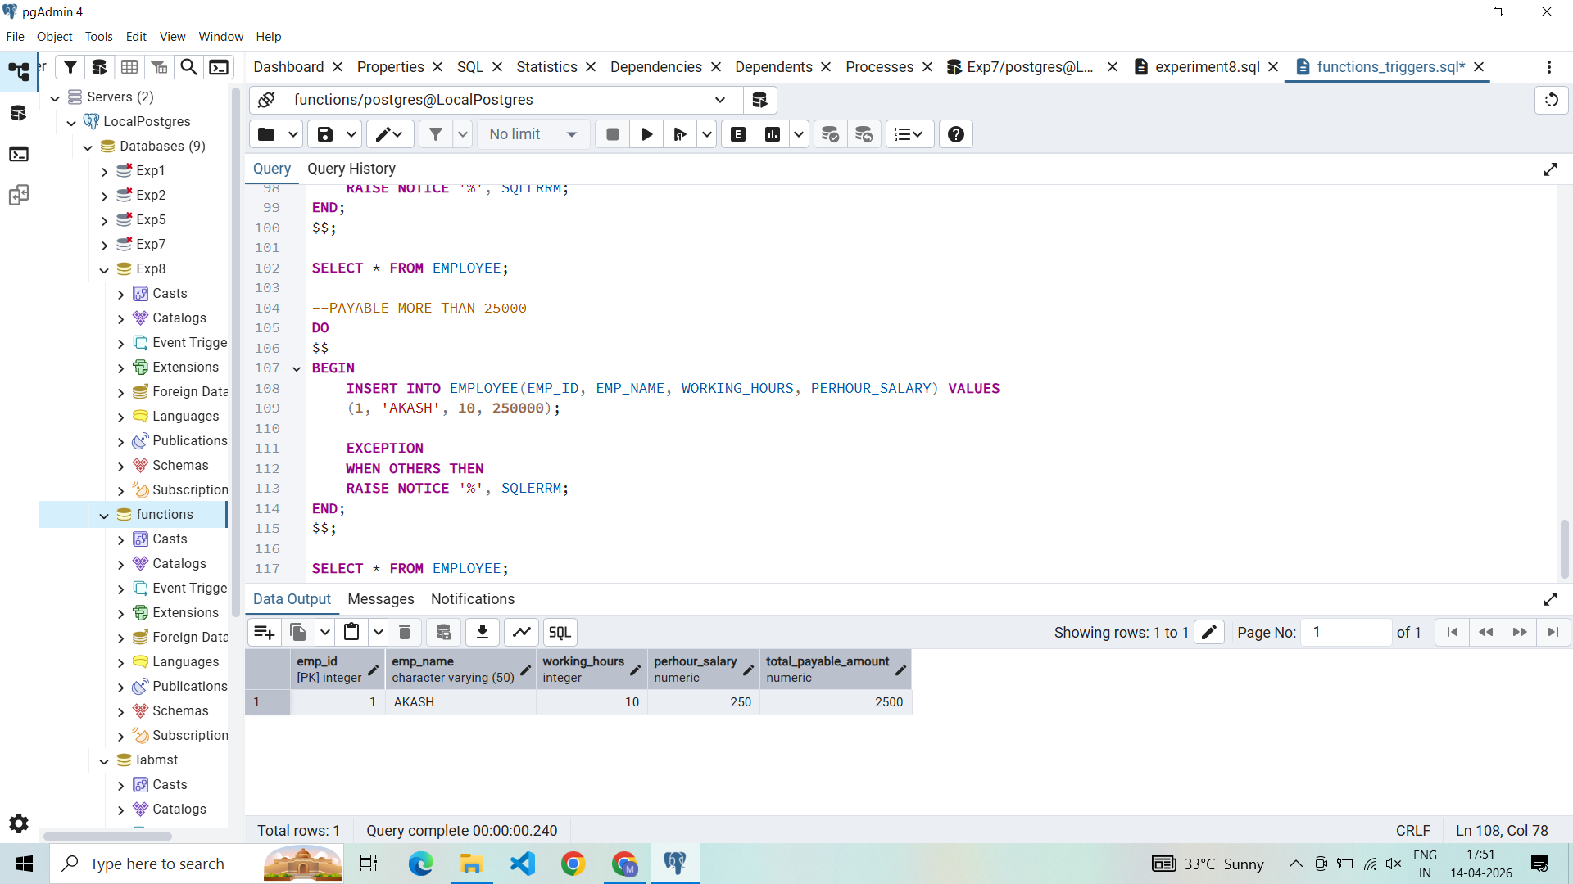

Learning Outcomes
- Trigger Lifecycle Mastery: Understanding the difference between statement-level and row-level triggers and when to use BEFORE vs AFTER events.
- Automated Data Calculation: Proficiency in using triggers to derive and populate column values, reducing the logic burden on the application layer.
- Custom Constraint Enforcement: Ability to implement complex business rules and validations that go beyond standard CHECK constraints.
- Error Handling and Signaling: Mastery of the RAISE EXCEPTION mechanism to communicate specific business logic failures to the user or application.

