Experiment 4: Conditional Control Statements in PL/SQL
Student Name: Mohd Rehan Khan UID: 24BAI70004
Branch: CSE - AIML Section/Group: 24AIT_KRG G1
Semester: 4 Date of Performance: 16/01/26
Subject Name: DBMS Subject Code: 24CSH-298

1. Aim of the Session
To design and implement PL/SQL programs utilizing conditional control statements such as IF–ELSE, IF–ELSIF–ELSE, ELSIF ladder, and CASE constructs to control the flow of execution based on logical conditions.

2. Objectives of the Session
- Understand conditional control statements in PL/SQL
- Implement IF–ELSE statements
- Apply IF–ELSIF–ELSE and ELSIF ladder
- Use CASE statements for decision making
- Display output using DBMS_OUTPUT.PUT_LINE

3. Practical / Experiment Code
SET SERVEROUTPUT ON;
-- Program 1: IF–ELSE
DECLARE
num NUMBER := -5;
BEGIN
IF num > 0 THEN
DBMS_OUTPUT.PUT_LINE('The number is Positive');
ELSE
DBMS_OUTPUT.PUT_LINE('The number is Non-Positive');
END IF;
END;
/
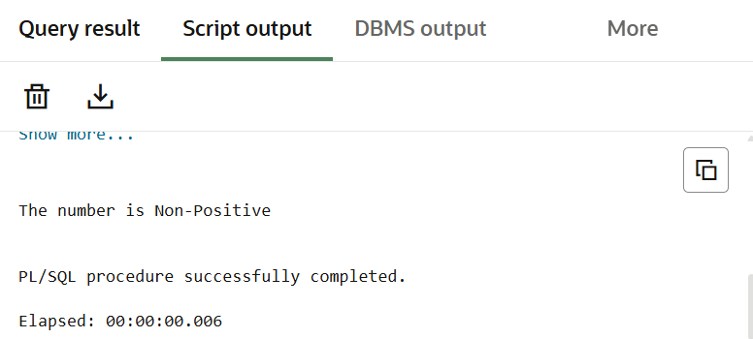
-- Program 2: IF–ELSIF–ELSE
DECLARE
marks NUMBER := 82;
BEGIN
IF marks >= 90 THEN
DBMS_OUTPUT.PUT_LINE('Grade: A');
ELSIF marks >= 75 THEN
DBMS_OUTPUT.PUT_LINE('Grade: B');
ELSIF marks >= 60 THEN
DBMS_OUTPUT.PUT_LINE('Grade: C');
ELSIF marks >= 40 THEN
DBMS_OUTPUT.PUT_LINE('Grade: D');
ELSE
DBMS_OUTPUT.PUT_LINE('Grade: F');
END IF;
END;
/
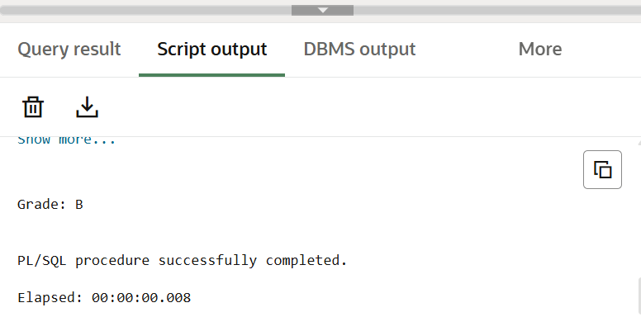
-- Program 3: ELSIF Ladder
DECLARE
marks NUMBER := 68;
BEGIN
IF marks >= 85 THEN
DBMS_OUTPUT.PUT_LINE('Performance: Excellent');
ELSIF marks >= 70 THEN
DBMS_OUTPUT.PUT_LINE('Performance: Very Good');
ELSIF marks >= 55 THEN
DBMS_OUTPUT.PUT_LINE('Performance: Good');
ELSIF marks >= 40 THEN
DBMS_OUTPUT.PUT_LINE('Performance: Average');
ELSE
DBMS_OUTPUT.PUT_LINE('Performance: Poor');
END IF;
END;
/
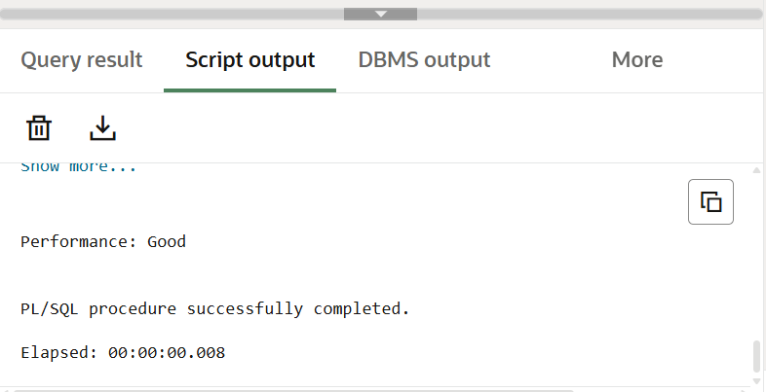
-- Program 4: CASE Statement
DECLARE
day_num NUMBER := 3;
BEGIN
CASE day_num
WHEN 1 THEN DBMS_OUTPUT.PUT_LINE('Monday');
WHEN 2 THEN DBMS_OUTPUT.PUT_LINE('Tuesday');
WHEN 3 THEN DBMS_OUTPUT.PUT_LINE('Wednesday');
WHEN 4 THEN DBMS_OUTPUT.PUT_LINE('Thursday');
WHEN 5 THEN DBMS_OUTPUT.PUT_LINE('Friday');
WHEN 6 THEN DBMS_OUTPUT.PUT_LINE('Saturday');
WHEN 7 THEN DBMS_OUTPUT.PUT_LINE('Sunday');
ELSE
DBMS_OUTPUT.PUT_LINE('Invalid Day Number');
END CASE;
END;
/
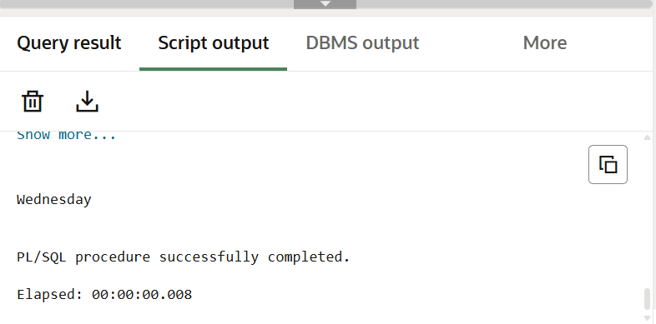

4. Learning Outcomes
- Gained understanding of PL/SQL control structures
- Implemented decision-making logic using IF and CASE statements
- Improved logical thinking for database programming
- Executed PL/SQL blocks successfully in Oracle FreeSQL

