Student Name: Mohd Rehan Khan UID: 24BAI70004
Branch: CSE - AIML Section/Group: 24AIT_KRG G1
Semester: 4 Date of Performance: 16/1/26
Subject Name: DBMS Subject Code: 24CSH-298

Experiment 2: SQL GROUP BY, ORDER BY, and HAVING with Aggregation Functions

1. Aim of the Session
The aim of this practical is to gain hands-on experience in using advanced SQL clauses for data grouping, sorting, aggregation, and filtering. Students learn how to generate meaningful statistical reports from database records using GROUP BY, ORDER BY, HAVING, and aggregation functions.

2. Objectives of the Session
After completing this experiment, students will be able to:
- Understand GROUP BY for organizing records into categories
- Use aggregation functions: COUNT, AVG
- Apply ORDER BY to sort grouped results
- Use HAVING to filter grouped data
- Generate statistical reports from student records
- Write multi-clause SQL queries

3. Practical / Experiment Steps
Step 1: Create Students Table
CREATE TABLE Students (
id NUMERIC(10,0) PRIMARY KEY,
name VARCHAR(50),
city VARCHAR(30),
marks NUMERIC(10,0)
);

Step 2: Insert Sample Student Data
‘
INSERT INTO Students VALUES (2, 'Rohit', 'Mohali', 78);
INSERT INTO Students VALUES (3, 'Neha', 'Mohali', 92);
INSERT INTO Students VALUES (4, 'Simran', 'Amritsar', 88);
INSERT INTO Students VALUES (5, 'Karan', 'Amritsar', 75);
INSERT INTO Students VALUES (6, 'Diwansh', 'Chandigarh', 90);

Step 3: Retrieve All Records
SELECT * FROM Students;

Step 4: GROUP BY with COUNT
SELECT city, COUNT(*) AS COUNT_STUDENTS
FROM Students
GROUP BY city;
Purpose: Counts number of students in each city.

Step 5: GROUP BY + ORDER BY
SELECT city, COUNT(id) AS COUNT_STUDENTS
FROM Students
GROUP BY city
ORDER BY COUNT_STUDENTS ASC;
Purpose:
Groups students city-wise and sorts cities in ascending order of student count.

Step 6: GROUP BY + HAVING
SELECT city, COUNT(*) AS COUNT_STUDENTS
FROM Students
GROUP BY city
HAVING COUNT(*) >= 3;
Purpose:
Displays only cities having 3 or more students.

Step 7: GROUP BY with AVG
SELECT city, AVG(marks)::NUMERIC(10,2) AS AVERAGE_MARKS
FROM Students
GROUP BY city;
Purpose:
Calculates average marks of students city-wise.

4. Output Analysis
Query 1 – COUNT by City
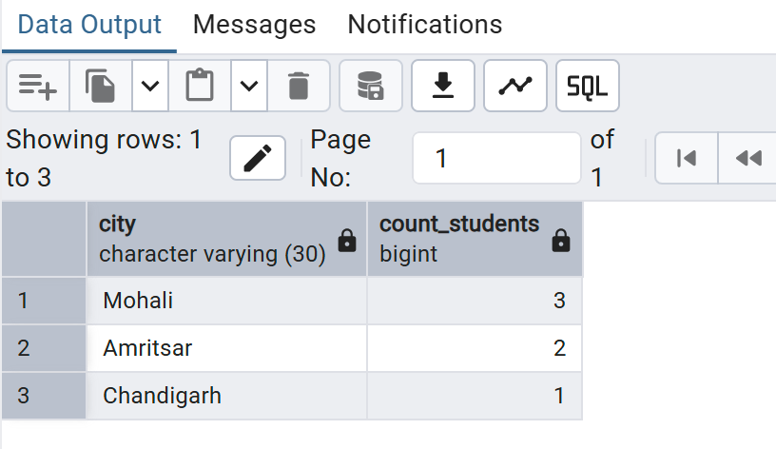

Query 2 – Sorted Count
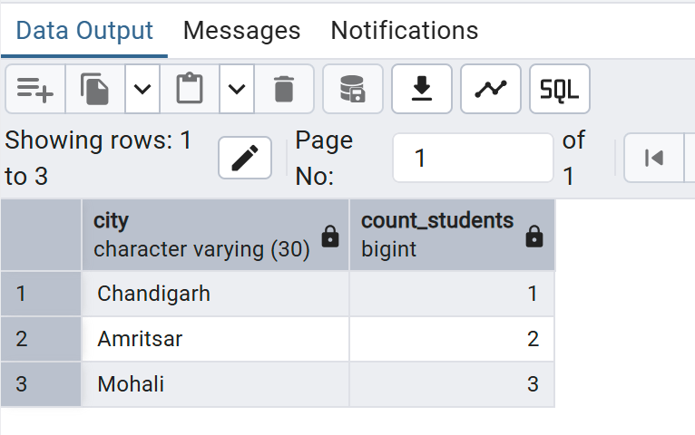

Query 3 – HAVING Filter
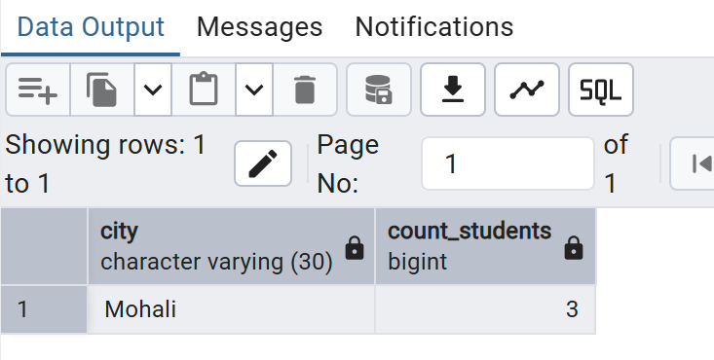

Query 4 – Average Marks
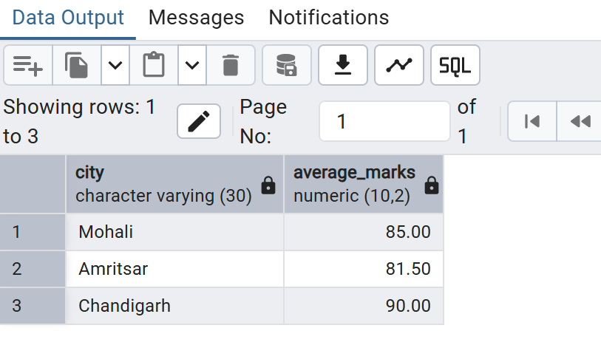

5. Key Concept Difference
WHERE | HAVING
Filters rows before grouping | Filters groups after aggregation
Cannot use aggregate functions | Can use aggregate functions

6. Learning Outcomes
Students learned to:
- Organize data using GROUP BY
- Perform statistical analysis using COUNT & AVG
- Sort grouped data using ORDER BY
- Filter grouped results using HAVING
- Generate analytical SQL reports

