Reenul Sirsat 24BCE11314

1.package Mongo_DB;

import com.mongodb.client.FindIterable;
import com.mongodb.client.MongoClient;
import com.mongodb.client.MongoClients;
import com.mongodb.client.MongoCollection;
import com.mongodb.client.MongoDatabase;

import com.mongodb.client.model.Filters;
import com.mongodb.client.model.Updates;

import org.bson.Document;

public class mongo_insertone {

public static void main(String[] args) {

// Connect to MongoDB
MongoClient mongoClient = MongoClients.create("mongodb://localhost:27017");

// Access database
MongoDatabase database = mongoClient.getDatabase("CollegeDB");

// Access collection
MongoCollection<Document> collection = database.getCollection("Students");

// ==========================
// CREATE (Insert)
// ==========================
Document student = new Document("id", 101)
.append("name", "John")
.append("department", "CSE")
.append("cgpa", 8.7);

collection.insertOne(student);
System.out.println("Document Inserted Successfully");

// ==========================
// READ (Find)
// ==========================
System.out.println("\nStudent Records:");

FindIterable<Document> students = collection.find();

for (Document doc : students) {
System.out.println(doc.toJson());
}

// ==========================
// UPDATE
// ==========================
collection.updateOne(
Filters.eq("id", 101),
Updates.set("cgpa", 9.2)
);

System.out.println("\nDocument Updated Successfully");

// ==========================
// READ Updated Record
// ==========================
Document updatedStudent = collection
.find(Filters.eq("id", 101))
.first();

System.out.println("\nUpdated Record:");

if (updatedStudent != null) {
System.out.println(updatedStudent.toJson());
}

// ==========================
// DELETE
// ==========================
collection.deleteOne(Filters.eq("id", 101));

System.out.println("\nDocument Deleted Successfully");

// Close connection
mongoClient.close();
}
}
OUTPUT :
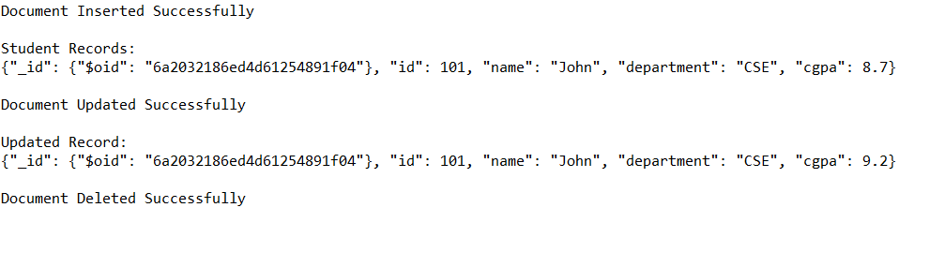
2. package Mongo_DB;

import com.mongodb.client.*;
import com.mongodb.client.model.Filters;
import com.mongodb.client.model.Updates;
import org.bson.Document;

import java.util.Arrays;
import java.util.List;

public class mongo_insertmany {

public static void main(String[] args) {

// Connect to MongoDB
MongoClient mongoClient = MongoClients.create("mongodb://localhost:27017");

// Access Database
MongoDatabase database = mongoClient.getDatabase("CollegeDB");

// Access Collection
MongoCollection<Document> collection = database.getCollection("Students");

// ==========================
// CREATE MANY DOCUMENTS
// ==========================

Document student1 = new Document("id", 101)
.append("name", "Rahul")
.append("department", "CSE")
.append("cgpa", 9.2);

Document student2 = new Document("id", 102)
.append("name", "Priya")
.append("department", "IT")
.append("cgpa", 9.4);

Document student3 = new Document("id", 103)
.append("name", "Amit")
.append("department", "ECE")
.append("cgpa", 9.6);

List<Document> studentsList = Arrays.asList(
student1,
student2,
student3
);

collection.insertMany(studentsList);

System.out.println("Documents Inserted Successfully");

// ==========================
// READ ALL DOCUMENTS
// ==========================

System.out.println("\nAll Student Records:");

FindIterable<Document> students = collection.find();

for (Document doc : students) {
System.out.println(doc.toJson());
}

// ==========================
// UPDATE ONE STUDENT
// ==========================

collection.updateOne(
Filters.eq("id", 102),
Updates.set("cgpa", 9.8)
);

System.out.println("\nStudent Updated Successfully");

// ==========================
// READ UPDATED STUDENT
// ==========================

Document updatedStudent =
collection.find(Filters.eq("id", 102)).first();

System.out.println("\nUpdated Student:");

if (updatedStudent != null) {
System.out.println(updatedStudent.toJson());
}

// ==========================
// DELETE ONE STUDENT
// ==========================

collection.deleteOne(Filters.eq("id", 103));

System.out.println("\nStudent Deleted Successfully");

// ==========================
// DISPLAY REMAINING STUDENTS
// ==========================

System.out.println("\nRemaining Students:");

for (Document doc : collection.find()) {
System.out.println(doc.toJson());
}

// Close Connection
mongoClient.close();
}
}
