MY SQL CODE :
create database crud;
use crud;
CREATE TABLE `user` (
`sl_no` INT(5) NULL DEFAULT NULL,
`name` VARCHAR(100) NULL DEFAULT NULL,
`email` VARCHAR(100) NULL DEFAULT NULL
)
COLLATE='latin1_swedish_ci'
ENGINE=InnoDB
;

OUTPUT :

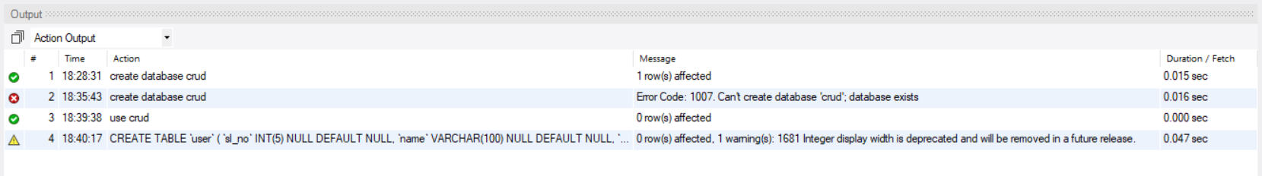

DB_Connection.java CODE:
package crud_operations;
import java.sql.Connection;
import java.sql.DriverManager;
public class DB_Connection {
public static void main(String[] args) {
DB_Connection obj_DB_Connection=new DB_Connection();
System.out.println(obj_DB_Connection.get_connection());
}
public Connection get_connection(){
Connection connection=null;
try {
Class.forName("com.mysql.cj.jdbc.Driver");
connection = DriverManager.getConnection("jdbc:mysql://localhost:3306/crud","root", "sashank");
}
catch (Exception e) {
System.out.println(e);
}
return connection;
}
}

OUTPUT :
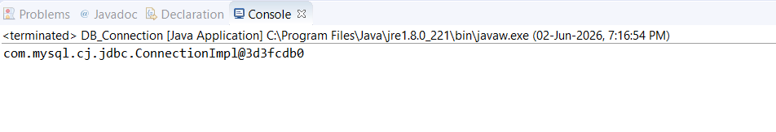

CREATING DATA CODE IN DB_Connection.java :
package crud_operations;
import java.sql.Connection;
import java.sql.PreparedStatement;
import java.sql.ResultSet;
public class CRUD_Test {
public void create_data(String sl_no,String name,String email){
DB_Connection obj_DB_Connection=new DB_Connection();
Connection connection=obj_DB_Connection.get_connection();
PreparedStatement ps=null;
try {
String query="insert into user(sl_no,name,email) values (?,?,?)";
ps=connection.prepareStatement(query);
ps.setString(1, sl_no);
ps.setString(2, name);
ps.setString(3, email);
System.out.println(ps);
ps.executeUpdate();
} catch (Exception e) {
System.out.println(e);
}
}
public static void main(String[] args) {
CRUD_Test objTest=new CRUD_Test();
objTest.create_data("1", "sashank", "sashank@gmail.com");
objTest.create_data("2", "saketh", "saketh@gmail.com");
}
}

OUTPUT :
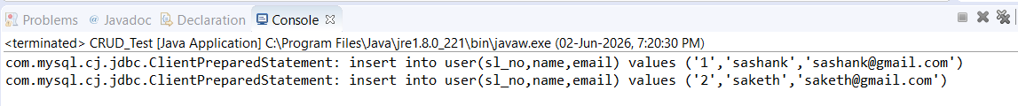

READ DATA:
package crud_operations;
import java.sql.Connection;
import java.sql.PreparedStatement;
import java.sql.ResultSet;
public class CRUD_Test {
public void create_data(String sl_no,String name,String email){
DB_Connection obj_DB_Connection=new DB_Connection();
Connection connection=obj_DB_Connection.get_connection();
PreparedStatement ps=null;
try {
String query="insert into user(sl_no,name,email) values (?,?,?)";
ps=connection.prepareStatement(query);
ps.setString(1, sl_no);
ps.setString(2, name);
ps.setString(3, email);
System.out.println(ps);
ps.executeUpdate();
} catch (Exception e) {
System.out.println(e);
}
}
public void read_data(){
DB_Connection obj_DB_Connection=new DB_Connection();
Connection connection=obj_DB_Connection.get_connection();
PreparedStatement ps=null;
ResultSet rs=null;
try {
String query="SELECT * FROM user";
ps=connection.prepareStatement(query);
System.out.println(ps);
rs=ps.executeQuery();
while(rs.next()){
System.out.println("Sl no -"+rs.getString("sl_no"));
System.out.println("name -"+rs.getString("name"));
System.out.println("email -"+rs.getString("email"));
System.out.println("---------------");
}
} catch (Exception e) {
System.out.println(e);
}
}
public static void main(String[] args) {
CRUD_Test objTest=new CRUD_Test();
//read data
objTest.read_data();
}

}

OUTPUT :
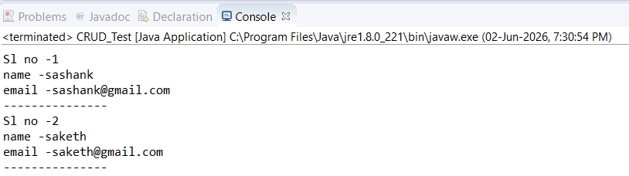

UPDATE DATA :
package crud_operations;
import java.sql.Connection;
import java.sql.PreparedStatement;
import java.sql.ResultSet;
public class CRUD_Test {
public void update_data(String sl_no,String new_sl_no,String name,String email){
DB_Connection obj_DB_Connection=new DB_Connection();
Connection connection=obj_DB_Connection.get_connection();
PreparedStatement ps=null;
try {
String query="update user set sl_no=?,name=?,email=? where sl_no=?";
ps=connection.prepareStatement(query);
ps.setString(1, new_sl_no);
ps.setString(2, name);
ps.setString(3, email);
ps.setString(4, sl_no);
System.out.println(ps);
ps.executeUpdate();
} catch (Exception e) {
System.out.println(e);
}
}
public static void main(String[] args) {
CRUD_Test objTest=new CRUD_Test();
//update data
objTest.update_data("2", "22", "jawad2", "jawad2@gmail");
}

}

OUTPUT :

DELETE DATA :
package crud_operations;
import java.sql.Connection;
import java.sql.PreparedStatement;
import java.sql.ResultSet;
public class CRUD_Test {
public void delete_data(String sl_no){
DB_Connection obj_DB_Connection=new DB_Connection();
Connection connection=obj_DB_Connection.get_connection();
PreparedStatement ps=null;
try {
String query="delete from user where sl_no=?";
ps=connection.prepareStatement(query);
ps.setString(1, sl_no);
System.out.println(ps);
ps.executeUpdate();
} catch (Exception e) {
System.out.println(e);
}

}
public static void main(String[] args) {
CRUD_Test objTest=new CRUD_Test();
//delete data
objTest.delete_data("1");
}

}

OUTPUT :
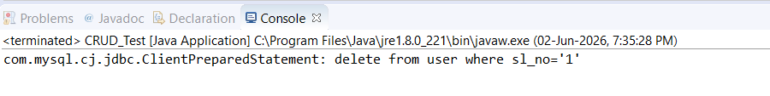

Read Data For Specific sl_no:
package crud_operations;
import java.sql.Connection;
import java.sql.PreparedStatement;
import java.sql.ResultSet;
public class CRUD_Test {
public void read_data(String sl_no){
DB_Connection obj_DB_Connection=new DB_Connection();
Connection connection=obj_DB_Connection.get_connection();
PreparedStatement ps=null;
ResultSet rs=null;
try {
String query="SELECT * FROM user WHERE sl_no=?";
ps=connection.prepareStatement(query);
ps.setString(1, sl_no);
System.out.println(ps);
rs=ps.executeQuery();
while(rs.next()){
System.out.println("Sl no -"+rs.getString("sl_no"));
System.out.println("name -"+rs.getString("name"));
System.out.println("email -"+rs.getString("email"));
System.out.println("---------------");
}
} catch (Exception e) {
System.out.println(e);
}
}
public static void main(String[] args) {
CRUD_Test objTest=new CRUD_Test();
//read data
objTest.read_data("22");
}
}

OUTPUT :
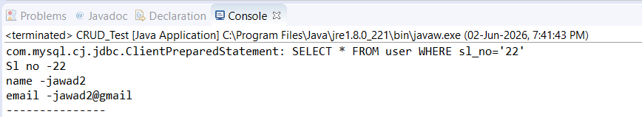

ALTER TABLE :
package crud_operations;
import java.sql.Connection;
import java.sql.PreparedStatement;
import java.sql.ResultSet;
public class CRUD_Test {
public void alter_table(String col_name,String type) {
DB_Connection obj_DB_Connection = new DB_Connection();
Connection connection = obj_DB_Connection.get_connection();
PreparedStatement ps = null;

try {
String query = "ALTER TABLE user ADD "+col_name+" "+type;
ps = connection.prepareStatement(query);
ps.executeUpdate();
System.out.println(ps);
} catch (Exception e) {
System.out.println(e);
}
}
public static void main(String[] args) {
CRUD_Test objTest=new CRUD_Test();
//alter table
objTest.alter_table("ph_no","VARCHAR(10)");

}
}

OUTPUT :
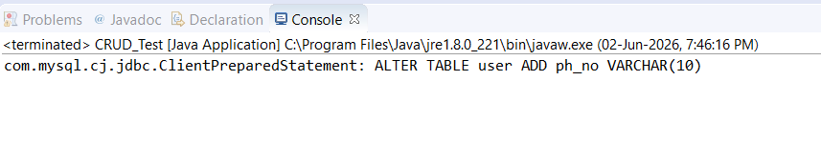

Truncate Table:
package crud_operations;
import java.sql.Connection;
import java.sql.PreparedStatement;
import java.sql.ResultSet;
public class CRUD_Test {
public void truncate_table() {
DB_Connection obj_DB_Connection = new DB_Connection();
Connection connection = obj_DB_Connection.get_connection();
PreparedStatement ps = null;
try {
String query = "TRUNCATE TABLE user";
ps = connection.prepareStatement(query);
ps.executeUpdate();
System.out.println(ps);

} catch (Exception e) {
System.out.println(e);
}
}
public static void main(String[] args) {
CRUD_Test objTest=new CRUD_Test();
//truncate table
objTest.truncate_table();

}
}

OUTPUT :
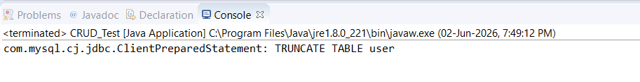

MONGO DB

CONNECTION :
import com.mongodb.client.MongoClient;
import com.mongodb.client.MongoClients;
import com.mongodb.client.MongoDatabase;

public class MongoDB_Connection {
public static void main(String[] args) {
String connectionString = "mongodb://localhost:27017";

try (MongoClient mongoClient = MongoClients.create(connectionString)) {
MongoDatabase database = mongoClient.getDatabase("testdb");
System.out.println("Connected successfully to MongoDB!");
}
}
}

OUTPUT :
