mongosh:127.0.0.1:27019 CODE AND OUTPUT :

rs.initiate({
_id: "configReplSet",
configsvr: true,
members: [
{ _id: 0, host: "localhost:27019" }
]
})
OUTPUT :
{
ok: 1,
'$clusterTime': {
clusterTime: Timestamp({ t: 1781183710, i: 1 }),
signature: {
hash: Binary.createFromBase64('AAAAAAAAAAAAAAAAAAAAAAAAAAA=', 0),
keyId: Long('0')
}
},
operationTime: Timestamp({ t: 1781183710, i: 1 })
}

rs.status()
OUTPUT :
{
set: 'configReplSet',
date: 2026-06-11T13:15:20.264Z,
myState: 1,
term: Long('1'),
syncSourceHost: '',
syncSourceId: -1,
configsvr: true,
heartbeatIntervalMillis: Long('2000'),
majorityVoteCount: 1,
writeMajorityCount: 1,
votingMembersCount: 1,
writableVotingMembersCount: 1,
optimes: {
lastCommittedOpTime: { ts: Timestamp({ t: 1781183719, i: 1 }), t: Long('1') },
lastCommittedWallTime: 2026-06-11T13:15:19.558Z,
readConcernMajorityOpTime: { ts: Timestamp({ t: 1781183719, i: 1 }), t: Long('1') },
appliedOpTime: { ts: Timestamp({ t: 1781183719, i: 1 }), t: Long('1') },
durableOpTime: { ts: Timestamp({ t: 1781183719, i: 1 }), t: Long('1') },
writtenOpTime: { ts: Timestamp({ t: 1781183719, i: 1 }), t: Long('1') },
lastAppliedWallTime: 2026-06-11T13:15:19.558Z,
lastDurableWallTime: 2026-06-11T13:15:19.558Z,
lastWrittenWallTime: 2026-06-11T13:15:19.558Z
},
lastStableRecoveryTimestamp: Timestamp({ t: 1781183710, i: 1 }),
electionCandidateMetrics: {
lastElectionReason: 'electionTimeout',
lastElectionDate: 2026-06-11T13:15:11.044Z,
electionTerm: Long('1'),
lastCommittedOpTimeAtElection: { ts: Timestamp({ t: 1781183710, i: 1 }), t: Long('-1') },
lastSeenWrittenOpTimeAtElection: { ts: Timestamp({ t: 1781183710, i: 1 }), t: Long('-1') },
lastSeenOpTimeAtElection: { ts: Timestamp({ t: 1781183710, i: 1 }), t: Long('-1') },
numVotesNeeded: 1,
priorityAtElection: 1,
electionTimeoutMillis: Long('10000'),
newTermStartDate: 2026-06-11T13:15:11.101Z,
wMajorityWriteAvailabilityDate: 2026-06-11T13:15:11.495Z
},
members: [
{
_id: 0,
name: 'localhost:27019',
health: 1,
state: 1,
stateStr: 'PRIMARY',
uptime: 86,
optime: { ts: Timestamp({ t: 1781183719, i: 1 }), t: Long('1') },
optimeDate: 2026-06-11T13:15:19.000Z,
optimeWritten: { ts: Timestamp({ t: 1781183719, i: 1 }), t: Long('1') },
optimeWrittenDate: 2026-06-11T13:15:19.000Z,
lastAppliedWallTime: 2026-06-11T13:15:19.558Z,
lastDurableWallTime: 2026-06-11T13:15:19.558Z,
lastWrittenWallTime: 2026-06-11T13:15:19.558Z,
syncSourceHost: '',
syncSourceId: -1,
infoMessage: 'Could not find member to sync from',
electionTime: Timestamp({ t: 1781183711, i: 1 }),
electionDate: 2026-06-11T13:15:11.000Z,
configVersion: 1,
configTerm: 1,
self: true,
lastHeartbeatMessage: ''
}
],
ok: 1,
'$clusterTime': {
clusterTime: Timestamp({ t: 1781183719, i: 1 }),
signature: {
hash: Binary.createFromBase64('AAAAAAAAAAAAAAAAAAAAAAAAAAA=', 0),
keyId: Long('0')
}
},
operationTime: Timestamp({ t: 1781183719, i: 1 })
}

mongosh:127.0.0.1:27011 CODE AND OUTPUT :
rs.initiate({
_id: "shard1ReplSet",
members: [
{ _id: 0, host: "localhost:27011" }
]
})
OUTPUT :
{
ok: 1,
'$clusterTime': {
clusterTime: Timestamp({ t: 1781183786, i: 1 }),
signature: {
hash: Binary.createFromBase64('AAAAAAAAAAAAAAAAAAAAAAAAAAA=', 0),
keyId: Long('0')
}
},
operationTime: Timestamp({ t: 1781183786, i: 1 })
}

mongosh:127.0.0.1:27012 CODE AND OUTPUT :
rs.initiate({
_id: "shard2ReplSet",
members: [
{ _id: 0, host: "localhost:27012" }
]
})
OUTPUT :
{
ok: 1,
'$clusterTime': {
clusterTime: Timestamp({ t: 1781183841, i: 1 }),
signature: {
hash: Binary.createFromBase64('AAAAAAAAAAAAAAAAAAAAAAAAAAA=', 0),
keyId: Long('0')
}
},
operationTime: Timestamp({ t: 1781183841, i: 1 })
}

mongosh:127.0.0.1:27017 CODE AND OUTPUT :
sh.addShard("shard1ReplSet/localhost:27011")
OUTPUT :
{
shardAdded: 'shard1ReplSet',
ok: 1,
'$clusterTime': {
clusterTime: Timestamp({ t: 1781183921, i: 28 }),
signature: {
hash: Binary.createFromBase64('AAAAAAAAAAAAAAAAAAAAAAAAAAA=', 0),
keyId: Long('0')
}
},
operationTime: Timestamp({ t: 1781183921, i: 28 })
}

sh.addShard("shard2ReplSet/localhost:27012")
OUTPUT :
{
shardAdded: 'shard2ReplSet',
ok: 1,
'$clusterTime': {
clusterTime: Timestamp({ t: 1781183932, i: 12 }),
signature: {
hash: Binary.createFromBase64('AAAAAAAAAAAAAAAAAAAAAAAAAAA=', 0),
keyId: Long('0')
}
},
operationTime: Timestamp({ t: 1781183932, i: 12 })
}

sh.status()
OUTPUT :
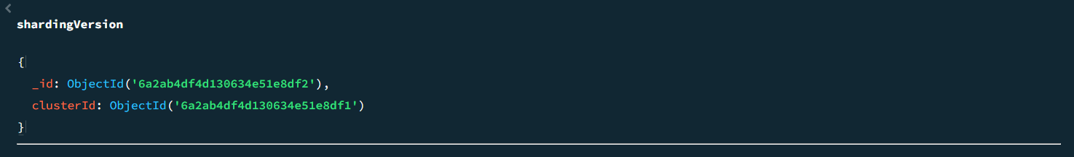
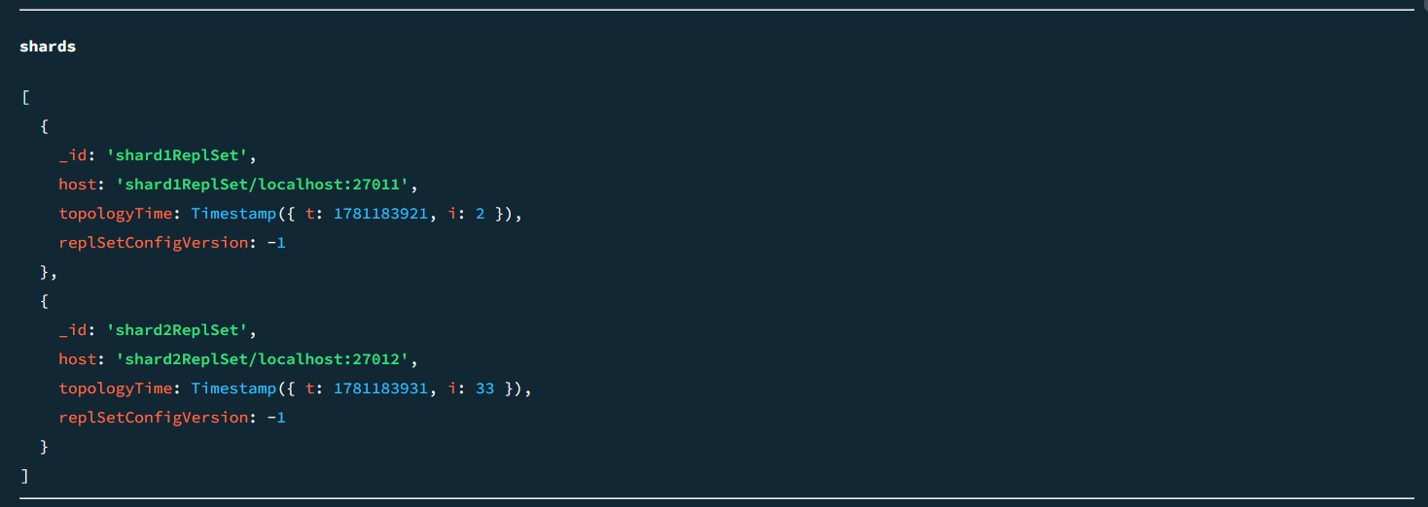
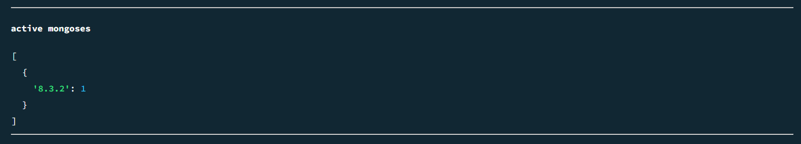
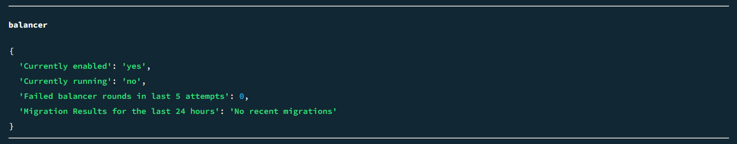
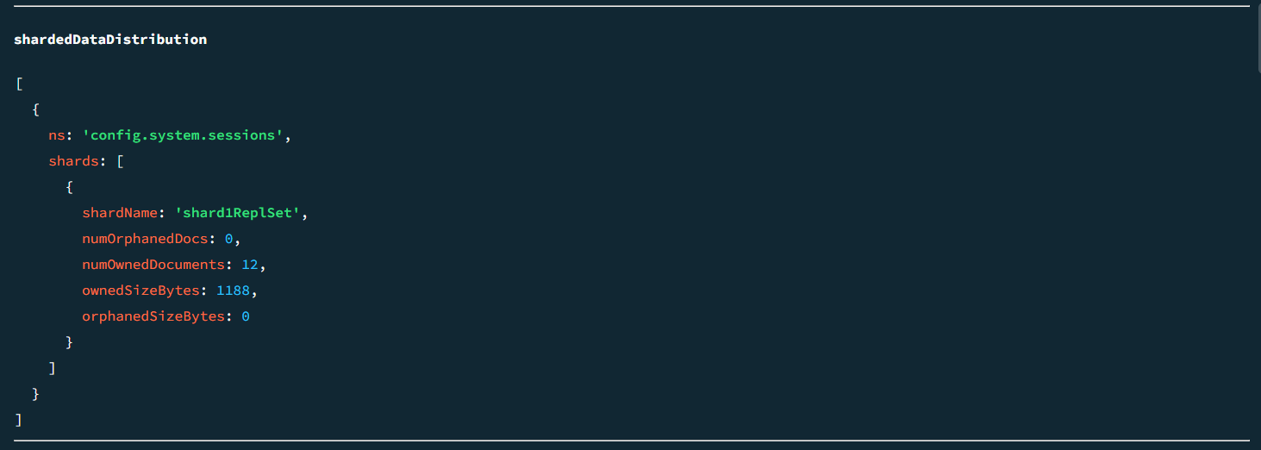
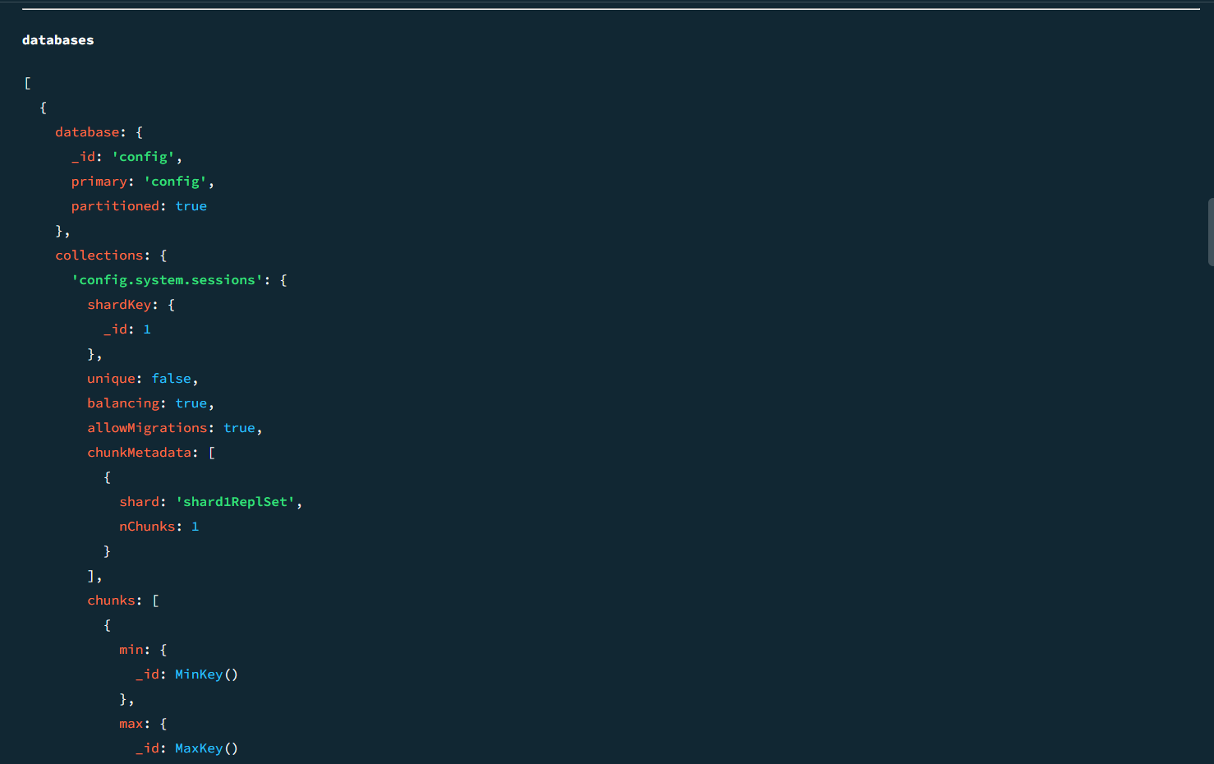
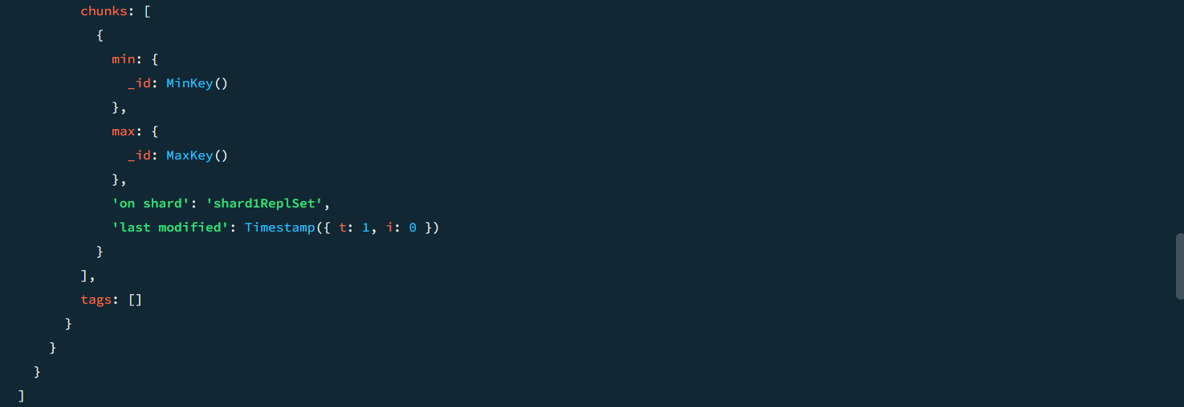

sh.enableSharding("eCommerceDB")
OUTPUT :
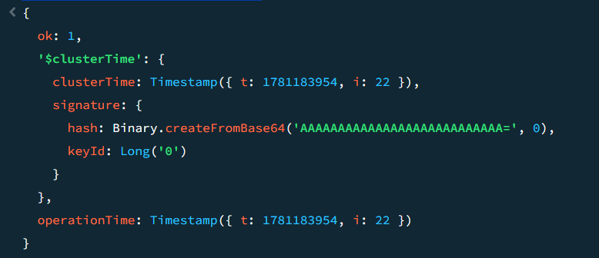

sh.shardCollection(
"eCommerceDB.orders",
{ customer_id: "hashed" }
)

OUTPUT :
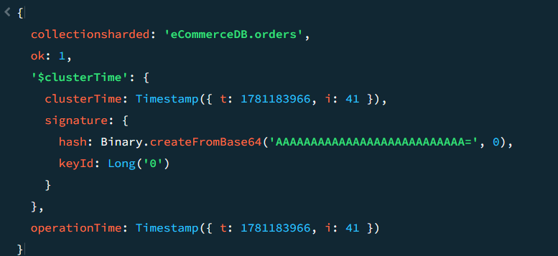

use eCommerceDB
OUTPUT :
switched to db eCommerceDB

for(let i=0;i<1000;i++){
db.orders.insertOne({
customer_id:"cust_"+i,
amount:Math.random()*100
})
}
OUTPUT :
{
acknowledged: true,
insertedId: ObjectId('6a2ab633b85981a745e0dc72')
}

sh.status()
OUTPUT :
