Real-Time ML-Based Library Book Availability Prediction for FCFS Borrowing
Datta Divyesh Vedurumudi  B.Tech ECE  Vellore Institute of Technology  Vellore, India | D. Methun  B.Tech ECE  Vellore Institute of Technology  Vellore, India | Mavuri Bhanu Tej  B.Tech ECE VLSI  Vellore Institute of Technology  Vellore, India | Siva Charan G  B.Tech ECE VLSI  Vellore Institute of Technology  Vellore, India
Faculty Guide: Dr. Aparna Mohanty

Abstract—During open-book examinations, demand for a small set of textbooks rises sharply, and students cannot tell whether a title will still be on the shelf if they delay borrowing. Libraries issue books First Come, First Served (FCFS), so any support tool must remain advisory and must not alter borrowing priority. This paper presents a student-facing decision-support prototype that forecasts short-term demand for each title and projects it against current stock to estimate when the title may become unavailable. Historical borrowing records are held in Amazon S3 for model training, current catalogue and transaction state is held in Amazon DynamoDB, and prediction is served by AWS Lambda behind Amazon API Gateway. The model is a regression-based demand forecaster that uses recent borrowing rates, days to the next examination and calendar features, and the stock projection is derived from its output. Evaluation uses a synthetic dataset of 68 engineering textbooks with 25–30 copies each, covering the 2023–2026 Fall and Winter examination cycles, with transactions in 2026 ending on 5 September. A comparison of multiple linear regression, decision tree and random forest regressors with always-zero and historical-average baselines, using MAE, RMSE and R², shows no material gain over the baselines on the synthetic data. No latency results are reported because the deployment logs were not available for this draft. We define the evaluation protocol, the baselines and the metrics, and we state what the evidence does and does not establish. The contribution is a precise problem formulation and a reproducible architecture for advisory availability forecasting under FCFS; validation on real circulation data remains future work.
Index Terms—library analytics, demand forecasting, regression, serverless computing, AWS Lambda, DynamoDB, FCFS, decision support
I. Introduction
Academic libraries lend a fixed number of copies of each prescribed textbook. In the examination structure considered here, the second continuous assessment test (CAT-2) is open-book, so borrowing of core textbooks rises sharply in the weeks before it. Students who borrow early hold copies for the whole examination period, and a title can reach zero available copies while later students are still planning to borrow it. A current copy count tells a student what is available now but not whether it will still be available when they intend to visit.
Short-term forecasting addresses this gap. If the rate of borrowing is known, current stock can be projected forward, and the student can be told that a title is likely to run out in a few days. The library issues books on a strict FCFS basis, and the prediction must not create reservations, priorities or any change to circulation rules. The system is therefore decision support for students, not inventory control.
Prior work on library demand has mostly addressed acquisition planning, collection allocation and long-horizon circulation forecasts [1]–[6]. Work on predicting whether an individual title will be available exists [6], [17], but the literature reviewed here does not combine an examination-aware, per-title forecast with livestock, a stockout-date estimate and a serverless deployment. We state this as a gap in the sources we reviewed, not as a claim of novelty over all literature.
The research question is: can recent borrowing behaviour, combined with the examination calendar, forecast near-term demand for a title accurately enough to estimate when it will run out of stock? The objectives are to (1) formulate availability forecasting under FCFS, (2) generate a dataset with examination-driven demand, (3) design a serverless architecture that separates training data from live state, (4) define a reproducible evaluation against naive baselines, and (5) identify the evidence needed before any accuracy claim can be made.
The contributions are: a formulation that separates demand forecasting, availability projection and stockout-risk estimation; a documented dataset specification with examination-linked demand and long-hold borrowing; an S3/DynamoDB/Lambda design for combining history with live state; and an explicit evidence audit that distinguishes the designed system from the verified one.
II. Related Work
Library circulation and demand. McGrath modelled circulation by subject using enrolment and shelf-list variables [3], an early regression treatment of the allocation problem. Topolska compared linear regression, MLP, CNN, LSTM and GRU for forecasting library demand, using a chronological 80/20 split, walk-forward validation and repeated runs, and reported seasonal increases in textbook demand before examination sessions [4]. Iqbal et al. applied predictive analytics to rental-book data from academic libraries for planning and management [5]. Daimari et al. built a machine-learning model for book availability prediction in a library management system [6]; that work is the closest to ours in objective, and the details of its features, horizon and deployment should be compared directly before submission . Liu et al. modelled book checkouts across the branches of a public library system with a Bayesian latent-variable model that controls for book availability [1]. Zhang and Tian predicted university library borrowing volume with an RBF neural network tuned by ant colony optimisation [2]. Geetha et al. compared random forest, support vector and neural network models for predicting book availability [17]. Arunruviwat and Muangsin proposed a hybrid book recommendation method for a university library that uses course syllabus data [15], and Jayawardena et al. described an AI-based smart library system built on RFID, Raspberry Pi and LSTM prediction [16].
Forecasting methodology. Hyndman and Athanasopoulos describe regression-based and time-series forecasting, including time-ordered validation [8]. Hyndman and Koehler discuss forecast-accuracy measures and the weaknesses of percentage errors when actual values are near zero [7], which matters here because daily borrowing counts for many titles are small. Syntetos et al. classify demand patterns by intermittency and variability [9], which is relevant to rarely borrowed titles.
Serverless and cloud services. Jonas et al. discuss the benefits and limits of serverless computing, including cold-start latency and state management [10]. Elhemali et al. describe DynamoDB as a managed key-value and document database with predictable performance [11]. AWS documentation defines the service behaviour used in this design [13], [14].
Calibration. Guo et al. show that model confidence scores are often miscalibrated and describe calibration evaluation [12]. We use this to justify not presenting regression-derived risk as a calibrated probability unless it is validated.
Table I compares the reviewed studies with this work. The gap is the absence, in the sources reviewed, of an examination-aware, per-title forecast that is joined to live stock, expressed as an estimated stockout date, and delivered to students without affecting FCFS.
TABLE I
Comparison with Related Work
Ref. | Method | Application | Limitation | Relevance
[3] | Regression on enrolment and shelf-list variables | Subject-level circulation allocation | Aggregate level, not per title or per day | Early regression baseline for circulation
[4] | Linear regression, MLP, CNN, LSTM, GRU | Library demand forecasting | Annual demand indicator; no live stock or availability output | Evaluation protocol and seasonality evidence
[5] | Predictive analytics on rental data | Planning and management in academic libraries | Planning focus, not student-facing | Academic-library demand modelling
[6] | ML classification / regression | Book availability prediction | Method and deployment details to be checked | Closest prior objective
[10], [11] | Serverless and managed NoSQL analysis | Cloud architecture | General-purpose, not library-specific | Justifies Lambda and DynamoDB design
This work | Demand regression + stock projection | Per-title advisory stockout estimate under FCFS | Synthetic data; evaluation pending | Examination-aware, live-state forecasting

III. Problem Formulation
Let b denote a title, t the current day, Δ the forecast horizon in days, and A_{t}(b) the number of copies available at the start of day t. Let c_{t}(b) and r_{t}(b) be the number of checkouts and returns on day t. Let e_{t} be the number of days from t to the next examination, and x_{t}(b) the feature vector built from history up to t (Section IV).
Demand forecast. The model estimates daily checkouts for the next Δ days:
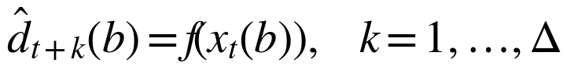 (1)
The predicted demand over the horizon is
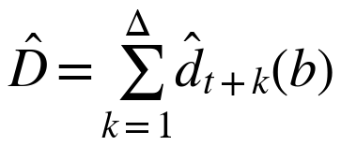 (2)
Availability projection. Following the conceptual mapping in the project presentation (expected available copies = current copies − predicted demand), the projected stock is
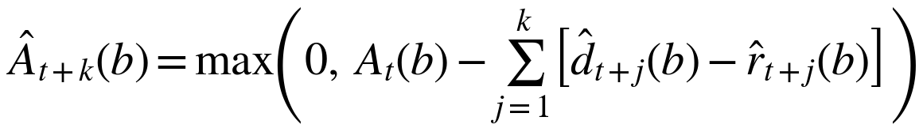 (3)
where r̂ is a forecast of returns. The subtraction of returns is required because, in this setting, returns are concentrated after the examination period and are small beforehand; ignoring them overstates depletion after the examination and understates stock if early returns occur. The max(·) term enforces non-negative inventory, and the projection must not exceed the number of physical copies. If the implementation uses gross demand only, as the presentation formula suggests, the paper must state that returns are ignored.
Estimated stockout date. The estimated stockout day is
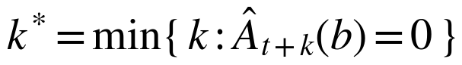 (4)
or “none within Δ” if no such k exists.
Three distinct quantities. Demand (checkouts per day) is the regression target; availability (copies on shelf) is a derived inventory quantity; stockout risk is a statement about the chance that availability reaches zero. A point demand forecast does not by itself give a probability. A probability such as the 78% and 94% values in the presentation mockup would require an explicit uncertainty model, for example prediction intervals or a classifier, and calibration checks [12]. Until that is validated, outputs are described as estimates or risk indicators.
FCFS constraint. The prediction is an observation of the system. It does not reserve a copy, change an issue order or give any user priority, and the access path for borrowing is independent of the forecasting path.
IV. Methodology
A. Data Sources and Dataset
The dataset was generated, not collected. Its structure follows the title-level availability and checkout records described in [1], adapted to the requirements of a college library that forecasts for students. It contains two tables: books.csv (book identifier, title, department, copies) and transactions.csv (transaction identifier, book identifier, date, CHECKOUT or RETURN, and examination context fields). The generator specification, as described to us, is:
- 68 textbooks across CSE, ECE, EEE, Mechanical, Civil, Chemical, Biotechnology and common engineering subjects; 25–30 copies per title, varying by title.
- Transactions for 2023, 2024, 2025 and 2026, 55,089 records in total. The 2026 data end on 5 September 2026, with no future transactions.
- Fall and Winter semester examination cycles. Fall: CAT-1 in the first or second week of August, CAT-2 in the last week of September, FAT from the second week of November to the first week of December. Winter: CAT-1 in the last week of January, CAT-2 in mid-March, FAT from mid-April to the first week of May.
- CAT-2 is open-book and has the highest demand; CAT-1 and FAT have moderate demand.
- A standard issue lasts 28 days, students borrow early and renew, and returns are concentrated after the relevant examination period.
- Stockout timing varies between titles. Some run out earlier or later than five days before CAT-2, and some do not run out, so the data do not hard-code a fixed stockout offset.
- Retained fields: days_to_first_exam, exam_cycle_id, exam_phase; consistency between transactions and available copies is preserved.
These figures come from the dataset specification and generation summary; the CSV files themselves were not inspected for this draft . The 68-title dataset is much smaller than the intended catalogue of about 24,000 titles. The 24,000 figure is a design target, and no test at that scale is claimed.
Examination windows are maintained by library and registrar administrators through the academic calendar console (Figs. 1 and 2), and the days-to-exam features are derived automatically from these records.
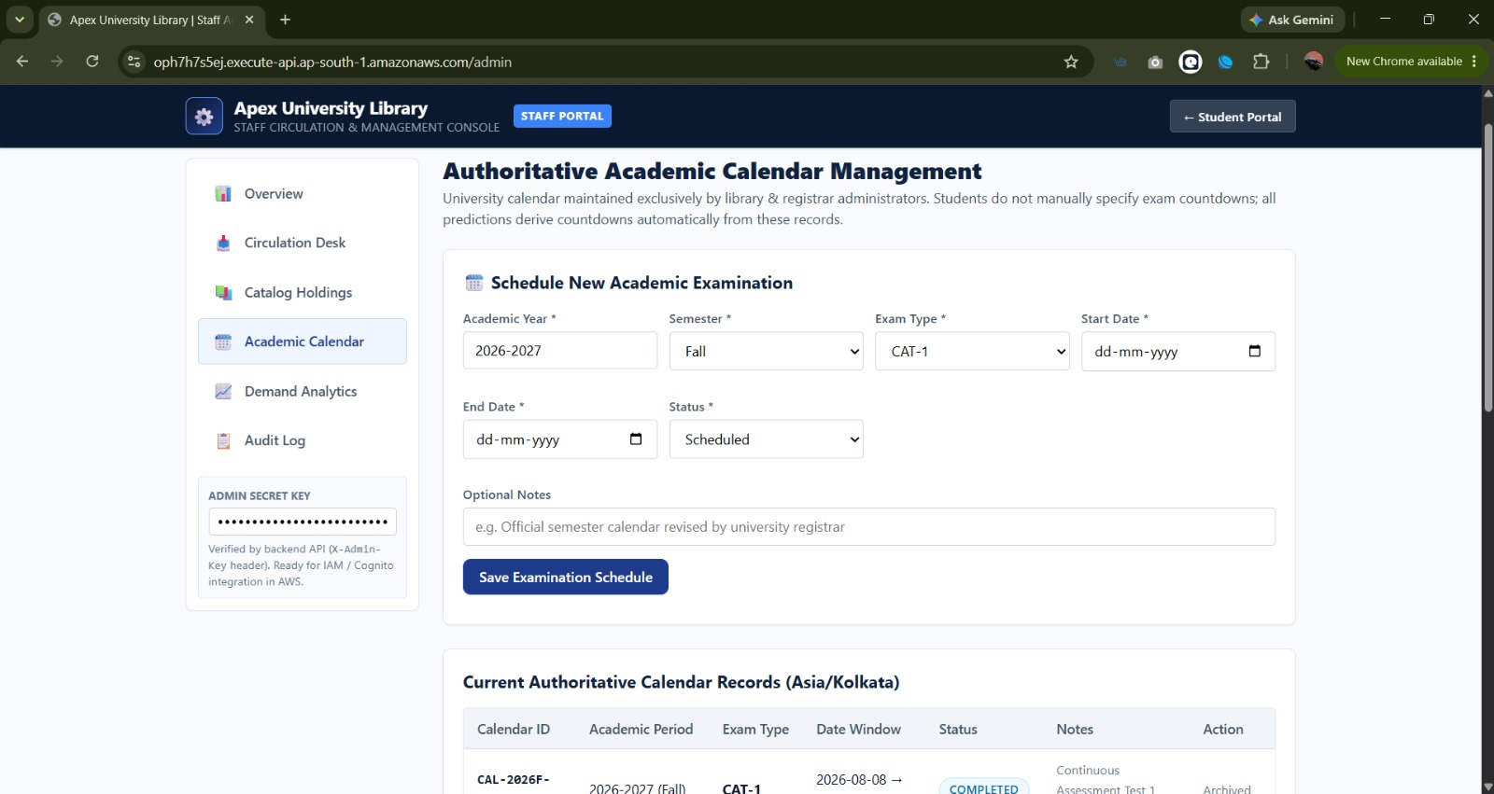
Fig. 1. Staff portal: academic calendar management form for scheduling an examination.
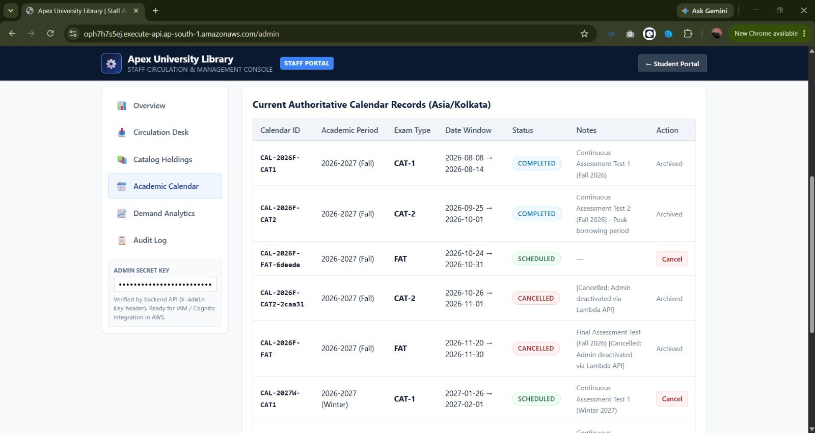
Fig. 2. Staff portal: authoritative academic calendar records for the Fall 2026–2027 and Winter 2027 cycles.
B. Preprocessing, Features and Missing Values
Transactions are aggregated to a title-day table of checkouts, returns and end-of-day available copies. The designed feature set is: current available copies; checkouts in the last 1, 3 and 7 days; returns in the last 7 days; relative growth of the 7-day rate; days to the next examination and the examination phase; calendar features; and the title’s historical demand near the same examination in earlier years. Titles with no history in a window receive zero counts. Rolling features for the first days of a series use only available history. Whether each feature is computed by the deployed Lambda is .
C. Model and Training Protocol
The predictor is a regression model of future demand, with the stock projection computed outside the model. The model artifact referenced in the project is model/regression_model.npz, whose exact form (for example linear or regularised regression with stored coefficients) is . A generic regression fits
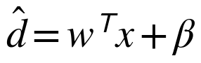 (5)
by minimising mean squared error with optional regularisation, where w is the coefficient vector and β the intercept. The target is the sum of checkouts over the next Δ days or the daily checkouts at each lead time; the choice must be stated once confirmed.
The split is chronological: 2023–2024 for fitting, 2025 for validation and model selection, and 2026 up to 5 September as an unseen test period that includes CAT-1 and the CAT-2 build-up. Walk-forward validation across cycles is preferred to random splits, which would leak future demand into training [4], [8]. Because the data are synthetic, performance on the test period measures recovery of the generator’s structure, not real student behaviour.
D. Baselines
The model must be compared with (1) the title’s mean daily demand over the preceding 7 days (naive persistence), (2) the same title’s demand in the same days-to-exam position in the previous year (seasonal naive), and (3) a global mean. A model that does not beat the seasonal naive baseline adds no value over looking at last year’s data.
E. Inference Path and Data Refresh
At request time, the Lambda function reads the title’s current state and recent transactions from DynamoDB, builds the feature vector, loads the model artifact from S3, forecasts demand and applies the projection of Section III. The model is not retrained at request time. Periodic offline retraining from the S3 history is the intended update mechanism; whether any automated retraining or event-triggered update exists is . New transactions change the features immediately, and therefore the forecast, without changing model parameters.
The student-facing forecast pop-up presents the availability assessment, current inventory, projected 7-day demand and estimated stockout horizon for the selected title (Figs. 3–5).
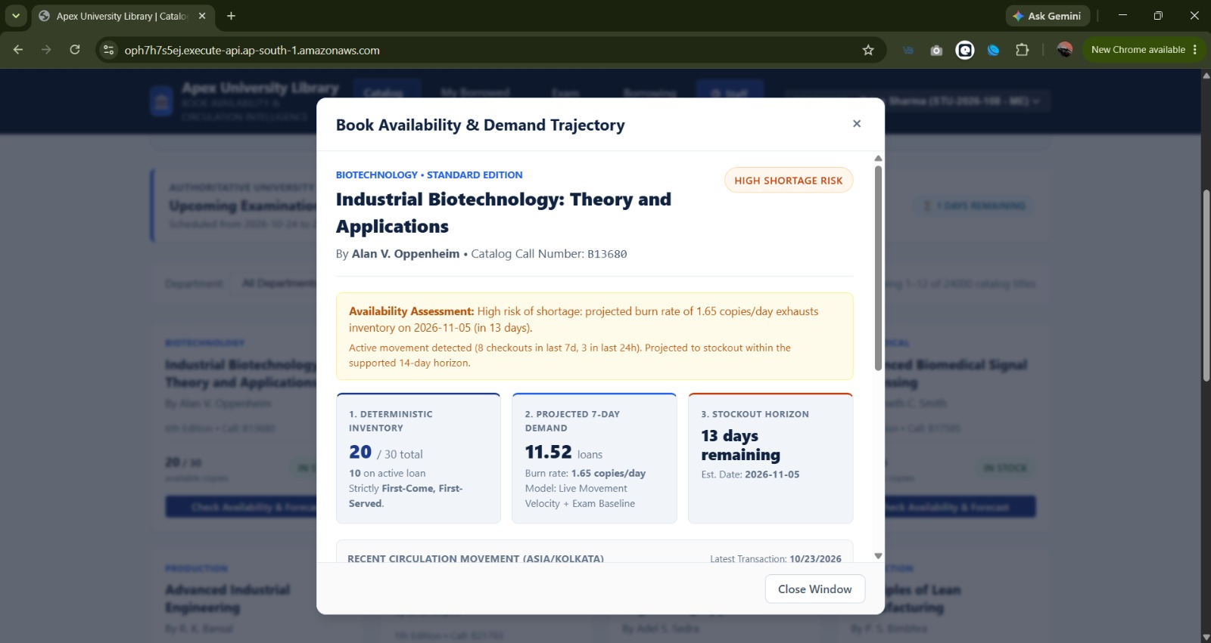
Fig. 3. Book availability and demand trajectory pop-up: availability assessment, inventory, projected 7-day demand and stockout horizon.
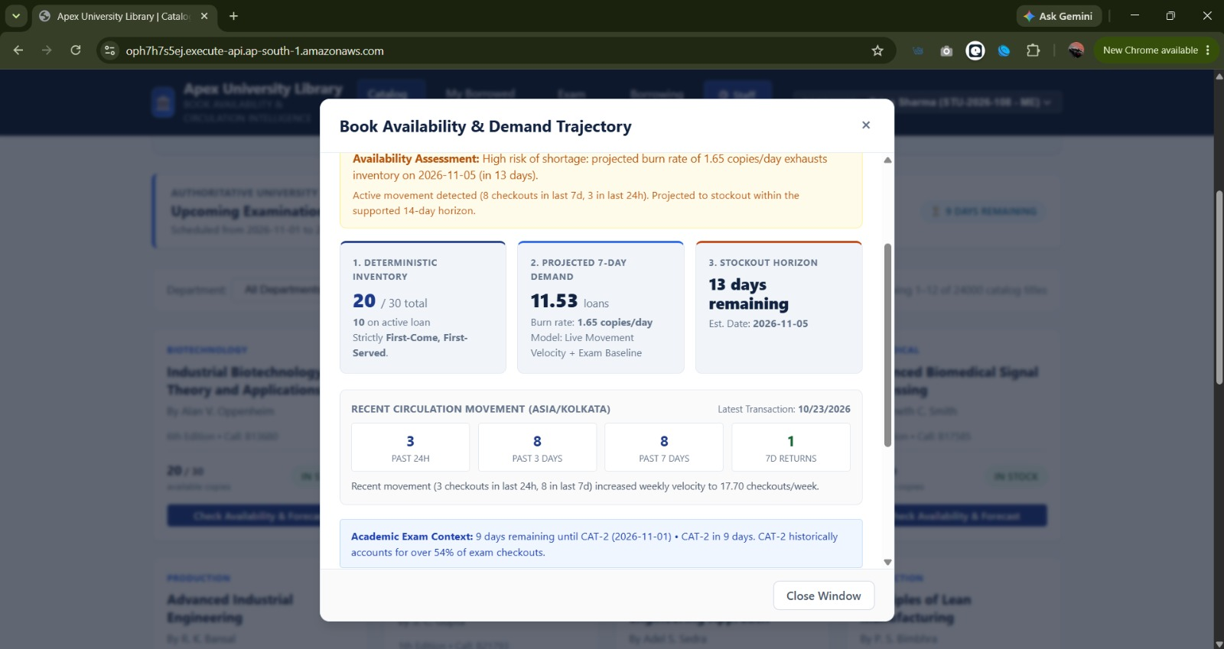
Fig. 4. Book availability and demand trajectory pop-up (continued): recent circulation movement and academic exam context.
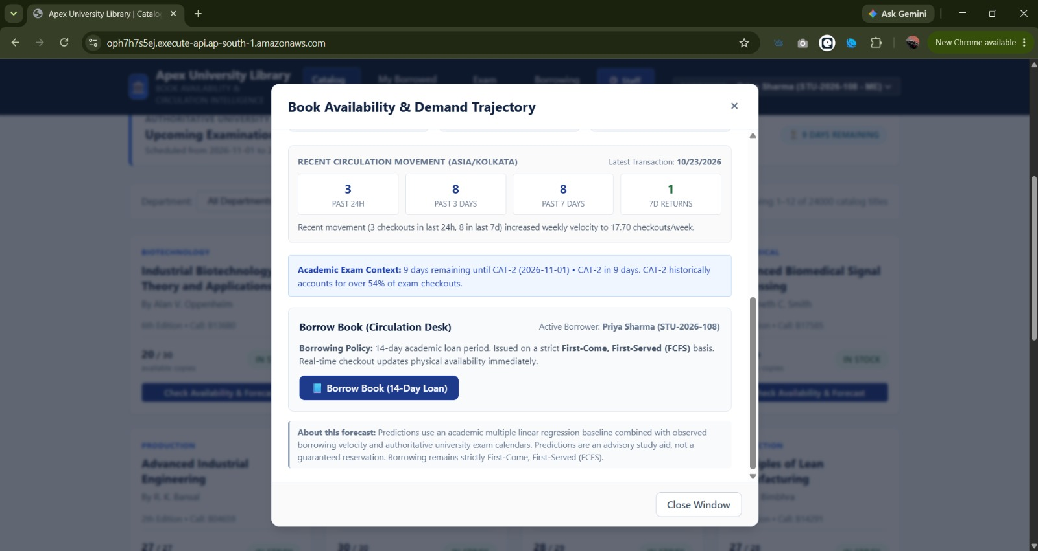
Fig. 5. Book availability and demand trajectory pop-up (continued): circulation desk borrowing policy and forecast notice.
V. System Architecture and Implementation
Fig. 6 shows the designed architecture and Fig. 7 traces one forecast query through it. Table II records which components have actually been observed.
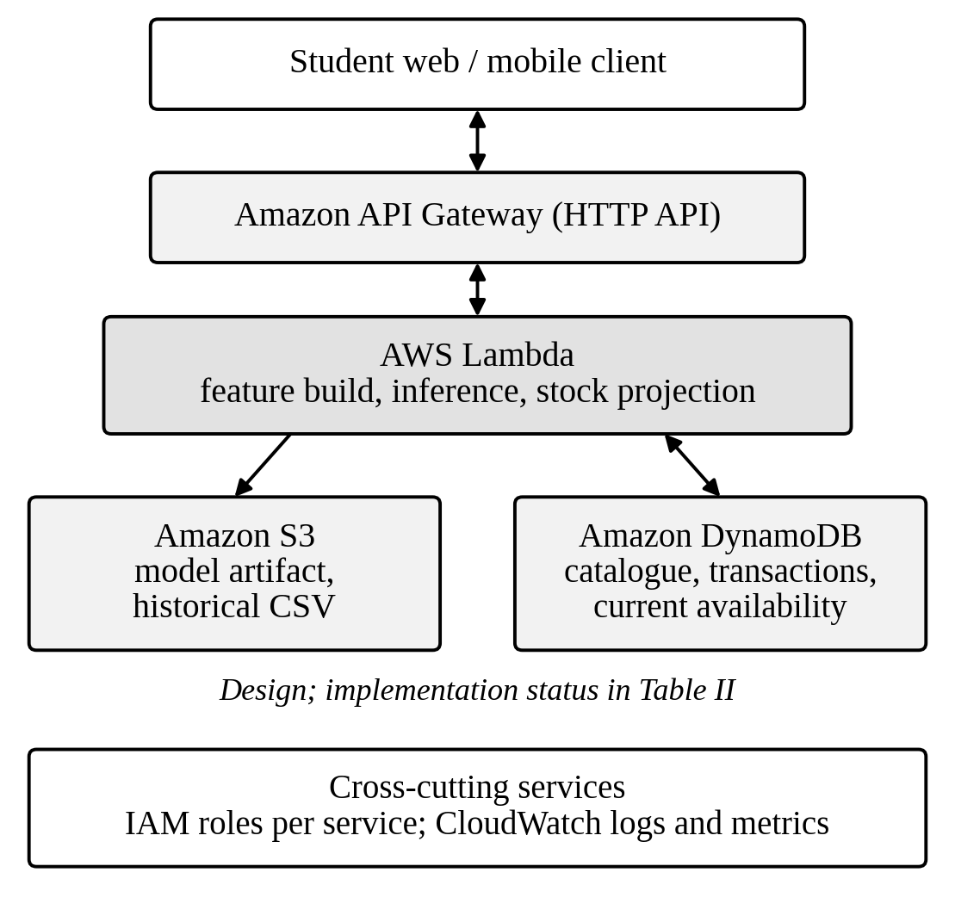
Fig. 6. Architecture (design; implementation status is given in Table II).

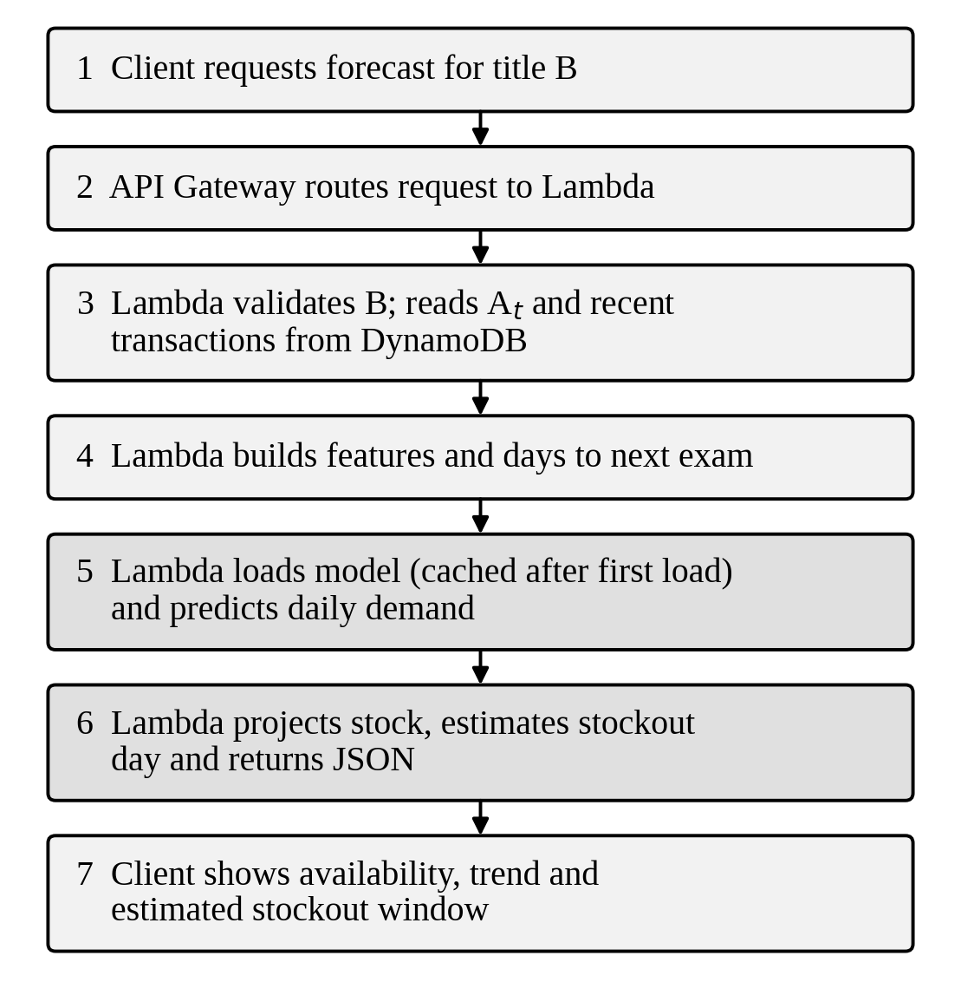
Fig. 7. Request flow for one forecast query.
TABLE II
Component Status
Component | Role
API Gateway + Lambda hosted app, ap-south-1 | Serves the web interface
Catalogue search, exam calendar, borrower selector, staff portal | Application features
DynamoDB tables | Catalogue, transactions
S3 model and dataset storage | Model artifact, history
Prediction route and 7-day forecast | Inference
IAM least privilege, CloudWatch | Security, monitoring
Automated retraining | Model updates

The hosted page identifies itself as “Apex University Library”, states that it is an academic prototype running on Lambda and DynamoDB in the Mumbai region, offers a borrower selector, a catalogue filtered by department and availability (all copies available, low stock of two or fewer), an examination-period section and an FCFS policy statement, and states that the forecasts are advisory. The dynamic content did not load in our fetch, so no API response was observed.
The student catalogue and borrowed-books views of the hosted prototype are shown in Figs. 8 and 9, and the staff circulation console in Figs. 10 and 11.
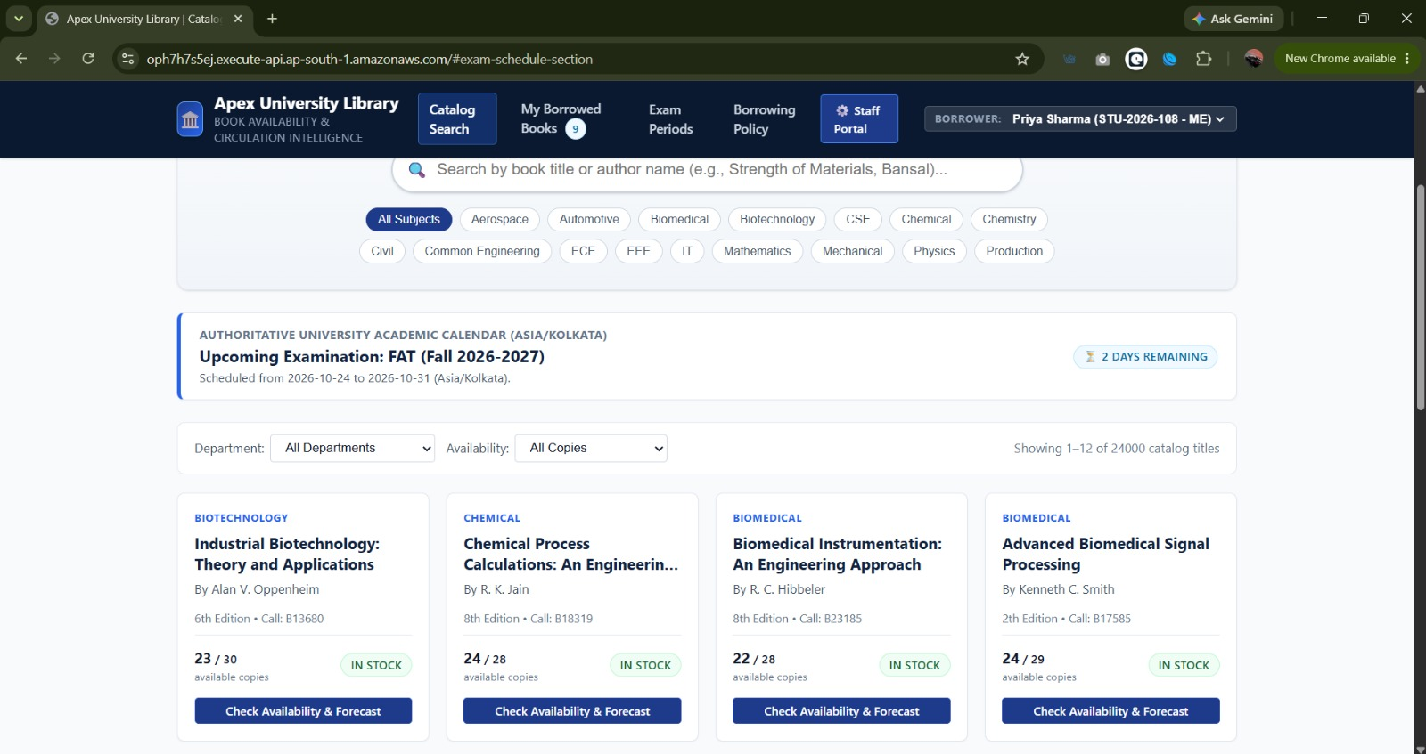
Fig. 8. Student catalogue search with department and availability filters and the upcoming examination banner.
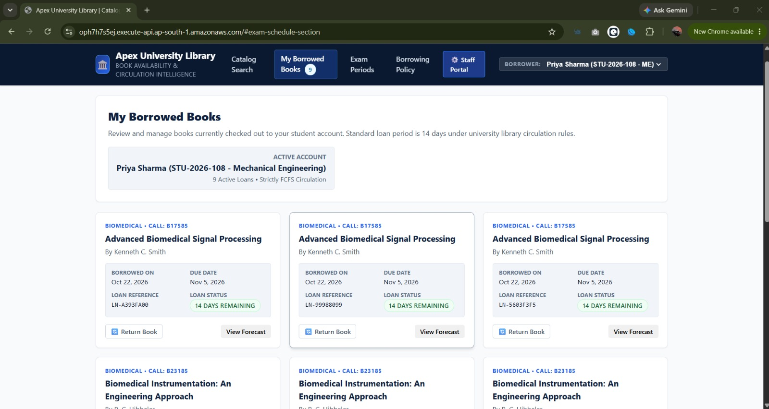
Fig. 9. “My Borrowed Books” view showing active loans under the 14-day loan period and FCFS circulation.
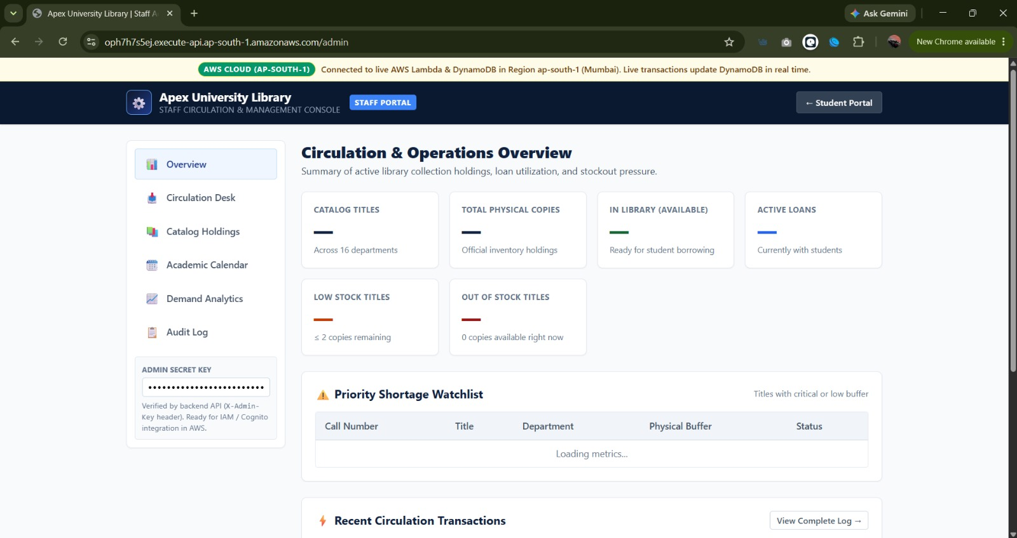
Fig. 10. Staff portal: circulation and operations overview.
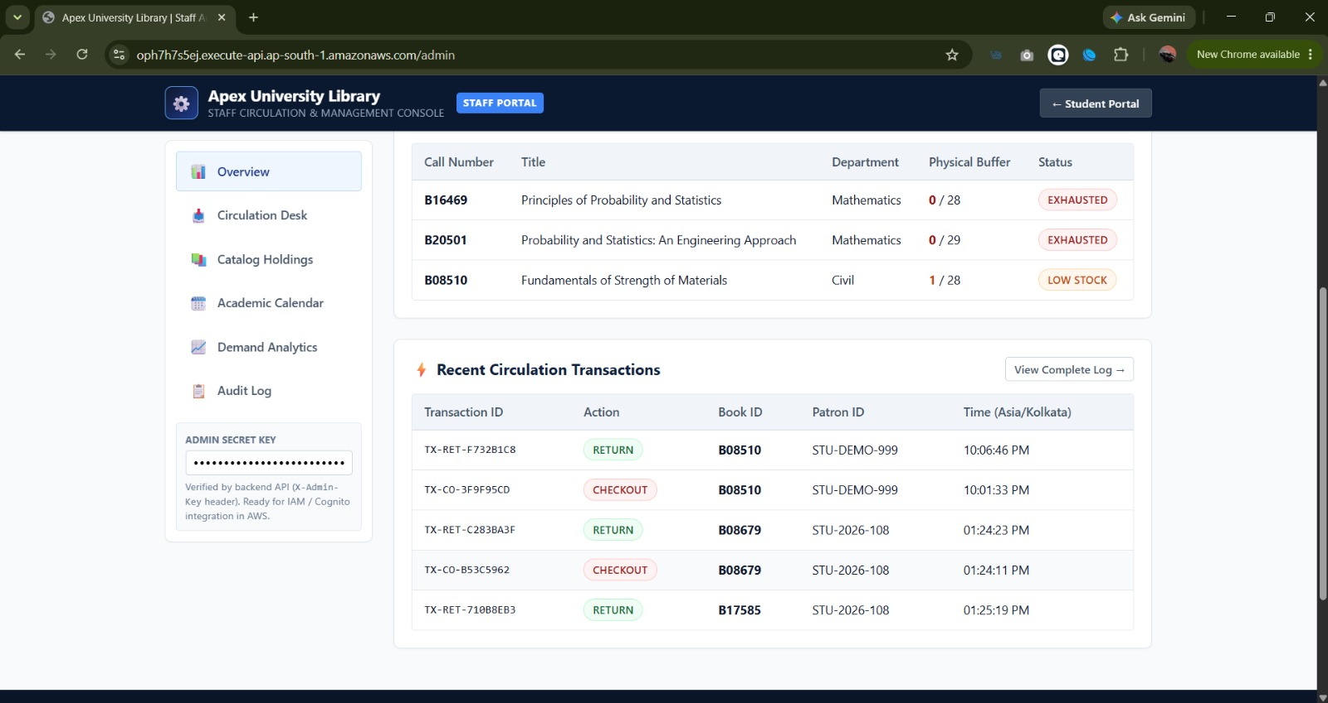
Fig. 11. Staff portal: priority shortage watchlist and recent circulation transactions.
Implementation notes to confirm. Input validation on book identifiers and dates; atomic decrement of available copies (for example conditional writes) so that two simultaneous checkouts cannot take the last copy; Lambda model caching outside the handler; and per-route IAM permissions limited to the required tables and the single model object.
VI. Experimental Setup and Evaluation Plan
A first model comparison was run for this draft and is reported in Table III. The protocol below defines the measures that will be reported in full.
Prediction quality. MAE and RMSE of daily demand at lead times 1 to Δ, R² against the baselines, and error broken down by examination phase, with CAT-2 reported separately. MAPE is excluded for low counts, and a scaled error [7] is used instead.
Availability and stockout. For each title and cycle in the test period, compare the predicted stockout day with the day on which the generated available copies first reach zero. Report the absolute date error, and for the binary question “will the title stock out within Δ days”, report precision, recall and F1. Titles that never stock out are included, so that false alarms are counted. Reliability diagrams and the Brier score are used only if probabilities are produced [12].
System performance. API latency (median, 95th and 99th percentile), cold versus warm invocations, error rate and throughput under a stated load, and DynamoDB read and write consumption.
Scalability. Report the catalogue size and the number of records actually tested. A claim for 24,000 titles requires a test at that size.
TABLE III
Model Comparison Results
Model | MAE | RMSE | R²
Always Predict Zero baseline | 0.013130 | 0.117035 | −0.012747
Historical Average baseline | 0.032378 | 0.116485 | −0.003246
Multiple Linear Regression | 0.033468 | 0.116241 | 0.000942
Decision Tree Regressor | 0.032234 | 0.127158 | −0.195525
Random Forest Regressor | 0.032287 | 0.125255 | −0.159999

VII. Results and Discussion
Table III reports the model comparison on daily demand. The always-predict-zero baseline has the lowest MAE (0.0131), which indicates that most title-days have no checkouts. On RMSE the models are close: multiple linear regression is lowest (0.1162), followed by the historical-average baseline (0.1165) and the always-zero baseline (0.1170), a spread of under 1%. Multiple linear regression is the only model with a positive R², and at 0.0009 it explains almost none of the variance. The decision tree and random forest regressors have a higher RMSE than every baseline (0.1272 and 0.1253) and a negative R² (−0.196 and −0.160), which is consistent with overfitting. No latency or scalability result has been measured, so none is reported. The evidence supports three statements. First, a hosted application is reachable in ap-south-1 and presents the advertised features. Second, a dataset with examination-driven demand has been specified and generated. Third, the design separates historical training data in S3 from live state in DynamoDB. The comparison does not support a claim of useful forecast accuracy, and the evidence does not support any statement about the correctness of the stockout date, response time, cost, security configuration or behaviour at 24,000 titles.
Inconsistencies between project materials. The presentation shows hour-scale outputs (30–60 minutes, next 2 hours, next 6 hours) and probability percentages, while the dataset has daily resolution and the hosted page advertises a 7-day forecast. The presentation mockup shows 15 copies per title, the dataset 25–30. The dataset uses a 28-day loan, and the hosted page states a 14-day loan. The hour-scale probabilities cannot be produced from daily data and should be removed, or a separate hourly model and dataset must be built.
Expected failure modes. The synthetic generator places the CAT-2 spike by construction, so a model with the days-to-exam feature may recover it easily and overstate real-world performance. Titles with sparse history will have unstable rates. The 2026 transactions stop on 5 September, so a query made after that date uses features computed from missing recent data.
VIII. Security, Reliability and Cost
Controls that should be confirmed in the deployment are least-privilege IAM roles per function, no embedded credentials, validation of request parameters, API throttling, and CloudWatch logging that excludes student identifiers. The borrower selector on the page uses student identifiers; real deployments would need authentication and protection of transaction data. DynamoDB writes that adjust available copies need conditional updates to avoid lost updates under concurrency. Lambda cold starts add latency on the first request after idle time [10]. AWS Free Tier terms and service quotas change, so cost claims require a measured request volume and the current pricing documentation [13], [14]. No claim of production security or zero cost is made.
IX. Limitations and Future Work
The main limitation is the synthetic data. The 68-title dataset is small relative to the intended catalogue, the model comparison is limited to two simple baselines and two tree-based regressors, and uncertainty is not quantified. Rarely borrowed titles have intermittent demand and need dedicated treatment [9]. Future work includes validation on real library circulation records, richer time-series and ensemble models, prediction intervals and calibrated probabilities [12], drift monitoring, load tests at the full catalogue scale, and recommendations for alternative titles or editions that preserve FCFS semantics.
X. Conclusion
We formulated advisory availability forecasting under FCFS as demand regression followed by stock projection, specified an examination-driven dataset, and described a serverless architecture that combines historical training data with live state. A hosted prototype is reachable, but the API behaviour and the deployment have not been verified in this draft. A first model comparison (Table III) shows that none of the tested regressors explains much of the daily variation in demand, so no accuracy claim is made for the forecaster. The next step is to supply the code, the model and the logs, extend the feature set, run the remaining protocol in Section VI, and report the system measurements.
References
[1] Z. Liu, S. Rankin, and N. Garg, “Identifying and addressing disparities in public libraries with Bayesian latent variable modeling,” in Proc. AAAI Conf. Artif. Intell., vol. 38, 2024, pp. 22258–22265.
[2] X. Zhang and D. Tian, “Research on the prediction model of university library borrowing behavior based on big data and machine learning,” in Proc. IEEE 2nd Int. Conf. Image Process. Comput. Appl. (ICIPCA), Shenyang, China, Jun. 2024, pp. 588–593, doi: 10.1109/ICIPCA61593.2024.10709036.
[3] W. E. McGrath, “Two models for predicting subject circulation: A contribution to the allocation problem,” J. Amer. Soc. Inf. Sci., vol. 30, no. 5, pp. 264–268, 1979.
[4] K. Topolska, “Intelligent management of library collections: The application of neural networks for predicting book demand,” Zarządzanie Biblioteką, vol. 1, no. 17, 2025.
[5] N. Iqbal, F. Jamil, S. Ahmad, and D. Kim, “Toward effective planning and management using predictive analytics based on rental book data of academic libraries,” IEEE Access, vol. 8, pp. 81978–81996, 2020.
[6] D. Daimari, M. Narzary, N. Mazumdar, and A. Nag, “A machine learning based book availability prediction model for library management system,” Library Philosophy and Practice, Winter 2021.
[7] R. J. Hyndman and A. B. Koehler, “Another look at measures of forecast accuracy,” Int. J. Forecasting, vol. 22, no. 4, pp. 679–688, 2006.
[8] R. J. Hyndman and G. Athanasopoulos, Forecasting: Principles and Practice, 3rd ed. Melbourne, Australia: OTexts, 2021.
[9] A. A. Syntetos, J. E. Boylan, and J. D. Croston, “On the categorization of demand patterns,” J. Oper. Res. Soc., vol. 56, no. 5, pp. 495–503, 2005.
[10] E. Jonas et al., “Cloud programming simplified: A Berkeley view on serverless computing,” arXiv:1902.03383, 2019.
[11] M. Elhemali et al., “Amazon DynamoDB: A scalable, predictably performant, and fully managed NoSQL database service,” in Proc. USENIX Annu. Tech. Conf., 2022.
[12] C. Guo, G. Pleiss, Y. Sun, and K. Q. Weinberger, “On calibration of modern neural networks,” in Proc. Int. Conf. Mach. Learn., 2017, pp. 1321–1330.
[13] Amazon Web Services, “AWS Lambda Developer Guide.” [Online]. Available: https://docs.aws.amazon.com/lambda/
[14] Amazon Web Services, “Amazon DynamoDB Developer Guide.” [Online]. Available: https://docs.aws.amazon.com/amazondynamodb/
[15] P. Arunruviwat and V. Muangsin, “A hybrid book recommendation system for university library,” in Proc. 26th Int. Comput. Sci. Eng. Conf. (ICSEC), 2022, doi: 10.1109/ICSEC56337.2022.10049318.
[16] C. Jayawardena, G. H. T. Wijayawardhana, S. Reyal, K. R. Kekirideniya, D. G. I. U. Rupasinghe, and S. Y. R. M. Lakranda, “Artificial intelligence based smart library management system,” in Proc. 6th IEEE Int. Conf. Recent Adv. Innov. Eng. (ICRAIE), 2021, doi: 10.1109/ICRAIE52900.2021.9703998.
[17] K. Geetha, G. S. Rao, C. Kaur, and K. K. Kumar, “Machine learning based library management system,” in Proc. 6th Int. Conf. Electron., Commun. Aerosp. Technol. (ICECA), 2022, doi: 10.1109/ICECA55336.2022.10009423.

