ITUE301: Advance Web Development Framework 24CS033
Student ID : | 24CS033 | Student Name: | Romit Kakadiya
Subject code & Name : | ITUE301: Advance Web Development Framework | Practical : | 1 | Academic Year | : | 2026-27
Task - 1
Aim
To set up a React development environment using Vite and develop a simple student portfolio application using reusable functional components, demonstrating component-based architecture and data passing through props.
Code
GitHub Link Repository Link: https://github.com/24CS033Romit/AWDF_Practical_1
Output
Practical 1 execution and implementation output verified for Romit Kakadiya (24CS033).
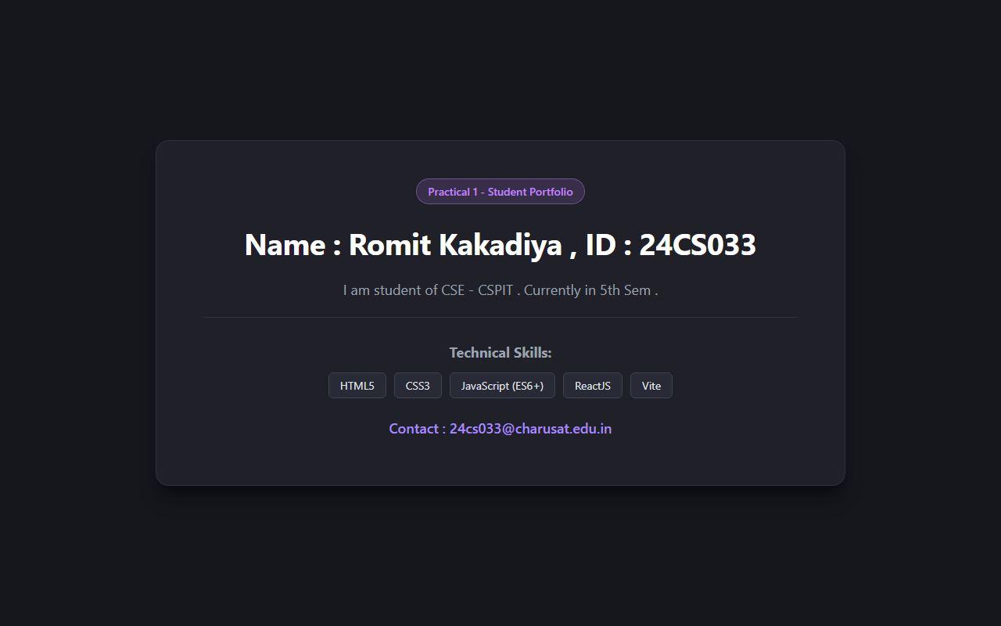
Department of Computer Science and Engineering, CSPIT Page 1

