Practical 1: Linux System Administration and File Management for Marketing Analytics Team

1. Identify the current user
whoami
Explanation: Displays the username of the currently logged-in user.

2. Find the current working directory
pwd
Explanation: Displays the full path of the current working directory.

3. Display system information
uname -a
Explanation: Displays detailed information about the Linux operating system, kernel, processor architecture, and system.

4. Check system uptime and date
uptime
date
Explanation: uptime displays how long the system has been running and the current system load. date displays the current date and time.

5. Create a directory named MarketingAnalytics
mkdir MarketingAnalytics
cd MarketingAnalytics
Explanation: mkdir creates a new directory named MarketingAnalytics, and cd enters that directory.

6. Create subdirectories
mkdir RawData ProcessedData Reports
Explanation: Creates three subdirectories: RawData, ProcessedData, and Reports.

7. Create data and report files
touch RawData/data1.txt RawData/data2.txt
touch Reports/report1.txt Reports/report2.txt
Explanation: The touch command creates new empty files.

8. Add sample content
echo "Customer ID: 101, Sales: 5000" > RawData/data1.txt
echo "Customer ID: 102, Sales: 7500" > RawData/data2.txt
echo "Marketing Report 1 - Sales Analysis" > Reports/report1.txt
echo "Marketing Report 2 - Customer Analysis" > Reports/report2.txt
Explanation: The echo command writes text into files. The > operator redirects the output into the specified file.

9. Display file contents
cat RawData/data1.txt
cat RawData/data2.txt
cat Reports/report1.txt
cat Reports/report2.txt
Explanation: The cat command displays the contents of a file directly in the terminal.

10. List all files and directories

Basic listing
ls
Explanation: Lists files and directories in the current directory.

Long listing
ls -l
Explanation: Displays detailed information such as permissions, owner, file size, and modification date.

Reverse listing
ls -r
Explanation: Lists directory contents in reverse alphabetical order.

11. Search for report files
find . -name "*.txt"
Explanation: The find command searches for files and directories. The -name "*.txt" option searches for all files with the .txt extension in the current directory and its subdirectories.

12. Search specific content inside files
grep "Sales" RawData/data1.txt
grep "Marketing" Reports/report1.txt
Explanation: The grep command searches for a specific word or pattern inside files and displays the matching lines.

13. Copy report files to Backup directory
mkdir Backup
cp Reports/*.txt Backup/
ls Backup
Explanation: mkdir Backup creates a Backup directory. cp Reports/*.txt Backup/ copies all .txt report files from the Reports directory to the Backup directory.

14. Rename a file
mv Reports/report1.txt Reports/final_report.txt
Explanation: The mv command can be used to rename or move files. Here, report1.txt is renamed to final_report.txt.

15. Move files between directories
mv Reports/final_report.txt ProcessedData/
Explanation: Moves final_report.txt from the Reports directory to the ProcessedData directory.

16. Delete a file
rm Reports/report2.txt
Explanation: The rm command permanently deletes the specified file.

17. Delete an empty directory
rmdir Reports
Explanation: The rmdir command deletes an empty directory. The directory must not contain any files or subdirectories.

Practical 2: Hadoop Installation, Configuration and HDFS Operations on Windows/Linux
AIM: Hadoop Installation, Configuration and HDFS Operations on Windows/Linux
Problem Definition:
DataAnalytics Inc. processes large-scale customer, sales, and marketing data using the Hadoop ecosystem. Due to increasing data volumes, the organization wants to migrate from traditional file systems to Hadoop Distributed File System (HDFS). The task is to install and configure Hadoop in a single-node cluster, verify Hadoop services, access the Web UI, and perform HDFS data management operations.

1. Install and configure Hadoop
Download and install Hadoop on Windows/Linux.
For Windows installation, refer to the installation video provided in the practical file.
After installation, configure Hadoop using the following configuration files:
core-site.xml
hdfs-site.xml
mapred-site.xml
yarn-site.xml
For a pseudo-distributed configuration:
<!-- core-site.xml -->
<property>
<name>fs.defaultFS</name>
<value>hdfs://localhost:9000</value>
</property>
Configure HDFS storage directories and replication:
<!-- hdfs-site.xml -->
<property>
<name>dfs.replication</name>
<value>1</value>
</property>
Configure MapReduce to use YARN:
<!-- mapred-site.xml -->
<property>
<name>mapreduce.framework.name</name>
<value>yarn</value>
</property>
The practical describes pseudo-distributed mode as running Hadoop daemons such as NameNode, DataNode, ResourceManager, and NodeManager as separate Java processes on the same machine.

2. Start Hadoop services
Open Command Prompt as Administrator and start the Hadoop services.
start-dfs.cmd
start-yarn.cmd
Explanation:
start-dfs.cmd starts the HDFS services, while start-yarn.cmd starts the YARN services.

3. Verify Hadoop services
jps
Expected processes include:
NameNode
DataNode
SecondaryNameNode
ResourceManager
NodeManager
Explanation:
The jps command displays the Java processes currently running. These processes confirm that the Hadoop services have started successfully.

4. Access Hadoop Web UI
Open the following addresses in a web browser:
http://localhost:9870
NameNode Web UI
http://localhost:8088
YARN ResourceManager Web UI
Explanation:
The Hadoop Web UI can be used to monitor HDFS storage, DataNodes, applications, and cluster status. The practical specifically requires accessing the Hadoop Web UI.

5. Create directories in HDFS
Create a directory for sales and marketing data:
hdfs dfs -mkdir /sales_data
Create additional directories if required:
hdfs dfs -mkdir /sales_data/customer
hdfs dfs -mkdir /sales_data/reports
Verify the directories:
hdfs dfs -ls /
Explanation:
The hdfs dfs -mkdir command creates directories inside HDFS.

6. Create a sample file
Create a sample file on the local Windows system:
echo Customer_ID,Customer_Name,Sales > customer.txt
echo 101,Vivek,5000 >> customer.txt
echo 102,Rahul,7500 >> customer.txt
echo 103,Amit,6200 >> customer.txt
Explanation:
The echo command creates sample data. The > operator creates/overwrites the file, while >> appends additional data.

7. Upload files to HDFS
Upload the local file into the HDFS directory:
hdfs dfs -put customer.txt /sales_data/
Alternatively:
hdfs dfs -copyFromLocal customer.txt /sales_data/
The practical also demonstrates uploading a large CSV dataset with hdfs dfs -put.

8. List HDFS files and directories
hdfs dfs -ls /sales_data
For human-readable file sizes:
hdfs dfs -ls -h /sales_data
Explanation:
The -ls command displays files and directories stored in HDFS. The -h option displays file sizes in a human-readable format.

9. Display file contents
hdfs dfs -cat /sales_data/customer.txt
Explanation:
The -cat command displays the contents of a file stored in HDFS directly in the terminal.

10. Copy a file within HDFS
hdfs dfs -cp /sales_data/customer.txt /sales_data/customer_backup.txt
Explanation:
The -cp command creates a copy of a file within HDFS.

11. Move or rename a file
hdfs dfs -mv /sales_data/customer_backup.txt /sales_data/customer_final.txt
Explanation:
The -mv command moves or renames a file or directory within HDFS.

12. Download a file from HDFS
hdfs dfs -get /sales_data/customer_final.txt C:\HadoopProject\
Alternatively:
hdfs dfs -copyToLocal /sales_data/customer_final.txt C:\HadoopProject\
Explanation:
The -get or -copyToLocal command copies a file from HDFS to the local Windows file system.

13. Delete a file from HDFS
hdfs dfs -rm /sales_data/customer_final.txt
Explanation:
The -rm command removes a file from HDFS.

14. Check HDFS storage utilization
hdfs dfs -du -h /
Explanation:
The -du -h command displays the amount of storage used by files and directories in a human-readable format.
The practical uses hdfs dfs -du -h / to analyze HDFS storage utilization.

15. Check HDFS cluster status
hdfs dfsadmin -report
Explanation:
This command displays information about the HDFS cluster, including DataNodes, configured capacity, available capacity, and DFS usage.
The practical uses hdfs dfsadmin -report to examine cluster capacity and available storage.

16. Check file replication
hdfs fsck /sales_data/customer.txt
Explanation:
The fsck command checks the health of files and blocks stored in HDFS and provides information about replication.

17. Change HDFS replication factor
hdfs dfs -setrep -w 2 /sales_data/customer.txt
Expected message:
Replication 2 set: /sales_data/customer.txt
Waiting for /sales_data/customer.txt ... done
The supplied practical demonstrates this command and notes that a single-DataNode cluster cannot provide true replication of two copies because HDFS needs separate DataNodes for replica placement.

18. Upload a large dataset
For a large sales CSV file:
hdfs dfs -put C:\large_sales_dataset.csv /sales_data/
Verify the uploaded file:
hdfs dfs -ls -h /sales_data
HDFS can split large files into blocks and distribute those blocks across available DataNodes. The supplied practical uses a 128 MB block size example.

Practical No. | Details
Practical - 3 | AIM: Implement word count / frequency programs using MapReduce
Problem Definition | Step 1: Verify Java Installation  java -version  javac -version  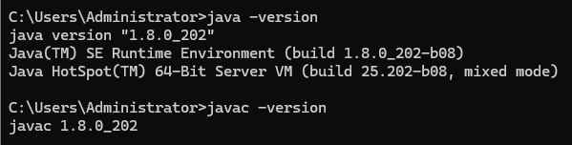  Step 2: Start Hadoop Services  start-dfs.cmd  start-yarn.cmd  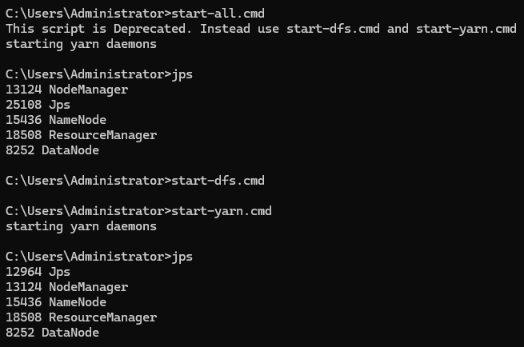  Step 3: Verify Hadoop Services  jps  Step 4: Create Project Folder  mkdir C:\HadoopProject  mkdir C:\HadoopProject\WordCount  cd C:\HadoopProject\WordCount  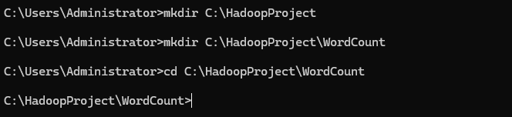  Step 5: Create Java Program  WordCount.java  import java.io.IOException;  import org.apache.hadoop.conf.Configuration;  import org.apache.hadoop.fs.Path;  import org.apache.hadoop.io.IntWritable;  import org.apache.hadoop.io.Text;  import org.apache.hadoop.mapreduce.Job;  import org.apache.hadoop.mapreduce.Mapper;  import org.apache.hadoop.mapreduce.Reducer;  import org.apache.hadoop.mapreduce.lib.input.FileInputFormat;  import org.apache.hadoop.mapreduce.lib.output.FileOutputFormat;  public class WordCount {  public static class TokenizerMapper  extends Mapper < Object, Text, Text, IntWritable > {  private final static IntWritable one = new IntWritable(1);  private Text word = new Text();  public void map(Object key, Text value, Context context)  throws IOException,  InterruptedException {  String[] words = value.toString().split("\\s+");  for (String w: words) {  word.set(w);  context.write(word, one);  }  }  }  public static class IntSumReducer  extends Reducer < Text, IntWritable, Text, IntWritable > {  private IntWritable result = new IntWritable();  public void reduce(Text key,  Iterable < IntWritable > values,  Context context)  throws IOException,  InterruptedException {  int sum = 0;  for (IntWritable val: values) {  sum += val.get();  }  result.set(sum);  context.write(key, result);  }  }  public static void main(String[] args) throws Exception {  Configuration conf = new Configuration();  Job job = Job.getInstance(conf, "Word Count");  job.setJarByClass(WordCount.class);  job.setMapperClass(TokenizerMapper.class);  job.setCombinerClass(IntSumReducer.class);  job.setReducerClass(IntSumReducer.class);  job.setOutputKeyClass(Text.class);  job.setOutputValueClass(IntWritable.class);  FileInputFormat.addInputPath(job, new Path(args[0]));  FileOutputFormat.setOutputPath(job, new Path(args[1]));  System.exit(job.waitForCompletion(true) ? 0 : 1);  }  }  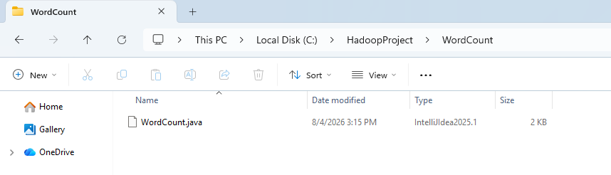  Step 6: Create Input File  input.txt  hadoop map reduce  hadoop is fast  map reduce is powerful  hadoop hadoop  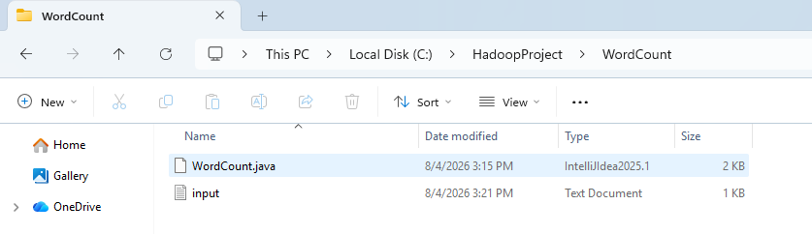  Step 7: Compile the Java Program  javac -cp "%CLASSPATH%;C:\hadoop\etc\hadoop;C:\hadoop\share\hadoop\common\*;C:\hadoop\share\hadoop\common\lib\*;C:\hadoop\share\hadoop\hdfs\*;C:\hadoop\share\hadoop\hdfs\lib\*;C:\hadoop\share\hadoop\mapreduce\*;C:\hadoop\share\hadoop\mapreduce\lib\*;C:\hadoop\share\hadoop\yarn\*;C:\hadoop\share\hadoop\yarn\lib\*" WordCount.java  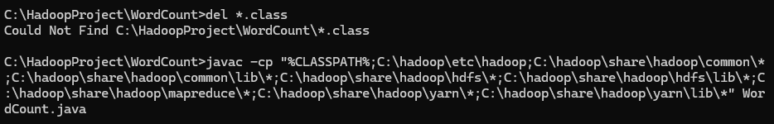  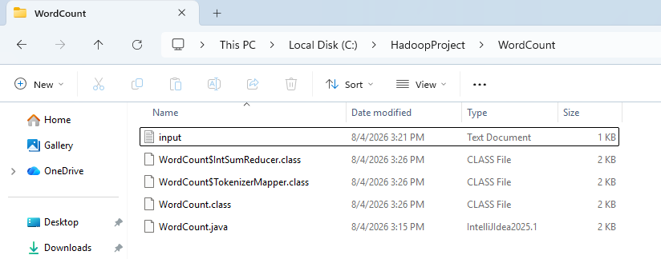  Step 8: Create JAR File  jar cf WordCount.jar *.class  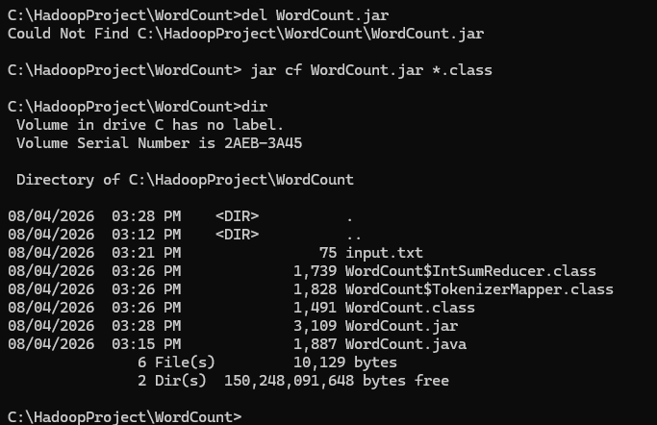  Step 9: Create Input Directory in HDFS  hdfs dfs -mkdir /input  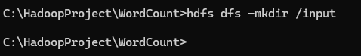  Step 10: Upload Input File to HDFS  hdfs dfs -put input.txt /input  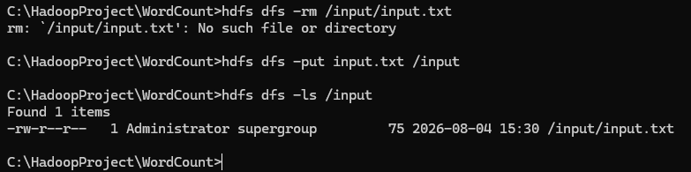  Step 11: Remove Previous Output Directory  hdfs dfs -rm -r /output  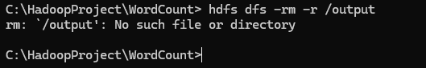  Step 12: Execute the MapReduce Job  hadoop jar WordCount.jar WordCount /input /output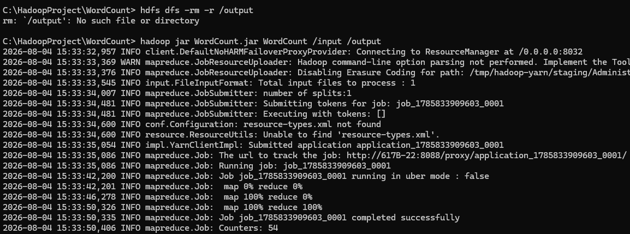  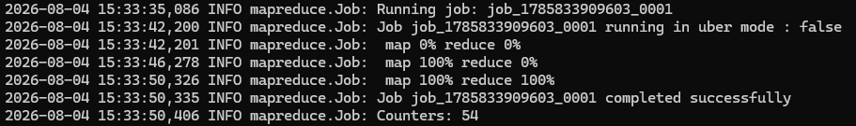  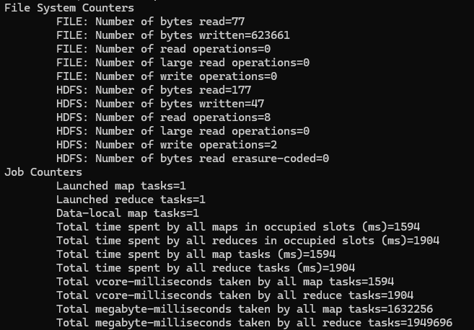  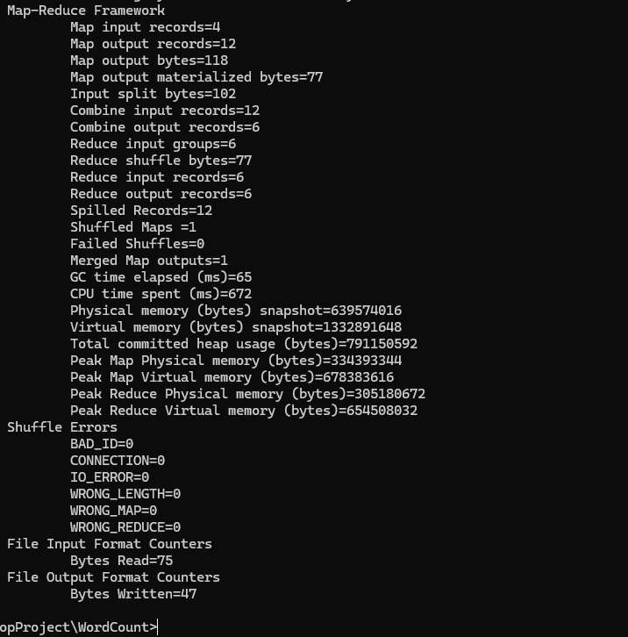  Step 13: View Output Files  hdfs dfs -ls /output  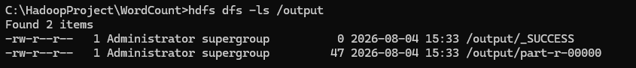  Step 14: Display Final Result  hdfs dfs -cat /output/part-r-00000  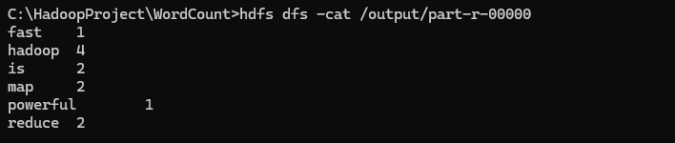  Step 15: View Job in YARN  .  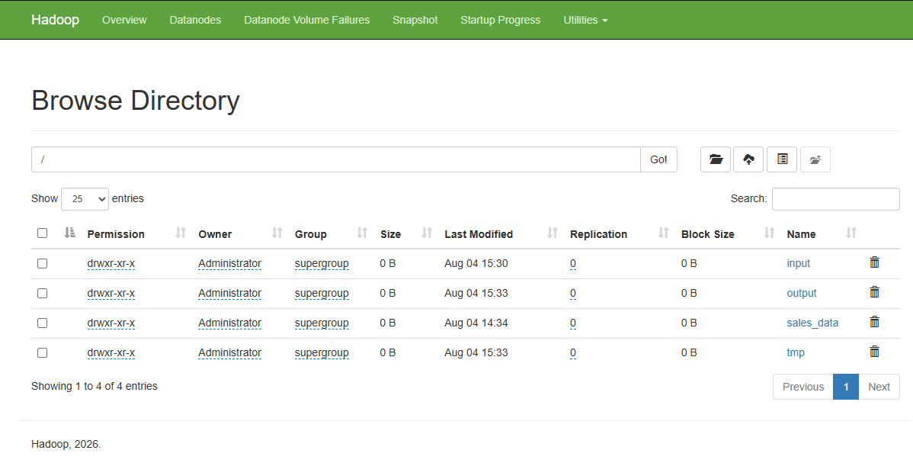  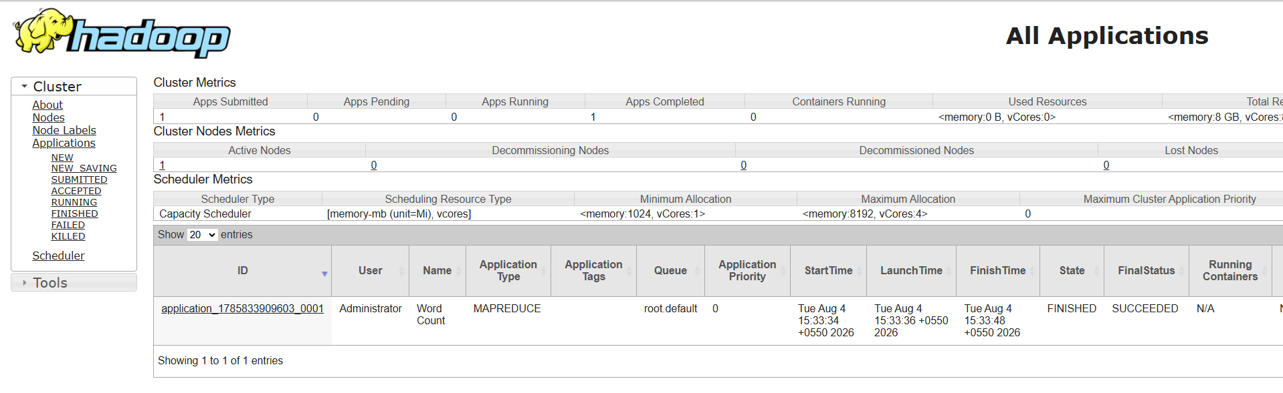

Practical 4: Maximum temperature for each year using MapReduce
Assume Hadoop is installed in C:\hadoop and your project folder is C:\HadoopProject\MaxTemperature.

1. Start Hadoop services
bat
start-dfs.cmd
start-yarn.cmd

2. Verify Hadoop is running
bat
jps
Expected processes include: NameNode, DataNode, SecondaryNameNode, ResourceManager, NodeManager.

3. Create project folder
bat
mkdir C:\HadoopProject
mkdir C:\HadoopProject\MaxTemperature
cd C:\HadoopProject\MaxTemperature

4. Create Java program
Create a file named MaxTemperature.java:
Java

import java.io.IOException;

import org.apache.hadoop.conf.Configuration;

import org.apache.hadoop.fs.Path;

import org.apache.hadoop.io.FloatWritable;

import org.apache.hadoop.io.Text;

import org.apache.hadoop.mapreduce.Job;

import org.apache.hadoop.mapreduce.Mapper;

import org.apache.hadoop.mapreduce.Reducer;

import org.apache.hadoop.mapreduce.lib.input.FileInputFormat;

import org.apache.hadoop.mapreduce.lib.output.FileOutputFormat;

public class MaxTemperature {

public static class TempMapper

extends Mapper<Object, Text, Text, FloatWritable> {

private Text year = new Text();

private FloatWritable temperature = new FloatWritable();

public void map(Object key, Text value, Context context)

throws IOException, InterruptedException {

String line = value.toString();

if (line.startsWith("STATION") || line.contains("MAX"))

return;

String[] fields = line.split(",");

if (fields.length > 21) {

String date = fields[1].replace("\"", "").trim();

String maxTemp = fields[20].replace("\"", "").trim();

if (!maxTemp.isEmpty() && !maxTemp.equals("999.9")) {

year.set(date.substring(0, 4));

temperature.set(Float.parseFloat(maxTemp));

context.write(year, temperature);

}

}

}

}

public static class MaxReducer

extends Reducer<Text, FloatWritable, Text, FloatWritable> {

private FloatWritable result = new FloatWritable();

public void reduce(Text key, Iterable<FloatWritable> values,

Context context)

throws IOException, InterruptedException {

float max = Float.MIN_VALUE;

for (FloatWritable val : values) {

if (val.get() > max) {

max = val.get();

}

}

result.set(max);

context.write(key, result);

}

}

public static void main(String[] args) throws Exception {

Configuration conf = new Configuration();

Job job = Job.getInstance(conf, "Maximum Temperature by Year");

job.setJarByClass(MaxTemperature.class);

job.setMapperClass(TempMapper.class)

job.setReducerClass(MaxReducer.class);

job.setOutputKeyClass(Text.class);

job.setOutputValueClass(FloatWritable.class);

FileInputFormat.addInputPath(job, new Path(args[0]));

FileOutputFormat.setOutputPath(job, new Path(args[1]));

System.exit(job.waitForCompletion(true) ? 0 : 1);

}

}

5. Copy your CSV file
Place your uploaded file in the project folder and rename it to sample.csv for simplicity.

6. Compile the Java program
bat
del *.class

javac --release 8 -cp "%CLASSPATH%;C:\hadoop\etc\hadoop;C:\hadoop\share\hadoop\common\*;C:\hadoop\share\hadoop\common\lib\*;C:\hadoop\share\hadoop\hdfs\*;C:\hadoop\share\hadoop\hdfs\lib\*;C:\hadoop\share\hadoop\mapreduce\*;C:\hadoop\share\hadoop\yarn\*;C:\hadoop\share\hadoop\yarn\lib\*" MaxTemperature.java
If compilation succeeds, you will get MaxTemperature.class, MaxTemperature$TempMapper.class, and MaxTemperature$MaxReducer.class.

7. Create the JAR file
bat
del MaxTemperature.jar
jar cf MaxTemperature.jar *.class
dir
You should see MaxTemperature.jar.

8. Create HDFS input directory
bat
hdfs dfs -mkdir /weather

9. Upload the CSV file to HDFS
bat
hdfs dfs -put sample.csv /weather

hdfs dfs -ls /weather
You should see sample.csv in HDFS.

10. Remove previous output directory
Run this before every execution:
bat
hdfs dfs -rm -r /output

11. Execute the MapReduce job
bat
hadoop jar MaxTemperature.jar MaxTemperature /weather /output
Expected messages include “Submitted application…”, “map 100%”, “reduce 100%”, and “Job completed successfully”.

12. View output files
bat
hdfs dfs -ls /output
You should see _SUCCESS and part-r-00000.

13. Display the final result
bat
hdfs dfs -cat /output/part-r-00000
For your uploaded file, the output will be similar to:
2018 98.1
This means the maximum temperature recorded in 2018 was 98.1.

14. Verify in browser (optional)
http://localhost:9870
http://localhost:8088
This is the complete Practical 4 solution for your uploaded CSV file, including all Hadoop commands and the required Java MapReduce code.

