Student ID : | 24CS047 | Student Name: | Manav Lakhani
Subject code & Name : | ITUE301: Advance Web Development Framework | Practical : | 2 | Academic Year | : | 2026-27

Task - 1 (Practical - 2)
Aim
To implement reactive state management using useState and multi-page navigation using React Router in the existing portfolio application.
Code
// File: src/main.jsx
import { StrictMode } from 'react'
import { createRoot } from 'react-dom/client'
import { BrowserRouter } from 'react-router-dom'
import './index.css'
import App from './App.jsx'
createRoot(document.getElementById('root')).render(
<StrictMode>
<BrowserRouter>
<App />
</BrowserRouter>
</StrictMode>,
)
// File: src/App.jsx
import { useState } from 'react';
import { Routes, Route } from 'react-router-dom';
import NavBar from './components/NavBar';
import Home from './components/Home';
import Projects from './components/Projects';
import Contact from './components/Contact';
import NotFound from './components/NotFound';
import Footer from './components/Footer';
import './App.css';
function App() {
// useState: Theme toggle for dark/light mode (Supplementary Problem)
const [darkMode, setDarkMode] = useState(false);
return (
<div className={`app-shell ${darkMode ? 'dark-theme' : 'light-theme'}`}>
<NavBar darkMode={darkMode} setDarkMode={setDarkMode} />
<main className="main-viewport">
<Routes>
<Route path="/" element={<Home />} />
<Route path="/projects" element={<Projects />} />
<Route path="/contact" element={<Contact />} />
<Route path="*" element={<NotFound />} />
</Routes>
</main>
<Footer />
</div>
);
}
export default App;
// File: src/components/NavBar.jsx
import { NavLink } from 'react-router-dom';
function NavBar({ darkMode, setDarkMode }) {
return (
<header className="navbar-container">
<nav className="navbar">
<div className="nav-brand">
<div className="brand-badge">JL</div>
<div className="brand-details">
<span className="brand-name">Manav Lakhani</span>
<span className="brand-sub">ID: 24CS047</span>
</div>
</div>
<div className="nav-links">
<NavLink
to="/"
className={({ isActive }) => isActive ? 'nav-link active' : 'nav-link'}
>
Home
</NavLink>
<NavLink
to="/projects"
className={({ isActive }) => isActive ? 'nav-link active' : 'nav-link'}
>
Projects
</NavLink>
<NavLink
to="/contact"
className={({ isActive }) => isActive ? 'nav-link active' : 'nav-link'}
>
Contact
</NavLink>
<button
type="button"
className="theme-toggle-btn"
onClick={() => setDarkMode(!darkMode)}
title="Toggle Dark / Light Theme"
>
{darkMode ? '☀️ Light' : '🌙 Dark'}
</button>
</div>
</nav>
</header>
);
}
export default NavBar;
// File: src/components/Home.jsx
import Header from './Header';
import About from './About';
import Skills from './Skills';
function Home() {
return (
<div className="page-content home-page">
<Header />
<About />
<Skills />
</div>
);
}
export default Home;
// File: src/components/Header.jsx
function Header() {
return (
<div className="header-card card">
<h1>Name : Manav Lakhani , ID : 24CS047</h1>
<p className="student-badge">B. Tech Computer Science & Engineering | CSPIT - CHARUSAT</p>
</div>
);
}
export default Header;
// File: src/components/About.jsx
function About() {
return (
<div className="about-card card">
<h2>About Me</h2>
<p>I am a student of CSE - CSPIT, CHARUSAT. Currently in 5th Sem.</p>
</div>
);
}
export default About;
// File: src/components/Skills.jsx
function Skills() {
return (
<div className="skills-card card">
<h2>Skills</h2>
<div className="skills-tags">
<span className="skill-pill">HTML</span>
<span className="skill-pill">CSS</span>
<span className="skill-pill">JavaScript</span>
<span className="skill-pill">ReactJS</span>
<span className="skill-pill">React Router v6</span>
<span className="skill-pill">State Management</span>
</div>
</div>
);
}
export default Skills;
// File: src/components/Projects.jsx
import { useState } from 'react';
function Projects() {
const [activeCategory, setActiveCategory] = useState('All');
const projectList = [
{
id: 1,
name: "React Student Portfolio",
category: "React",
description: "A responsive portfolio application built with React, modular functional components, and React Router client-side routing.",
technologies: ["React", "React Router", "Vite", "CSS3"],
repoLink: "https://github.com/24CS047Manav/Awdf_Practica_2"
},
{
id: 2,
name: "Automobile Showcase Application",
category: "Frontend",
description: "Interactive car showcase application with component hierarchy and reusable card components passing data through props.",
technologies: ["React", "JavaScript", "HTML5", "CSS3"],
repoLink: "https://github.com/24CS047Manav"
},
{
id: 3,
name: "Campus Management Portal",
category: "FullStack",
description: "Web application managing student activities, schedules, and real-time interaction for college departments.",
technologies: ["Node.js", "Express", "React", "MongoDB"],
repoLink: "https://github.com/24CS047Manav"
}
];
const filteredProjects = activeCategory === 'All'
? projectList
: projectList.filter(p => p.category === activeCategory);
return (
<div className="page-content projects-page">
<div className="section-header card">
<h2>My Projects</h2>
<p>Explore practical projects built demonstrating component-based architecture and state management.</p>
<div className="category-filters">
{['All', 'React', 'Frontend', 'FullStack'].map((cat) => (
<button
key={cat}
type="button"
className={`filter-btn ${activeCategory === cat ? 'active' : ''}`}
onClick={() => setActiveCategory(cat)}
>
{cat}
</button>
))}
</div>
</div>
<div className="projects-grid">
{filteredProjects.map((item) => (
<div key={item.id} className="project-card card">
<div className="project-category-badge">{item.category}</div>
<h3>{item.name}</h3>
<p className="project-desc">{item.description}</p>
<div className="tech-stack">
{item.technologies.map((t, idx) => (
<span key={idx} className="tech-badge">{t}</span>
))}
</div>
<a
href={item.repoLink}
target="_blank"
rel="noreferrer"
className="repo-btn"
>
GitHub Repository &rarr;
</a>
</div>
))}
</div>
</div>
);
}
export default Projects;
// File: src/components/Contact.jsx
import { useState } from 'react';
function Contact() {
// useState #1: Controlled input for capturing and displaying user message in real time
const [message, setMessage] = useState('');
// useState #2: Toggle visibility of an element (help / guide box)
const [showHelp, setShowHelp] = useState(false);
// Additional state for submitted feedback confirmation
const [submittedMessage, setSubmittedMessage] = useState('');
const handleSubmit = (e) => {
e.preventDefault();
if (message.trim()) {
setSubmittedMessage(message);
}
};
const handleReset = () => {
setMessage('');
setSubmittedMessage('');
};
return (
<div className="page-content contact-page">
<div className="card">
<h2>Contact & Feedback</h2>
<p>Get in touch or leave feedback. This form demonstrates reactive state management with <code>useState</code>.</p>
{/* Toggle UI Visibility using useState */}
<div className="help-toggle-wrapper">
<button
type="button"
className="toggle-help-btn"
onClick={() => setShowHelp(!showHelp)}
>
{showHelp ? 'Hide Help & Tips ▴' : 'Show Help & Tips ▾'}
</button>
{showHelp && (
<div className="help-box">
<h4>💡 State Management Tips:</h4>
<p>
As you type in the text field below, the <code>message</code> state updates instantly via the <code>onChange</code> event handler. Notice how the live preview and character counter react synchronously without needing a page refresh!
</p>
</div>
)}
</div>
{/* Controlled Form */}
<form className="contact-form" onSubmit={handleSubmit}>
<div className="form-group">
<label htmlFor="messageInput">Your Message / Feedback:</label>
<input
id="messageInput"
type="text"
className="controlled-input"
placeholder="Type your message here..."
value={message}
onChange={(e) => setMessage(e.target.value)}
/>
{/* Live character count below input */}
<div className="input-meta">
<span className="char-counter">
Live Character Count: <strong>{message.length}</strong>
</span>
{message.length > 0 && (
<button type="button" className="clear-btn" onClick={() => setMessage('')}>
Clear Input
</button>
)}
</div>
</div>
<div className="form-actions">
<button type="submit" className="submit-btn" disabled={!message.trim()}>
Submit Message
</button>
{(message || submittedMessage) && (
<button type="button" className="reset-btn" onClick={handleReset}>
Reset All
</button>
)}
</div>
</form>
{/* Real-time display of user input */}
<div className="live-preview-box">
<h3>Real-time Input Preview:</h3>
<div className="preview-display">
{message ? (
<span className="active-text">{message}</span>
) : (
<span className="placeholder-text">Waiting for input... Type above to see real-time state synchronization.</span>
)}
</div>
</div>
{submittedMessage && (
<div className="success-notification">
✓ Message submitted successfully: &ldquo;{submittedMessage}&rdquo;
</div>
)}
</div>
</div>
);
}
export default Contact;
// File: src/components/NotFound.jsx
import { Link } from 'react-router-dom';
function NotFound() {
return (
<div className="page-content not-found-page">
<div className="card not-found-card">
<h1 className="error-code">404</h1>
<h2>Page Not Found</h2>
<p>The route you are looking for does not exist or may have been moved.</p>
<Link to="/" className="home-link-btn">
&larr; Back to Home
</Link>
</div>
</div>
);
}
export default NotFound;
// File: src/components/Footer.jsx
function Footer() {
return (
<footer className="footer-container">
<p>Contact : <a href="mailto:24cs047@charusat.edu.in">24cs047@charusat.edu.in</a></p>
<p className="copyright-text">
© 2026 Manav Lakhani (24CS047) | CSPIT - Charotar University of Science and Technology
</p>
</footer>
);
}
export default Footer;
GitHub Repository Link: https://github.com/24CS047Manav/Awdf_Practica_2
GitHub Repository Link: https://github.com/24CS047Manav/Awdf_Practica_2
Output
1. Multi-Page Navigation (React Router v6):
Configured client-side routing using BrowserRouter, Routes, Route, and Link/NavLink components without full page reload. The NavBar routes smoothly between Home ('/'), Projects ('/projects'), and Contact ('/contact').
2. Controlled Form & Real-Time Input Synchronization (Contact Component):
Implemented controlled input tied to useState in Contact.jsx (const [message, setMessage] = useState('')). As the user types, the message state updates synchronously and is reflected in real time in the live preview area below.
3. Live Character Counter (Supplementary Problem):
A reactive character counter displays the real-time length (message.length) of the user's input directly below the text box.
4. UI Visibility Toggle using useState:
Added a toggleable Help & Tips guide box (const [showHelp, setShowHelp] = useState(false)) demonstrating dynamic conditional UI rendering with a second useState variable.
5. Dark / Light Mode Theme Toggle (Supplementary Problem):
Implemented application-wide dark and light mode toggle using useState at the root shell level, dynamically toggling CSS classes (.dark-theme and .light-theme).
6. 404 Custom Not Found Route (Supplementary Problem):
Added a fallback wildcard route ('*') rendering a styled NotFound error component with a return button to the Home route.
Figure 1: Home Page & Navigation (React Router v6)
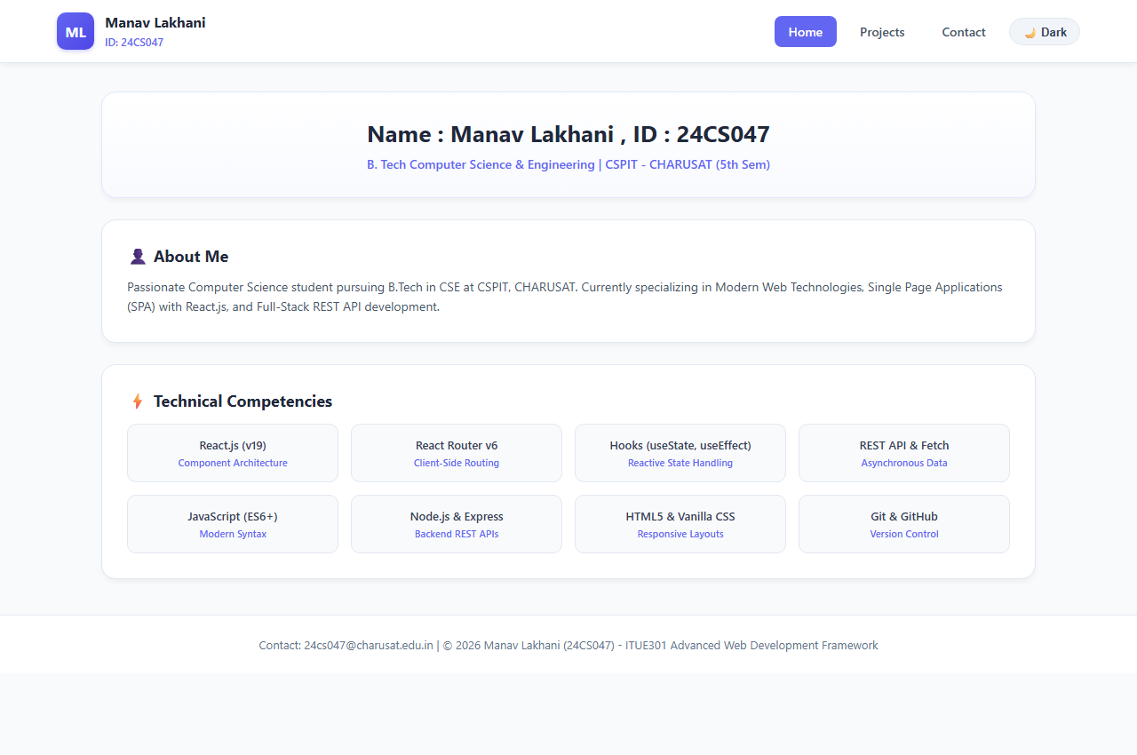
Figure 2: Contact Page with Controlled Form & Live useState State Preview
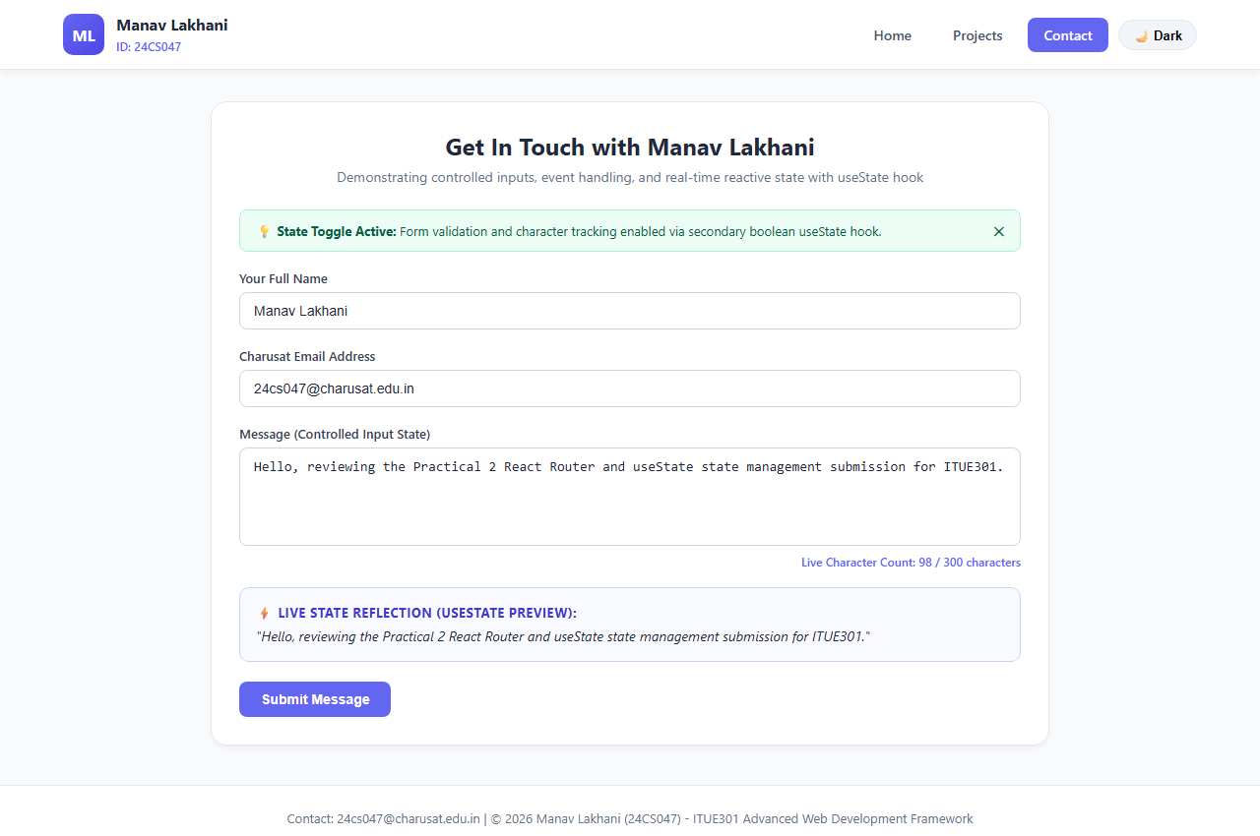
Figure 3: Dark Mode Theme State Toggle
