IT620 Object Oriented Programming
Code Crafters | Path B: Modular Hardware Platform

AURA RETAIL OS
Designing an Autonomous Modular Smart-City Retail Infrastructure

Prepared By:
Student ID | Name
202512003 | Priya Patel
202512006 | Naitik Sutariya
202512007 | Gaurang Rahani
202512013 | Harshal Prajapati

Guided By: Prof. Sourish Dasgupta & TAs

Table Of Contents
No. | Topic | Page No.
1. | Problem Statement | 3
2. | System Overview | 4
3. | Subsystem Architecture | 5
4. | Design Patterns Used | 7
5. | Major Class Descriptions | 10
6. | UML Diagrams | 12
7. | Path B Requirements Coverage | 20
8. | System Constraints & Enforcement | 23
9. | Simulation Scenarios | 25
10. | System Persistence | 27
11. | GitHub Repository | 28
12. | Team Contributions | 30
13. | Conclusion | 31

- Problem Statement
The smart city of Zephyrus deploys autonomous retail kiosks - called Aura Kiosks - across a wide range of urban environments, each with unique operational requirements:
- Hospitals dispensing prescription medication
- Metro stations selling daily essentials
- University campuses selling electronics
- Disaster zones distributing emergency supplies

Every kiosk shares the same physical hardware but must operate under very different policies, security constraints, and hardware configurations. The original system - Aura-Kiosk v1.0 - was a monolithic application. As deployment expanded across the city, several critical problems emerged:
- Hardware changes required rewriting large sections of the codebase.
- Payment systems from different vendors were completely incompatible.
- Security checks were inconsistent and unreliable across kiosk types.
- Inventory and transaction failures left the system in inconsistent states.
- New features such as refrigeration modules or solar monitoring could not be added dynamically without modifying the core system.

To solve these structural issues, the city council commissioned Aura Retail OS - a redesigned platform that treats each kiosk as a modular, software-driven system capable of adapting to hardware changes, policy updates, and unexpected events without modifying the entire system. Our team was assigned Path B: Modular Hardware Platform, focusing on hardware extensibility, modular architecture, flexible inventory structures, and multi-provider payment compatibility.

- System Overview
Aura Retail OS is structured around five major subsystems that communicate through well-defined interfaces, ensuring low coupling and high cohesion across the entire platform.
  - Subsystem Responsibilities

- Kiosk Core System - Handles user interaction and kiosk lifecycle operations. Exposes a simplified KioskInterface (Facade) as the single external entry point.
- Inventory System - Manages products, product bundles, and stock levels. Supports individual items and nested bundle structures via the Composite pattern.
- Payment System - Processes transactions across multiple incompatible payment provider APIs through a unified interface using the Adapter pattern.
- Hardware Abstraction Layer - Decouples high-level kiosk logic from specific hardware implementations using the Bridge pattern.
- City Monitoring / Registry - A central Singleton registry that stores registered kiosks, global configuration, and system mode (NORMAL / EMERGENCY).

  - Kiosk Types Created by Abstract Factory
Kiosk Type | Dispenser | Verification | Pricing | Inv. Policy
FoodKiosk | ConveyorDispenser | ExpiryVerification | DynamicPricing | PerishableInventoryPolicy
PharmacyKiosk | SpiralDispenser | PrescriptionVerification | StandardPricing | ControlledInventoryPolicy
EmergencyReliefKiosk | RoboticArmDispenser | EmergencyVerification | EmergencyPricing | EmergencyInventoryPolicy

- SubSystem Architecture
All external systems interact exclusively with KioskInterface. No subsystem is accessed directly from outside.
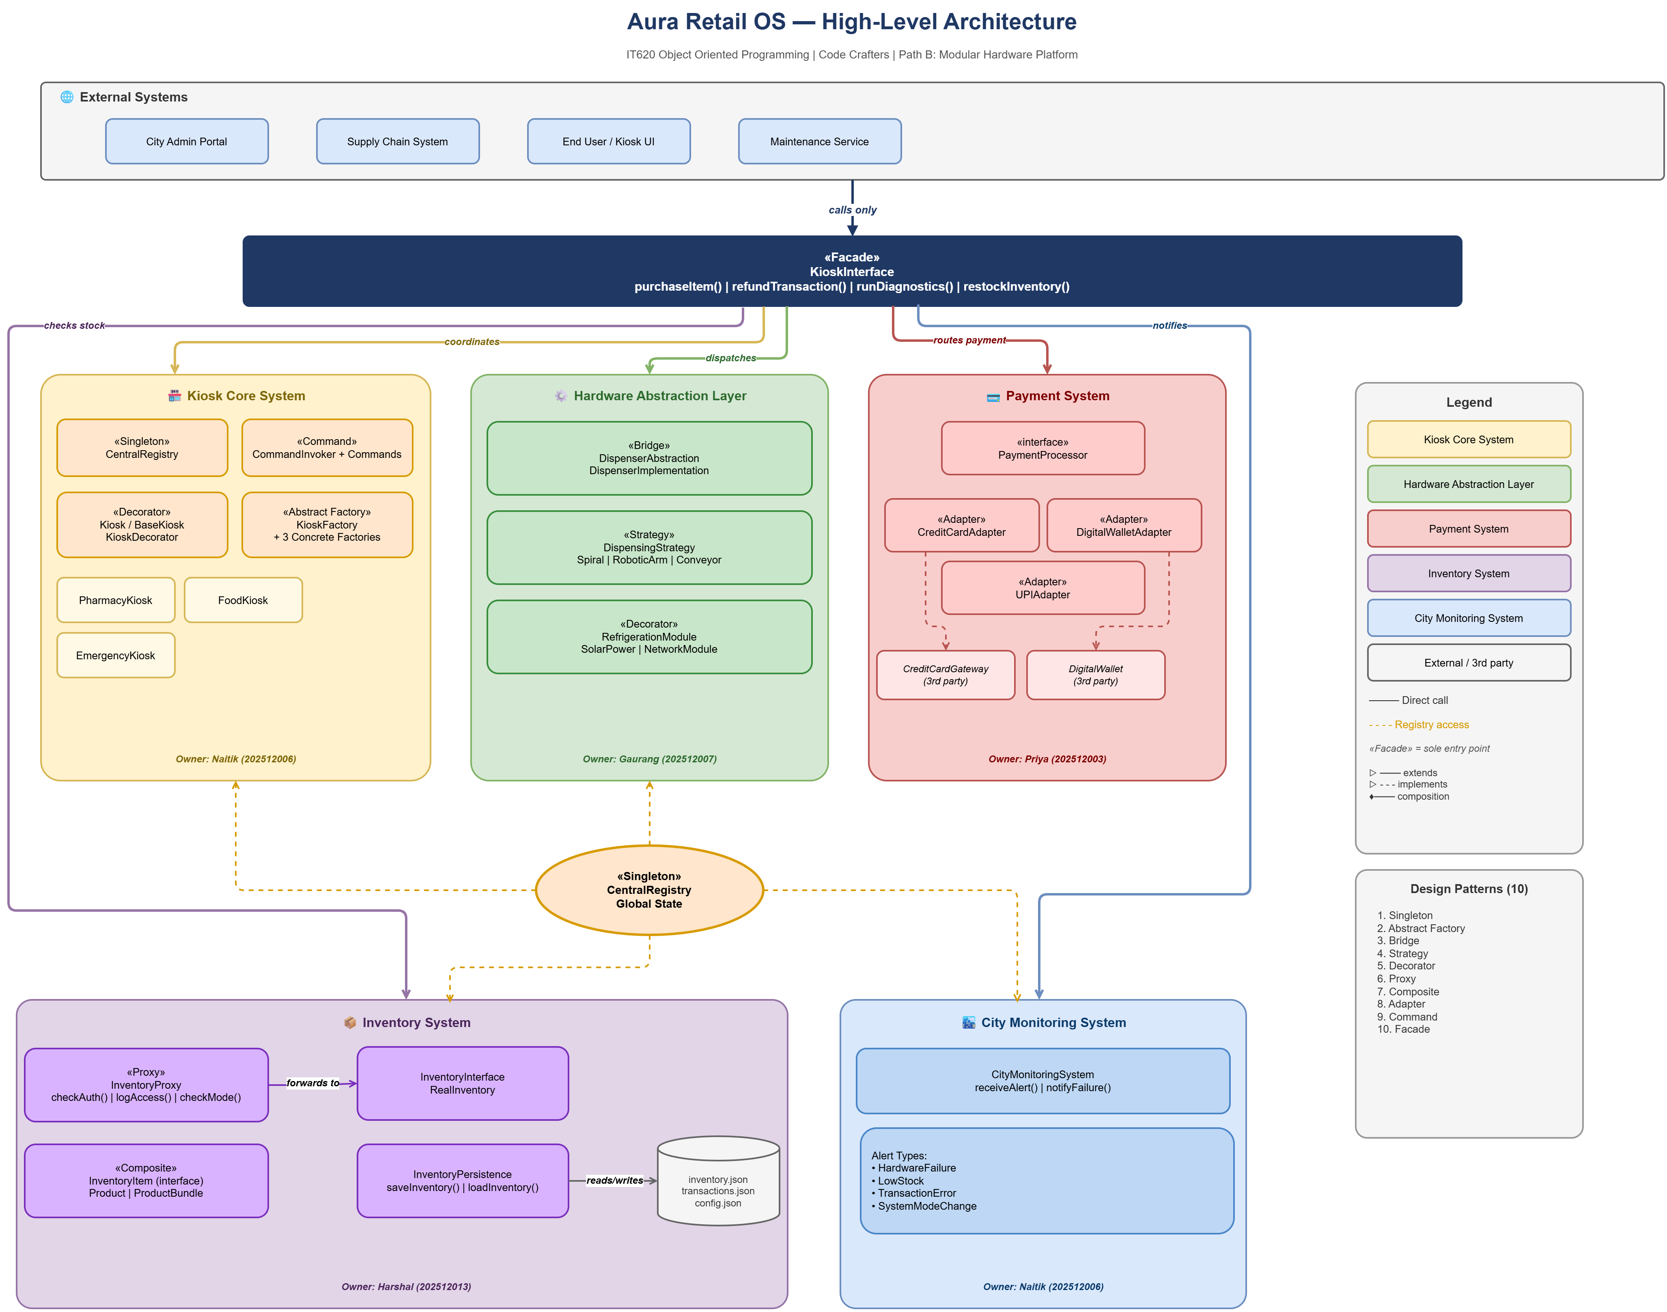
  - Object-Oriented Principle Applied
- Encapsulation - Every subsystem exposes only its required interface. Internal state (inventory maps, transaction logs, hardware references) is hidden behind class boundaries.
- Abstraction - Interfaces such as InventoryComponent, PaymentProcessor, and DispenserAbstraction define contracts without revealing implementation details.
- Inheritance - Concrete factories, hardware implementations, and adapters extend abstract base classes allowing polymorphic usage throughout the system.
- Low Coupling - No subsystem holds a direct reference to another's concrete implementation. All dependencies are on interfaces or abstractions.

- Design Patterns Used
Aura Retail OS implements 10 design patterns across three GoF categories. The table below gives an overview, followed by detailed explanations.

Pattern | Category | Key Classes | Purpose
Abstract Factory | Creational | KioskFactory + concrete factories | Creates compatible kiosk component families
Singleton | Creational | CentralRegistry | Single global system state and kiosk registry
Bridge | Structural | DispenserAbstraction + HW impls | Decouples dispensing logic from hardware
Decorator | Structural | BaseKiosk + hardware modules | Dynamically attaches optional capabilities
Facade | Structural | KioskInterface | Single simplified entry point for all operations
Adapter | Structural | PaymentProcessor + adapters | Unifies incompatible payment provider APIs
Composite | Structural | Product + ProductBundle | Uniform treatment of products and bundles
Proxy | Structural | InventoryProxy | Security, logging, and emergency restrictions
Command | Behavioural | PurchaseItemCommand, RefundCommand | Encapsulates operations; enables audit log
Strategy | Behavioural | Pricing & Dispensing Strategies | Interchangeable algorithms at runtime

  - Creational Patterns
Abstract Factory
KioskFactory declares factory methods for creating each component family - dispenser, verification module, pricing module, and inventory policy. Concrete factories produce sets of compatible components without exposing concrete classes. Adding a new kiosk type requires only one new factory class with zero changes to existing code.
Singleton
CentralRegistry is implemented as a Singleton, ensuring exactly one instance exists across the entire runtime. It maintains the list of registered kiosks, the current system mode (NORMAL or EMERGENCY), and global configuration. The simulation confirmed the registry was created only once across all three scenarios.

  - Structural Patterns
Bridge
Separates DispenserAbstraction (high-level logic) from hardware implementations (SpiralDispenser, RoboticArmDispenser, ConveyorDispenser). Hardware can be swapped at runtime by changing the implementor reference. The simulation confirmed: '3 hardware types swapped with 0 kiosk changes.'
Decorator
BaseKiosk provides minimal kiosk functionality. Optional hardware modules - RefrigerationModule, SolarPowerModule, NetworkModule - are decorators that wrap the kiosk and add capabilities dynamically at runtime. The simulation confirmed the capability list grew from 3 to 6 entries after module attachment, with BaseKiosk never modified.
Facade
KioskInterface provides a single simplified entry point for all external interactions. Operations such as purchaseItem(), refundTransaction(), runDiagnostics(), restockInventory(), and saveState() are exposed while internal orchestration is completely hidden.
Adapter
Three incompatible payment provider APIs are each wrapped in a concrete adapter (CreditCardAdapter, UPIAdapter, DigitalWalletAdapter) that conforms to the common PaymentProcessor interface. Adding a fourth payment provider requires only one new adapter class. The simulation confirmed: 'Adding provider 4 requires only 1 new class. 0 existing changes.

Composite
Individual Product objects and ProductBundle objects are treated uniformly through a common InventoryComponent interface. Bundles may contain other bundles. Calling isAvailable() cascades down the entire tree - if any leaf is out of stock, all ancestor bundles report unavailable.
Proxy
InventoryProxy intercepts every inventory operation. Before forwarding any call it checks user authorization, logs the operation with a precise timestamp, and in EMERGENCY mode blocks all write operations while permitting reads needed for emergency dispensing.

  - Behavioral Patterns
Command
Every kiosk operation is encapsulated as a command object that stores all parameters needed for execution. The CommandInvoker executes commands and maintains a full transaction history. The Command pattern also enables atomicity - a command checks all preconditions before initiating any side effects.
Strategy
Dispensing behaviour (SpiralDispensingStrategy, RoboticArmDispensingStrategy, ConveyorDispensingStrategy) and pricing algorithms (DynamicPricing, StandardPricing, EmergencyPricing) are implemented as interchangeable strategies that can be swapped at runtime without modifying the surrounding logic.

- Major Class Descriptions

  - Core System
- CentralRegistry (Singleton) - Global registry holding all kiosk registrations and system mode. Exposes registerKiosk(), setMode(), getMode(), and getRegisteredKiosks().
- KioskInterface (Facade) - The sole external-facing class per kiosk. Coordinates inventory proxy, payment adapter, dispenser bridge, and command invoker for all user-facing operations.
- BaseKiosk - Minimal kiosk with core capabilities. Serves as the wrappable component for all decorators.

  - Factory Classes
- KioskFactory (Abstract) - Declares factory methods: createDispenser(), createVerification(), createPricing(), createInventoryPolicy().
- FoodKioskFactory - Creates ConveyorDispenser, ExpiryVerification, DynamicPricing, PerishableInventoryPolicy.
- PharmacyKioskFactory - Creates SpiralDispenser, PrescriptionVerification, StandardPricing, ControlledInventoryPolicy.
- EmergencyKioskFactory - Creates RoboticArmDispenser, EmergencyVerification, EmergencyPricing, EmergencyInventoryPolicy.

  - Hardware Abstractions(Bridge)
- DispenserAbstraction - High-level dispensing logic. Holds a hardware implementor reference. Methods: dispense(productId), swapImplementation(impl).
- SpiralDispenser - Dispenses via spiral mechanism at configurable speed.
- RoboticArmDispenser - Dispenses with configurable precision using a robotic arm.
- ConveyorDispenser - Dispenses via belt conveyor at configurable speed.

  - Decorator Classes
- RefrigerationModule - Adds RefrigerationUnit capability. Unblocks products that require refrigeration hardware.
- SolarPowerModule - Adds SolarPowerMonitoring capability.
- NetworkModule - Adds NetworkConnectivity capability.

  - Inventory System
- InventoryProxy - Wraps InventoryManager. Enforces authorization, logs operations with timestamps, and blocks writes in EMERGENCY mode.
- InventoryManager - Real inventory subject. Maintains product stock map. Methods: addProduct(), updateStock(), getStock().
- Product (Composite Leaf) - Individual stocked item implementing InventoryComponent with isAvailable() and getPrice(). Tracks hardware dependency requirements.
- ProductBundle (Composite Node) - Collection of InventoryComponent objects. isAvailable() returns true only if all children are available; getPrice() sums all children recursively.

  - Payment System
- PaymentProcessor (Interface) - Common interface: processPayment(amount, provider). Implemented by all adapters.
- CreditCardAdapter - Wraps CreditCardGateway API and translates processPayment() into gateway-specific calls.
- UPIAdapter - Wraps UPISystem API. Handles VPA routing and UPI reference generation.
- DigitalWalletAdapter - Wraps DigitalWallet API. Handles wallet debit and transaction ID management.

  - Command System
- PurchaseItemCommand - Encapsulates a full purchase: stock check, payment, dispense, stock update, transaction log entry.
- RefundCommand - Encapsulates a refund: payment reversal and stock restoration.
- RestockCommand - Encapsulates a restock operation with inventory update and log entry.
- CommandInvoker - Executes commands and maintains an indexed transaction history for auditing.

  - Strategy Classes
- DynamicPricing - Computes price based on demand, time, and stock levels. Used by FoodKiosk.
- StandardPricing - Fixed price lookup. Used by PharmacyKiosk.
- EmergencyPricing - Applies emergency pricing rules (subsidies or caps). Used by EmergencyReliefKiosk.

- UML Diagrams
The following UML diagrams document the system architecture, class relationships, operational flows, and user interactions. All diagrams reflect the final implemented system.

  - Class Diagram
Shows all major classes, interfaces, and their relationships including inheritance hierarchies, associations, dependencies, and multiplicities across all subsystems.
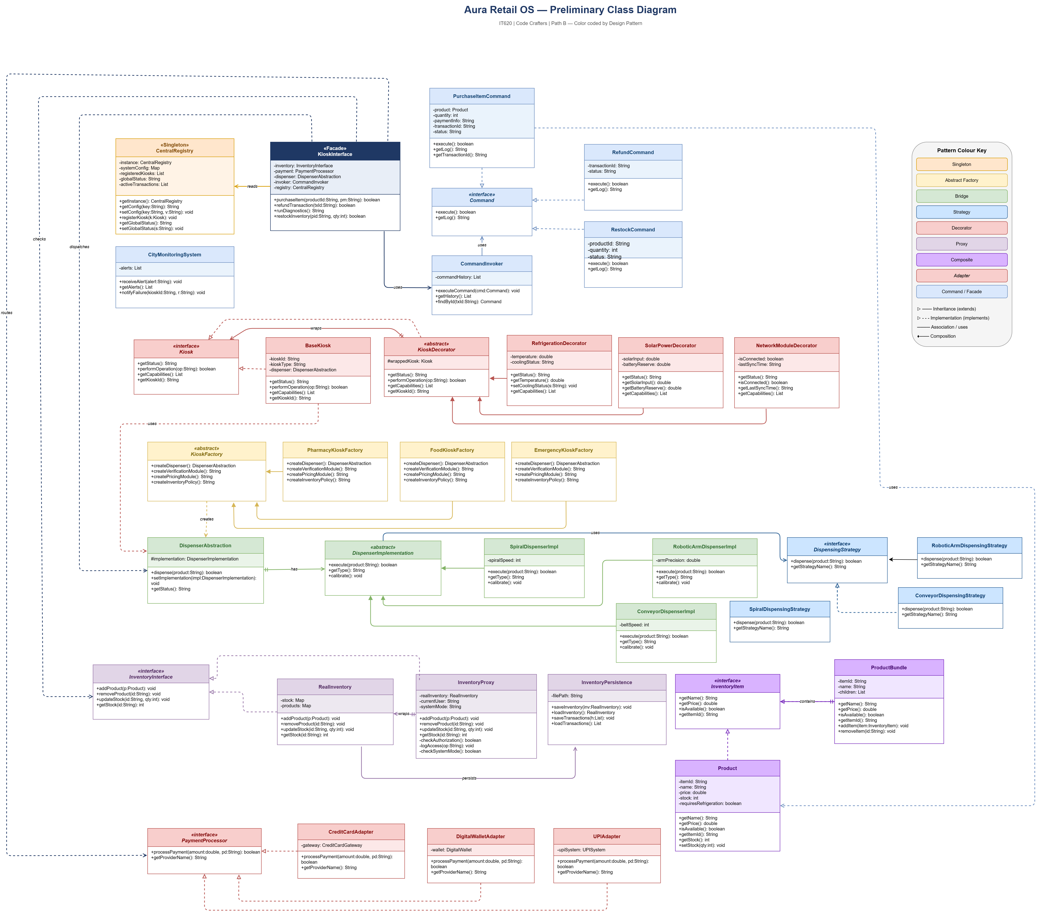

  - Use Case Diagram
Identifies all actors interacting with the system (Customer, Admin, City Monitor, Payment Provider, Hardware) and the operations they can trigger through KioskInterface.
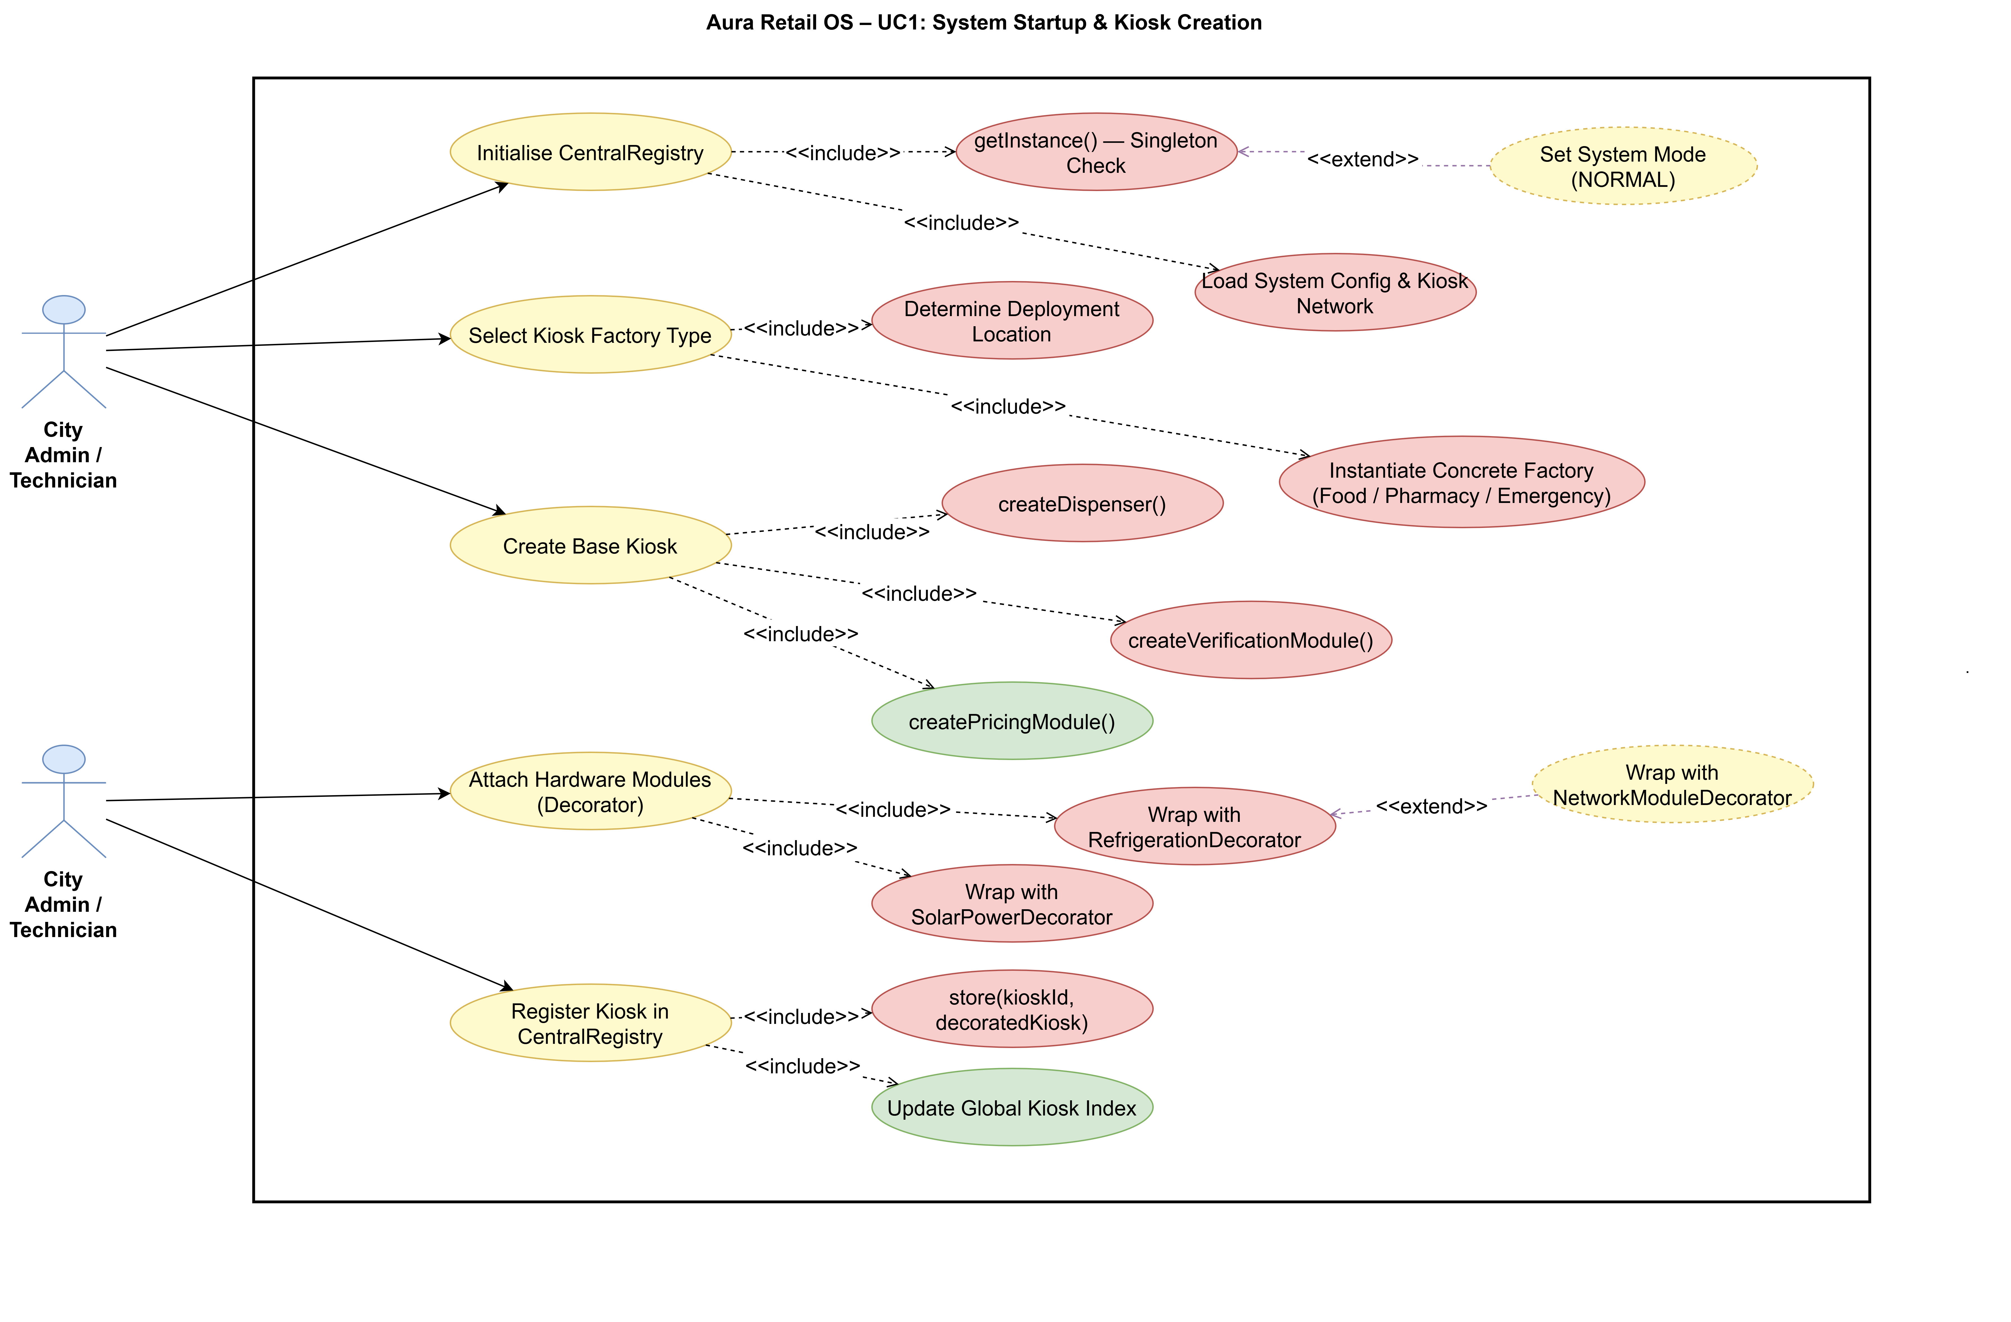
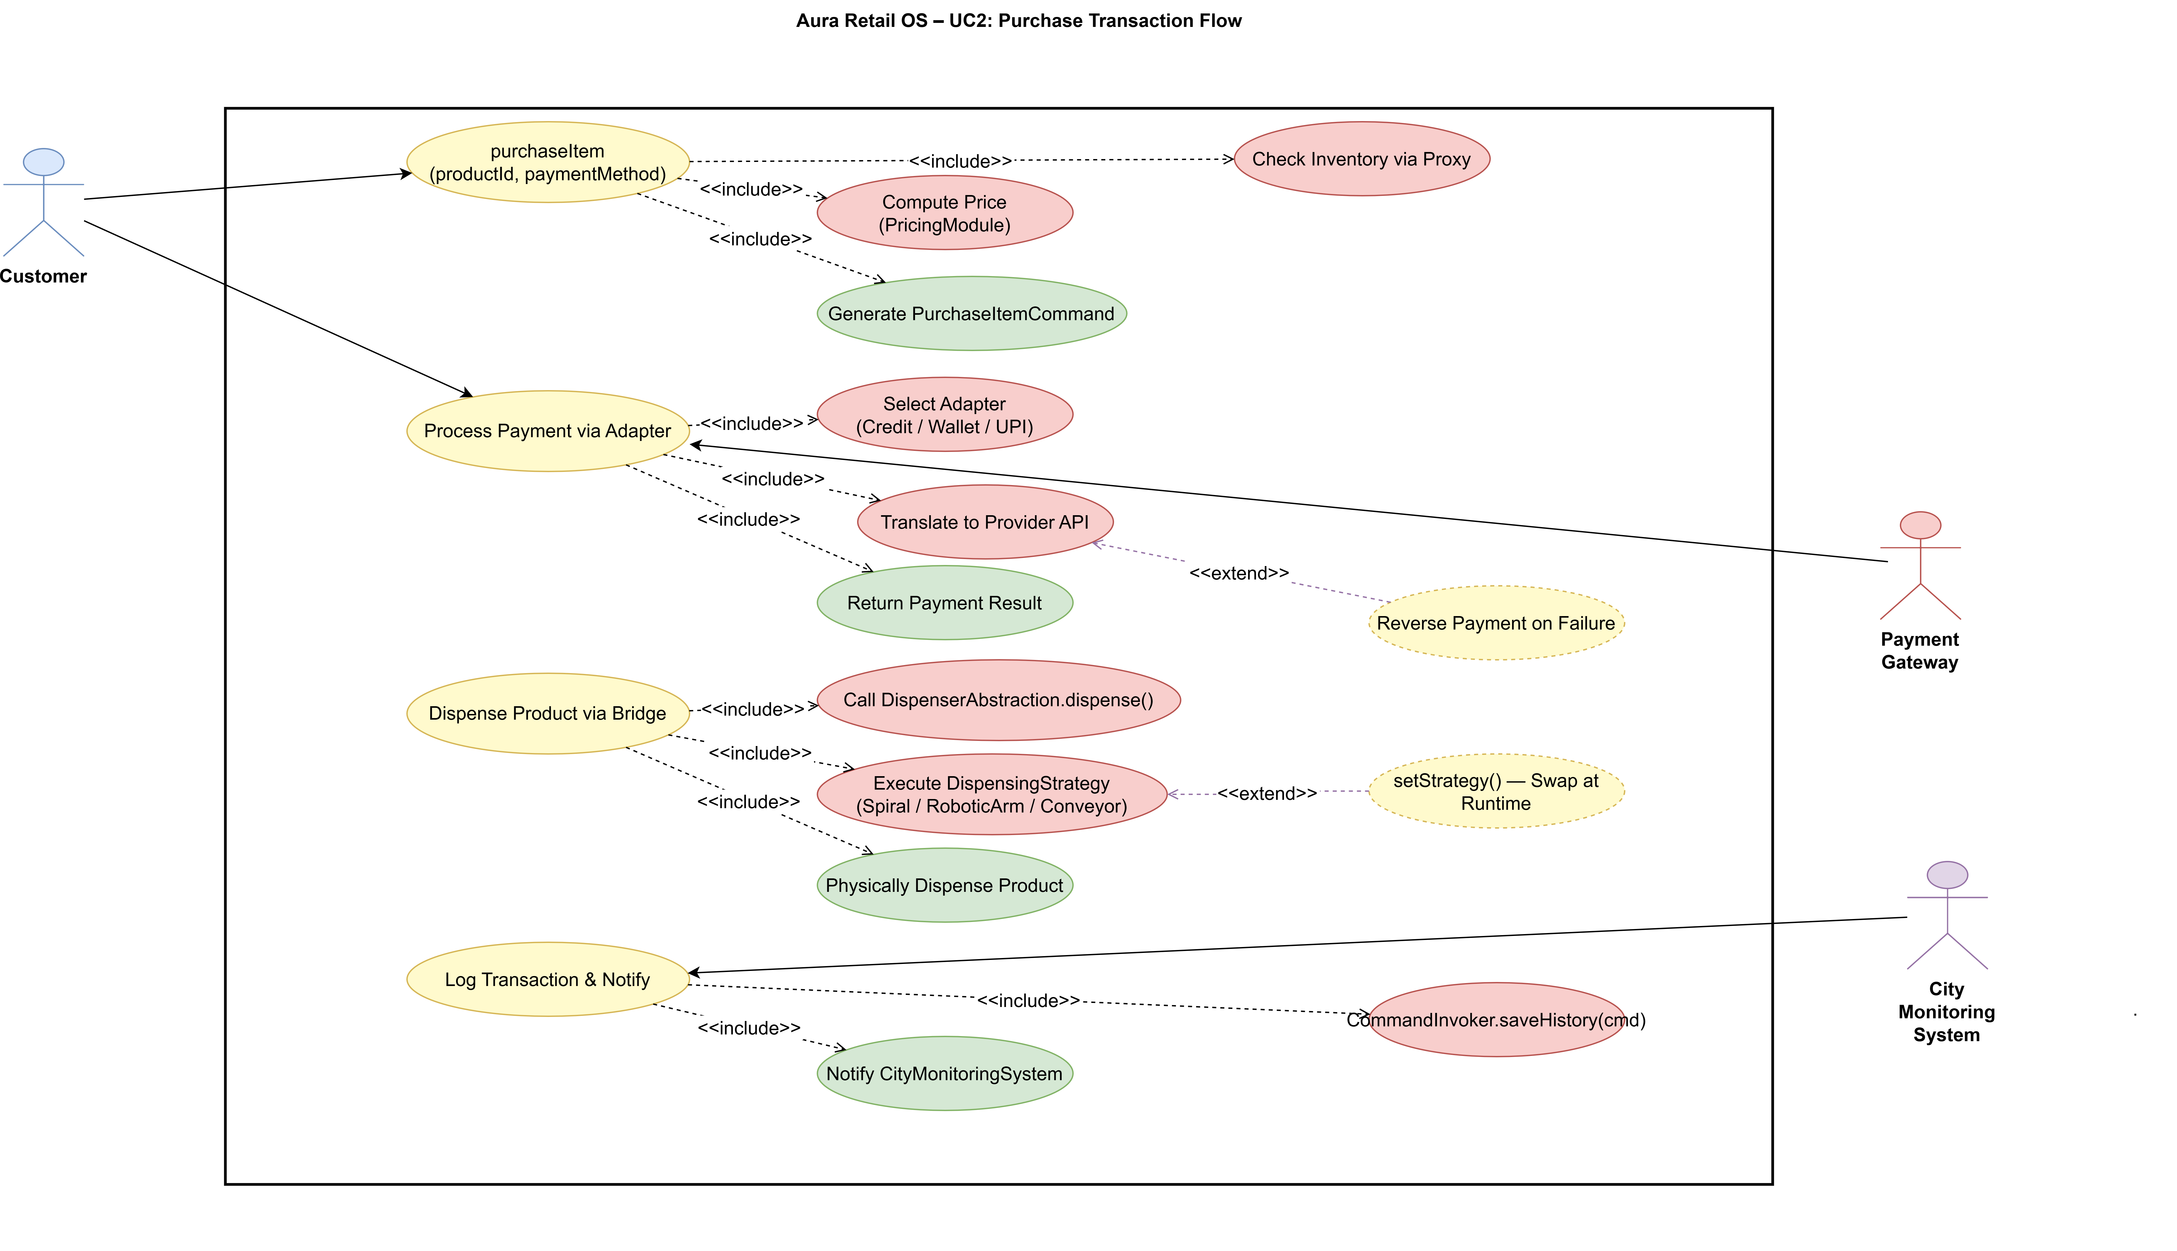
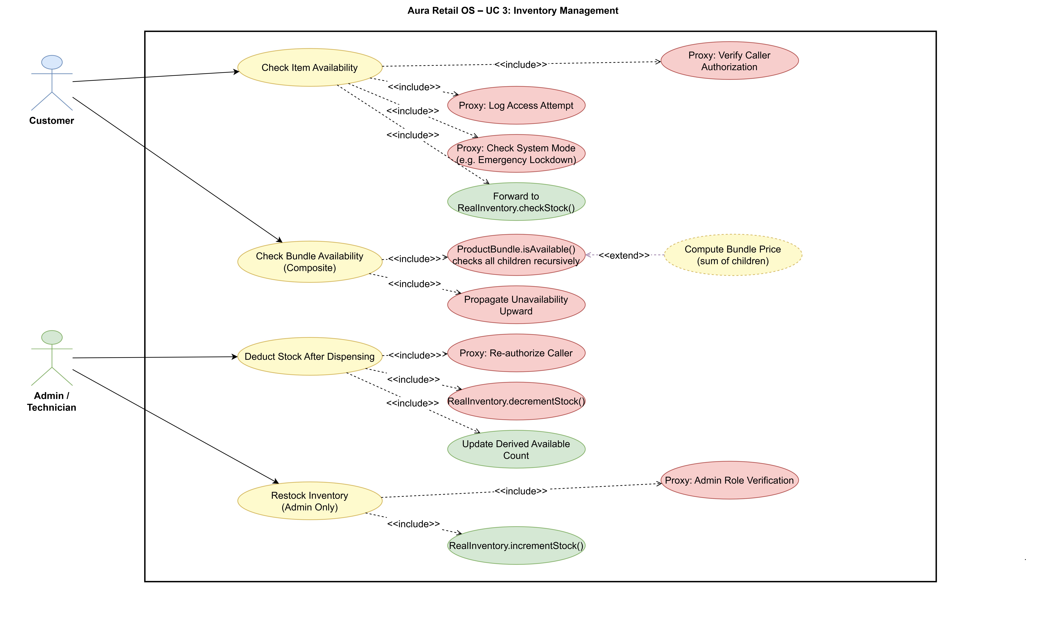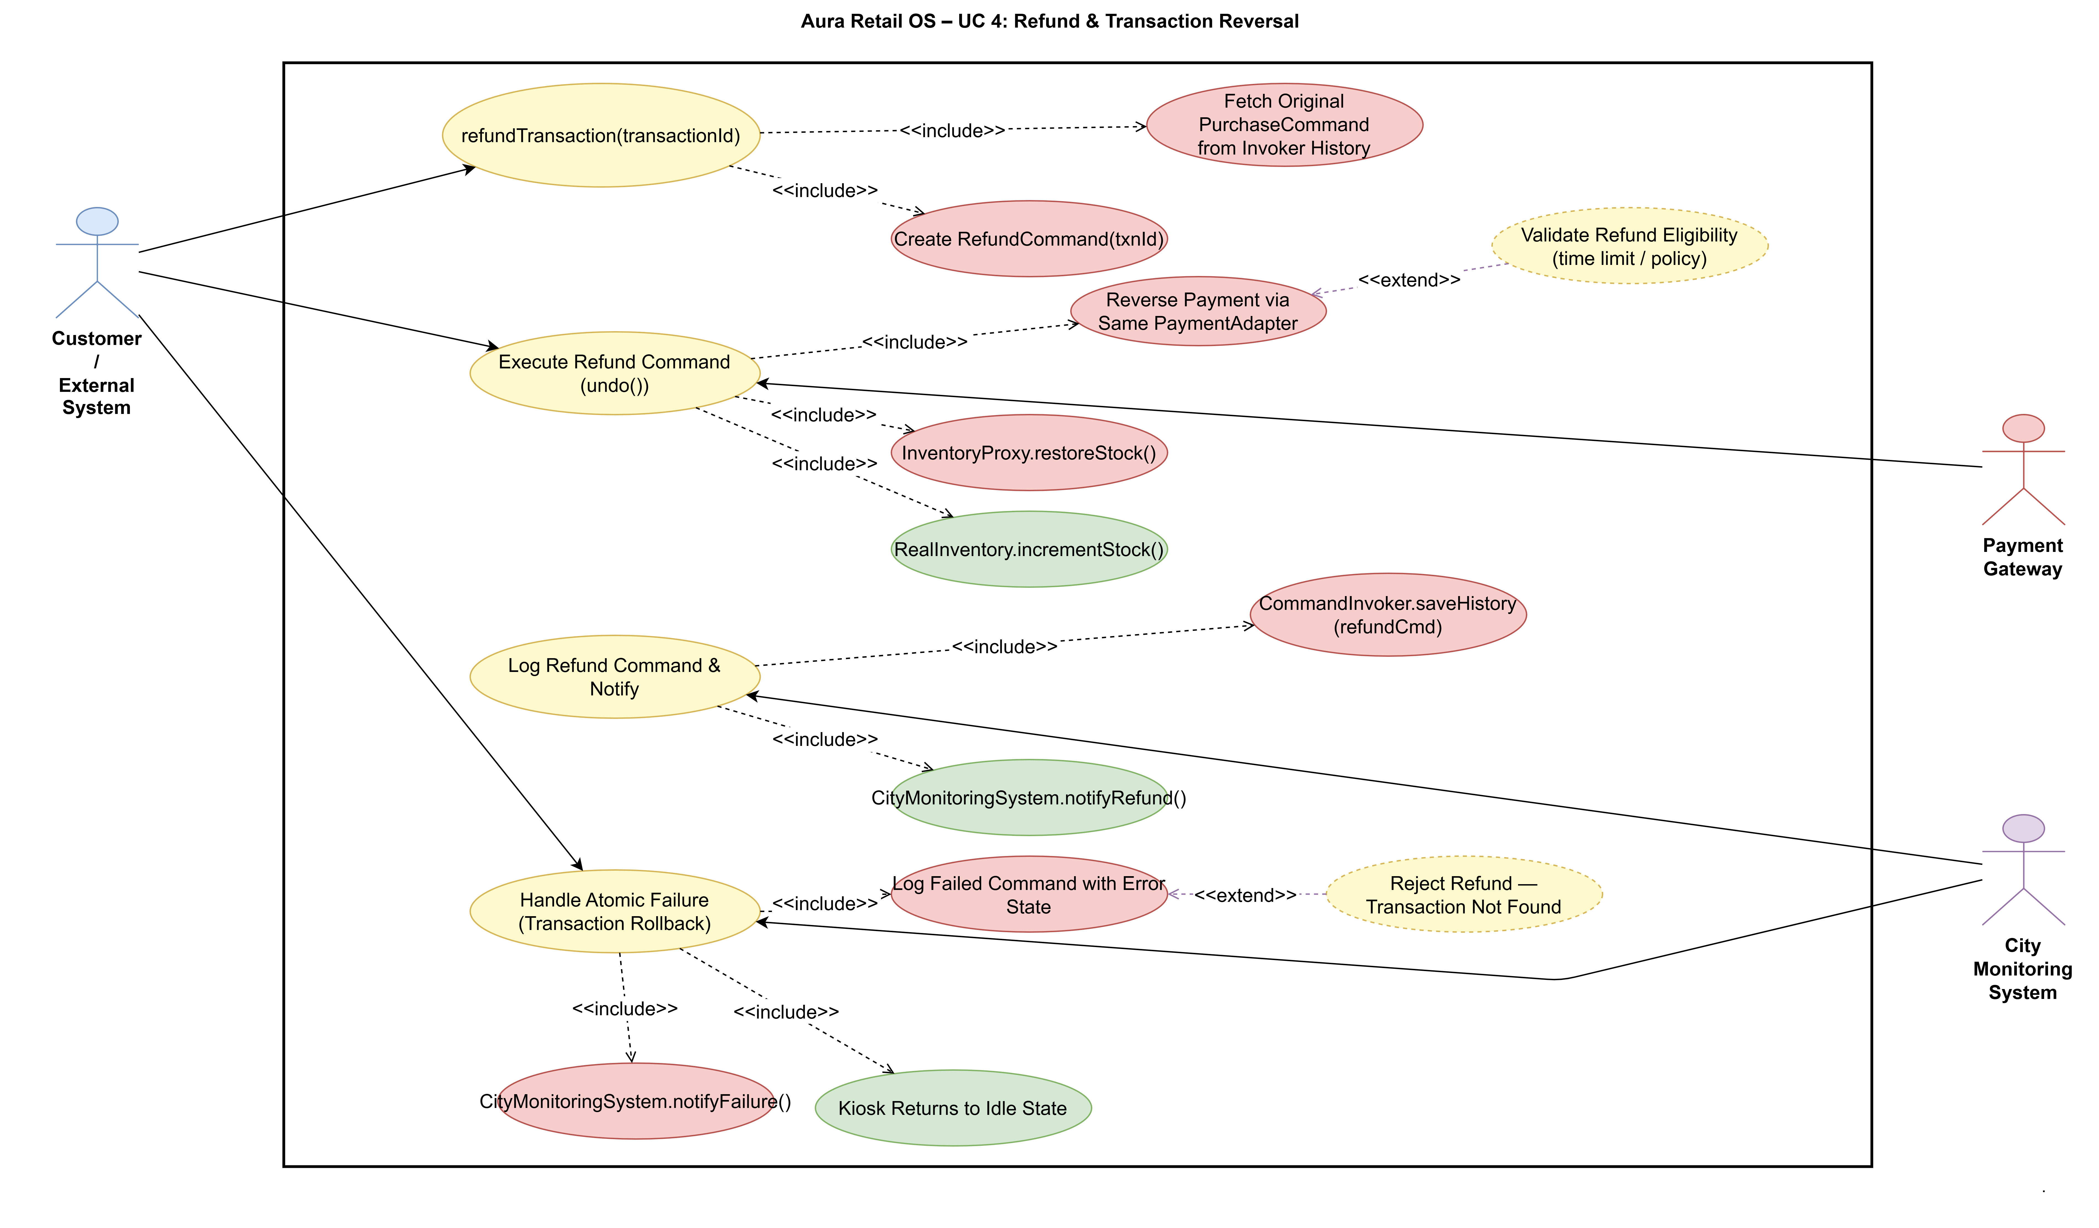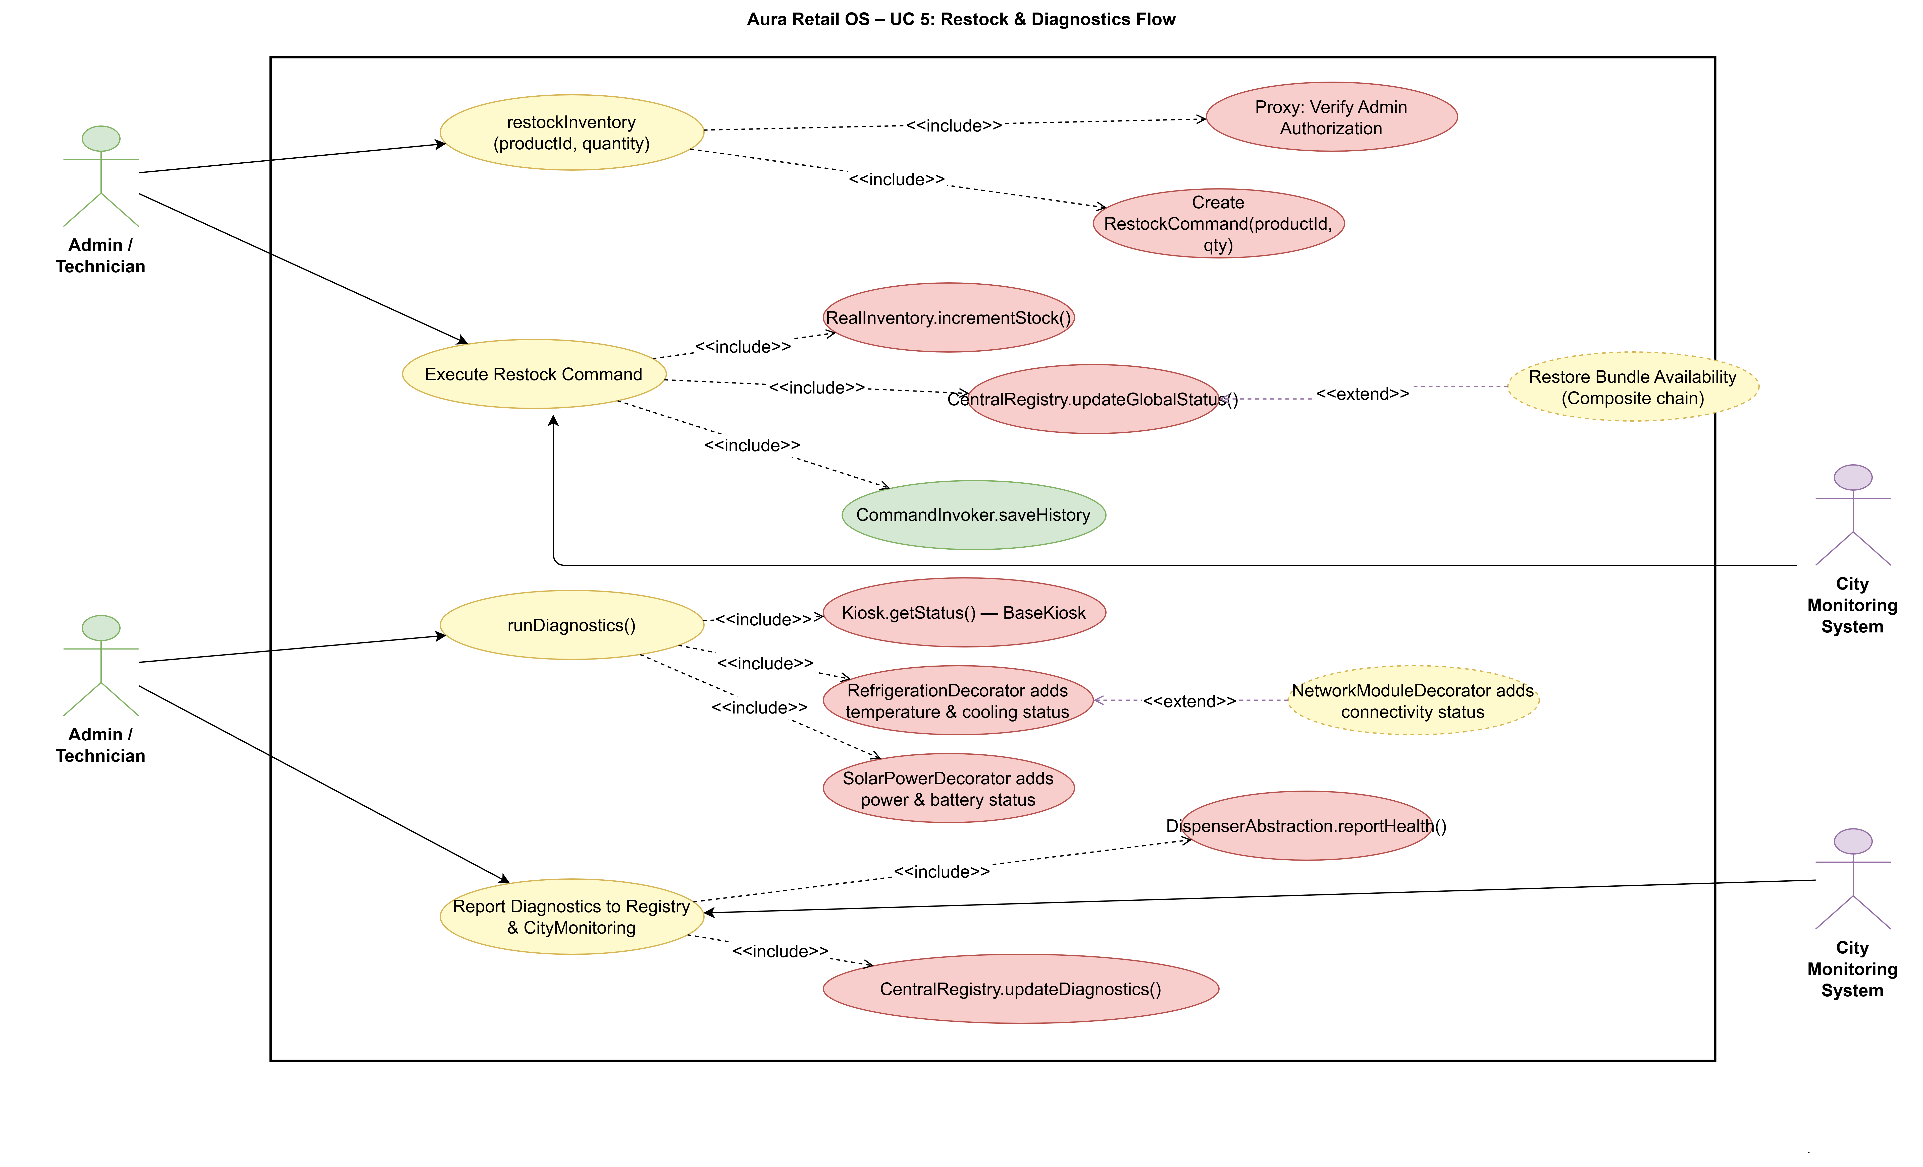

  - Activity Diagram
Illustrates the full purchase transaction flow - from product selection through stock validation, payment processing, hardware dispensing, inventory update, and transaction logging - including failure branches for insufficient stock and hardware errors.
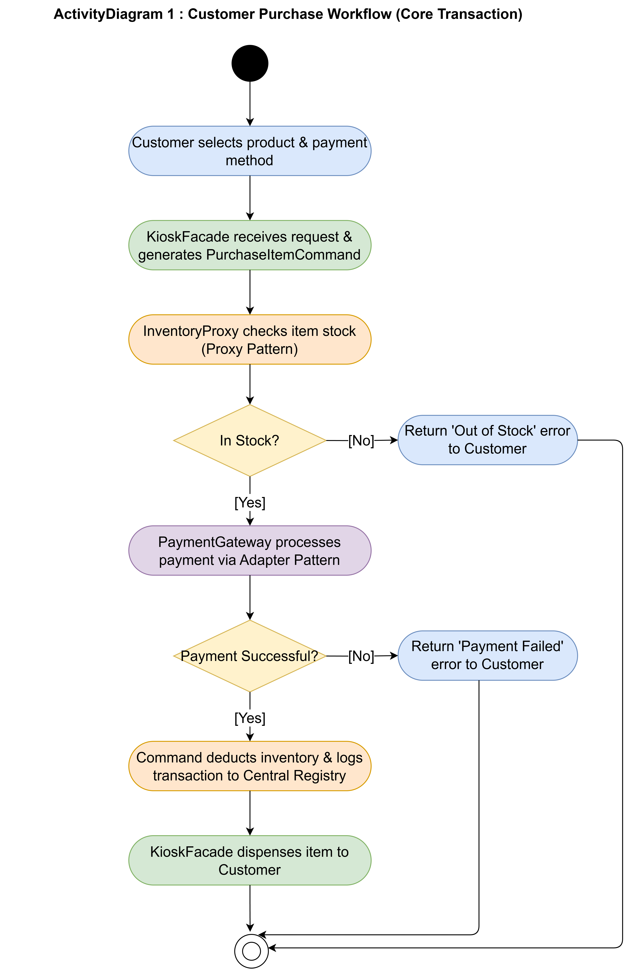
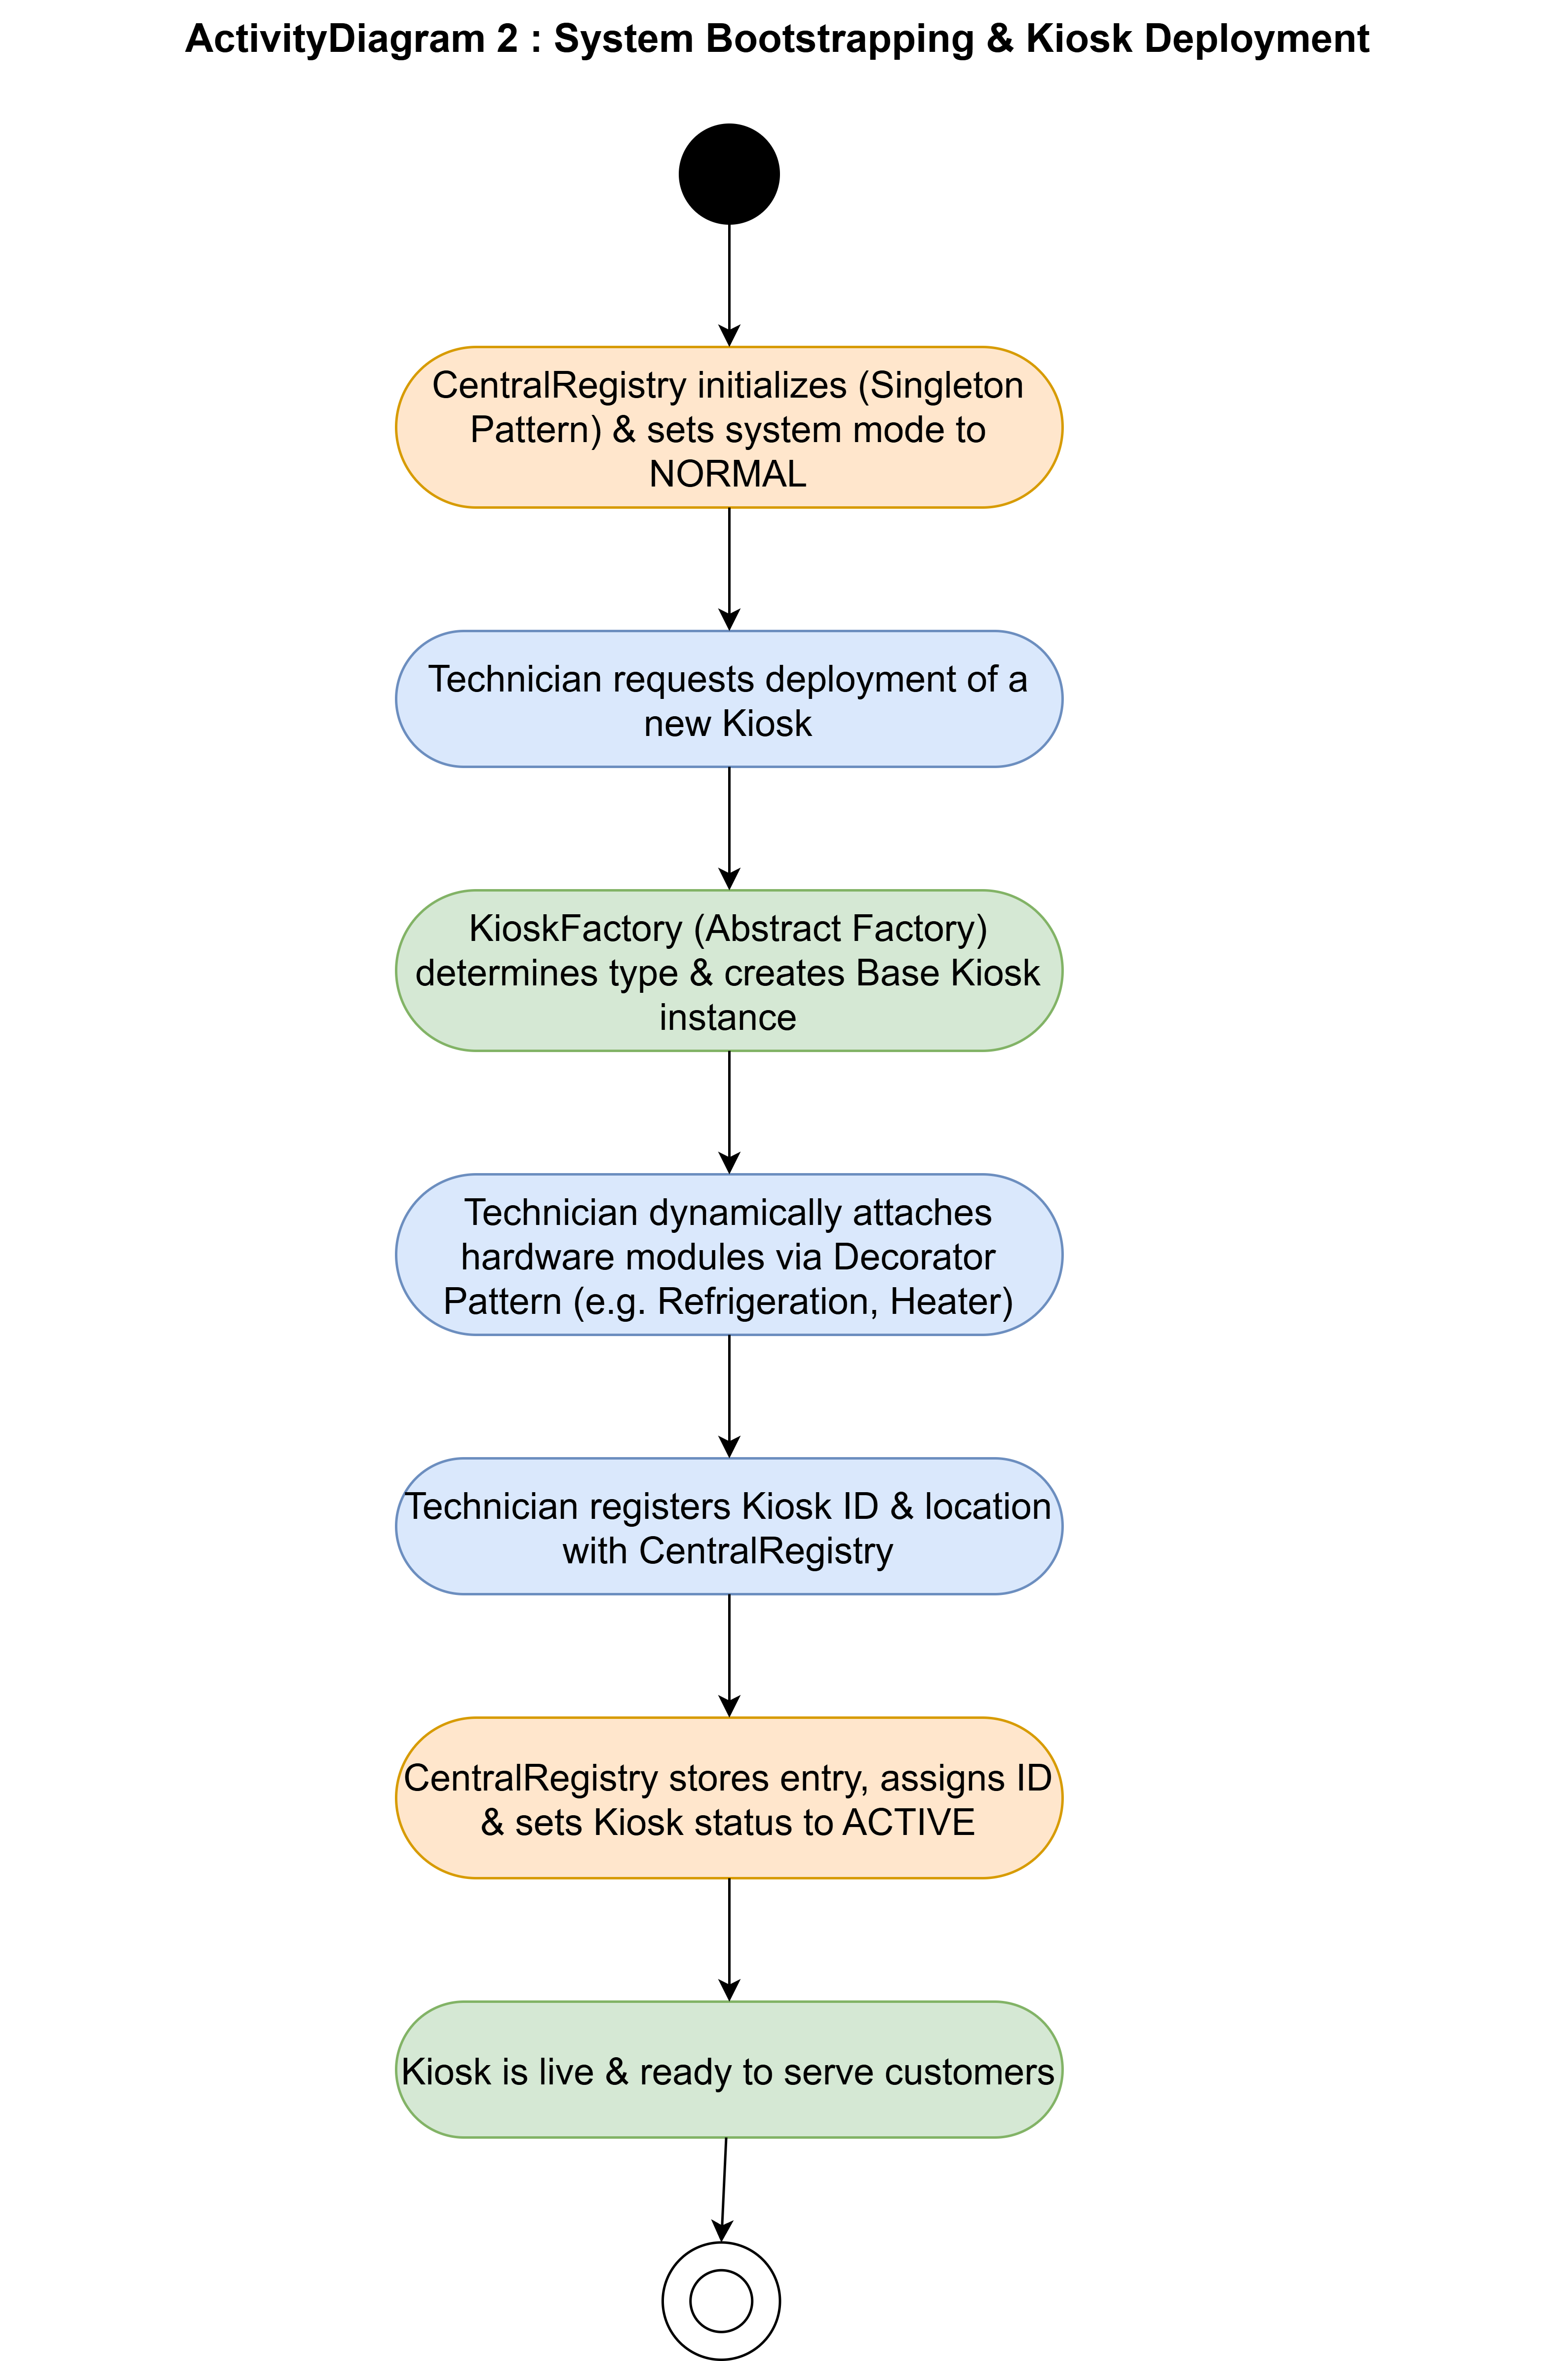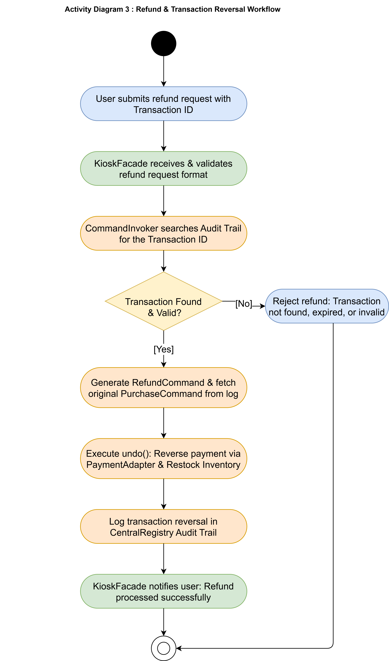
  - Sequence Diagram
Shows the interaction between objects over time for a complete purchase: KioskInterface → InventoryProxy → InventoryManager → PaymentAdapter → PaymentProvider → DispenserAbstraction → Hardware → CommandInvoker.
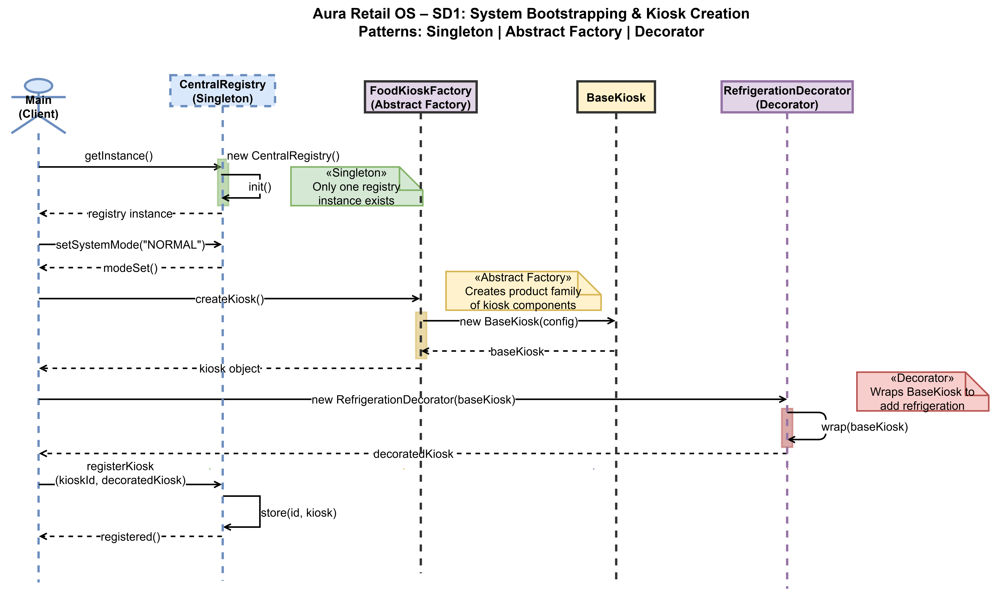
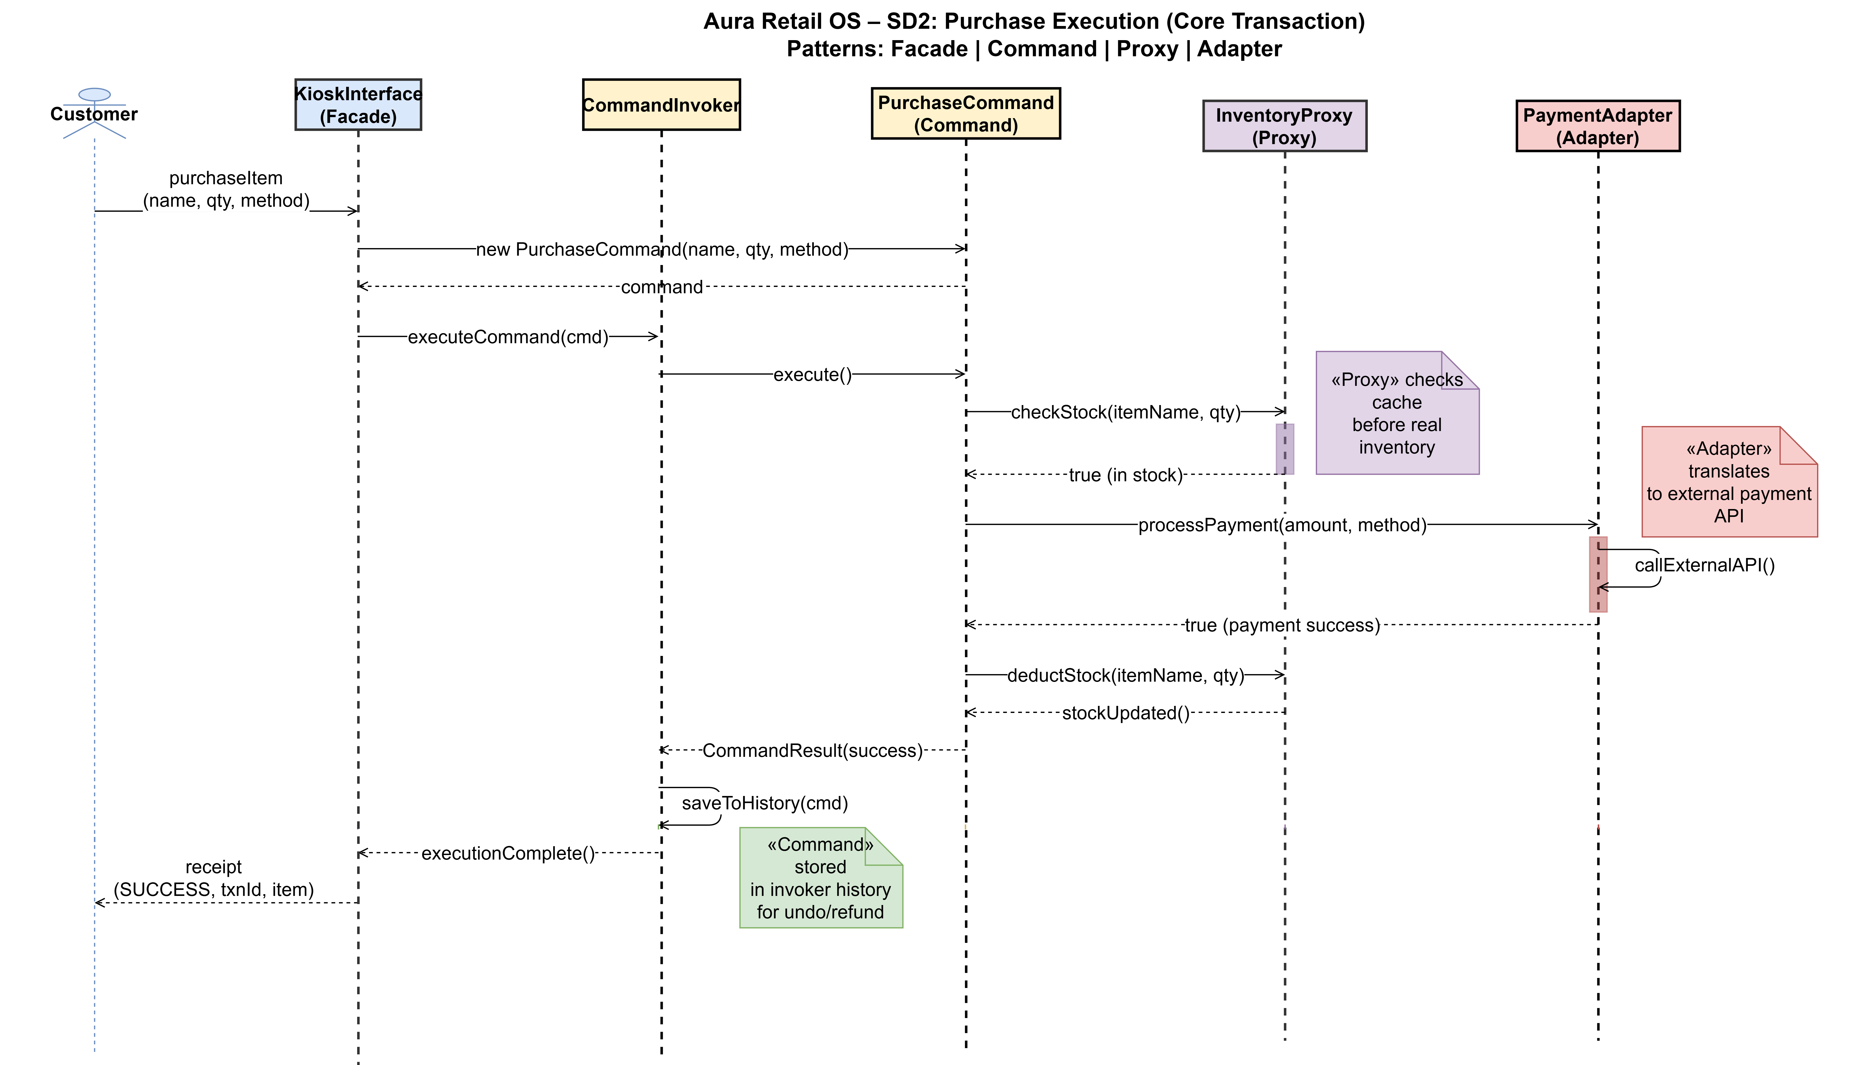
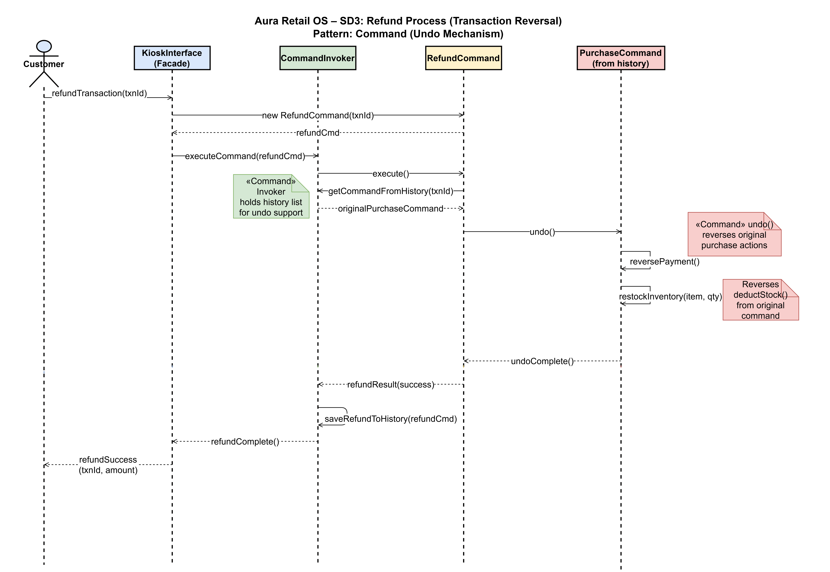

Note: For clear view of diagram refer GitHub Repository docs folder :
https://github.com/24Chessman/aura-retail-os/tree/main/docs

- Path B Requirements Coverage
All eight Path B requirements were fully implemented and demonstrated in the automated simulation. The table below maps each requirement to its pattern, mechanism, and verified status.

Req. | Requirement | Pattern | Mechanism | Status
REQ-1 | Hardware Abstraction | Bridge | Swap dispensers with zero kiosk changes | ✅ Done
REQ-2 | Secure Inventory Access | Proxy | Auth + logging on every operation | ✅ Done
REQ-3 | Optional Hardware Modules | Decorator | Attach modules at runtime | ✅ Done
REQ-4 | Payment System Integration | Adapter | Unify 3+ incompatible payment APIs | ✅ Done
REQ-5 | Inventory Hierarchy | Composite | Bundles with cascading availability | ✅ Done
REQ-6 | Atomic Transactions | Command | All-or-nothing purchase operations | ✅ Done
REQ-7 | Emergency Mode Restrictions | Proxy + Registry | Block writes in EMERGENCY mode | ✅ Done
REQ-8 | Hardware Dependency | Decorator | Block products without required hardware | ✅ Done

  - Simulation Verification Summary
The automated simulation produced the following final summary confirming complete coverage:
Patterns Implemented : 10 / 10
Scenarios Completed : 3 / 3
Requirements Covered : 8 / 8

- System Constraints & Enforcement

  - Atomic Transactions
Enforced by the Command pattern. PurchaseItemCommand checks stock availability before initiating payment. If stock is insufficient, the command halts - payment is never charged and inventory is never modified. Stock is decremented only after payment approval and successful dispense. The simulation demonstrated this: an OutOfStockItem (stock 0, requested 5) was blocked, payment was not charged, and inventory remained unchanged.

  - Hardware Dependency Constraint
Enforced by the Decorator pattern. Products that require specific hardware (e.g., ColdDrink requires RefrigerationUnit) check the kiosk's current capability list at purchase time. If the required module is absent the product is marked unavailable and the purchase is blocked. The simulation confirmed ColdDrink purchase was blocked before RefrigerationModule attachment and succeeded immediately after.

  - Emergency Mode Restrictions
Enforced by InventoryProxy in conjunction with CentralRegistry. When the registry reports EMERGENCY mode, the proxy blocks all write operations (addProduct, updateStock) while permitting reads (getStock) needed for emergency dispensing. The simulation confirmed write operations returned 'EMERGENCY MODE - restricted access' while reads proceeded normally.

  - Inventory Consistency
Inventory updates occur exclusively inside successfully completing command objects, after payment approval and dispense confirmation. No partial state can arise because a command either completes all steps or stops at the first failure without executing subsequent steps.

  - Derived Attributes
Available stock is computed from live inventory state at purchase time (not cached), preventing overselling in rapid sequential purchases. Product price is computed dynamically by the injected pricing strategy at the moment of purchase, allowing time-based or stock-level-based adjustments in real time.

  - Secure Access Control
Every inventory operation is intercepted by InventoryProxy regardless of the caller. The proxy performs authorization checks and logs each operation with a precise timestamp. UNAUTHORIZED_USER access is denied before any inventory data is touched. All authorized operations are recorded in an append-only audit log.

- Simulation Scenarios
The system was demonstrated through three automated simulation scenarios, each targeting specific Path B requirements and design patterns.

Scenario 1 - Hardware Module Attachment (FoodKiosk: KIOSK-F01)
This scenario demonstrated the Bridge, Decorator, Proxy, and Command patterns on a FoodKiosk configured with a ConveyorDispenser.
- Swapped dispenser hardware live between SpiralDispenser, RoboticArmDispenser, and ConveyorDispenser - zero kiosk code changed. (REQ-1, Bridge)
- Attempted inventory access with UNAUTHORIZED_USER - correctly denied by InventoryProxy. (REQ-2, Proxy)
- Attempted purchase of ColdDrink before RefrigerationModule was attached - correctly blocked. (REQ-8, Decorator)
- Attached RefrigerationModule, SolarPowerModule, and NetworkModule at runtime - capabilities expanded from 3 to 6. (REQ-3, Decorator)
- Completed successful purchases of ColdDrink (P002 x1) and Water Bottle (P001 x2) after module attachment.
- Demonstrated atomic transaction failure: OutOfStockItem (stock 0, requested 5) - purchase blocked, payment not charged. (REQ-6, Command)

Scenario 2 - Payment Provider Integration (PharmacyKiosk: KIOSK-P01)
This scenario demonstrated the Adapter pattern by integrating a brand-new payment provider without modifying any existing code.
- Processed payments via existing CreditCardAdapter (CreditCardGateway) and UPIAdapter (UPISystem).
- Plugged in DigitalWalletAdapter as a new provider - only one new class added, zero existing changes. (REQ-4, Adapter)
- Completed a Paracetamol (P004 x1) purchase via DigitalWallet on PharmacyKiosk, confirming end-to-end integration.

Scenario 3 - Nested Bundle Availability (EmergencyReliefKiosk: KIOSK-E01)
This scenario demonstrated the Composite and Proxy patterns with a nested bundle structure and emergency mode enforcement.
- Built a nested EmergencyKit containing FirstAidKit (Bandages, Antiseptic, Gauze), WaterBottle, and Flashlight. (REQ-5, Composite)
- Confirmed EmergencyKit.isAvailable() = true and total computed price = Rs. 103.
- Set Antiseptic stock to 0 - isAvailable() cascaded to false at FirstAidKit and EmergencyKit level.
- Switched CentralRegistry to EMERGENCY mode - InventoryProxy blocked all write operations, permitted reads. (REQ-7, Proxy + Registry)
- Restored Antiseptic stock, switched back to NORMAL mode - EmergencyKit.isAvailable() returned true.
- Completed a Bandages (P010 x1) purchase through EmergencyReliefKiosk using RoboticArmDispenser.
- Triggered saveState() - persisted all transactions, inventory, and config to JSON files.

- System Persistence
Aura Retail OS persists its full operational state to JSON files at the end of each session via KioskInterface.saveState(). Three files are maintained:
- data/transactions.json - Full transaction history. Each entry includes transaction ID, product ID, quantity, payment method, result (SUCCESS / FAIL), and timestamp.
- data/inventory.json - Current stock levels for all registered products across all kiosks.
- data/config.json - System configuration including all registered kiosk IDs and current system mode.

The simulation confirmed successful persistence at the end of Scenario 3:

[PERSISTENCE] Transactions saved to data/transactions.json
[PERSISTENCE] Inventory saved to data/inventory.json
[PERSISTENCE] Config saved to data/config.json
On startup, the system can reload prior state from these files, restoring transaction history and inventory levels from the last saved session.

- GitHub Repository
Repository URL: aura-retail-os
Repository Structure
aura-retail-os/
|-- src/
| +-- com/aura/retailos/
| |-- Main.java
| |-- core/ (KioskInterface, BaseKiosk, CentralRegistry)
| |-- factory/ (KioskFactory and concrete factories)
| |-- inventory/ (InventoryManager, InventoryProxy, Product, Bundle)
| |-- payment/ (PaymentProcessor interface + all adapters)
| |-- hardware/ (DispenserAbstraction + hardware implementations)
| |-- decorator/ (RefrigerationModule, SolarPowerModule, NetworkModule)
| |-- command/ (PurchaseItemCommand, RefundCommand, CommandInvoker)
| +-- strategy/ (Pricing strategies, dispensing strategies)
|-- data/
| |-- transactions.json
| |-- inventory.json
| +-- config.json
|-- out/ (compiled .class files)
|-- docs/ (UML diagrams)
+-- README.md
How To Run
# Step 1 - Compile
javac -d out -sourcepath src src\com\aura\retailos\Main.java

# Step 2 - Run
java -cp out com.aura.retailos.Main

# Then select:
# [1] Automated Simulation -> demonstrates all 10 patterns
# [2] Interactive Mode -> manually test all features

- Team Contributions
The following table summarises each team member's primary responsibilities in the design and implementation of Aura Retail OS. All members participated in simulation design, integration testing, and report preparation.

Name | Student ID | Responsibilities
Naitik Sutariya | 202512006 | Team Lead. Facade pattern (KioskInterface), Singleton pattern (CentralRegistry), Command pattern (PurchaseItemCommand, RefundCommand, RestockCommand, CommandInvoker), Decorator base structure (Kiosk interface, BaseKiosk, KioskDecorator), Main simulation design, system integration, final GitHub submission
Priya Patel | 202512003 | Abstract Factory pattern (KioskFactory, PharmacyKioskFactory, FoodKioskFactory, EmergencyKioskFactory), Adapter pattern (PaymentProcessor interface, CreditCardAdapter, DigitalWalletAdapter, UPIAdapter), third-party provider simulation classes
Gaurang Rahani | 202512007 | Bridge pattern (DispenserAbstraction, DispenserImplementation, SpiralDispenserImpl, RoboticArmDispenserImpl, ConveyorDispenserImpl), Strategy pattern (DispensingStrategy and all 3 strategy implementations), Decorator hardware modules (RefrigerationDecorator, SolarPowerDecorator, NetworkModuleDecorator)
Harshal Prajapati | 202512013 | Proxy pattern (InventoryProxy, RealInventory, InventoryInterface), Composite pattern (InventoryItem interface, Product, ProductBundle with recursive availability), System Persistence (InventoryPersistence - JSON save and load for inventory, transactions, and config)

- Conclusion
Aura Retail OS successfully demonstrates how a carefully designed object-oriented architecture can transform a fragile monolithic application into a modular, extensible platform. By applying 10 design patterns across creational, structural, and behavioural categories, the system achieves key quality attributes that the original Aura-Kiosk v1.0 lacked:

- Hardware Independence - New dispenser types can be integrated without touching any business logic. The Bridge pattern guarantees the kiosk never depends on a concrete hardware class.
- Payment Extensibility - New payment providers require only one new Adapter class. No existing processing logic is ever modified, satisfying the Open/Closed Principle.
- Dynamic Capability Expansion - Optional hardware modules attach at runtime via the Decorator pattern. BaseKiosk is never modified regardless of how many modules are added.
- Consistent Security - Every inventory operation is intercepted, authorized, and logged by InventoryProxy. Security policy is enforced uniformly with no possibility of bypass.
- Flexible Inventory Modelling - Individual items and arbitrarily nested bundles are treated uniformly via the Composite pattern. Availability checks cascade correctly through any tree depth.
- Transaction Integrity - All purchases are atomic. The Command pattern ensures payment is never charged for a failed stock check and stock is never decremented for a failed payment.
- Emergency Resilience - CentralRegistry and InventoryProxy cooperate to restrict write access during emergencies while preserving read access required for life-safety dispensing.

All 8 Path B requirements were fully implemented and verified across 3 simulation scenarios with all 10 design patterns operational. The codebase is modular, clearly commented with pattern identifiers, and structured so that future extensions - new kiosk types, new payment providers, new hardware modules - require only the addition of new classes with no modification to the existing system. This embodies the Open/Closed Principle and positions Aura Retail OS as a sustainable long-term platform for the smart city of Zephyrus.

