**NAME :** Dhananjay Salunke

**BRANCH :** IT

**UID :** 2020401073

**COURSE :** CSS LAB

**EXPERIMENT :** 7

**AIM :** To create and read QR Codes for the given exercise

**PROCEDURE:**

1. **The quickest way to create a QR code is with the Qrencode command-line utility. Any major distribution can install Qrencode via the package manager. The following command then creates a QR code containing the text “Hello World!”: $ qrencode -o qrcode.png 'Hello World!'**

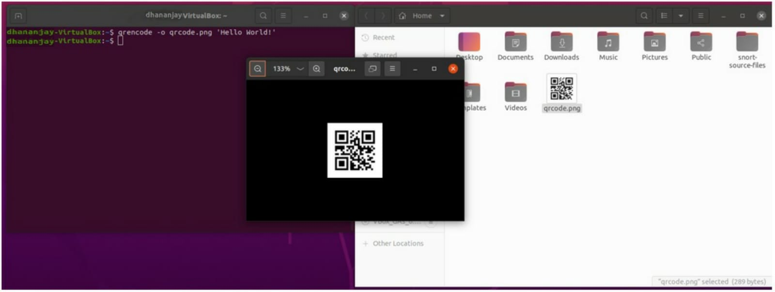

1. **$ qrencode -t EPS -o qrcode.eps 'Hello World!'**

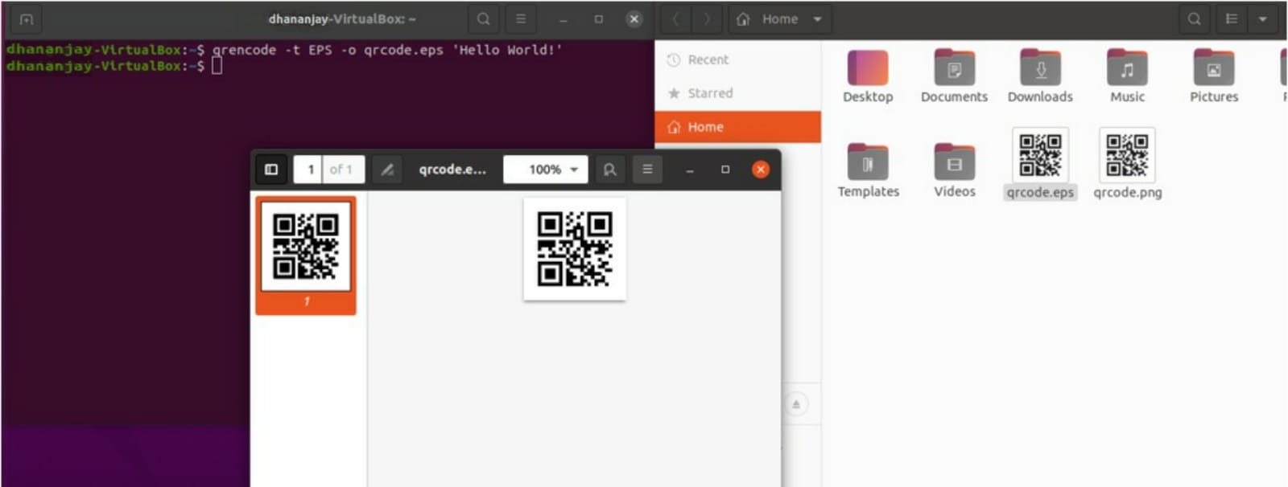

1. **$ qrencode -s 2 -m 10 -o qrcode.png 'Hello World!'**

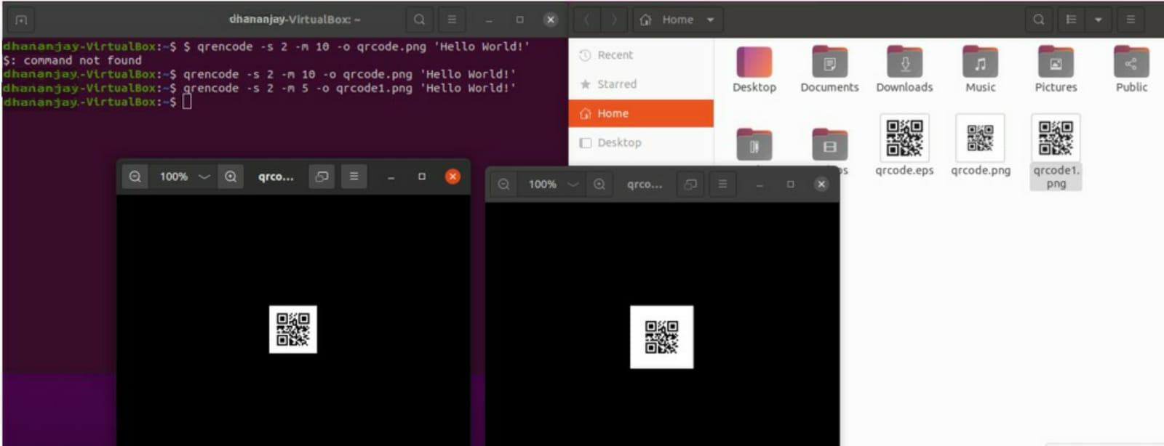

1. **Checking tolerance**





