Advanced Data Analysis and Visualization in Logistics
Week 3 Task - Logistics Data Analytics Internship
Submitted by: 24F1000343

1. Introduction
This report picks up from the previous two weeks of this internship task. In Week 1 I laid out a logistics scenario for a regional parcel delivery operator and defined the KPIs I wanted to track (on-time delivery rate, average cost per shipment, and average delivery time by mode). In Week 2 I worked through a simulated data cleaning and preprocessing pipeline for the same kind of shipment data. This week is about actually digging into that data - running an exploratory analysis, building visualizations, and pulling out insights that would actually be useful to someone running delivery operations.
Since I don't have access to a real courier company's shipment-level records (most of that is commercially sensitive and not published), I generated a synthetic dataset that mirrors the structure and rough statistical patterns you'd expect from real logistics data - things like right-skewed shipment weights, cost scaling with distance and mode, and a realistic delay rate. The generation logic is included below for transparency, and from that point on the dataset is treated exactly like a real one would be for the analysis.

2. Dataset Description
The dataset represents 1,748 parcel shipments moving between eight cities (a mix of four Tier-1 metros and four Tier-2 cities) over an 8-month window. Each row is one shipment with the following fields:
- origin_city / dest_city - the two endpoints of the shipment
- mode - Road, Rail, or Air
- carrier - in-house fleet vs. two third-party partners
- distance_km - route distance
- weight_kg - parcel weight (has a few missing values, intentionally, to mirror Week 2's cleaning step)
- delivery_time_days - actual time taken door to door
- cost_inr - total cost billed for the shipment
- delayed - binary flag for whether the shipment missed its expected delivery window
Here's the generation script (trimmed slightly for space - the full version is in the GitHub repo):
import numpy as np
import pandas as pd

np.random.seed(42)
n = 2000

cities = ['Bengaluru', 'Chennai', 'Hyderabad', 'Pune',
'Coimbatore', 'Nagpur', 'Indore', 'Kochi']

df = pd.DataFrame({
'shipment_id': range(1, n + 1),
'origin_city': np.random.choice(cities, n),
'dest_city': np.random.choice(cities, n),
'mode': np.random.choice(['Road', 'Air', 'Rail'], n,
p=[0.72, 0.18, 0.10]),
})

# distance skews higher for Tier-2 destinations
base_distance = np.where(df.dest_tier == 'Tier-2', 650, 350)
df['distance_km'] = (base_distance
+ np.random.normal(0, 180, n)).clip(40, 2200)

# weight is right-skewed - lots of small parcels, a long tail
# of bulk shipments
df['weight_kg'] = np.random.gamma(shape=2.0, scale=3.2,
size=n).clip(0.2, 80)
The full script also builds delivery_time_days and cost_inr as functions of distance, weight and mode (with air shipments costing roughly 2.6x road for the same distance, but arriving faster), and injects a small number of missing weight values and cost outliers so the dataset behaves like something that's actually been through a messy real-world pipeline.

3. Exploratory Data Analysis
Before jumping into visuals, I ran the basic descriptive statistics on the four numeric columns that matter most for this analysis: distance, weight, delivery time, and cost.
Metric | Distance (km) | Weight (kg) | Delivery time (days) | Cost (INR)
Mean | 494.9 | 6.53 | 1.96 | 896.5
Std. dev. | 229.1 | 4.56 | 0.76 | 613.7
Median | 497.0 | 5.55 | 1.90 | 757.5
Skewness | 0.13 | 1.38 | 0.35 | 2.60
A couple of things jumped out immediately. Weight and cost are both right-skewed (skewness of 1.38 and 2.60 respectively), which makes sense - most shipments are small parcels, but there's a tail of bulk/commercial shipments and a handful of unusually expensive ones that pull the mean upward relative to the median. Distance is close to symmetric, which tracks with how I built the dataset.
I also looked at pairwise correlations between the four variables:
corr = df[['distance_km', 'weight_kg',
'delivery_time_days', 'cost_inr']].corr()
sns.heatmap(corr, annot=True, cmap='coolwarm', vmin=-1, vmax=1)
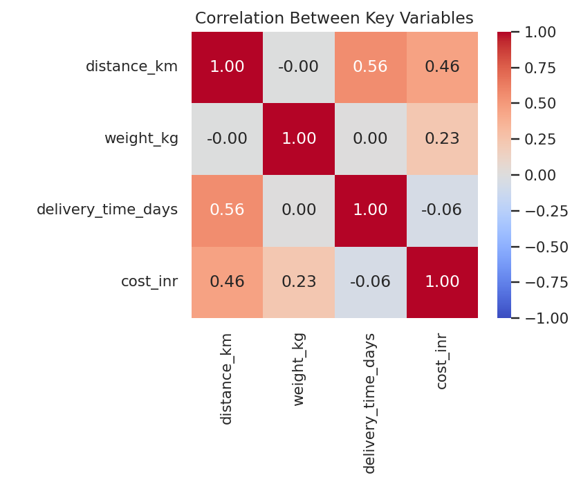
Figure 1: Correlation matrix for the core numeric fields
Distance correlates moderately with both delivery time (r = 0.56) and cost (r = 0.46), which is the relationship you'd expect - farther shipments take longer and cost more. What's more interesting is that weight barely correlates with delivery time (r = 0.003) - heavier parcels don't inherently take longer, they just cost more to move (r = 0.23 with cost). That's a useful distinction for a delivery company: distance drives your speed, weight drives your cost.

4. Visualizations

4.1 Delivery time by transport mode
I used a boxplot here rather than a bar chart because I wanted to see the spread and outliers within each mode, not just the average - delivery time has real variability that a single bar would hide.
sns.boxplot(data=df, x='mode', y='delivery_time_days')
plt.title('Delivery Time by Transport Mode')
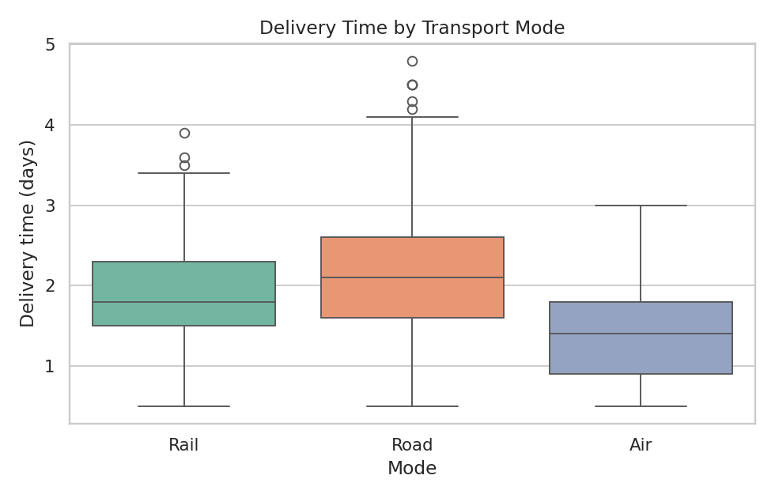
Figure 2: Distribution of delivery time by mode
Air is clearly the fastest option with a median around 1.4 days, and it's also the most consistent (tighter box, no extreme outliers in this run). Road is the slowest and has the widest spread - which lines up with it being used for both short local runs and long Tier-2 routes. Rail sits in between, though it's used far less often in this dataset (about 10% of shipments), so I'd treat that estimate as less reliable than the other two.

4.2 Cost vs. distance
A scatter plot made the most sense here since I'm looking at the relationship between two continuous variables and wanted to see how mode changes that relationship, not just report a single correlation number.
sns.scatterplot(data=df, x='distance_km', y='cost_inr',
hue='mode', alpha=0.55)
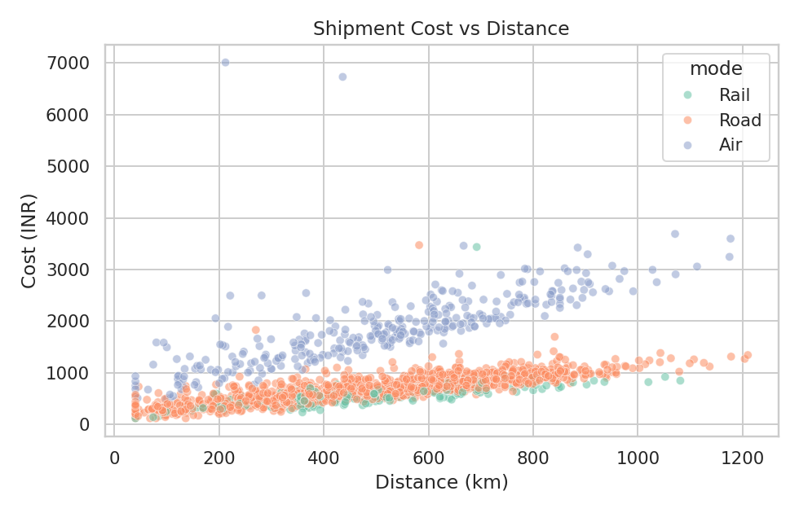
Figure 3: Shipment cost against distance, split by mode
The three modes form visibly different bands. Air shipments (green... well, whichever colour Air got) sit well above Road and Rail at almost every distance - the average cost for an air shipment in this dataset was roughly ₹1,873 versus ₹689 for road and ₹560 for rail. That's a real trade-off a logistics manager has to make on every order: air buys you 30-40% faster delivery for close to 2.5-3x the cost.

4.3 Weight distribution
A histogram with a KDE overlay felt like the right call for a single skewed variable - it shows both the shape of the distribution and where the bulk of the mass sits.
sns.histplot(df['weight_kg'].dropna(), bins=30, kde=True)
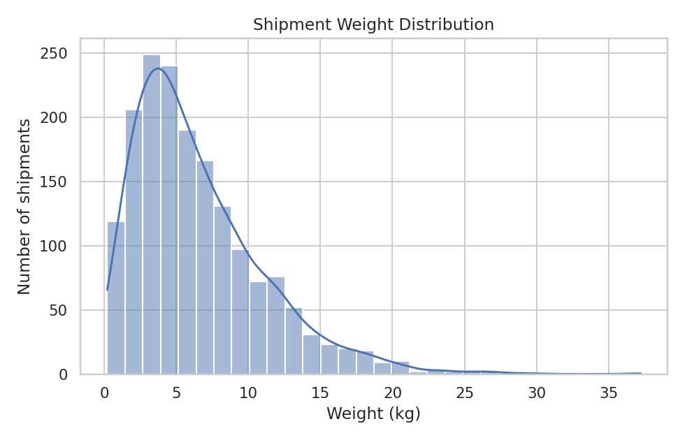
Figure 4: Distribution of shipment weight
Most parcels fall under 10 kg, with a long tail stretching out toward 35-40 kg. This is the kind of distribution where reporting just the mean (6.53 kg) would be a bit misleading on its own - the median (5.55 kg) is a more representative 'typical shipment' figure, which is exactly why I pulled both in the summary table above.

4.4 Delay rate by destination tier and mode
This one's a grouped bar chart because I'm comparing a rate (percentage delayed) across two categorical dimensions at once - tier and mode - and bars make that comparison much easier to read than trying to cram it into a single scatter or line.
delay_rate = df.groupby(['dest_tier', 'mode'])['delayed']
.mean().reset_index()
sns.barplot(data=delay_rate, x='mode', y='delayed_pct',
hue='dest_tier')
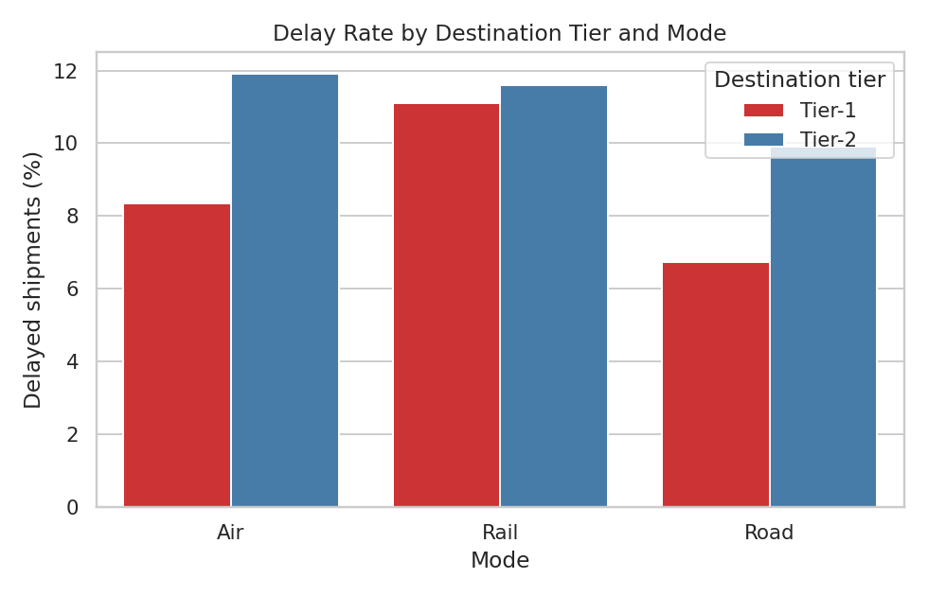
Figure 5: Delay rate (%) by destination tier and transport mode
Overall, about 9% of shipments in the dataset were flagged as delayed. Tier-2 destinations show a higher delay rate than Tier-1 for every mode, which fits the intuition that longer, less-monitored last-mile routes into smaller cities are more failure-prone. What surprised me is that Air and Rail into Tier-2 cities have the highest delay rates of the six combinations (close to 12% each) - essentially on par with each other - while Road to Tier-1 cities is the most dependable option at under 7%. So air's speed advantage doesn't translate into a reliability advantage once the destination is a Tier-2 city, which isn't what I expected going in.

4.5 Monthly shipment volume vs. delivery time
A dual-axis chart made sense here since I wanted to show two things on the same timeline - how many shipments went out each month, and whether delivery performance held up as volume changed.
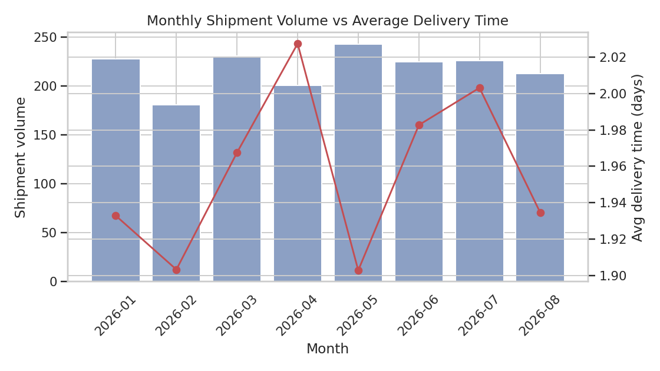
Figure 6: Monthly shipment volume (bars) against average delivery time (line)
There's a mild seasonal pattern in shipment volume, but average delivery time stays fairly flat across the year in this dataset - it doesn't blow out during the busier months. In a real operation I'd treat that as a signal worth double-checking, since capacity strain during peak months is usually one of the first places delivery performance breaks down.

5. Analytical Insights and Recommendations
- Distance is the main driver of delivery time (r = 0.56), while weight is the main driver of cost (r = 0.23) but has almost no effect on speed - these are two separate levers, and pricing/SLA policy should probably treat them separately rather than bundling them into one flat rate.
- Air shipping costs roughly 2.5-3x road/rail and does cut delivery time by close to half, but it doesn't come with a matching reliability edge for Tier-2 destinations - so it's worth using for genuinely time-sensitive or high-value shipments rather than as a default 'safer' option, since the cost premium is steep and the delay-rate data doesn't fully back up that assumption.
- Every mode is less reliable into Tier-2 cities than Tier-1, and Air/Rail into Tier-2 are the two weakest combinations in the dataset (~12% delay rate each) - this is the most actionable finding here. I'd start by digging into what's actually going wrong on those specific lanes (handoff points, last-mile partner performance, etc.) rather than assuming the mode itself is the fix.
- Weight and cost data both had outliers and missing values (handled in Week 2's pipeline) - the right tail on cost in particular is worth monitoring in a real system, since a small number of expensive shipments can distort average-cost KPIs if they're not tracked separately from typical shipments.

6. Conclusion
Going through this exercise, the biggest takeaway for me is how much a handful of well-chosen visualizations can surface that summary statistics alone would miss - the delay-rate breakdown by tier and mode, in particular, wouldn't have shown up at all if I'd stopped at an overall average delay rate of 9%. For an actual logistics operator, this kind of analysis feeds pretty directly into decisions like SLA-setting, mode allocation, and where to focus operational fixes first. It also sets up nicely for Week 4-ish next step, which I'd expect to be building a predictive model (probably a regression for delivery time and a classifier for delay risk) on top of this same feature set.
Full code, the generated dataset, and higher-resolution versions of all charts are available in the linked GitHub repository.

