AI Usage DISCLOSURE FORM

1. Team Details
Team Name: Codexa
Project / Product Name: NexaGuide – Smart Guided Troubleshooting Engine
Organization / Institution (if any): VIT Vellore
Submission Date: 04.10.2026

2. AI Usage Declaration
Did your team use any Artificial Intelligence (AI) in developing this project? Yes / No
Yes

3. Purpose of AI Usage ( Brief Details)
Idea generation / brainstorming - Used to explore the troubleshooting workflow, possible system components, feature organization, and alternative approaches for understanding everyday device complaints.
Code generation or assistance - Used for development assistance, reviewing implementation approaches, interpreting errors, and refining selected parts of the implementation using AI tools including ChatGPT and Claude. The team reviewed and tested the suggestions before incorporating relevant changes.
UI / UX design - Used for improving the presentation of the troubleshooting workflow, pipeline stages, product walkthrough, architecture representation, and overall interface clarity.
Content creation - Used for editing technical descriptions, project explanations, documentation, and presentation content to improve clarity and organization.
Data analysis - Not used.
Testing / debugging - ChatGPT and Claude were used during development to understand implementation errors, review possible issues, and identify suitable fixes. The team tested the implementation after making changes.
Other - AI tools including ChatGPT and Claude were used as supporting tools for technical communication, implementation guidance, debugging assistance, and refinement of project documentation. The team reviewed and adapted the suggestions according to the actual NexaGuide implementation.

4. Feature Origin Classification ( Please add/delete based on the number of the feature)
(i)
1. Feature Name - Interactive Clarification & Hybrid Retrieval
2. Self-Generated/AI-Generated/Both - Both
3. Description -
AI Tool: ChatGPT
Prompt Used: Guidance on designing a troubleshooting flow that can handle vague everyday device complaints using clarification, lexical retrieval, and semantic retrieval.
Output Summary: Suggestions for structuring the complaint-understanding stage and combining lexical and semantic retrieval to find relevant troubleshooting information.
Modification: The team reviewed the suggestions and adapted the relevant concepts to the actual NexaGuide pipeline. The implemented system uses clarification for broad complaints and combines BM25-style lexical scoring with semantic similarity.
(ii)
1. Feature Name - Grounded Troubleshooting Plan Generation
2. Self-Generated/AI-Generated/Both - Both
3. Description -
AI Tool: ChatGPT
Prompt Used: Assistance in understanding how an LLM could generate structured troubleshooting steps using retrieved reference information rather than producing an unrestricted answer.
Output Summary: Suggestions for using retrieved evidence as context and returning an ordered troubleshooting plan.
Modification: The team adapted the approach to the actual NexaGuide implementation. The Groq-hosted LLM is used for query enrichment and structured troubleshooting-plan generation using retrieved reference text, followed by application validation and Pydantic schema checks.
(iii)
1. Feature Name - Development & Debugging Assistance
2. Self-Generated/AI-Generated/Both - Both
3. Description -
AI Tool: ChatGPT and Claude
Prompt Used: Reviewing implementation errors, interpreting error messages, and suggesting possible fixes during development.
Output Summary: Explanations of implementation issues and alternative approaches for resolving development problems.
Modification: The team evaluated the suggestions, incorporated only relevant changes, and tested the implementation to verify the fixes.
(iv)
1. Feature Name - Technical Content & Presentation Refinement
2. Self-Generated/AI-Generated/Both - Both
3. Description -
AI Tool: ChatGPT and Claude
Prompt Used: Clarification of technical explanations, architecture descriptions, troubleshooting workflow, innovation points, and presentation wording.
Output Summary: Provided alternative wording and organization for explaining the NexaGuide system and its workflow.
Modification: The team reviewed, edited, and adapted the content according to the actual implementation, project requirements, and submission format.
5. Ethical & Compliance Confirmation
AI usage complies with guidelines and policies. Yes
No proprietary or copyrighted data misused. I Agree

6. Declaration & Sign-Off
Name of Team Representative: Mano Bharathi R
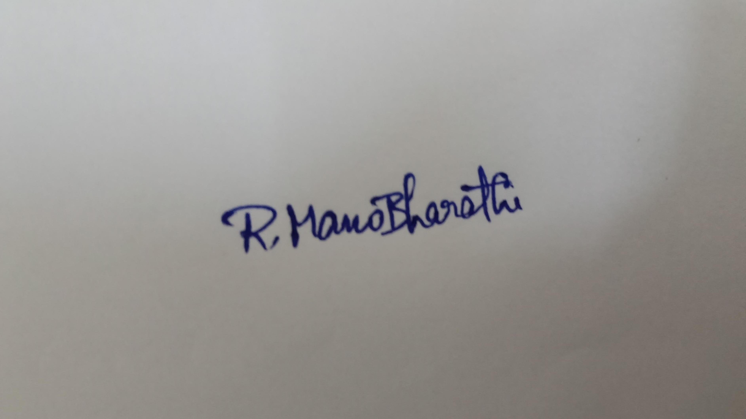
Role: Team Lead
Signature:
Date: 30.09.2026

