EXPERIMENT 6

**Aim: Design of Arithmetic Logic Shift Unit and Multiplier.**

**Exercise#1:** Design 4-bit, 8-operations (given in Table) Arithmetic Logic Shift Unit as shown in block diagram of figure-2 using initial carry (Cin) as LSB of the control lines of multiplexers. Use control signals and input/output signals in the form of **bus**.

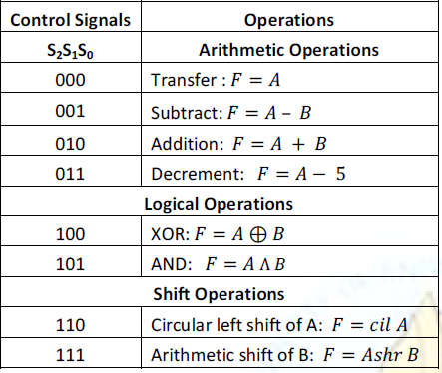

|  |
| --- |
| **Logic Diagram** |
|  |

**Exercise#2:** Repeat **Exercise#1** using **in-built block of tri-state (controlled) buffers** and

**decoder.**

|  |
| --- |
| **Truth Table** |
|  |
| **Logic Diagram** |
|  |