**EXPERIMENT-8**

**Aim: Design of ROM and RAM using in-built block of register..**

**Exercise-1:** Design 8×8 ROM (convert Fig. 1) and 16x8 RAM (convert to Fig. 2) using in-built block of register. Perform Write/Read operation in the memories using following in instructions:

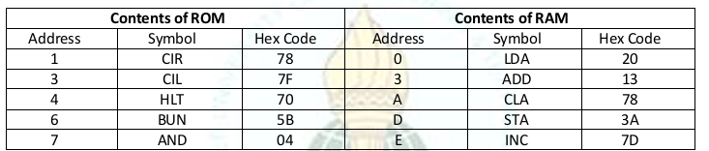

|  |
| --- |
| **Logic Diagram** |
|  |
|

**Exercise-2:** Design 56×8 memory system as shown in block diagram using sub-circuits of RAM and ROM chips designed in Exercise#1. Find the address maps of each memory chip and perform Write/Read operation in the memories using instructions given in the table:

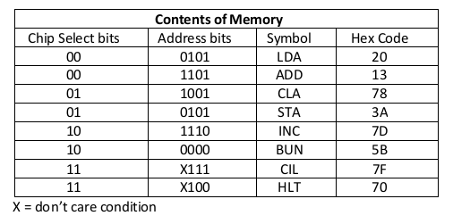

|  |
| --- |
| **Logic Diagram** |
|  |
|  |