



Table of Contents

1 Introduction 2

2 Purpose of YUVA PAY 2

3 Overview of YUVA PAY 2

4 Login/Register 2

5 Home Page 3

5.1 Money Transfer 3

5.1.1 BHIM UPI 3

5.1.2 Yuva Wallet 3

5.1.3 Top-up 4

5.1.4 Nearby Merchants 4

5.2 Recharge and Bill Payments 4

5.3 Financial Service 4

6 My Account 4

6.1.1 Change Language 4

6.1.2 Disable Screen Lock 4

6.1.3 My Coupons 4

6.1.4 My insurance Polices 4

6.1.5 Change Pin 4

6.1.6 Reset Pin 5

6.1.7 Policies 5

6.1.8 Yuva pay Guide 5

6.1.9 Contact Customer Care 5

6.1.10 Customer Support 5

6.1.11 NPCI Grievance Redressal 5

6.1.12 Yes Bank Grievance Redressal 5

6.1.13 Logout 5

7 Scan & Pay 5

8 History 5

9 Rewards 5

# Introduction

YUVA PAY is a mobile payment platform for the last-mile rural population that is Unconnected and Unbanked. It is a pioneer in the mobile payments field, and it designed a new payment platform that can be used to make payments with or without an internet connection. It also supports both smart and feature phones.

YUVA PAY aims to enable its users/customers/merchants to send and receive money seamlessly anywhere and anytime. The company plans to empower 500+ million Lower and Middle-Income rural users with 5+ million retail shops across Tier-2 and below cities in India. Using the power of Offline Mobile Payment (PATENT Pending Technology), we have made it our mission to build a One Single Payment Solution that translates all our cash transactions into digital payments to enable a CASHLESS society.

# Purpose of YUVA PAY

**“The value of an idea lies in the use of it” -** Yuva pay application has been created for the convenience of India’s digital market.

# Overview of YUVA PAY

The scope of this document is to define the Modules of the YUVA PAY Mobile Application. As UDMA Technologies developed from Scratch, this document explains each Module's workflow. YUVA PAY consists of Six Main modules: **Login/Register**, **Home Page**, **Rewards**, **Account**, **History**, and **Scan &** **Pay.**

# Login/Register

To use the app, the User must Register for the first time. After downloading the YUVAPAY from the playstore, the User can register by entering their mobile number, name, and six-digit PIN. They can also add a Referral Code to the account to which they are referring. The User can log in by entering the Mobile Number if the User has already created the account,

After logging in, the User can view the home page.

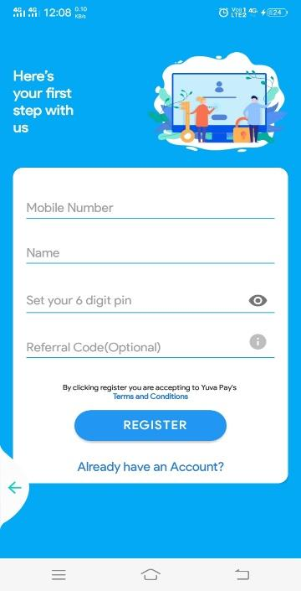

# Home Page

The YUVA PAY app's Homepage is set as the default or start-up page. It offers **Money transfers**, **Recharges and Bill Payments**, and **Financial Services**.

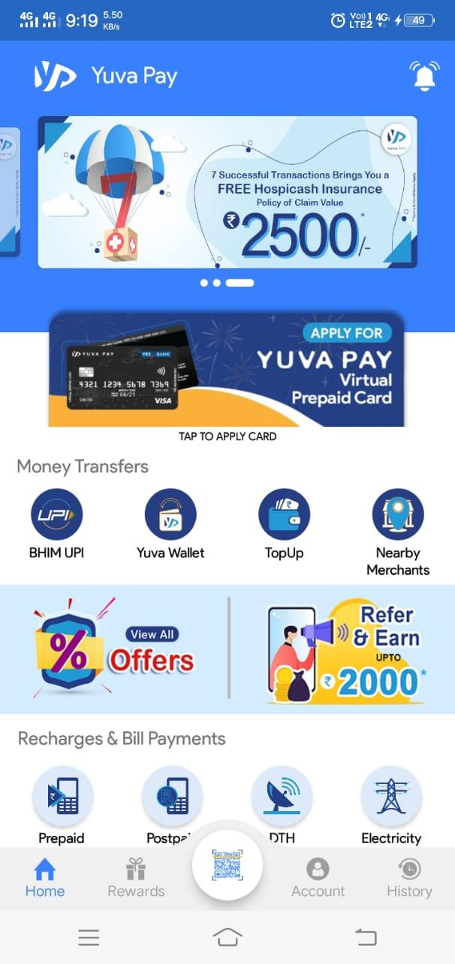

## Money Transfer

Money Transfer consists of many submodules: **BHIM UPI**, **Yuva Wallet**, **Top-up**, and **Nearby**. In this, the User can Send Money to any Merchant.

### BHIM UPI

Bharat Interface for Money (**BHIM**) is a payment option that lets users make simple, easy, and quick transactions using Unified Payments Interface (**UPI**). User can make direct bank payments to anyone on **UPI** using their **UPI** ID or scanning their QR with the **BHIM** option. Users can also request money through the app from a **UPI** ID.

YUVA PAY Enables the **UPI,** and the User can Link the bank account to make hassle-free transactions.

### Yuva Wallet

The User must have a bank account to use other digital payment applications. However, when it comes to the Yuva Pay application, users need to connect with banks. They can make digital payments with the help of the Yuva Pay wallet. Yuva Pay wallet users can top up or lock their wallets through the Yuva Mithra Agent.

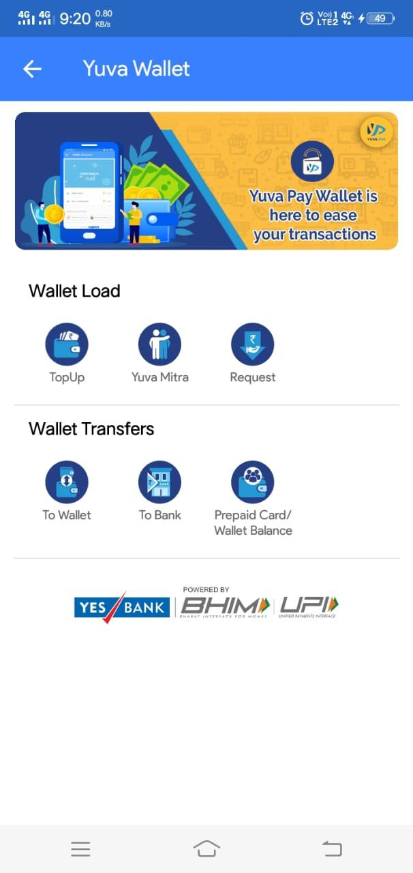

### TopUp

Top-up Provides a Payment Gateway UPI. The User can enter the UPI ID (e.g., XYX@okAxis) in Top-Up, which sends the request to the UPI app. The User can accept the request and enter the UPI PIN to complete the transaction.

### Nearby Merchants

Nearby Merchants Offers to Find YUVA PAY Merchants Nearby the User, the User ensures the location before searching.

## Recharge and Bill Payments

YUVA PAY provides many more features to users than any other App like Phonepe, Google Pay, etc. Users can recharge their postpaid or prepaid bills, electricity, broadband, LPG booking, DTH, municipal services, etc.

## Financial Service

YUVA PAY provides health insurance products, such as **Hospicash**, which covers the customer for up to 30 days of hospitalization. The policy also covers the customer against an unfortunate death or disability due to an accident or illness. **Group Safeguard Insurance**: This sachet-based group insurance product will also bear the hospitalization cost of COVID-19 patients. To claim the amount from the insurance company, the customers no longer need to produce hospital bills.

# My Account

My Account Module consists of several sub-modules, which you can find below.

### Change Language

YUVA PAY provides a Change Language Option Consisting of Eleven Languages of India, and the User Can Select any of them.

### Disable Screen Lock

Users can turn off the screen lock by selecting the Disable Screen Lock option.

### My Coupons

YUVA PAY provides many vouchers that give the holder a discount on a particular product. The user can avail of these in the future.

### My insurance Polices

YUVA PAY provides futures to Users; they can create new insurance police/renew the policies of existing ones.

### Change Pin

YUVA PAY provides users with the option to change their PIN at any time by giving their existing password or creating a new one.

### Reset Pin

YUVA PAY provides a cashless and seamless experience. Users can change or reset their Yuva Pay UPI PIN at any time.

### Policies

YUVA PAY provides policies as per RBI Guidelines for money Transfer through mobile applications.

### Yuva pay Guide

YUVA PAY Guide takes users to an animated Video Library that explains how to use this app, like how to add Beneficiary Accounts on YUVA PAY.

### Contact Customer Care

YUVA PAY provides a customer care number that any user can call in an emergency between 9 AM and 5 PM.

### Customer Support

YUVA PAY provides a core responsibility of customer service, which is answering any simple customer issues.

### NPCI Grievance Redressal

The National Payments Corporation of India (NPCI), the umbrella entity for digital payments in India, has launched a new application named “UPI-HELP” on YUVA PAY, which will act as a grievance redressal mechanism for the users of the YUVA PAY application. Initially, UPI-Help was made live on the YUVA PAY application for bank customers.

### Yes Bank Grievance Redressal

YES BANK allows you to complete the Complaint Form online just a click away. YUVA PAY provides you with all the banking services you need.

### Logout

Logout is an act of Exit from the YUVA PAY.

# Scan & Pay

Using this option, the User can pay by scanning the QR code through Scan & Pay and generate your QR option, which is also present.

# History

The History Shows The transaction list, which is all transactions made by customers via YUVA PAY to the merchant during a given period, and the transaction can be searched using the YUVA PAY Transaction ID, Collect ID, merchant Order ID/reference ID on the default search bar above the page.

# Rewards

YUVA PAY rewards users for money transfers or referring someone. Users can Earn up to Rs. 500 for every money transfer to a YUVA PAY user. Get YUVA PAY scratch cards for mobile recharges, electricity bill payments, metro card recharges, DTH recharges, and more.

Thank you for Reading